Designed for the NGSS: Foundations Teacher Support Evidence Chart

Teacher materials… | Strong | Adequate | Weak
F1. Presence of Phenomena/Problems. Identify and provide background information about the phenomena/problems in the unit and how they match the targeted learning goals. | ✓
F2. Presence of Three Dimensions. Identify and provide background information about the each of the three dimensions in the unit.  - the SEPs  - the DCIs (including engineering)  - the CCCs  - also note (NoS/CNS) and Connections to Engineering, Technology and the Applications of Science (ETS/CETAS) | ✓
F3. Presence of Logical Sequence. Identify and provide background information on the sequence of learning in the unit. | ✓

Strengths related to these Teacher Supports
F1. Presence of Phenomena/Problems.
The module is strong at identifying and providing background information about the phenomena/problems in the unit and how they match the targeted learning goals.
Evidence
- A Module Introduction (TE p.i), online and in print, sets out at a high level how students will solve the Module Phenomenon.
- Teacher Background Information on the phenomena and DCIs addressed in every Driving Question (DQ) is explained simply, in a question-answer format, with supporting diagrams and visuals. For example, in DQ2 (Driving Question 2) the Teacher Background Information explains the parts of plants and their functions.
- A glossary of scientific terms is also provided.
F2. Presence of Three Dimensions.
The module is strong at identifying and providing Teacher Background Information about each of the three dimensions in the unit. It also supports opportunities to connect to the Nature of Science and Engineering, Technology, and Applications of Science.
Evidence
- A digital guide to SEPs and CCCs provides a clear explanation for each practice and concept, with guidance on what these skills should look like in a first grade classroom, and with specific reference to how students should apply the concepts of structure and function (CCC-6), patterns (CCC-1), developing and using models (SEP-2), and constructing explanations and designing solutions.
- Additional module specific support is frequently given at point of use in the instructional materials for all dimensions, Connections to the Nature of Science (CNS/NoS) and Connections to Engineering, Technology, and Applications of Science (CETAS/ETS)—often in the Connect.
F3. Presence of Logical Sequence.
The module is strong at Identifying and providing background information on the sequence of learning in the unit.
Evidence  - A Module Introduction video provides the teacher with an engaging overview on the Module Phenomenon explored in Museum of Leafology, the sequence of learning, and an explanation of how the Performance Expectations are addressed, and how they build on each other. (Museum of Leafology Introduction video)  - The Module Contents for each module identifies the sequence of the three dimensions addressed in Grade 1, Module 1 and explains how they build on each other.  - In DQ1L1 and DQ1L2, students review their prior knowledge with a class read aloud about living things, then sort cards into living and non-living things (K-LS1-1).  - In DQ2, students observe seedling roots, and learn about the different parts plants have, through hands-on, video, close reading, and interactive investigations. They learn a song about plant parts, then write about what each part does (CCC-1, CCC-6, LS1.1).  - In DQ3 students compare different seeds and gather information about how they disperse. They then design, build and test a seed model that can be dispersed by wind (LS1.A, CCC-6, SEP-2).  - In DQ4, students compare different plants, listing similarities and differences, through hands-on and video investigations (LS1.A, 1-LS3-1).  - In DQ5, students investigate how different plants use external structures for defense and protection. They use video and close readings to gather information (LS1.A, SEP-2, CCC-6).  - In DQ6, students apply what they have learned so far in the module to design a solution that mimics the structure of plants to a human problem (1-LS1-1, LS1.A, ETS1.A, ETS1.B, SEP-2, SEP-6, CCC-6).  - In DQ7, the module culminates in the the class preparing and presenting their museum rooms to the public, and sharing what they have learned about plants over the course of the module. | 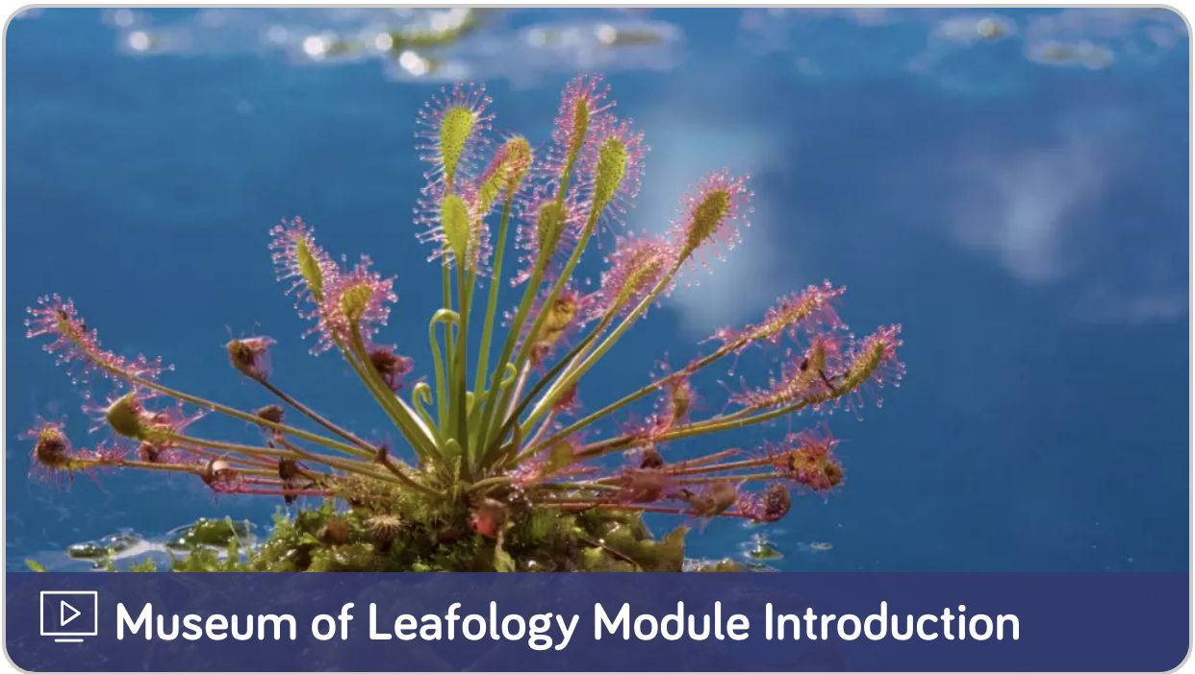  Museum of Leafology Introduction video
- Driving Question Dividers tell the story of how the students will, sequentially, use the three dimensions in each lesson to answer the Driving Question posed. For example, the DQ4 Overview explains that students will observe the seedlings they planted, and record the similarities and differences between them. Students explore plants in nature, sketch model plants (SEP-2), and use the concepts of patterns (CCC-1) and structure and function (CCC-6), to compare and contrast young and adult plants (1-LS3-1).
- The Driving Question Overviews and Lesson Overviews identify the dimensions used in each lesson and detail how the dimensions relate to the learning experience. For example, the Driving Question 4 Overview explains that students will observe their seedlings and make drawings of the similarities and differences (L1 and L2), later comparing seedlings and their parents by watching a video and completing a matching activity (L4). (DQ4 Overview TE p. 126) | 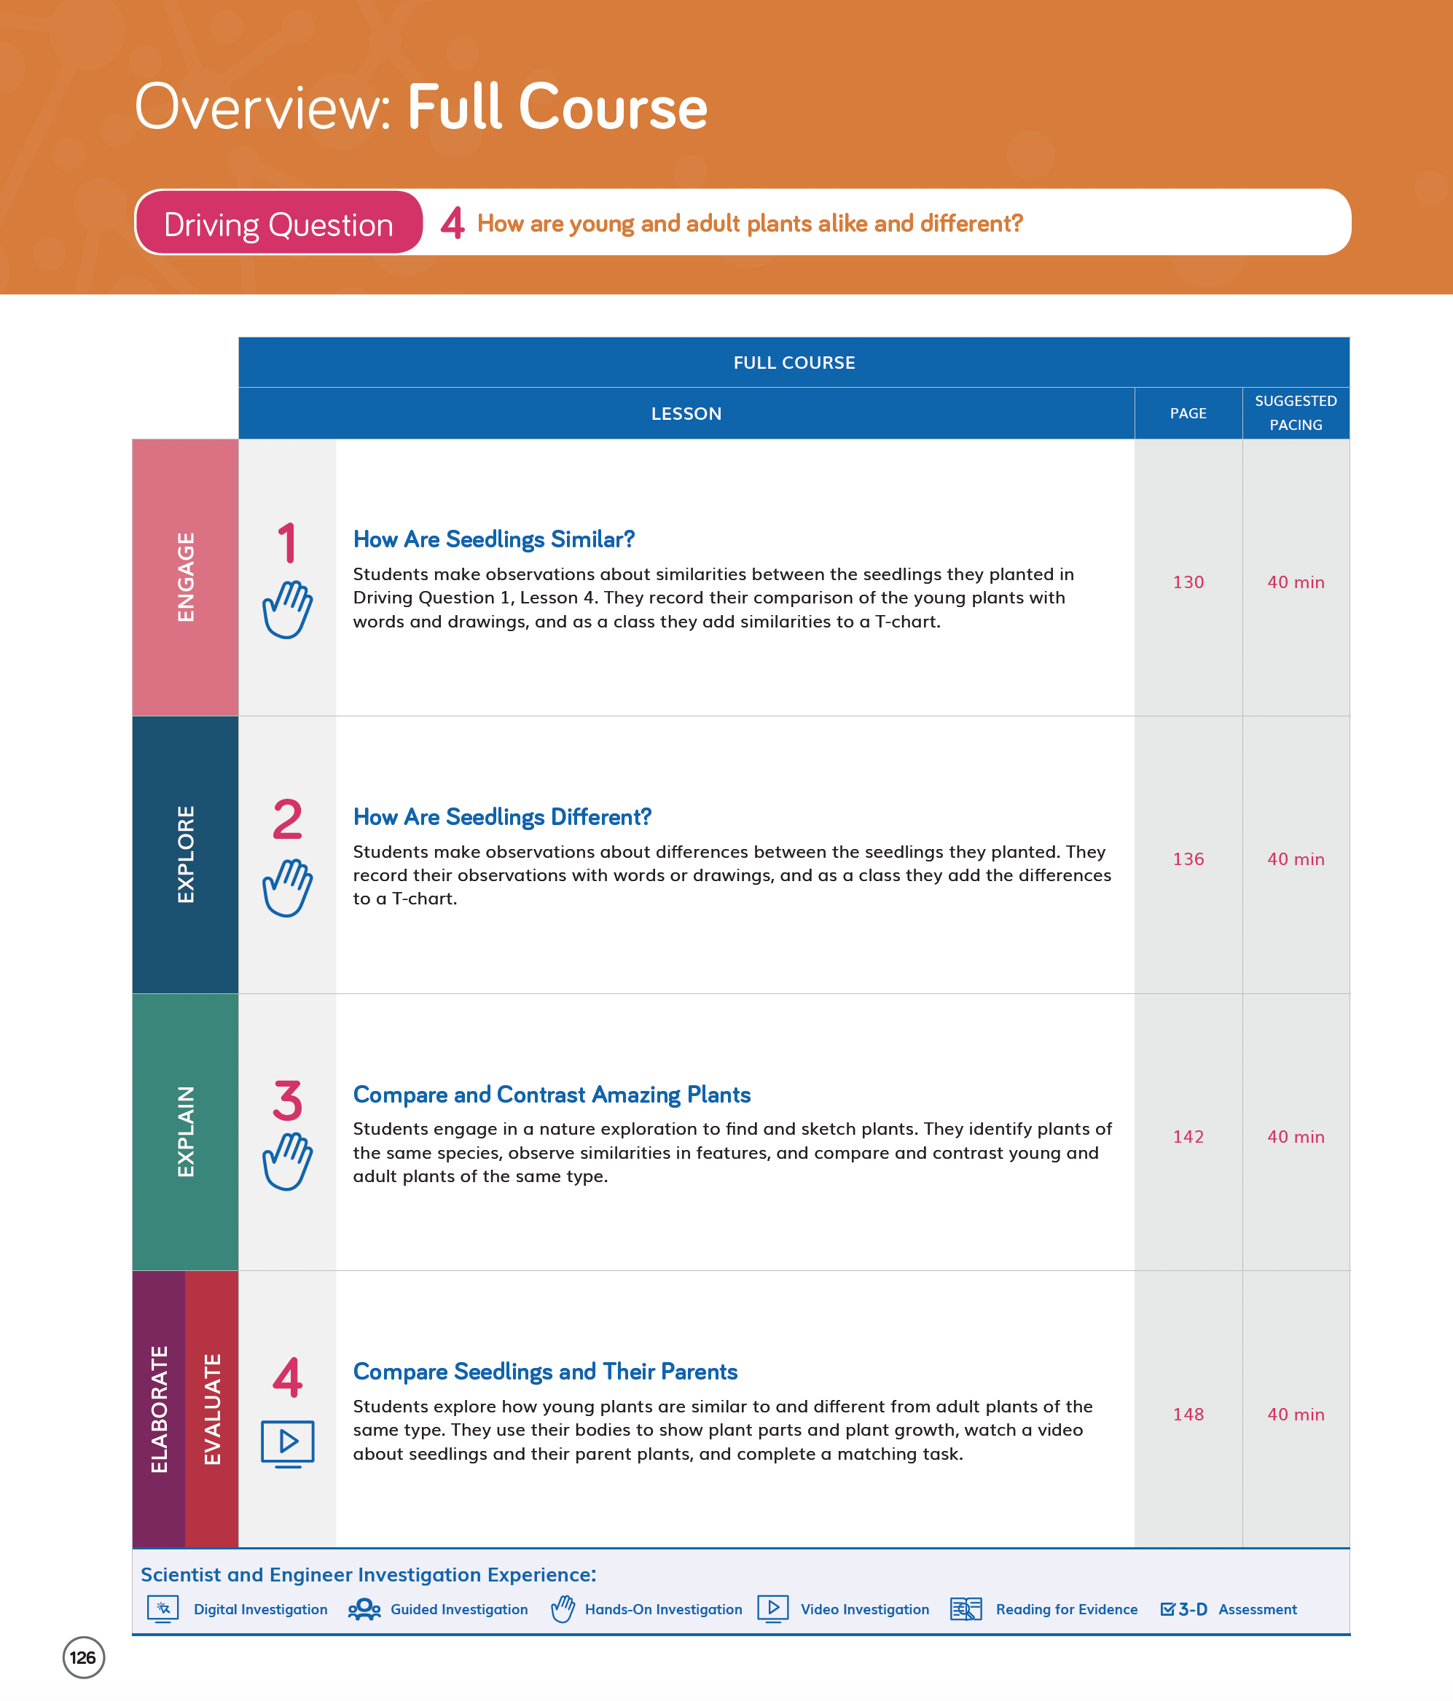  DQ4 Overview TE p. 126
- The DQ4L4 3-D Learning Objectives (TE p. 148) explicitly state that students will identify similarities and differences between young plants and their parents, before constructing an explanation of how young plants and their parents are alike but not identical. | 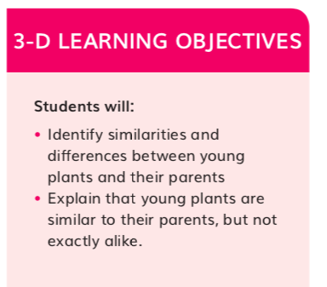  DQ4L4 3-D Learning Objectives TE p. 148

Designed for the NGSS: Foundations Teacher Support Evidence Chart

Teacher materials… | Strong | Adequate | Weak
SW1. Phenomena/Problems. Provide support and strategies for how to help students figure out/solve authentic and relevant phenomena/problems using the three dimensions. | ✓
SW2. Three-dimensional Conceptual Framework. Provide support and strategies for how teachers:  - help students develop a conceptual framework of scientifically accurate understandings and abilities related to DCIs, SEPs, and CCCs, CNS and CETAS, ELA and math,  - create a learning environment that values students’ ideas, motivates learning, and helps students negotiate new meaning as they interact with others’ ideas, new information, and new experiences. | ✓
SW3. Prior Knowledge. Provide support and strategies to leverage students’ prior knowledge and experiences to motivate learning. | ✓
SW4. Metacognitive Abilities. Provide support and strategies for how to help students develop metacognitive abilities. | ✓
SW5. Equitable Learning Opportunities. Provide resources and strategies for how to ensure that all students, including those from non-dominant groups and with diverse learning needs, have access to the targeted learning goals and experiences. | ✓

Strengths related to these Teacher Supports
SW1. Phenomena/Problems.
The module is strong at providing support and strategies for how to help students figure out authentic and relevant phenomena using the three dimensions.
Evidence  - The instructional materials have been designed to support the teacher in guiding students on a scaffolded learning journey, in order to figure out the the Module Phenomenon: How are all plants alike and how are they different? Students tackle the problem one Driving Question at a time, applying the three dimensions with increasing sophistication, building the skills and knowledge they need through a series of investigations.  - The teacher is supported in the instructional material to connect students’ learning experiences back to the Module Phenomenon at strategic points, with discussions in which students share their ideas and evidence for how to approach phenomena. Examples of this include:  - DQ1L4 Discuss Seeds introduces students to the Module Phenomenon. (DQ1L4 Spark TE p. 28) | 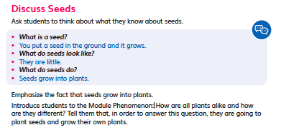  DQ1L4 Spark TE p. 28
- DQ4L3 Connect Today’s Learning to the Module Phenomenon (DQ4L3 Connect TE p. 147) | 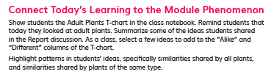  DQ4L3 Connect TE p. 147
- DQ7L2 Connect Today’s Learning to the Module Phenomenon (DQ7L2 Connect TE p. 233) | 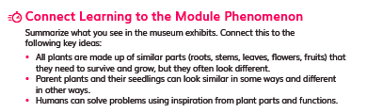  DQ7L2 Connect TE p. 233
- DQ7L3 Celebrate the Museum of Leafology, Reflect on the Museum of Leafology (DQ7L3 Connect/Reflect TE p. 239) | 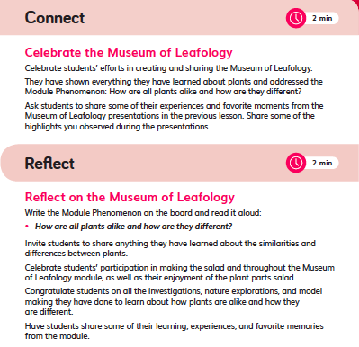  DQ7L3 Connect/Reflect TE p. 239
SW2. Three-dimensional Conceptual Framework.
The module is strong at providing support for helping students develop a conceptual framework across the dimensions and creating a learning environment that values all students.
Evidence  - The instructional materials are designed to elicit student’s understanding of how plants are alike and how they are different at the start of the module, and then to develop their understanding over time, through hands-on, reading, digital, video, and data investigations.  - Opportunities to articulate, question and revise students’ conceptual frameworks are woven into the instructional resources.Teachers are supported with continuous assessment for learning strategies, and with support for how to tailor instruction accordingly.  - Teachers are supported in creating a positive learning environment where all contributions are valued, along with activities that support teamwork and collaboration. For example:  - In DQ6L2, students engage in a collaborative discussions, sharing their observations with a partner (DQ6L2 TE p. 194). These activities are scaffolded with sidebars that help teachers provide additional support for special needs, English Learner, and Standard English Learner students | 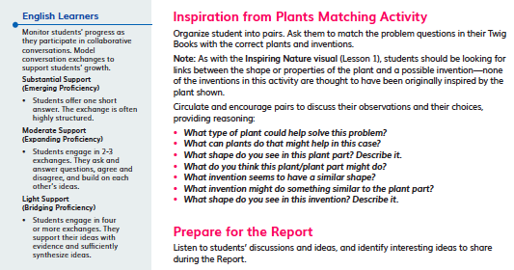  DQ6L2 TE p. 194
SW3. Prior Knowledge.
The module provides strong support and strategies to leverage students’ prior knowledge and experiences to motivate learning.
Evidence  - Teachers are supported with strategies to leverage prior knowledge of forces and motion through resources such as videos. For example, videos like the Plant Parts Song video (DQ7), Seedlings and their Parent Plants video (DQ4), Extremely Clever Plants video (DQ5), and the Plants Are Amazing! video (DQ1) bring phenomena and concepts to life for all students.  - Additional support is provided at point of use for strategies to leverage prior knowledge and solve the Module Phenomenon. For example, in DQ1L2 TE p. 14, students engage with their prior knowledge of living things, and what they need to survive, through a class read aloud and card sorting activity. | 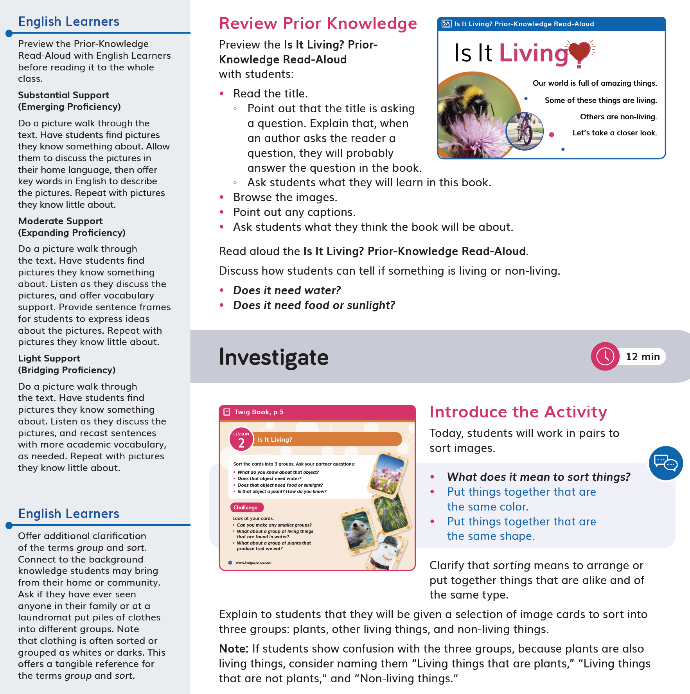  DQ1L2 TE p .14
SW4. Metacognitive Abilities.
The module provides strong support and strategies for how to help students develop metacognitive abilities.
- Support is given at point of use for teachers to develop students' metacognitive abilities. The Connect of the lesson often guides the teacher to draw students' attention to their growing use of the SEPs and CCCs, understanding of the DQ, or increasing ability to answer the Module Phenomenon. For example:  - In DQ3L6 Reflect TE p. 117 students reflect on their test results, and discuss how they would improve seed design.  - In DQ1L1 TB p.4, and DQ1L1 Reflect TE p.11, students are assessed on their prior knowledge of living and non-living things.  - In DQ1L3 TE p.24, students communicate their prior knowledge about plants. | 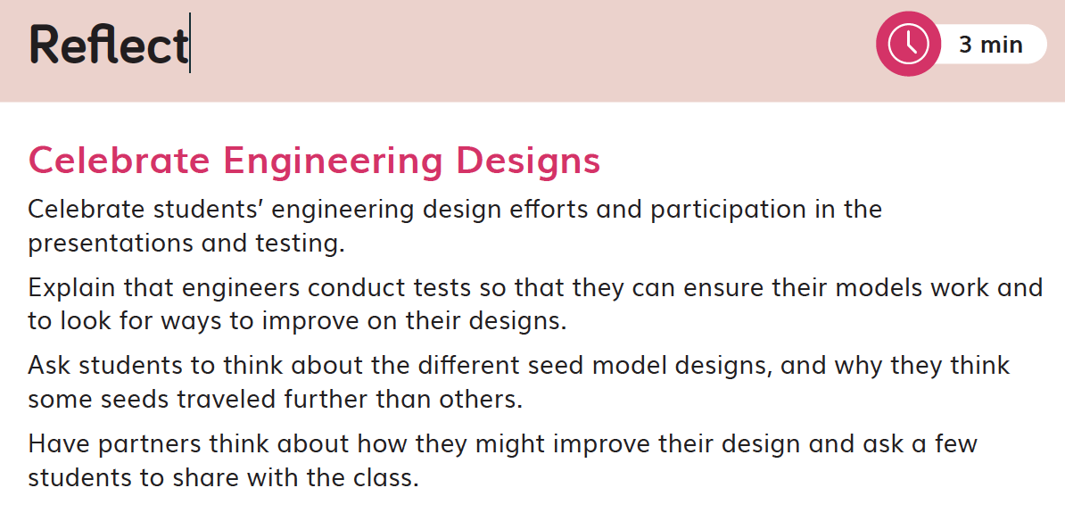  DQ3L6 Reflect TE p. 117
- In DQ3L1 Investigate TE p. 79, the teacher uses a Meta-Think-Aloud to show how students might model a seed, explicitly pointing out key aspects of the model and how they relate to the seed itself. | 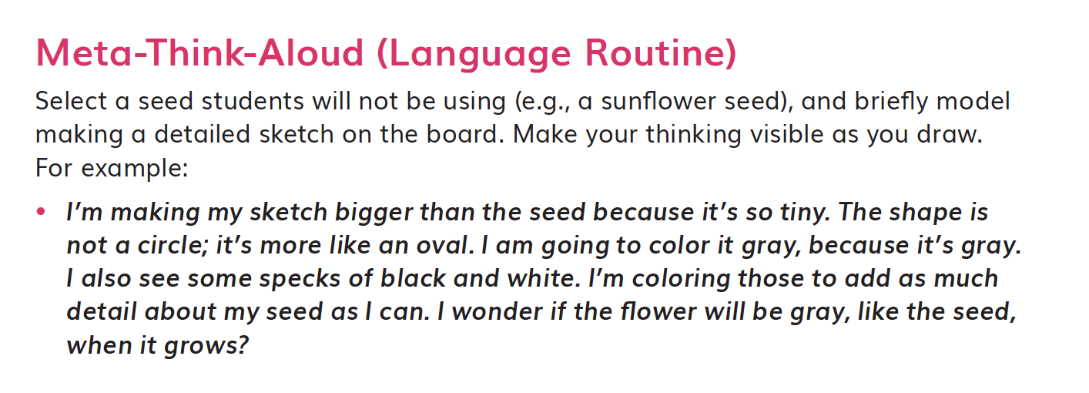  DQ3L1 Investigate TE p. 79
- Discussions following diagnostic pre-assessments (Pre-Explorations) in DQ1, DQ2, DQ3, and DQ4 support teachers to track students' understanding of the three dimensions that make up the module's Performance Expectations. For example, in DQ3L7, students complete a Pre-Exploration to decide which of two statements they agree with—that seedlings will look exactly like their parent plants or that seedlings will look a little bit different from their parent plants. (DQ3L7 TE p. 123) | 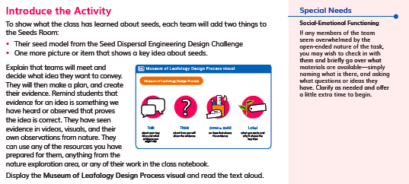  DQ3L7 TE p. 123

Designed for the NGSS: Foundations Teacher Support Evidence Chart

Teacher materials… | Strong | Adequate | Weak
SP1. Three-dimensional Performances. Provide support with a range of sample student responses and/or rubrics for interpreting evidence of student learning across the three dimensions, specific to the element of each dimension, and related to the phenomenon/problem that provides context for the student performance. | ✓
SP2. Variety of Measure. Provide guidance and scoring tools for using a variety of measures matched to the targeted learning goals to help students monitor their progress toward learning goals and reflect on what they have learned, how they learn it, and how to use metacognition productively. | ✓
SP3. Student Progress Over Time. Provide guidance for using formative and summative assessments to monitor student progress over time. Examples include support for: capturing student growth; interpreting results; adjusting instruction and planning for future instruction; providing feedback to students; prompting students to consider what and how they’ve learned. | ✓
SP4. Equitable Access. Provide support and strategies for ensuring that assessments are accessible to students from diverse backgrounds and with diverse learning needs. | ✓

Strengths related to these Teacher Supports
SP1. Three-dimensional Performances.
The module provides strong support with a range of sample student responses and rubrics for interpreting evidence of student learning across the three dimensions. These are specific to the element of each dimension and related to the Module Phenomenon that provides the context for the student performance.
Evidence  - Rubrics are provided for the Performance Tasks and the Benchmark Assessment. The rubrics provide sample answers in the form of look fors, supporting teachers to interpret evidence of students’ attainment of the four different levels—emerging, developing, proficient, and advance. The rubrics are specific to certain Performance Expectations, with the assessed dimensions highlighted.  - The assessment tasks are well connected to the problems, phenomena, and dimensions being assessed. For example, in DQ3L6 Investigate (TE p. 114), students identify a plant part that they can copy to solve a human problem. They then design, build, and test an invention, before making a poster to communicate how a design inspired by plants solves a problem. | 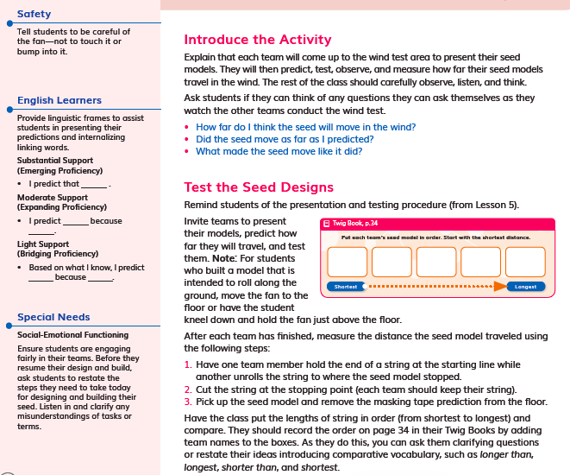  DQ3L6 Investigate TE p. 114
SP2. Variety of Measure.
The module provides strong guidance and scoring tools for using a variety of measures matched to the targeted learning goals to help students monitor their progress toward learning goals and reflect on what they have learned, how they learn it, and how to use metacognition productively.
Evidence  - Teacher support for guidance and scoring tools matched to the learning goals is integrated throughout the module. In addition to the rubrics mentioned above, and answer guides for the module multiple choice assessment, the printed Teacher Edition contains Twig Book pages with sample student answers, so that, at a glance, teachers have guidance on what student understanding looks like. A digital version of the Twig Book with sample answers is also available online.  - Assessments are multimodal and support a variety of learning styles and abilities. They include:  - Performance Tasks (written, drawn, and hands-on DQ3L6 Investigate TE p. 114, DQ6L6 Investigate TE p. 216, DQ7L2 TE p. 242) | 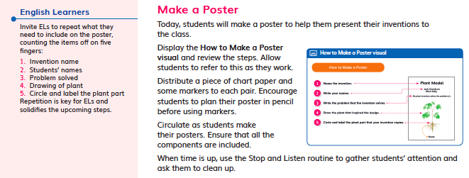  DQ6L6 Investigate TE p. 216
- Discussions (DQ1L3 TE p. 24, DQ1L4 Reflect TE p. 33) | 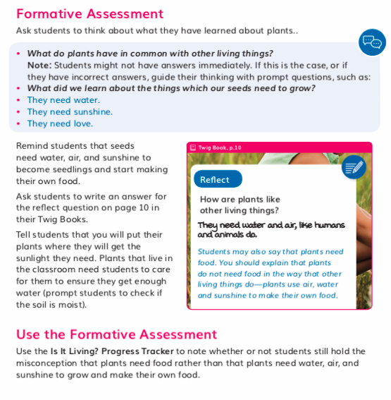  DQ1L4 Reflect TE p. 33
- Constructed responses (discussion, annotating a model and drawn DQ5L1 Reflect TE p. 176, DQ7L2 Spark TE p. 236) | 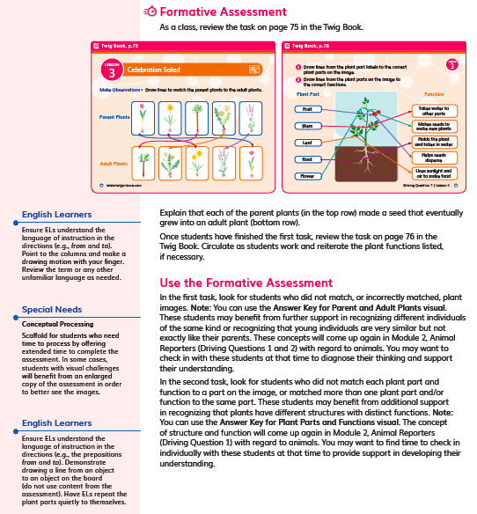  DQ7L2 Spark TE p. 236
- Peer and self-assessment (DQ4L4 investigate TE p. 152)  - Text-to-speech functionality is available for all assets. | 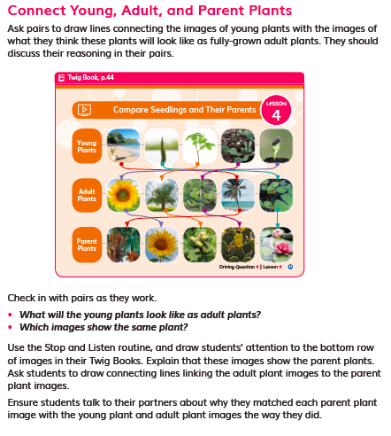  DQ4L4 Investigate TE p. 152
- Class discussions are supported with question scaffolds and sample answers (for example, DQ6L2 Spark TE p. 193). | 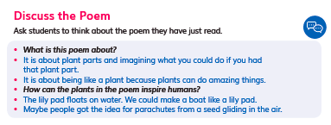  DQ6L2 Spark TE p. 193
- The Reflect of most lessons integrates Formative Assessment opportunities, and gives students the opportunity to self-reflect on what they have learned and how they used the three dimensions (for example, DQ4L4 Investigate TE p. 152).
SP3. Student Progress Over Time.
The module provides strong guidance for using Formative and Summative Assessments to monitor student progress over time. Examples include support for capturing student growth, interpreting results, adjusting instruction and planning for future instruction, providing feedback to students, and prompting students to consider what and how they’ve learned.
Evidence
- Teachers can elect to administer the Pre-Explorations assessments digitally or in print. Answers are tagged to specific dimensions and, if administered digitally, teachers will be able to track student growth in level of attainment of the dimensions over time and tailor instruction accordingly. Teachers can also provide students with feedback digitally. Teachers can opt to add the scores manually for all non-digital assessment tasks.

- Downloadable Progress Trackers support teachers in tracking students' mastery of their misconceptions, as assessed in the Pre-Explorations, as well as the results of Formative Assessments of the three dimensions across the DQs (for example, Plant Parts Progress Tracker used in DQ2). Guidance for teachers on how to adjust instruction for students needing more support, in order to clear up their misconceptions, is provided at point of use in the instructions (for example, DQ3L2 TE p. 85).

SP4. Equitable Access.
The module provides strong support and strategies for ensuring that assessments are accessible to students from diverse backgrounds and with diverse learning needs.
Evidence  - Assessments of the three dimensions are multimodal and include multiple choice, writing, drawing, physical models, and oral discussions. This allows all students to access a range of assessment types to suit their learning style and/or reading level.  - The digital Twig Book and digital assessment items (Pre-Exploration, Performance Tasks, and Rubrics) have a text to speech function allowing students of all reading levels to access the assessments.  - The rubrics for the Performance Tasks (DQ3L6, DQ7L2) have four levels (emerging, developing, proficient, advanced) allowing all students to demonstrate their current level of attainment.  - Writing, Reading, Listening and Speaking domain tasks dedicated to monitor English language development are integrated into the core instructional resources (DQ2L1 Investigate TE p. 43, DQ5L1 TE p. 241) and the On-Level reader lessons (Chapter 3 Second Read TE p. 257). | 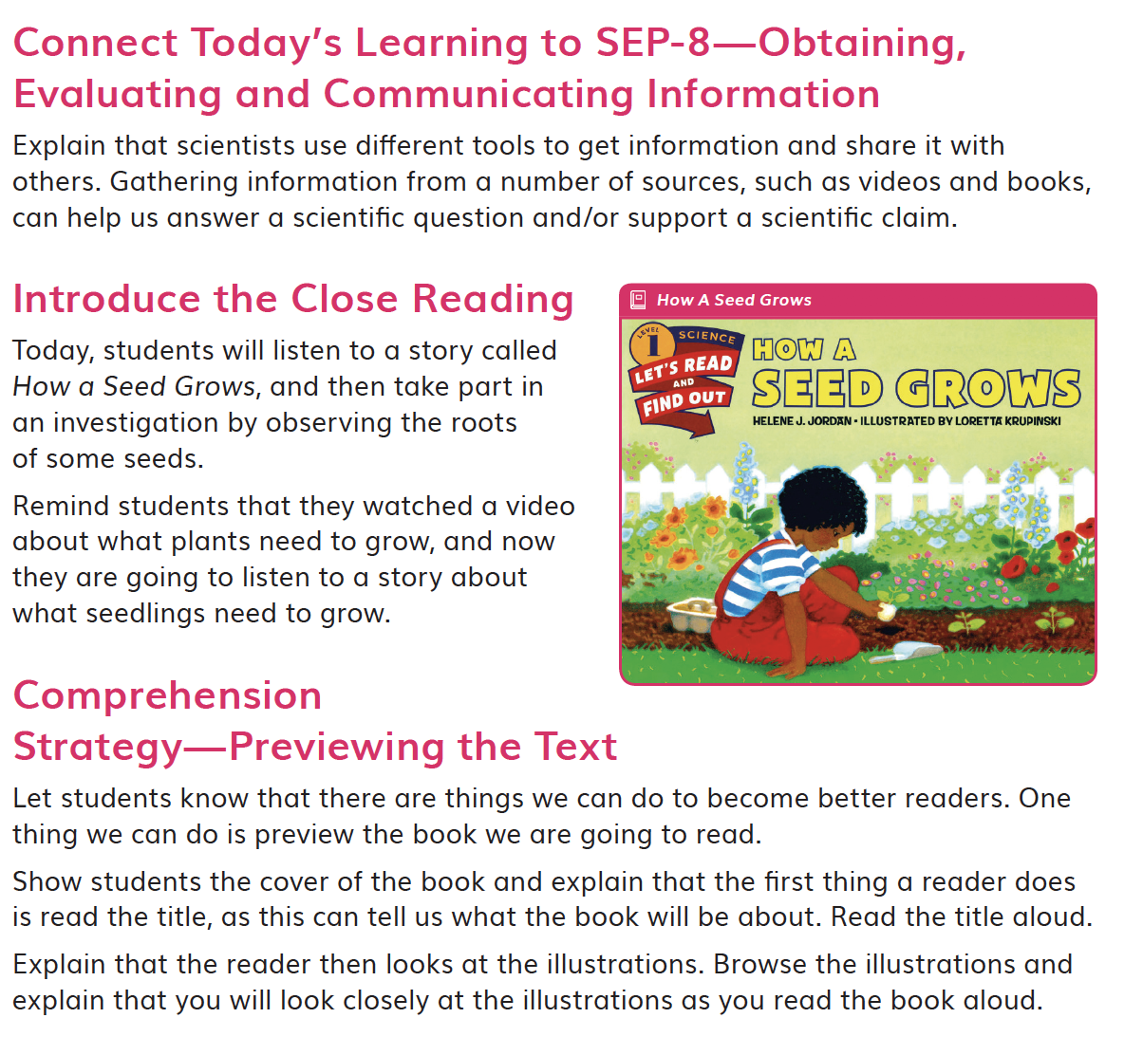  DQ2L1 Investigate TE p. 43  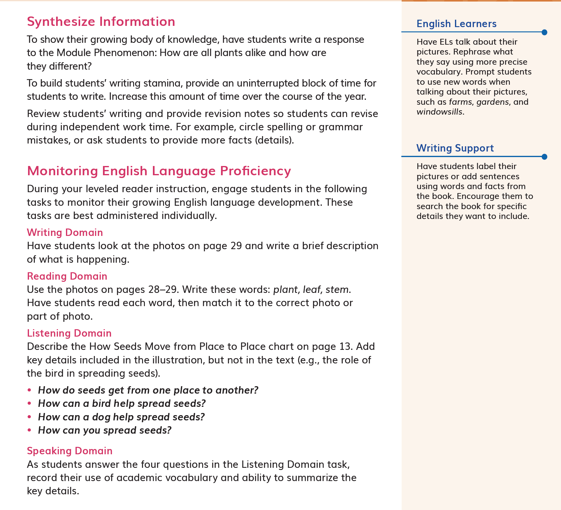  Reader Lesson Chapter 3 Second Read TE p. 257

Designed for the NGSS: Foundations | High Quality  5 | Medium Quality  3 | Low Quality  1
TS1. Phenomenon/Problem Driven Three-Dimensional Learning. Teacher materials provide:  - background information about the phenomena or problems included in the learning sequence and across sequences;  - an explanation of the role of phenomena or problems in driving student learning;  - rationale for why the unit phenomena or problems were selected for the targeted DCIs, SEPs, and CCCs.  Refer to F1, F2, SW1, SW2, SP1. | Materials provide clear guidance to teachers on how students develop, use, and integrate the three dimensions to make sense of phenomena or design solutions to problems. | Materials provide some guidance to teachers about how students develop, use, and integrate the three dimensions. | Materials provide little guidance on developing, using, or integrating them to make sense of phenomena or design solutions to problems.
TS2. Coherence. Teacher materials describe and provide a rationale for:  - the conceptual framework and sequence of ideas, practices, and learning experiences in the learning sequences and across sequences;  - strategies for linking student experiences across lessons to ensure student sense- making and/or problem-solving focused on phenomena or problems is linked to learning across all three dimensions;  - Connections to other Science Domains, Nature of Science, Engineering, Technology, and Applications of Science, math, and ELA.  Refer to F2, F3, SW2, SP2. | Materials provide strong support for understanding unit coherence and helping students link experiences to learning across all three dimensions and to phenomena or problems. | Materials provide some support for understanding unit coherence and helping students link experiences to learning across all three dimensions and to phenomena or problems. | Materials provide little support for understanding unit coherence and helping students link experiences to learning across all three dimensions and to phenomena or problems.
TS3. Effective Teaching. Teacher materials support the use of and provide a rationale and evidence of effectiveness for strategies that:  - support students in learning through authentic and meaningful phenomena or design problems;  - support student learning across the three dimensions;  - make student thinking visible; promote reasoning, sense-making, and problem- solving; challenge student thinking; and develop metacognitive abilities.  Refer to SW1, SW2, SW3, SW4, SP3. | Materials provide rationale and robust support for implementing strategies that enhance student performances, thinking, and metacognition. | Materials provide some rationale and support for implementing strategies that enhance student performances, thinking, and metacognition. | Materials provide little rationale and support for teachers to implement strategies that enhance student performances, thinking, and metacognition.
TS4. Support for Students with Diverse Learning Needs. Teacher materials provide an array of strategies:  - to support student access to the targeted learning goals, experiences, and performances;  - that help teachers differentiate instruction.  Refer to SW5, SP4. | Materials include robust and comprehensive strategies for supporting learners with diverse needs. | Materials include some robust strategies for supporting learners with diverse needs. | Materials include few robust strategies for supporting learners with diverse needs.
TS5. Support to Monitor Student Progress. Materials provide support for teachers to:  - monitor student learning and progress over time;  - make decisions about instruction and provide feedback to students.  Refer to SW3, SW4, SP1, SP2, SP3. | Materials provide robust support for interpreting and using data generated from assessments. | Materials provide some support for interpreting and using data generated from assessments. | Materials provide little support for interpreting and using data generated from assessments.

Designed for NGSS: Teacher Support Rubric
Analyze Evidence
Directions:
- Review the Designed for NGSS: Foundations Rubric.
- Reflect on the evidence (or lack of evidence) that you and your team gathered and represented.
- Record strengths and limitations for each criterion based on your evidence. Cite specific examples.

Strengths
TS1. Phenomenon/Problem Driven Three-Dimensional Learning.
The Module materials are High Quality 5 in regards to TS1.
They provide clear guidance to teachers on how students develop, use, and integrate the three dimensions to make sense of phenomena or design solutions to problems.
Evidence
- In DQ1L1 and L2, students review their prior knowledge with a class read aloud about living things, then sort cards into living and non-living things (K-LS1-1).
- In DQ2, students observe seedling roots, and learn about the different parts plants have, through hands-on, video, close reading, and interactive investigations. They learn a song about plant parts, then write about what each part does (CCC-1, CCC-6, LS1.1).
- In DQ3, students compare different seeds and gather information about how they disperse. They then design, build and test a seed model that can be dispersed by wind.(LS1.A, CCC-6, SEP-2)
- In DQ4, students compare different plants, listing the similarities and differences, through hands-on and video investigations (LS1.A, 1-LS3-1).
- In DQ5, students investigate how different plants use their external structures for defense and protection. They use video and close readings to gather information (LS1.A, SEP-2, CCC-6).
- In DQ6, students apply what they have learned so far in the module to design a solution that mimics the structure of plants to a human problem (1-LS1-1, LS1.A, ETS1.A, ETS1.B, SEP-2, SEP-6, CCC-6).
- In DQ7, the module culminates in the the class preparing and presenting their museum rooms to the public, and sharing what they have learned about plants over the course of the module.
TS2. Coherence.
The Module materials are High Quality 5 in regards to TS2.
They provide teachers with a clear conceptual framework in a logical sequence, strategies for linking student experiences across lessons, and connections to other science domains, CNS (NoS), CETAS (ETS), math, and ELA.
Evidence  - The Module Phenomenon (in the Module Introduction) challenges students to be creative problem solvers, immersing them in engaging challenges that require mastery of the three dimensions of NGSS to solve.  - The instructional materials have been designed to support the teacher in guiding students on a scaffolded learning journey to solve the Module Phenomenon: How are all plants alike and how are they different? Students tackle the problem one Driving Question at a time, applying the three dimensions with increasing sophistication, building on the skills and knowledge they need through a series of investigations.  - The Module Phenomenon targets the DCIs, SEPs and CCCs explicitly stated in 1-ESS1-2, 1-LS1-1, 1-LS3-1, K–2-ETS1-1, K–2-ETS1-2, K–2-ETS1-3.  - Links are made to preceding grades, such as GKM1, My Big Nature Adventure, where DCIs (LS1.A) have previously been covered.  - A digital guide to SEPs and CCCs provides a clear explanation for each practice and concept, with guidance on what these skills should look like in a first grade classroom, and with specific reference for how students apply the concepts of patterns, structure and function, and construct explanations in G1M1.  - Additional module-specific support is frequently given at point of use in the instructional materials for all dimensions, Connections to the Nature of Science (CNS) and Connecting to Engineering, Technology, and Applications of Science (CETAS), often in the Connect.  - Opportunities for students to articulate, question, and revise their conceptual frameworks are woven into the instructional resource,s with teachers supported by continuous assessment for learning strategies and support for tailoring instruction accordingly.  - Driving Question Introductions and Overview pages show the sequence of learning, the rationale behind it, and the three dimensional aspect of the activities.  - Connections to other science domains are covered across the sequence of lessons and Driving Questions. | 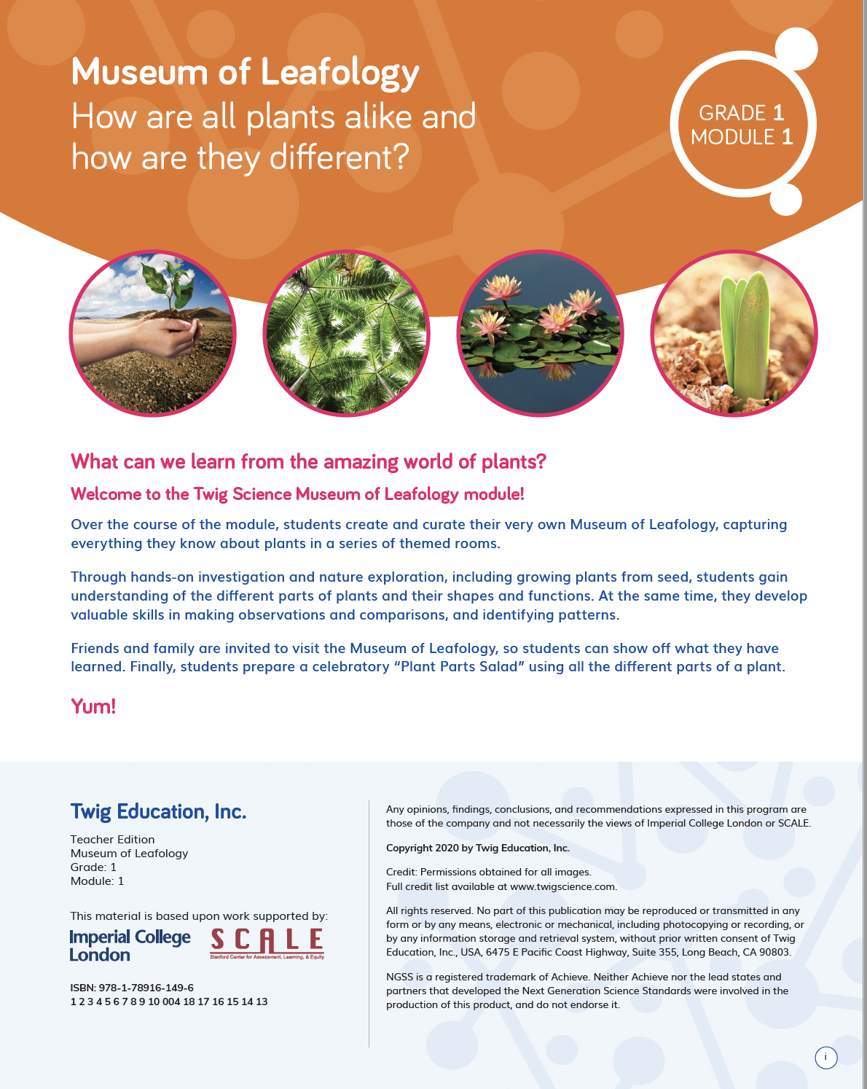  Module Introduction
TS3. Effective Teaching.
The Module materials are High Quality 5 in regards to TS3.
They provide strong guidance to support students in learning through authentic and meaningful phenomena/problems, support student learning across the three dimensions, and develop students’ metacognitive abilities.
Evidence
Instructional materials support authentic and meaningful learning experiences. Teacher support includes scaffolded discussion questions in the Teacher Edition (with sample answers), notes, lesson preparation, background information, Professional Learning videos and Progress Trackers.
- The 3-D Learning Objectives in each lesson provide teachers with information detailing how students will learn across the three dimensions, while the Lesson Preparation notes provide further explanation of how to support students’ learning.
- The teacher is supported in the instructional material to connect students’ learning experiences to the Module Phenomenon at strategic points, with discussions in which students share their ideas and evidence for how to understand phenomena. Examples of this include:
- DQ1L4 Discuss Seeds introduces students to the Module Phenomenon (DQ1L4 Spark TE p. 28) | DQ1L4 Spark TE p. 28
- DQ4L3 Connect Today’s Learning to the Module Phenomenon (DQ4L3 Connect TE p. 147) | DQ4L3 Connect TE p. 147
- DQ7L2 Connect Today’s Learning to the Module Phenomenon (DQ7L2 Connect TE p. 233) | DQ7L2 Connect TE p. 233
- DQ7L3 Celebrate the Museum of Leafology, Reflect on the Museum of Leafology (DQ7L3 Connect/Reflect TE p. 239) | DQ7L3 Connect/Reflect TE p. 239
- Teachers use a number of language routines, discussions, and metacognitive strategies to ensure that students are reflecting on what they are learning and how they are learning it. For example, in the DQ3L1 Investigate (TE p. 79), the teacher uses a Meta-Think-Aloud to show how students might model drawing a seed, explicitly pointing out key aspects of the model and how they relate to the seed itself. | DQ3L1 Investigate TE p. 79
TS4. Support for Students with Diverse Learning Needs.
The Module materials are High Quality 5 in regards to TS4.
They provide a strong array of strategies to support student access to the targeted learning goals and help teachers differentiate instruction.
- Integrated EL sidebars offer teachers guidance to support students’ engagement with the material. (DQ3L5 English Learners TE p. 114) | 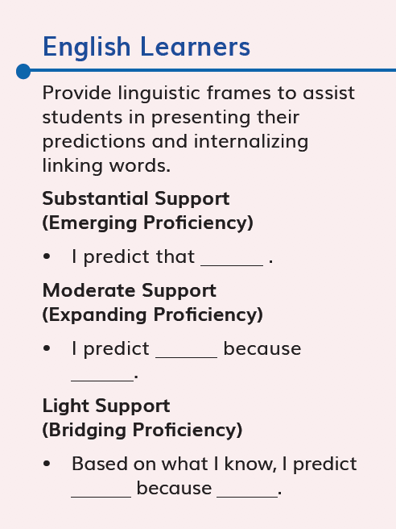  DQ3L5 English Learners TE p. 114
- Integrated Special Needs sidebars offer teachers guidance to support students of all abilities as they participate in class activities and grasp key concepts. (DQ3L5 Special Needs TE p. 109) | 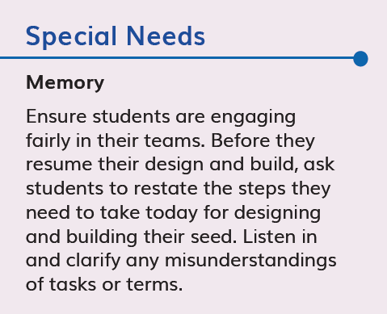  DQ3L5 Special Needs TE p. 109
- Integrated Challenges interspersed throughout the TB support GATE students who have met the learning goals. (DQ3L5 Challenge TE p. 110)  - Videos like the Plant Parts Song video (DQ7), Seedlings and their Parent Plants video (DQ4), Extremely Clever Plants video (DQ5), and the, Plant Are Amazing! video (DQ1) bring phenomena and concepts to life for all students.  - Assessments of the three dimensions are multimodal and include multiple choice, writing, drawing, physical models, and oral discussions. This allows all students to access a range of assessment types to suit their learning style and/or reading level.  - The digital Twig Book and digital assessment items (Pre-Exploration, Performance Task, and Rubrics) have a text-to-speech function, allowing students of all reading levels to access the assessments. | 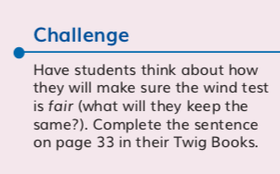  DQ3L5 Challenge TE p. 110
- The Performance Task Rubrics have four levels (Emerging, Developing, Proficient, Advanced) allowing all students to demonstrate their current level of attainment. | 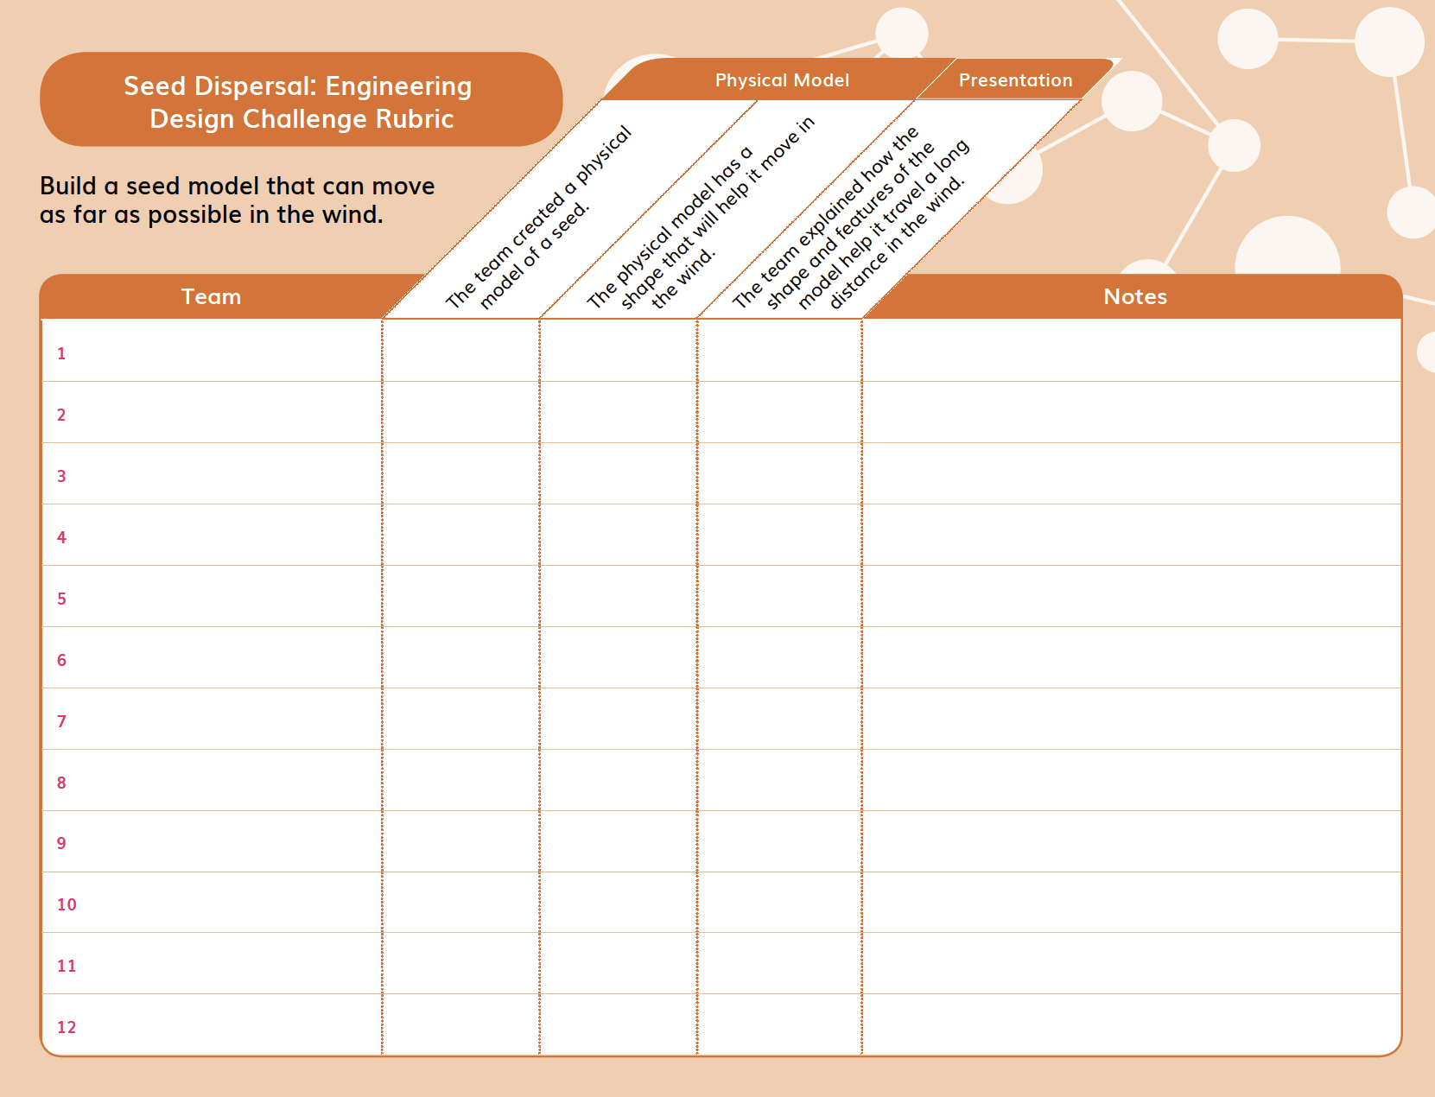 Performance Task Rubric
- Writing, Reading, Listening and Speaking domain tasks dedicated to monitor English language development are integrated into the core instructional resources (DQ2L1 Investigate TE p. 43) and the On-Level reader lessons (Chapter 3, Second Read TE p. 257). | DQ2L1 Investigate TE p. 43
TS5. Support to Monitor Student Progress.
The Module materials are High Quality 5 in regards to TS5.
They provide strong support for teachers to monitor student learning and progress over time, and make decisions about instruction and provide feedback.
- There are four diagnostic pre-assessments called Pre-Explorations at strategic points in the module that assess prior knowledge and misconceptions. Notes in the Teacher Edition and Progress Trackers support teachers in monitoring students as they clear up their misconceptions and master the three dimensions, giving suggestions for how to tailor instruction accordingly.  - Progress Trackers, digital assessment trackers, class notebooks and Rubrics support teachers in monitoring students’ progress. Pre-Explorations and regular Formative Assessments inform teacher at the point of use as to which students require further support.  Examples include:  - DQ1L4 Reflect (TE p. 33) | DQ1L4 Reflect TE p. 33
- DQ4L1 Reflect (TE p. 135) | 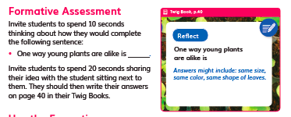  DQ4L1 Reflect TE p. 135
- DQ7L2 Spark TE (p. 236) | DQ7L2 Spark TE p. 236
- DQ4L4 Investigate (TE p. 152) | DQ4L4 Investigate TE p. 152

