1.1 Museum of Leafology
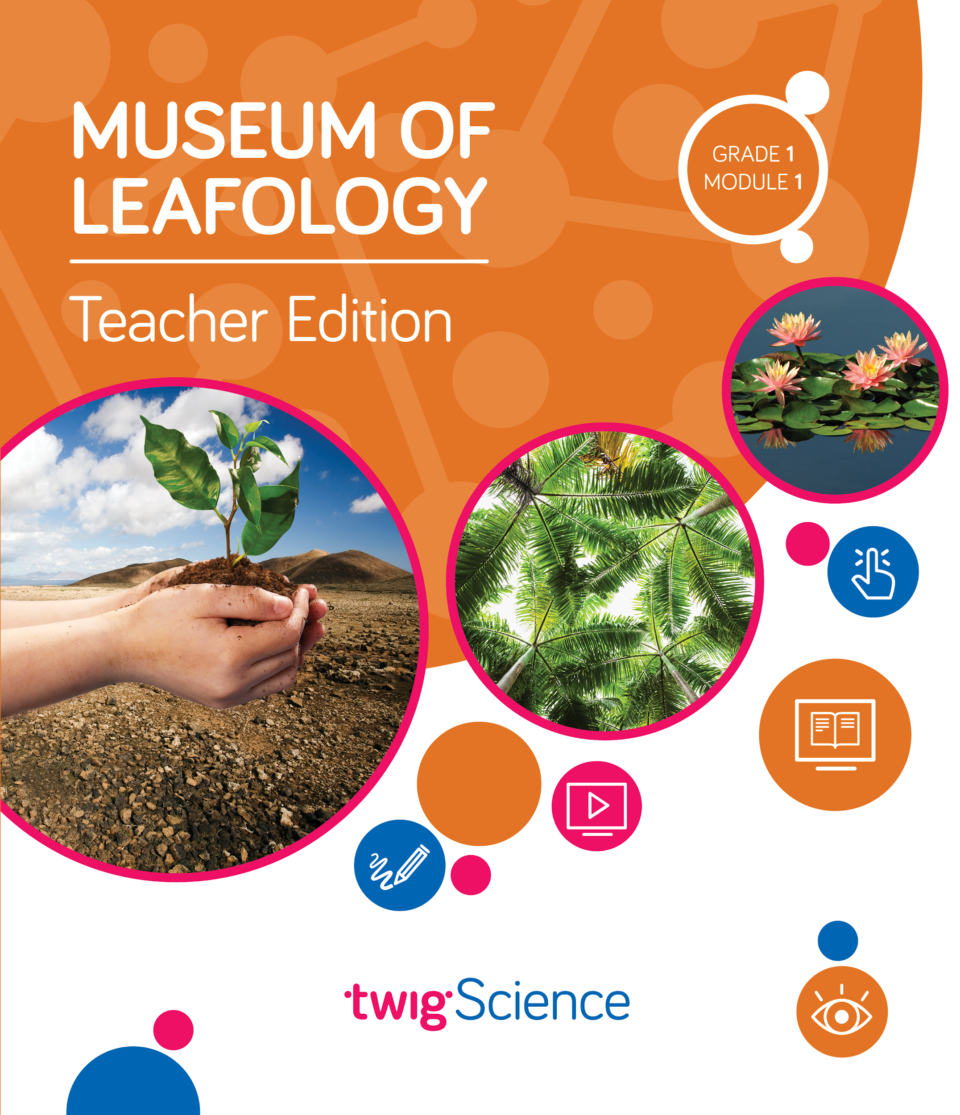
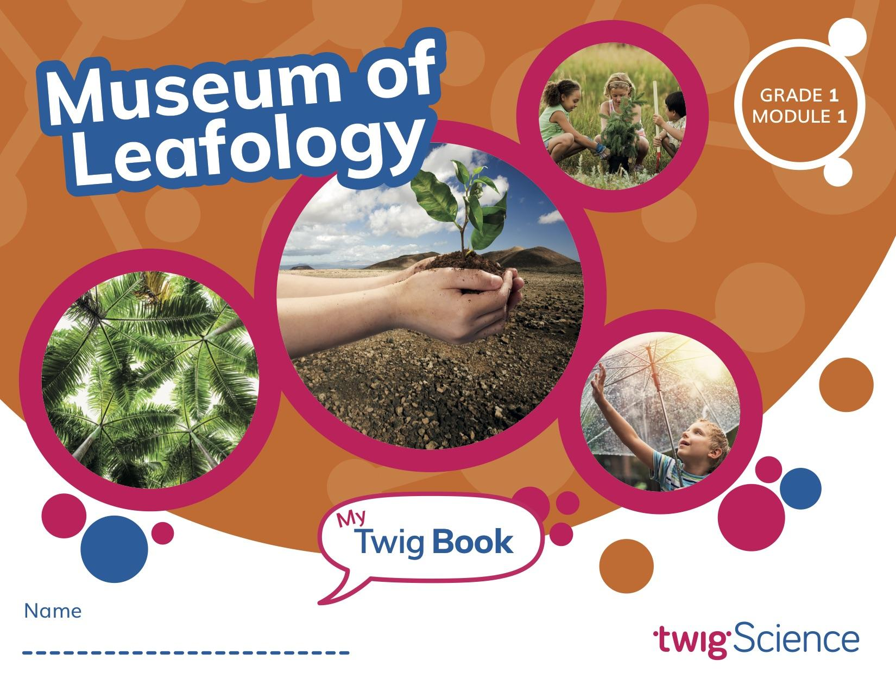
Assessment Overview

In this module, students build their own Museum of Leafology in order to answer the Module Phenomenon: How are all plants alike and how are they different? The museum showcases student learning about plant growth, seed dispersal, plant defences, and plant-inspired inventions.

Students begin by investigating what plants need and how a plant’s parts help it to grow and survive. They go on to explore the many methods that plants use to distribute seeds away from the parent plant. Students work in teams to tackle their first Engineering Design Challenge: to design and build seeds for dispersal by wind. They then test and present the results of their design.

Students observe the seedlings they planted, as well as plants in nature, and record similarities and differences. They also investigate the clever strategies plants use to get what they need, including the defences that some plants use. After observing and discussing existing inventions that were inspired by plants, students tackle their second Engineering Design Challenge: to design, build, and present their own plant-inspired solution to a human problem.

At the end of the module, students invite other classes and their own families to visit the museum in order to demonstrate their learning. The final lesson features a pair of assessment tasks, followed by a celebratory plant parts salad.

Pre-Explorations (Diagnostic Pre-Assessment)
Key: Driving Question (DQ) Lesson (L) Teacher Edition (TE) Twig Book (TB)
Reference | Assessment Tool | Description | Type | Misconceptions identified
DQ1L1, Reflect (TE p. 11) | Is It Living? Progress Tracker | Students look at 12 images and check those that show things that are living. | Constructed response  Multiple choice (TB p. 4) | - Things that move or make noise are living.  - Plants are non-living.  - Trees, grass, vegetables, and weeds are not plants.  - Birds are non-living.  - Humans and other animals are non-living.
DQ2L1, Reflect (TE p. 47) | Plant Parts Progress Tracker | Students read four statements about plant parts and check those they think are correct. | Constructed response  Multiple choice (TB p. 14) | - Plants do not need sunlight.  - Plants get food from the soil/plants eat food.  - Leaves take in water.  - Roots are not a plant part.
DQ3L1, Reflect (TE p. 82) | What Happens to Seeds? Progress Tracker | Students read six statements (with images) and check those they think are correct. | Constructed response  Multiple choice (TB p. 27) | - Seeds always drop right beneath a plant. New plants grow right there.  - Objects that travel on the wind always use wings.  - Seeds are only dispersed by animals.  - Seeds always sink. They can’t float.  - Seeds can’t travel through the air.
DQ3L7, Reflect (TE p. 123) | Young and Adult Plants Progress Tracker | Students read the opinions of two people and check the one they agree with, and provide reasoning. | Constructed response  Multiple choice and written explanation (TB p. 36) | - Once a seedling becomes an adult plant, it will look exactly like its parent plant.  - There are no differences between plants of the same type.
DQ5L1, Reflect (TE p. 166) | Special Plant Parts Progress Tracker | Students read a statement about plants, and explain why they agree or disagree with it. | Constructed response  Multiple choice and written explanation (TB p. 52) | - There is nothing unique about different types of plants.

Formative Assessment (Informal Assessment)
Key: Driving Question (DQ) Lesson (L) Teacher Edition (TE) Twig Book (TB)
Page | Assessment Tool | Description | Type | What’s being assessed?
DQ1L2, Investigate (TE p. 15) | Is It Living? Progress Tracker | Students sort image cards into three groups: plants, other living things, and non-living things. | Hands-on | Student ability to provide evidence that something is alive, and whether  or not something is a plant (LS1.A).
DQ1L3, Investigate (TE p. 23) | Is It Living? Progress Tracker | Students look for and photograph plants outside, and ask questions. | Hands-on and discussion | Student ability to explore natural  environments, observe, and  ask questions in order to  learn about the natural world (SEP-1, CCC-1).
DQ1L4, Reflect  (TE p. 33) | Is It Living? Progress Tracker | Students think about what they have learned about plants, and describe how plants are like other living things. | Constructed response  Written answer to a question (TB p. 10) | Student understanding of what plants need to grow—water, sunlight, and air (LS1.A).
DQ2L1, Investigate (TE p. 45) | Plant Parts Progress Tracker | Students watch a video about what plants need and listen to a text about how seeds grow. | Partner discussion | Student ability to obtain information from text and video (SEP-8).
DQ2L3, Reflect  (TE p. 63) | Plant Parts Progress Tracker | Students listen to four statements about plant parts and give a thumbs up or thumbs down to indicate if they agree or not. | Constructed response  Written answer (TB p. 20) | Student understanding that plants have different parts (roots, stems, leaves, flowers, fruits) that help them grow and survive (LS1.A, CCC-6).
DQ2L4, Investigate (TE p. 67) | Plant Parts Progress Tracker | Student teams design, make, and label an artifact that shows something they learned  about plants. | Hands-on | Student ability to develop a simple model (LS1.A, SEP-2).
DQ3L1, Investigate (TE p. 80) | What Happens to Seeds? Progress Tracker | Students observe and sketch seeds. | Hands-on and constructed response  Written and drawn (TB pp. 25–26) | Student understanding that plants have young by making seeds  (LS1.B).
DQ3L2, Investigate  (TE p. 89) | What Happens to Seeds? Progress Tracker | Students listen to a text about how seeds are dispersed. | Class discussion | Student ability to read text and use media to understand how plants disperse seeds (1-LS1-2, CCC-2).
DQ3L5, Reflect  (TE p. 111) | What Happens to Seeds? Progress Tracker | Students design and build seed models. | Class discussion | Student ability to relate the shapes of objects to their functions (ETS1.B, CCC-6).
DQ4L1, Reflect  (TE p. 135) | Young and Adult Plants Progress Tracker | Students describe how young plants are alike. | Constructed response  Written answer to one sentence starter (TB p. 40) | Student ability to provide evidence that young plants from the same parent are very similar but different (LS3.B, SEP-6).
DQ4L2, Reflect (TE p. 141) | Young and Adult Plants Progress Tracker | Students look at two images of young plants to identify their similarities and differences. | Constructed response  Written answer to two sentence starters (TB p. 42) | Student ability to make evidence-based observations about similarities in young plants (LS3.B, SEP-4, CCC-1).
DQ4L3, Reflect (TE p. 147) | Young and Adult Plants Progress Tracker | Students look for plants outdoors and create two field sketches, then discuss what makes the plants alike and different. | Constructed response  Drawn (TB p. 43) | Student ability to show, visually, that plants of the same type are similar but also have differences (LS3.B).
DQ4L4, Reflect (TE p. 154) | Young and Adult Plants Progress Tracker | Students look at an image of a young plant and an image of its parent plant to identify similarities and differences. | Constructed response  Written answer to two sentence starters (TB p. 46) | Student understanding that young plants are very similar but different than their parents (LS3.A, SEP-6).
DQ5L2, Investigate (TE p. 172) | Special Plant Parts Progress Tracker | Students use their knowledge of plants to make models of imaginary plants with defenses. | Hands-on | Student understanding that plants have different parts that help them respond to different conditions (LS1.D).
DQ6L1, Reflect (TE p. 189) | Twig Book | Students reflect on inventions they have looked at and complete a sentence using a word bank. | Constructed response  Written (TB p. 59) | Student ability to suggest ways in which plants  may have inspired human  inventions.
DQ6L4, Reflect (TE p. 207) | Twig Book | Students complete sentences summarizing their design plans. | Constructed response  Written (TB p. 66) | Student ability to engage in the planning stage of  the engineering design process, and share ideas with fellow  engineers.
DQ7L2, Reflect (TE p. 233) | Twig Book | Students reflect on  their museum presentations and answer five questions. | Self-reflect  Answer five questions (TB p. 74) | Student ability to reflect on their presentations  to note successes and opportunities for improvement.
DQ7L3, Spark (TE p. 236) | Twig Book | Students complete two tasks to show connections between adult and parent plants, and plant parts and functions. | Constructed response  Written (TB pp. 75–76) | Student ability to demonstrate an understanding  of the disciplinary core ideas  about plants.

English Language Proficiency Assessment
Key: Driving Question (DQ) Lesson (L) Teacher Edition (TE) Twig Book (TB)
Page | Description | Type | Standards
DQ2L2 Extension  TE p. 54 | Students draw a plant and label the plant parts. | Written and drawn constructed response | Writing Domain
DQ2L2 Extension  TE p. 54 | Students read the photo captions, and then name one fact about each photo. | Oral response | Reading Domain
DQ2L2 Extension  TE p. 54 | Teacher records students’ use of academic vocabulary and connecting words when answering the four questions in the Listening Domain task. | Oral response | Speaking Domain
DQ2L2 Extension  TE p. 54 | Students answer four questions about a text. | Oral response | Listening Domain
Leveled Reader Lesson, Chapter 3, Second Read TE p. 257 | Students look at a photos and write a brief  description of what is happening. | Written constructed response | Writing Domain
Leveled Reader Lesson, Chapter 3, Second Read TE p. 257 | Students read aloud three keywords, and then match each to the correct photo or part of a photo. | Oral response | Reading Domain
Leveled Reader Lesson, Chapter 3, Second Read TE p. 257 | Students listen to some information about a chart and illustration, and then answer four questions. | Oral response | Listening Domain
Leveled Reader Lesson, Chapter 3, Second Read TE p. 257 | Teacher records students’ use of academic vocabulary and ability to summarize the key details when answering the four questions in the Listening Domain task. | Oral response | Speaking Domain

Summative Assessment
Performance Tasks
Key: Driving Question (DQ) Lesson (L) Teacher Edition (TE) Twig Book (TB)
Page | Assessment Tool | Description | Type | What’s being assessed?
DQ3L4 (TE pp. 98–105) | Seed Dispersal: Engineering Design Challenge Rubric | Students design a seed that can travel as far as possible in the wind. | Constructed response  Written and drawn (TB p. 32) | K–2-ETS1-2, K–2-ETS1-3, ETS1.B, ETS1.C, SEP-2, SEP-4, CCC-6
DQ3L5 (TE pp. 106–111) | Seed Dispersal: Engineering Design Challenge Rubric | Students build their seed models. | Performance Task and constructed response  Written (TB p. 33)
DQ3L6 (TE pp. 112–117) | Seed Dispersal: Engineering Design Challenge Rubric | Students test their seed models. | Performance Task and constructed response  Written (TB p. 34)
DQ3L6 (TE pp. 118–123) | Seed Dispersal: Engineering Design Challenge Rubric | Students create a museum item based on a key idea about seeds. | Performance Task | K–2-ETS1-3, ETS1.C, SEP-4, CCC-6
DQ6L4 (TE pp. 202–207) | Inspiration from Plants:  Engineering Design Challenge Rubric | Students design a  solution for one of the problems they found while exploring their classroom/school. | Constructed response  Written and drawn (TB p. 65) | 1-LS1-1, K–2-ETS1-1, K–2-ETS1-2, ETS1.A, ETS1.B, SEP-1, SEP-2, CCC-6
DQ6L5 (TE pp. 208–213) | Inspiration from Plants:  Engineering Design Challenge Rubric | Students build  (and potentially redesign)  a model of an invention that solves a problem and is inspired by plants or plant parts. | Performance Task and constructed response  Drawn (TB p. 67)
DQ6L6 (TE pp. 214–218) | Inspiration from Plants:  Engineering Design Challenge Rubric | Students make posters to communicate how a design solves a problem and how it is inspired by a plant or plant part, then present their ideas with  peers and listen to  other presentations. | Performance Task | 1-LS1-1, K–2-ETS1-1, ETS1.A, SEP-1, SEP-2, CCC-6
DQ7L1 (TE pp. 224–229) | Museum of Leafology: Presentation Rubric | Students prepare presentations that demonstrate a key idea and provide evidence. | Performance Task  Written answer to two questions  (TB p. 73) | 1-LS3-1, 1-LS1-2, LS1.A, LS1.B, LS1.D, LS3.A, LS3.B, SEP-6, SEP-8, CCC-1, CCC-6
DQ7L1 (TE pp. 230–233) | Museum of Leafology: Presentation Rubric | Students practice and present their ideas in  a gallery walk. | Performance Task

