Introduction to Assessment

The Twig Science Assessment System has been developed in partnership with SCALE. It is designed to provide a three-dimensional assessment system that allows teachers to evaluate student attainment of the NGSS three dimensions and Performance Expectations.

The assessment str
ategies measure students’ knowledge and ability, favoring performance tasks over rote memorization, and include a variety of measures such as written assignments, collaborative engineering design challenges, and oral presentations. There are frequent opportunities to evaluate student progress against the standards in each module. The Assessment Module Overview provided with this rubric details where and how those dimensions are assessed.

Near the beginning of each module, students complete a Pre-Exploration (diagnostic pre-assessment) that supports teachers and students to identify prior knowledge and misconceptions about the dimensions addressed in the module. Teachers are supported in tracking how students address their misconceptions as they gain new understanding as they progress through the module. Additional Pre-Explorations are integrated at strategic points through the module.

Ongoing assessment opportunities are woven into each lesson. They are quick and easy to implement, and support teachers to tailor their instruction to the class requirements. They include class discussions, constructed responses (written and drawn), peer and self-assessment, and teacher observations.

Summative Performance Tasks allow students to demonstrate their attainment of the module Performance Expectations. These rich and highly engaging activities vary from written reports, to project work, to oral presentations. Rubrics are provided to support assessment.

Museum of Leafology Assessment Story

In this module, students figure out the Module Phenomenon: How are all plants alike and how are they different? Through a series of investigations, both hands-on and data-b
ased, and nature explorations, including growing plants from seeds, students gain understanding of the different parts of plants, as well as their shapes and functions. At the same time, students develop valuable skills in making observations and comparisons, and identifying patterns.

Students investigate what plants need and how a plant’s parts help it to grow and survive. They go on to explore the many methods that plants use to distribute seeds from the parent plant. Students work in teams to tackle their first Engineering Design Challenge: to design and build seeds for dispersal by wind. They test and present the results of their design before adding a Seeds Room to the Museum of Leafology.

Students then observe the seedlings they planted, as well as plants in nature, and record similarities and differences. They also investigate the clever strategies plants use to get what they need, including the defences that some plants use. After observing and discussing existing inventions that were inspired by plants, students tackle their second Engineering Design Challenge: to design, build, and present their own plant-inspired solution to a human problem.

At the end of the module, students invite other classes and their own families to visit the Museum of Leafology, in order to demonstrate their learning. The final lesson features a pair of assessment tasks and a close reading about edible plants, followed by a celebratory plant parts salad.

Designed for the NGSS: Student Progress Rubric

Evidence Chart
Directions
- Review your assigned materials to identify assessments of and for learning. Complete an evidence chart for each identified assessment.
- Respond to the prompts or answer the questions in the space provided.
- Be prepared to represent your responses visually on a public chart.

Assessment Description
DQ1L1 Reflect TE p.11 / DQ1L1 TB p.4  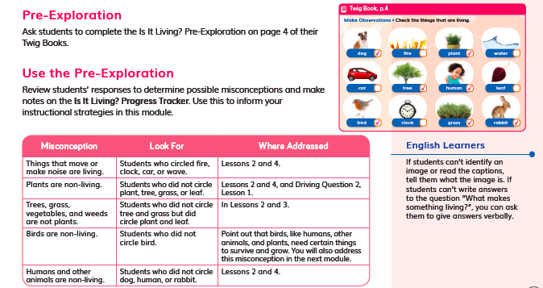 | Describe the assessment (e.g., how many questions, presence of tables/charts, graphs). | Purpose of Assessment  (i.e., peer, self, formative, summative, per/post) | Type of Measure (e.g., performance task, discussion, multiple choice. constructed response) | Note evidence of bias or problems with accessibility.
 | Activity prompt with images to check | Prior knowledge/  Pre-Exploration | Constructed response  Multiple choice
Match among Assessment, Phenomena/Problem, and Three Dimensions
What phenomenon or problem, if any, are students trying to figure out in this assessment? |  | What is the 2-3 dimensional learning goal assessed in this task?
Students figure out which images show a living things. |  | Students are assessed on their prior knowledge of living and nonliving things.

Assessment Description
DQ2L1 Reflect TE p. 47 / DQ2L1 TB p.14  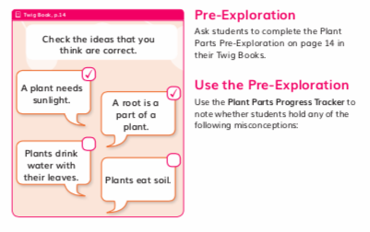 | Describe the assessment (e.g., how many questions, presence of tables/charts, graphs). | Purpose of Assessment  (i.e., peer, self, formative, summative, per/post) | Type of Measure (e.g., performance task, discussion, multiple choice. constructed response) | Note evidence of bias or problems with accessibility.
 | Activity prompt with ideas to check | Prior knowledge/  Pre-Exploration | Constructed response  Multiple choice
Match among Assessment, Phenomena/Problem, and Three Dimensions
What phenomenon or problem, if any, are students trying to figure out in this assessment? |  | What is the 2-3 dimensional learning goal assessed in this task?
Students figure out which of the statements about plant parts and plant needs are true. |  | Students are assessed on what they already know about plants, parts of a plant, and what plants need to grow.

Assessment Description
DQ3L1 Reflect TE p.82 / DQ3L1 TB p.27  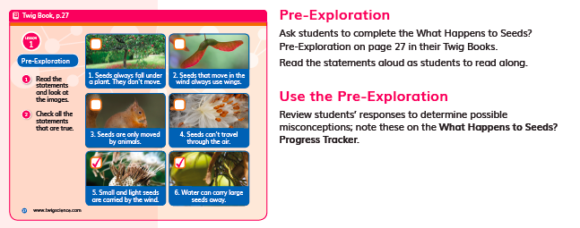 | Describe the assessment (e.g., how many questions, presence of tables/charts, graphs). | Purpose of Assessment  (i.e., peer, self, formative, summative, per/post) | Type of Measure (e.g., performance task, discussion, multiple choice. constructed response) | Note evidence of bias or problems with accessibility.
 | Two activity prompts and images to check | Prior knowledge/  Pre-Exploration | Constructed response  Multiple choice
Match among Assessment, Phenomena/Problem, and Three Dimensions
What phenomenon or problem, if any, are students trying to figure out in this assessment? |  | What is the 2-3 dimensional learning goal assessed in this task?
Students figure out which of the statements about plant parts and plant needs are true. |  | Students are assessed on what they already know about plants, parts of a plant, and what plants need to grow.

Assessment Description
DQ3L7 Reflect TE p.123 / DQ3L1 TB.36  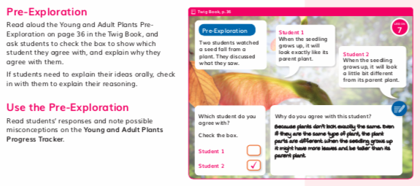 | Describe the assessment (e.g., how many questions, presence of tables/charts, graphs). | Purpose of Assessment  (i.e., peer, self, formative, summative, per/post) | Type of Measure (e.g., performance task, discussion, multiple choice. constructed response) | Note evidence of bias or problems with accessibility.
 | Two activity prompts, two statements. Students check the statement they agree with and write a reason for their selection. | Prior knowledge/  Pre-Exploration | Constructed response  Multiple choice | No evidence of bias. Teachers are prompted to modify the written response to an oral response if necessary.
Match among Assessment, Phenomena/Problem, and Three Dimensions
What phenomenon or problem, if any, are students trying to figure out in this assessment? |  | What is the 2-3 dimensional learning goal assessed in this task?
Students figure out the Module Phenomenon, whether seedlings will grow to look alike or different to their parent plants. |  | Students are assessed on their prior knowledge of how offspring look alike and different from their parents.

Assessment Description
DQ4L4 Spark TE p.150  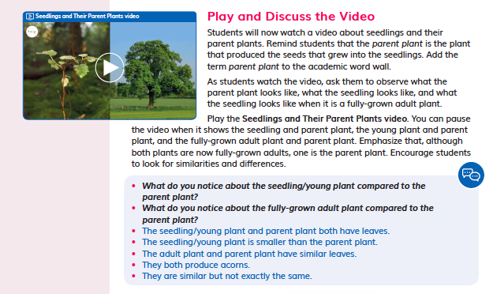 | Describe the assessment (e.g., how many questions, presence of tables/charts, graphs). | Purpose of Assessment  (i.e., peer, self, formative, summative, per/post) | Type of Measure (e.g., performance task, discussion, multiple choice. constructed response) | Note evidence of bias or problems with accessibility.
 | Students watch a video, then have a class discussion. | Formative | Discussion | No evidence of bias.
Match among Assessment, Phenomena/Problem, and Three Dimensions
What phenomenon or problem, if any, are students trying to figure out in this assessment? |  | What is the 2-3 dimensional learning goal assessed in this task?
Students observe seedlings and parent plants, then discuss the Module Phenomenon: How are plants alike and how are they different? |  | Students are assessed on their ability to make observations from a video, and explain ideas in a class discussion. They should be able to communicate how plant offspring look like, and look different to, their parent plants.

Assessment Description
DQ4L4 investigate TE p.152  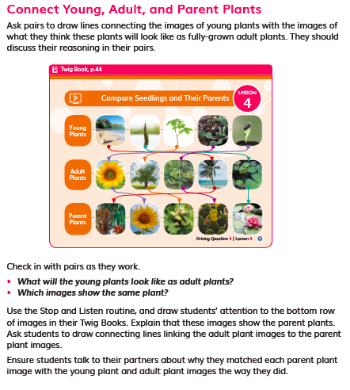 | Describe the assessment (e.g., how many questions, presence of tables/charts, graphs). | Purpose of Assessment  (i.e., peer, self, formative, summative, per/post) | Type of Measure (e.g., performance task, discussion, multiple choice. constructed response) | Note evidence of bias or problems with accessibility.
 | A table of images showing a row of Young Plants, Adult Plants, and Parent Plants. Students connect the Young Plant images to how they will look as adults, and then to their parent plant. | Peer and self-assessment | Constructed response, matching/sorting images, discussion
Match among Assessment, Phenomena/Problem, and Three Dimensions
What phenomenon or problem, if any, are students trying to figure out in this assessment? |  | What is the 2-3 dimensional learning goal assessed in this task?
Students work with a partner to match young plants to their parent plants, and discuss the reasons for their answers. |  | Students are assessed on their ability to recognize and match young plants to their parent plants, and to explain their reasoning to a peer based on evidence of how they are alike and how they are different.

Assessment Description
DQ5L1 Reflect TE p.166  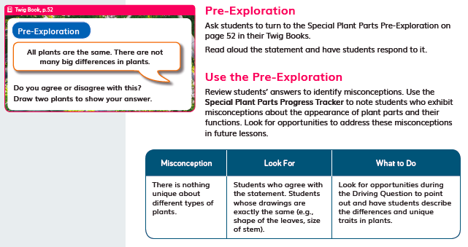 | Describe the assessment (e.g., how many questions, presence of tables/charts, graphs). | Purpose of Assessment  (i.e., peer, self, formative, summative, per/post) | Type of Measure (e.g., performance task, discussion, multiple choice. constructed response) | Note evidence of bias or problems with accessibility.
 | Discussion and drawing prompt | Prior knowledge/  Pre-Exploration | Constructed response, discussion and drawn response
Match among Assessment, Phenomena/Problem, and Three Dimensions
What phenomenon or problem, if any, are students trying to figure out in this assessment? |  | What is the 2-3 dimensional learning goal assessed in this task?
Students figure out whether they agree or disagree with a statement about how alike all plants are, and draw two plants to show their answer. |  | Students are assessed on what they have learned so far in the module. Their drawn responses should show that there are some big differences between the two plants, and some similarities.

Assessment Description
DQ3L6 Investigate TE p.114 / TB p. 34  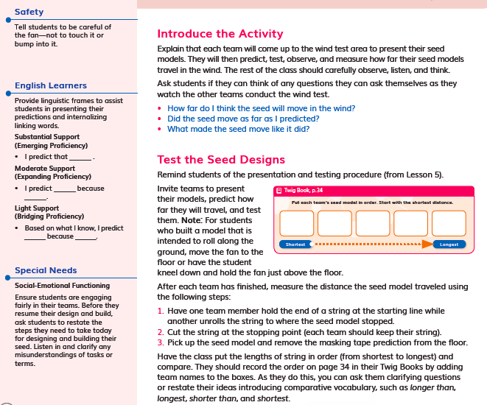 | Describe the assessment (e.g., how many questions, presence of tables/charts, graphs). |  | Purpose of Assessment  (i.e., peer, self, formative, summative, per/post) | Type of Measure (e.g., performance task, discussion, multiple choice. constructed response) | Note evidence of bias or problems with accessibility.
 | In DQ3 L1, L2, L4, L5 and L6 students work towards the performance task:  - In L1, students compare different seeds.  - In L2, students gather information of how seeds disperse.  - In L4, students design a seed model that can be dispersed as far as possible by wind.  - In L5, students make a seed model.  - In L6, students test their seed models. |  | Summative | Performance task, hands-on | No evidence of bias. Suggestions are made as to how the teacher can modify the task for students with special needs and English Learners.
Match among Assessment, Phenomena/Problem, and Three Dimensions
What phenomenon or problem, if any, are students trying to figure out in this assessment? |  | What is the 2-3 dimensional learning goal assessed in this task?
Students are figure out the phenomena that plants have different external parts that help them to survive, as well as how parent plants have offspring. They then solve a design problem. |  | Students are assessed on how they gather information, and their ability to apply their knowledge of seeds and seed dispersal, in order to make and test a model seed.

Assessment Description
DQ6L6 Investigate TE p. 216  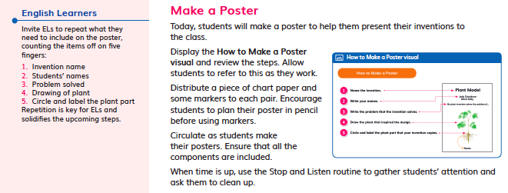 | Describe the assessment (e.g., how many questions, presence of tables/charts, graphs). | Purpose of Assessment  (i.e., peer, self, formative, summative, per/post) | Type of Measure (e.g., performance task, discussion, multiple choice. constructed response) | Note evidence of bias or problems with accessibility.
 | In DQ6 L1, L2, L4, L5 and L6 students work towards the performance task:  - In L1, students explore how nature inspires invention.  - In L3, students identify a plant part that they can copy to solve a human problem.  - In L4, students design a solution.  - In L5, students build their inventions.  - In L6, students make a poster to communicate how a design inspired by plants solves a problem. | Summative | Constructed, discussion, written, hands-on and drawn | No evidence of bias. Suggestions are made as to how the teacher can modify the task for students with special needs and English Learners.
Match among Assessment, Phenomena/Problem, and Three Dimensions
What phenomenon or problem, if any, are students trying to figure out in this assessment? |  | What is the 2-3 dimensional learning goal assessed in this task?
Students solve a problem by mimicking a plant structure. |  | Students are assessed on their ability to design a solution to a human problem by mimicking a plant structure.

Assessment Description
DQ7L2 Spark/Investigate TE p. 242  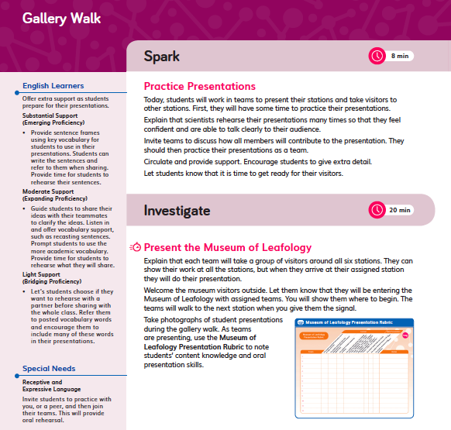 | Describe the assessment (e.g., how many questions, presence of tables/charts, graphs). | Purpose of Assessment  (i.e., peer, self, formative, summative, per/post) | Type of Measure (e.g., performance task, discussion, multiple choice. constructed response) | Note evidence of bias or problems with accessibility.
 | Students prepare and present three museum rooms to visitors. | Summative | Performance Task, written or drawn | No evidence of bias. Suggestions are made as to how the teacher can modify the task for students with special needs and English Learners.
Match among Assessment, Phenomena/Problem, and Three Dimensions
What phenomenon or problem, if any, are students trying to figure out in this assessment? |  | What is the 2-3 dimensional learning goal assessed in this task?
Students present what they have learned about plants over the course of the module, and how they are alike and different. |  | Students are assessed on what they learned over the course of the module.

Assessment Description
DQ1L2 Reflect TE p. 17  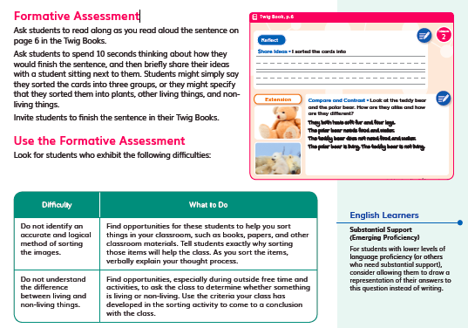 | Describe the assessment (e.g., how many questions, presence of tables/charts, graphs). | Purpose of Assessment  (i.e., peer, self, formative, summative, per/post) | Type of Measure (e.g., performance task, discussion, multiple choice. constructed response) | Note evidence of bias or problems with accessibility.
 | Discussion prompt | Peer | Discussion and written | No evidence of bias. Suggestions are provided for how the teacher can modify the activity for GATE students and English Learners.
Match among Assessment, Phenomena/Problem, and Three Dimensions
What phenomenon or problem, if any, are students trying to figure out in this assessment? |  | What is the 2-3 dimensional learning goal assessed in this task?
Students reflect on how they sorted image cards into three categories: plants, living things and non-living things. |  | Students reflect on the concepts and prior knowledge they applied when completing the card sorting activity.

Assessment Description
DQ1L3 Connect TE p. 24  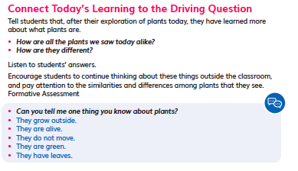 | Describe the assessment (e.g., how many questions, presence of tables/charts, graphs). | Purpose of Assessment  (i.e., peer, self, formative, summative, per/post) | Type of Measure (e.g., performance task, discussion, multiple choice. constructed response) | Note evidence of bias or problems with accessibility.
 | One discussion prompt | Formative | Discussion | No evidence of bias.
Match among Assessment, Phenomena/Problem, and Three Dimensions
What phenomenon or problem, if any, are students trying to figure out in this assessment? |  | What is the 2-3 dimensional learning goal assessed in this task?
Students discuss the things they know about plants. |  | Students are assessed on their ability to communicate their prior knowledge about plants.

Assessment Description
DQ1L4 Reflect TE p. 33  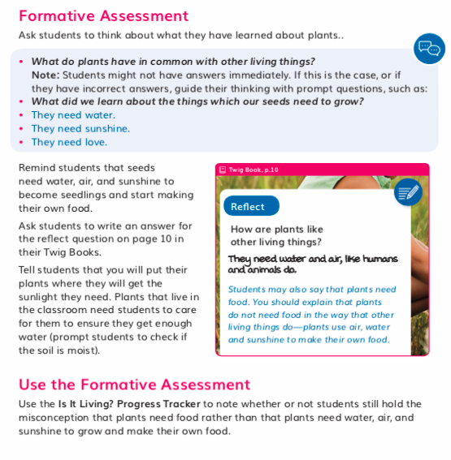 | Describe the assessment (e.g., how many questions, presence of tables/charts, graphs). | Purpose of Assessment  (i.e., peer, self, formative, summative, per/post) | Type of Measure (e.g., performance task, discussion, multiple choice. constructed response) | Note evidence of bias or problems with accessibility.
 | Discussion and writing prompt | Formative | Constructed response  Written answer to 1 question | No evidence of bias.
Match among Assessment, Phenomena/Problem, and Three Dimensions
What phenomenon or problem, if any, are students trying to figure out in this assessment? |  | What is the 2-3 dimensional learning goal assessed in this task?
Students discuss what plants have in common with other living things, and what seeds need to grow. They write about plants, and answer the driving question. |  | Students discuss what plants need to grow and write a sentence describing what makes plants a lving thing.

Assessment Description
DQ2L2 Reflect TE p.53 / TB p.19  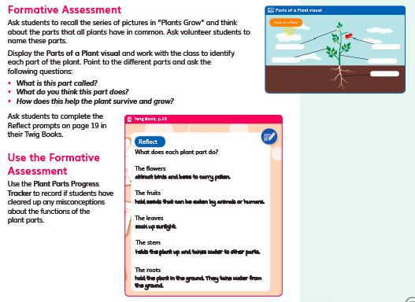 | Describe the assessment (e.g., how many questions, presence of tables/charts, graphs). | Purpose of Assessment  (i.e., peer, self, formative, summative, per/post) | Type of Measure (e.g., performance task, discussion, multiple choice. constructed response) | Note evidence of bias or problems with accessibility.
 | Five writing prompts | Formative | Constructed response, written
Match among Assessment, Phenomena/Problem, and Three Dimensions
What phenomenon or problem, if any, are students trying to figure out in this assessment? |  | What is the 2-3 dimensional learning goal assessed in this task?
Students write about the different plant parts. |  | Students identify the different parts of a plant, and write about their function(s). They discuss what parts plants have in common.

Assessment Description
DQ4L1 Reflect TE p.135 / TB p.40  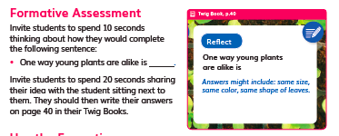 | Describe the assessment (e.g., how many questions, presence of tables/charts, graphs). | Purpose of Assessment  (i.e., peer, self, formative, summative, per/post) | Type of Measure (e.g., performance task, discussion, multiple choice. constructed response) | Note evidence of bias or problems with accessibility.
 | One writing prompt | Formative, peer | Constructed response  Written answer to 1 sentence starter (TB p.40)
Match among Assessment, Phenomena/Problem, and Three Dimensions
What phenomenon or problem, if any, are students trying to figure out in this assessment? |  | What is the 2-3 dimensional learning goal assessed in this task?
Students discuss and then complete a statement describing how young plants are alike. |  | Students discuss what young plants have in common, and are assessed on their ability to discuss ideas with peers, and to identify a pattern of things all plants have.

Assessment Description
DQ7L1 Reflect TE p. 229 / TB p.73  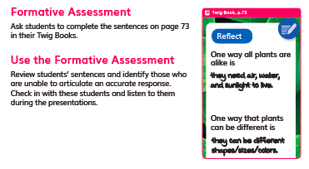 | Describe the assessment (e.g., how many questions, presence of tables/charts, graphs). | Purpose of Assessment  (i.e., peer, self, formative, summative, per/post) | Type of Measure (e.g., performance task, discussion, multiple choice. constructed response) | Note evidence of bias or problems with accessibility.
 | Two writing prompts | Formative | Constructed response, written
Match among Assessment, Phenomena/Problem, and Three Dimensions
What phenomenon or problem, if any, are students trying to figure out in this assessment? |  | What is the 2-3 dimensional learning goal assessed in this task?
Students answer the Module Phenomenon: How are plants alike and how are plants different to each other? |  | Students are assessed on their ability to answer the module phenomenon using what they have learned across the module.

Assessment Description
DQ7L2 Spark TE p. 236  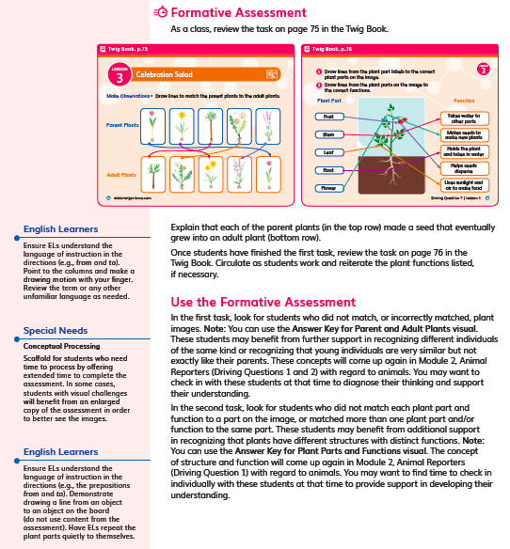 | Describe the assessment (e.g., how many questions, presence of tables/charts, graphs). | Purpose of Assessment  (i.e., peer, self, formative, summative, per/post) | Type of Measure (e.g., performance task, discussion, multiple choice. constructed response) | Note evidence of bias or problems with accessibility.
 | Two image-based questions | Formative | Constructed response  Written (TB pp. 75–76) | No evidence of bias. Includes suggestions for how teachers can modify the activity for English Learners and students with special needs.
Match among Assessment, Phenomena/Problem, and Three Dimensions
What phenomenon or problem, if any, are students trying to figure out in this assessment? |  | What is the 2-3 dimensional learning goal assessed in this task?
Students complete a task matching young plants to parent plants, then label and annotate a plant diagram. |  | Students revisit the task of matching young plants to their parent plants, and then label the parts and their functions on a pictorial model of a plant (SEP-2, CCC-6, LS1.A).

Designed for the NGSS: Foundations | High Quality  5 | Medium Quality  3 | Low Quality  1
SP1. Three-dimensional Performances. Materials include assessments designed to:  - match the targeted learning goals;  - elicit observable evidence of students’ use of grade-appropriate elements of the three dimensions to make sense of phenomena and/or to design solutions to problems. | Materials include assessments that are consistently designed to connect to learning goals and require students to apply appropriate elements of the three dimensions to make sense of the phenomenon/ solve the problem. | Materials include assessments that are sometimes designed to connect to learning goals and require students to apply appropriate elements of the three dimensions to make sense of the phenomenon/solve the problem. | Materials include assessments that are designed such that they have limited connection to learning goals and/or they require students to apply elements of only one dimension to demonstrate their understanding of the phenomenon/solve the problem.
SP2. Variety of Measures. Assessments within a unit of instruction are matched to the targeted learning goals and elicit a full range of student thinking through:  - use of a variety of measures (e.g., Performance Tasks, discussion questions, constructed response questions, project- or problem- based tasks, portfolios, justified multiple choice);  - multiple assessment opportunities so that students can demonstrate their understanding of the same learning goals in a variety of ways. | Materials include assessments that include a wide variety of formats with clear expectations that allow students to demonstrate their understanding of the learning goals in multiple ways. | Materials include assessments that include some variety of formats with clear expectations that allow students to demonstrate their understanding of the learning goals in multiple ways. | Materials include assessments that use just one format and/or the expectations for students to demonstrate their knowledge are absent or unclear.
SP3. Student Progress Over Time. The unit of instruction includes assessments that serve a variety of purposes (e.g., pre/post; formative, summative, peer, self) to measure students’ progress over time. The assessments:  - provide opportunities to see growth and development in the use of the dimensions over time;  - allow students to reflect on and monitor their sense-making/problem-solving over time. | Materials include assessments that offer multiple opportunities, using more than one type of measure to demonstrate learning, and these measures are strongly connected to show student progress both in and across the three dimensions. | Materials include assessments that offer multiple opportunities, using more than one type of measure to demonstrate learning, and these measures are somewhat connected to show student progress in or across the three dimensions. | Materials include assessments that offer limited opportunities for students to demonstrate progress on the three dimensions.
SP4. Equitable Access. Assessments within the unit of instruction are designed to:  - be free from bias (e.g., gender, racial, socioeconomic status, cultural, etc.);  - be accessible to all students (e.g., reading level, accommodations). | Most assessments in the materials are free from bias and are accessible. | Some assessments in the materials are free from bias and are accessible. | Few assessments in the materials are free from bias and are accessible.

Designed for the NGSS: Student Progress Rubric

Analyze Evidence

Directions
  - Review the Designed for NGSS: Student Work rubric.
  - Reflect on the evidence (or lack of evidence) that you and your team gathered.
  - Record strengths and limitations for each criterion based on your observations. Cite specific examples.

Strengths
SP1: Three-Dimensional Performance
The materials are High Quality 5 in regards to SP1.
They include assessments that are consistently designed to connect to learning goals and require students to apply appropriate elements of the three dimensions to make sense of the Module Phenomenon.
Evidence  - Assessments are well matched to the learning goals and require students to demonstrate observable use of three dimensions to make sense of phenomenon and solve problems. For example:  - In the DQ3 Performance Task, students design, build, and test (ETS1.B, ETS1.C) a seed model (SEP-2, SEP-3, SEP-4, SEP-6) that can be dispersed by wind. They observe the structure and function of different types of seed (LS1.A), and analyze their findings. (DQ3L6 Investigate TE p. 114) | DQ3L6 Investigate TE p. 114
- In the DQ7L2 Formative Assessment, students revisit the task of matching young plants to their parent plants, and then label the parts and their functions on a pictorial model of a plant (SEP-2, CCC-6, LS1.A). (DQ7L2 Spark TE p. 236) | DQ7L2 Spark TE p. 236
- In the DQ4 L1 Formative Assessment, students discuss what young plants have in common (LS1.A), and are assessed on their ability to discuss ideas with peers (SEP-4), and identify a pattern (CCC-1) of things all plants have. (DQ4L1 Reflect TE p. 135) | DQ4L1 Reflect TE p. 135 / TB p.40
SP2: Variety of Measures
The materials are High Quality in regards to SP2.
Materials include assessments that include a wide variety of formats with clear expectations that allow students to demonstrate their understanding of the learning goals in multiple ways.
Evidence  - Assessments allow students to demonstrate their understanding of the learning goals in a variety of way including:  - Performance Tasks (written, drawn, and hands-on DQ3L6 Investigate TE p. 114, DQ6L6 Investigate TE p. 216, DQ7L2 TE p. 242) | DQ6L6 Investigate TE p. 216
- Discussions (DQ1L3 TE p. 24, DQ1L4 Reflect TE p. 33) | DQ1L4 Reflect TE p. 33
- Constructed responses (discussion, annotating a model and drawn DQ5L1 Reflect TE p. 176, DQ7L2 Spark TE p. 236) | DQ7L2 Spark TE p. 236
- Peer and self-assessment (DQ4L4 investigate TE p. 152) | DQ4L4 investigate TE p. 152
SP3: Student Progress Over Time
The materials are High Quality in regards to SP3.
Materials include assessments that offer multiple opportunities, using more than one type of measure, to demonstrate learning and these measures are strongly connected to show student progress both in and across the three dimensions.
Evidence  - There are 4 diagnostic pre-assessments called Pre-Explorations at strategic points in the module that assess prior knowledge and misconceptions (DQ2L1 Reflect TE p. 47, DQ2L1 TB p. 14). Notes in the TE and progress trackers support teachers in monitoring students as they clear up their misconceptions and master the three dimensions, giving suggestions for how to tailor instruction accordingly. | DQ2L1 Reflect TE p. 47, DQ2L1 TB p. 14
- Formative assessments are frequent and varied, supporting students and teachers to understand how each student’s learning journey is progressing (DQ1L4 Reflect TE p. 33).  - The performance tasks at the end of DQ3, DQ6, and DQ7 allow students to demonstrate their mastery of the Performance Expectations in a variety of ways. | DQ1L4 Reflect TE p. 33
SP4: Equitable Access
The materials are High Quality in regards to SP4.
Most assessments in the materials are free from bias and are accessible.
Evidence  - The digital Twig Book has a text-to-speech function allowing students of all reading levels to access the assessments.  - Assessments of the three dimensions are multimodal and include: writing, drawing, creating/using physical models, posters, and oral presentations, giving all students access to a range of assessment types to suit their learning style and/or reading level.  - The rubrics for the Performance Tasks (DQ3, DQ6 and DQ7) have four levels—emerging, developing, proficient, and advanced, allowing all students to demonstrate their current level of attainment.  - There are Writing, Reading, Listening and Speaking domain tasks dedicated to monitor English language development are integrated into the core instructional resources (DQ2L1 TE p. 43) and the on-level reader lessons (Chapter 3 Second Read TE p. 257). | 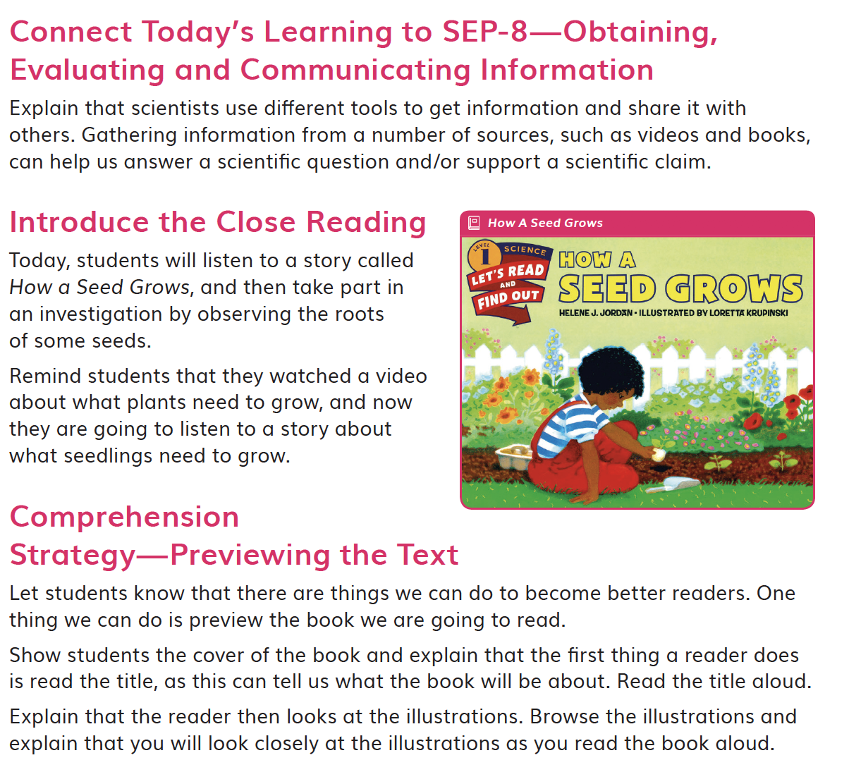  DQ2L1 Investigation TE p. 43

