Science made for the Next Generation

Twig Science was built from the ground up for the California NGSS by award-winning STEM education specialists.

Reviewing our program, you’ll find:

- ​A clear conceptual flow across the program, clearly set out in the program CA NGSS Framework Alignment
- Modules that bundle different scientific disciplines including engineering and environmental principles and concepts (as defined by the CDE), aligned 1:1 with the segments of the California Framework
- Phenomena and investigative problems at the heart of each module, with Grade Scope and Sequence tables that show how the dimensions flow and build in sophistication across each grade
- Module Contents that tell the story of how students apply the three dimensions in a module, with Driving Questions that scaffold their learning journey
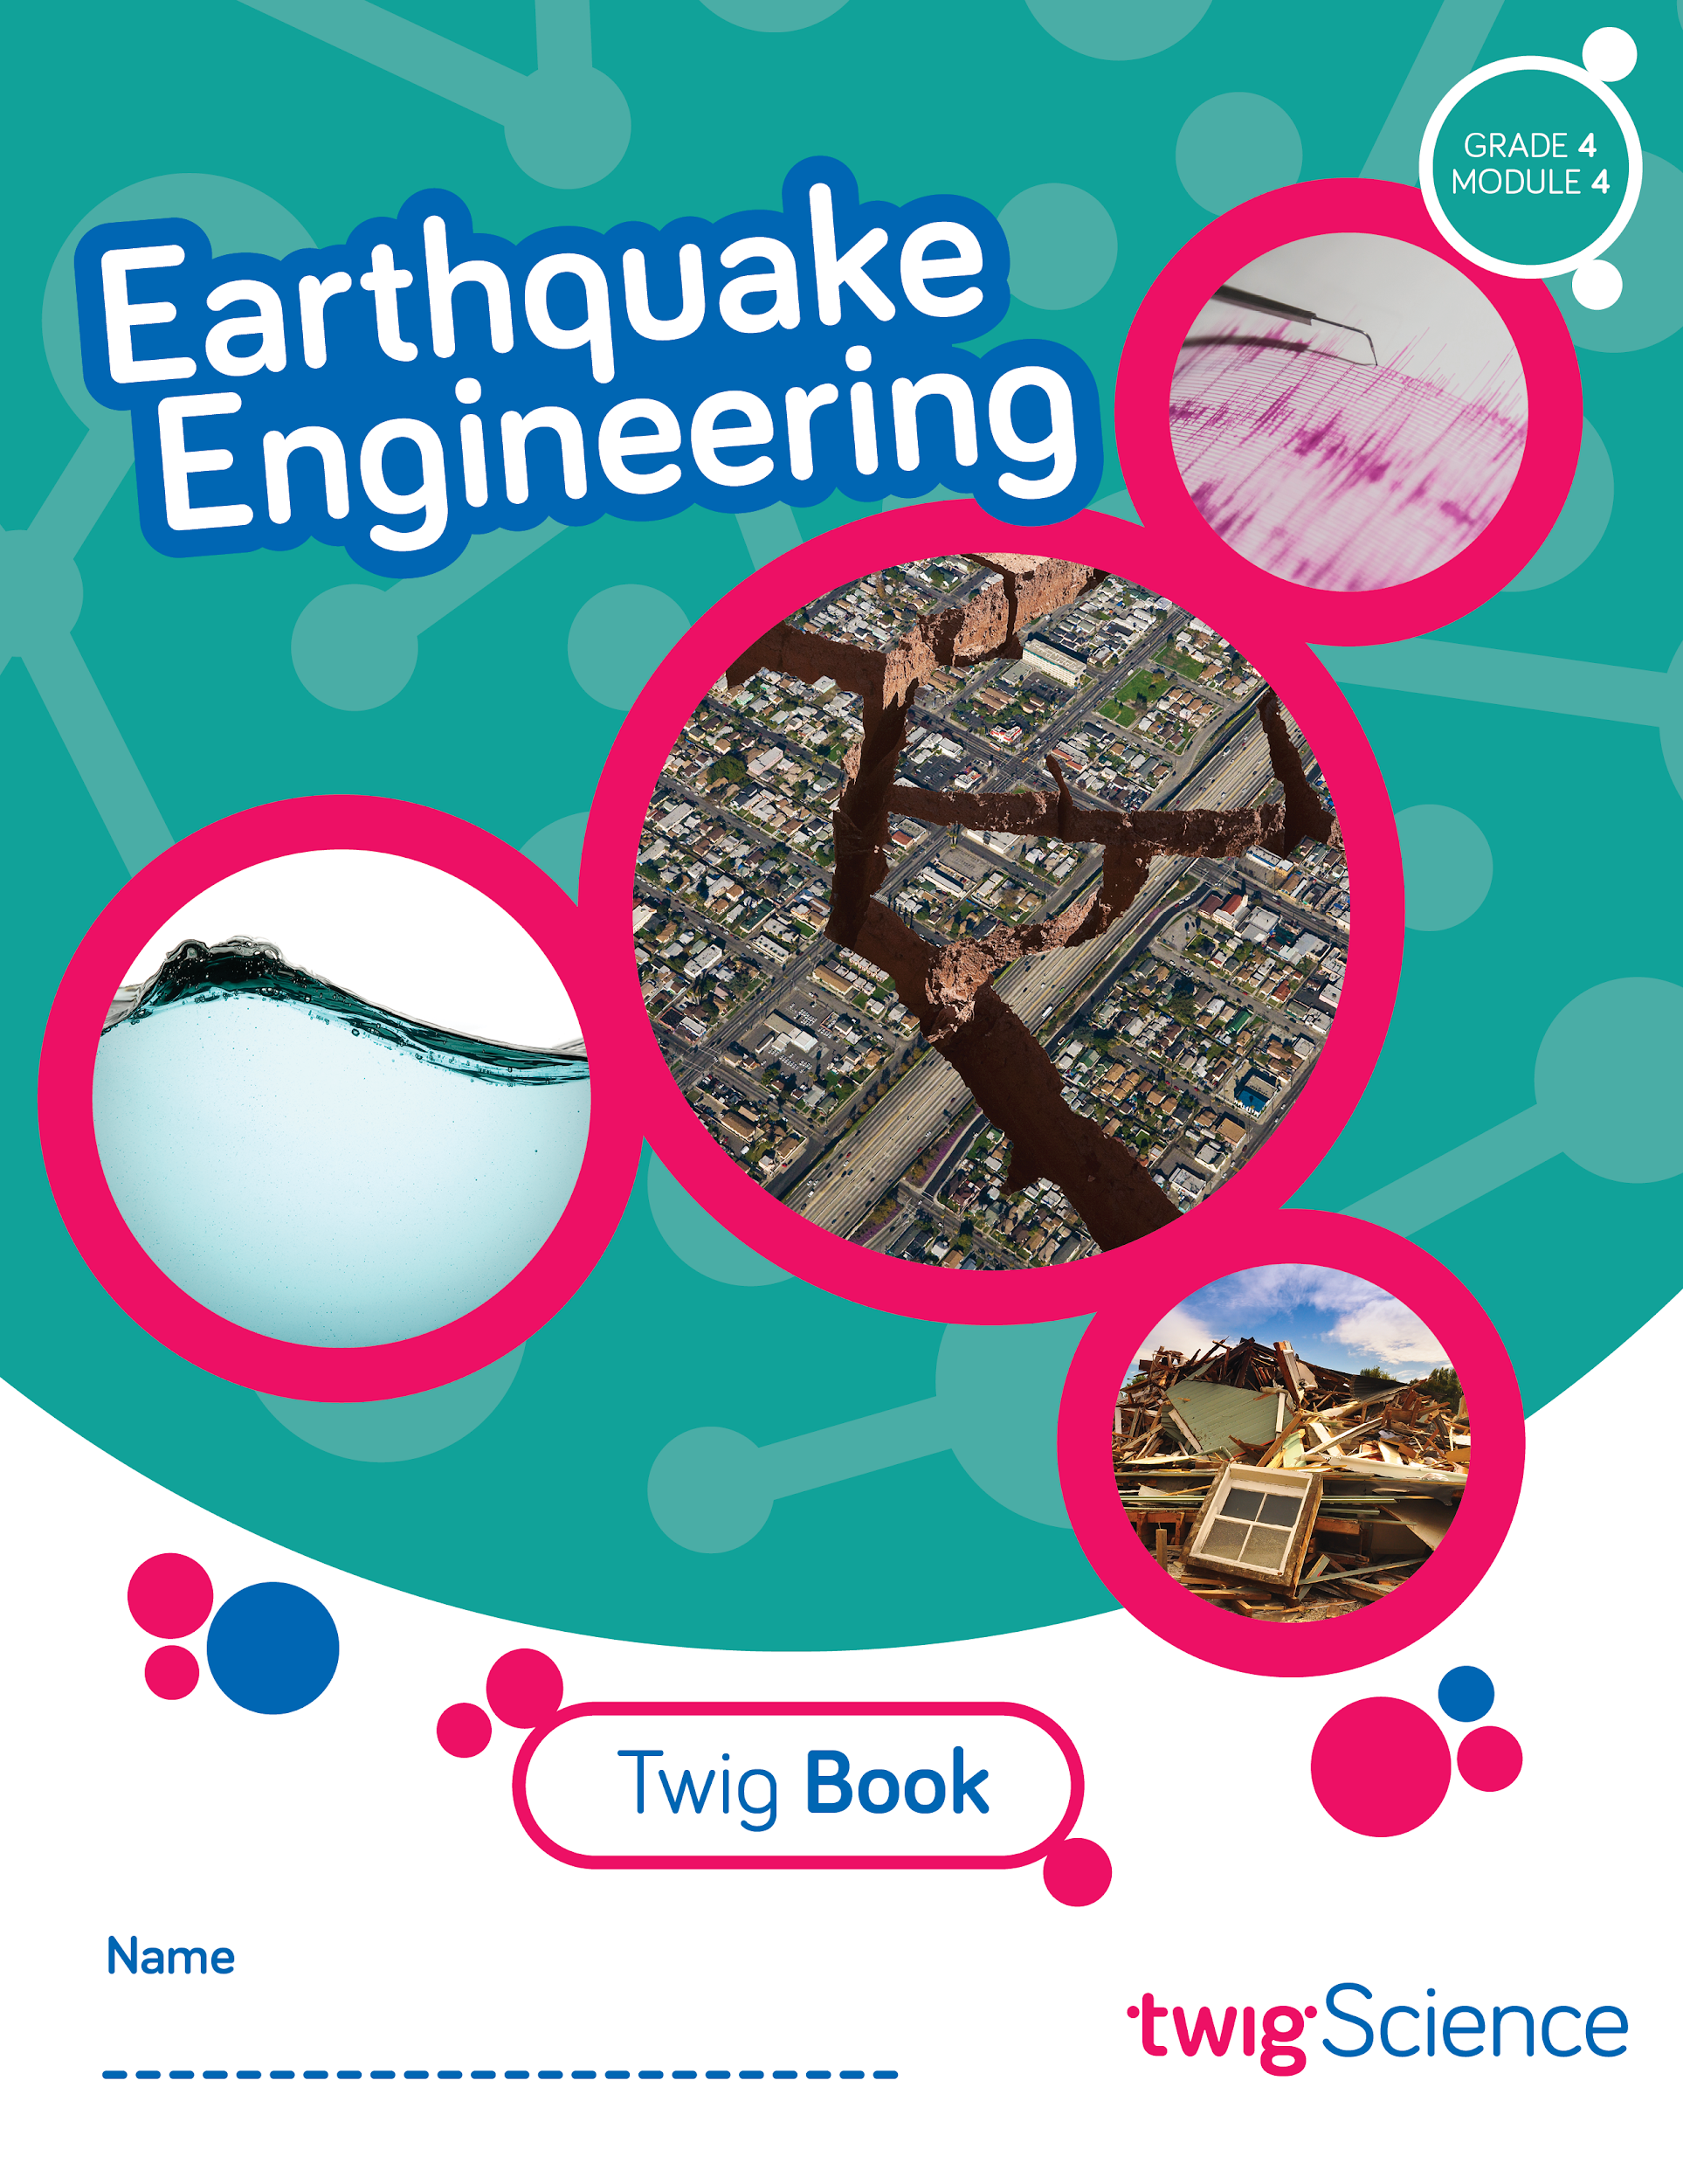
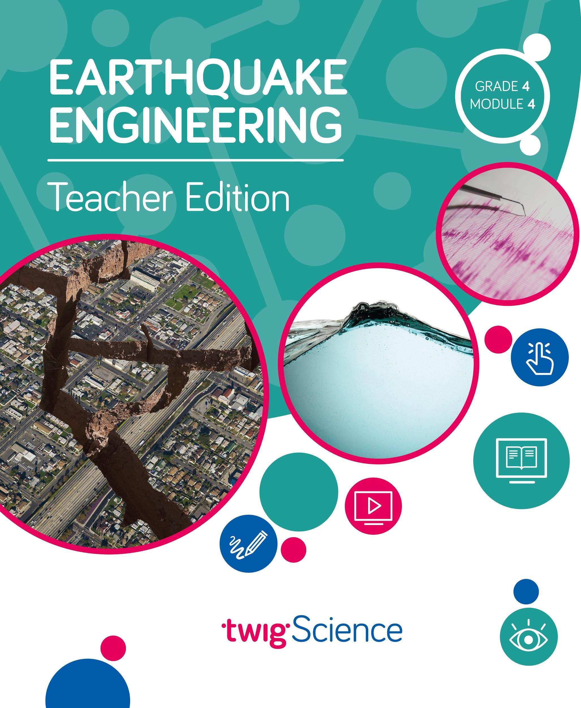
- Three-dimensional lessons and assessments that clearly outline the dimensions applied.
​
This is why we score so highly on NGSS-based rubrics such as NextGen TIME Paper screen evaluation.

This rubric has been completed for Grade 4 Module 4 Earthquake Engineering and is designed to highlight where you can find evidence for the Designed for NGSS: Foundations Rubric. The rubric includes citations to the printed Teachers Edition and Twig Book (Student Edition).

Designed for the NGSS: Foundations | High Quality  5 | Medium Quality  3 | Low Quality  1
F1. Presence of Phenomena/Problem. The materials include phenomena/problems that have the potential to drive student learning toward the targeted learning goals in the following ways:  - phenomena/problems in the materials are to be relevant to students;  - explanations for phenomena connect to the three dimensions;  - solutions to problems connect to the three dimensions. | The materials include phenomena/problems that have strong potential to drive student learning toward the targeted learning goals. | The materials include phenomena/problems that have some potential to drive student learning toward the targeted learning goals. | The materials include phenomena/problems that have limited potential to drive student learning toward the targeted learning goals.
F2. Presence of Three Dimensions. The materials include opportunities for students to develop and use the three dimensions, such that:  - the DCIs, SEPs, and CCCs are present and have the potential to support student learning toward the targeted learning goals for each dimension;  - when engineering design is a learning focus, it is integrated with other appropriate dimensions (i.e., engineering is not isolated). | The materials consistently provide opportunities for students to develop and use the three dimensions. | The materials occasionally provide opportunities for students to develop and use the three dimensions. | The materials rarely provide opportunities for students to use the three dimensions.
F3. Presence of Logical Sequence. Materials demonstrate appropriate sequencing of three dimensions when:  - they include a targeted set of DCIs, SEPs, and CCCs within a sequence;  - the sequence is clear and logical across the DCIs;  - the SEPs and CCCs are potentially sufficient and appropriate for students to figure out the phenomena or problems. | The materials consistently exhibit a clear, logical, and appropriate sequence across the three dimensions. | The materials occasionally exhibit a clear, logical, and appropriate sequence across the three dimensions. | The materials rarely exhibit a clear, logical, and appropriate sequence across the three dimensions.

Designed for NGSS: Foundations
Analyze Evidence
Directions:
- Review the Designed for NGSS: Foundations Rubric.
- Reflect on the evidence (or lack of evidence) that you and your team gathered and represented.
- Record strengths and limitations for each criterion based on your evidence. Cite specific examples.

Strengths
F1. Presence of Phenomena /Problems
The materials are High Quality 5 with regards to F1.
There is high quality evidence of phenomenon and problems that with a strong potential to drive student learning towards targeted goal. The phenomena/problems are very relevant to students, explanations for phenomena connect to the three dimensions, and solutions to problems connect to the three dimensions.
Evidence
Grade 4 Module 4: Earthquake Engineering
Module Investigative Problem: How can we reduce the damage caused by earthquakes?
Students tackle the problem in stages by following a sequence of Driving Questions (DQs) that drive a conceptual flow.

DQ1: How are waves involved in earthquakes?
DQ2: How can patterns help us predict where earthquakes and volcanoes will occur?
DQ3: How can building materials and shapes affect the severity of earthquake damage?
DQ4: How can our understanding of earthquakes and materials help us build safer buildings?
DQ5: What can we learn from engineers that will help us revise our designs?
DQ6: How can we redesign our buildings to make them safer during earthquakes?

Over the course of all six DQs, students investigate a series of phenomena/problems, which progressively build in complexity, scaffolding students' acquisition of the necessary DCIs, SEPs, and CCCs until they are able to address the central problem.

For example, in DQ1 students explore the phenomena of waves, using ropes and an interactive. They make the connection between wave amplitude and earthquake magnitude with the help of a seismograph. They gain understanding that seismic waves cause earthquakes. Then, in DQ2 they use an interactive map to explore the phenomenon of patterns in the location of earthquakes and work out what those patterns mean. In DQs 3–5 they witness the phenomenon of earthquake damage and tackle the problem of how to build earthquake-resistant structures. They follow the engineering design process to test different shapes, structures, and materials to compare and contrast engineering solutions in the real-world. They apply what they have learned to designing and building their own structure.

By the end of DQ6, students have figured out the answer to the Module Investigative Problem. They understand that earthquake damage can be reduced by not building on active fault lines where possible, and/or by using a variety of engineering solutions that allow buildings to withstand the shaking caused by the energy of seismic waves.
F2. Presence of Three Dimensions
The materials are High Quality 5 with regards to F2.
They consistently provide opportunities for students to use and develop the three dimensions.
In this module, students are supported to use the three dimensions with increasing sophistication to solve the Module Investigative Problem, answer the Driving Questions, and complete the assessment tasks.  Use and Development of Dimensions  For example, in DQ1 students explore the question: How are waves involved in earthquakes? Over five lessons, students are first introduced to the phenomena of natural hazards (ESS3.B), before carrying out investigations—both physical and digital—to model waves (SEP-2) and understand the properties of waves and how they transfer energy (PS4.A). They interrogate texts, watch videos, and apply the CCCs of cause and effect, and energy and matter to figure out the answer to the DQ—that seismic waves cause earthquakes and that larger waves that transfer more energy cause earthquakes of greater magnitude with the potential to cause more destruction. (Module Contents TE p.ii) | 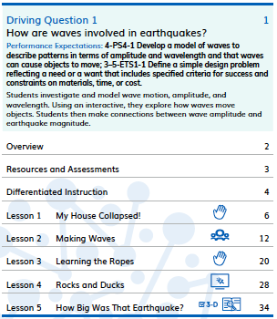  Module Contents TE p.ii
The 3-D Learning Objectives and dimensions addressed in every lesson are clearly identified at the start of each lesson. (DQ1L3 3-D Learning Objectives TE p. 20) | 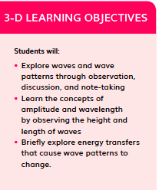  DQ1L3 3-D Learning Objectives TE p. 20
Science Tools Poster  Throughout the module, students use their class Science Tools poster to track their growing use of the SEPs. The poster is blank at the start of the year, and the eight SEPs are added when each one is used for the first time. In this module, students revisit “Develop and use models”(SEP-2), and add “Evaluate information” (SEP-8), “Analyze and interpret data” (SEP-4), and “Define problems” (SEP-1) to their poster. This metacognitive activity grows students' awareness of which skills they are using. | 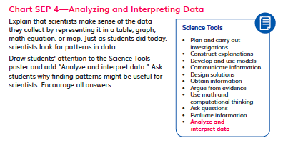  Science Tools poster
Engineering  Engineering design is fully embedded in this module. Students complete their first engineering challenge in the very first lesson, during which students build a tower out of newspaper (DQ1L1 TE p. 6). They revisit the engineering design process in DQ3, 4, and 6, using what they learn to solve the Module Investigative Problem. | 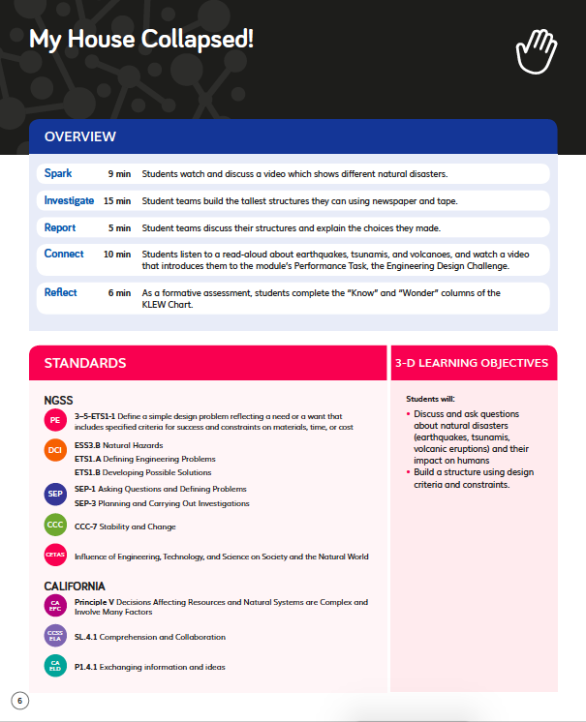  DQ1L1 TE p. 6
F3. Presence of Logical Sequence
The materials are High Quality 5 with regards to F3.
The materials consistently exhibit a clear, logical, and appropriate sequence across the three dimensions.
Evidence  Targeted Three Dimensions in a Logical Sequence  Grade Sequence  The Grade 4 Scope and Sequence clearly identifies the three dimensions targeted in Earthquake Engineering and where they fit into the sequence of dimensions that are addressed across the entire grade. For example, before this module, students have already encountered 3–5-ETS1-3 in both Module 1 and Module 3 and will go on to revisit 4-PS4-1 in Module 5. The sequence of all the DCIs, SEPs, and CCCs targeted at Grade 4 is easy to see at a glance. | 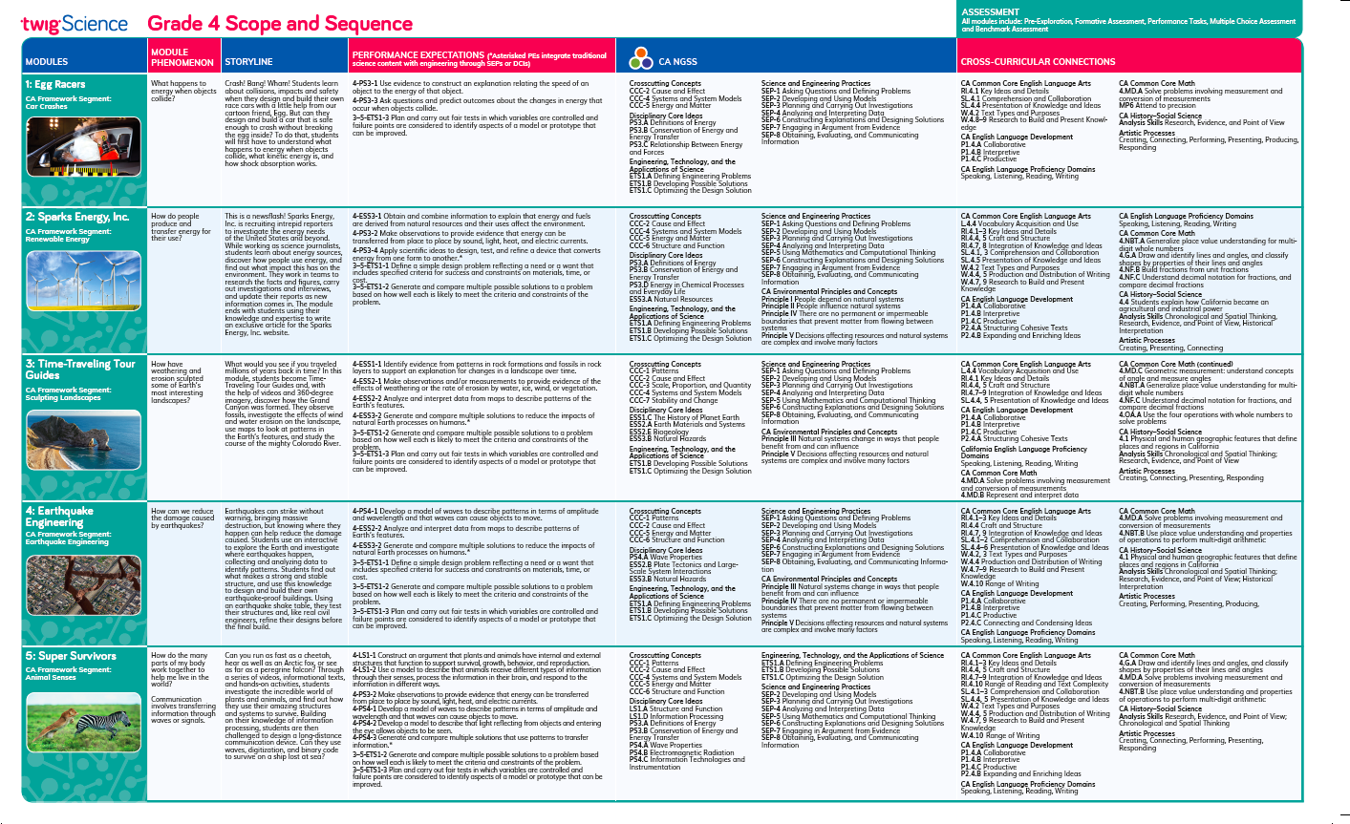  Grade 4 Scope and Sequence
Program Sequence  The Performance Expectations Progressions table identifies where students have encountered relevant dimensions in previous grades, for example, engineering in Kindergarten Module 2, Kindergarten Module 3, Grade 2 Module 2, Grade 2 Module 3, and Grade 3 Module 4. It also identifies where they will revisit dimensions in future grades, e.g. students exploring patterns in Grade 6 Module 2. | 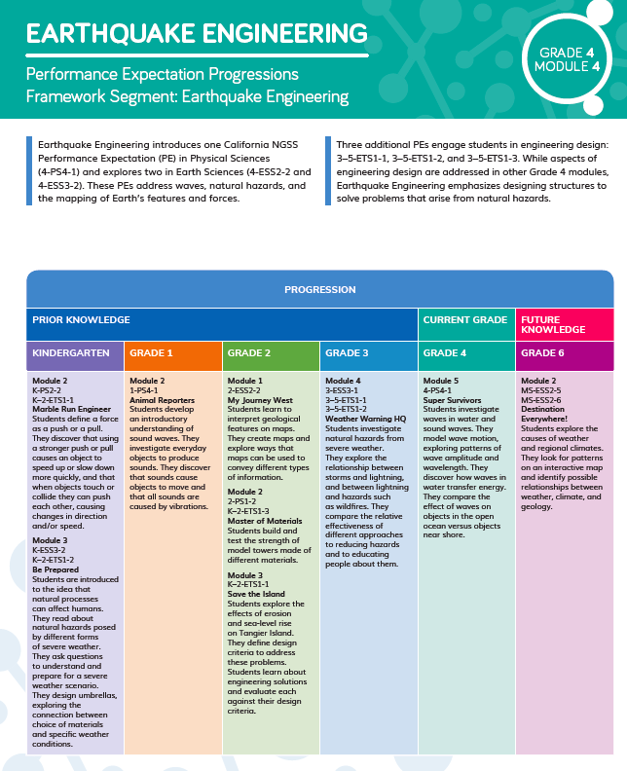  Performance Expectations Progressions table
Module Sequence  The Module Contents identifies the sequence of three dimensions addressed in Earthquake Engineering, and how they build on each other. For example, students investigate and model wave motion, before analyzing patterns in earthquake locations. They go on to build an increasingly sophisticated understanding of how engineers can design structures capable of withstanding the energy released by earthquakes. | 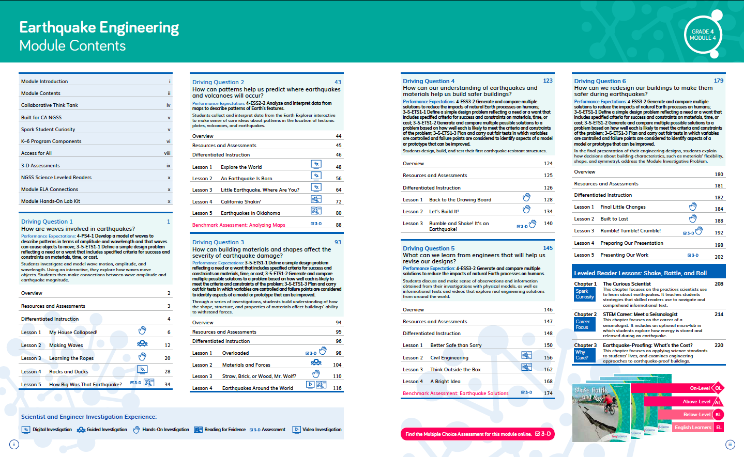  Module Contents TE pp. ii-iii
Driving Question Sequence  Each Driving Question Divider tells the story of how the students will sequentially use the three dimensions to answer the question posed. For example, in DQ2, students use the concept of patterns and the practice of analyzing data to figure out that earthquakes appear in bands along plate boundaries. This knowledge helps them realize that one way of reducing the damage caused by earthquakes is to avoid construction along active fault lines. (DQ2 Overview TE p. 43) | 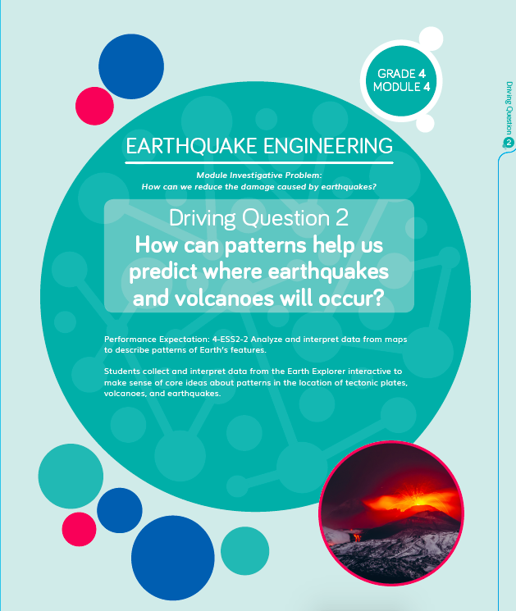  Driving Question Divider TE p. 43
Lesson Sequence  The five-part Twig Science lesson structure has been designed to support students to monitor what and how they have learned across the three dimensions on a daily basis.  Spark: An engaging hook activity motivates students for the investigations ahead.  Investigate: Students think like scientists and design like engineers through hands-on, digital, video, and information text investigations.  Report: Students articulate what they’ve learned, citing evidence and their use of the three dimensions.  Connect: Students make connections to the Driving Questions and Module Phenomenon while building knowledge of CCCs and SEPs.  Reflect: Students use different means to think about what they have learned so far and how they can use their new understandings to better figure out phenomena/problems.  The Lesson Overview summarizes how each part targets the standards and 3-D Learning Objectives.  Each Lesson Overview includes the lesson’s targeted Standards and 3-D Learning Objectives, which identify the dimensions and detail how they relate to the learning experience.  For example, in DQ2L1 (TE p. 48) students will Investigate patterns in the locations of earthquakes on an interactive map. They will record and Report their observations with each other, Connect what they have learned to PE 4-ESS2-2 and Reflect on how knowing where earthquakes occur will help them answer the Module Investigative Problem. | 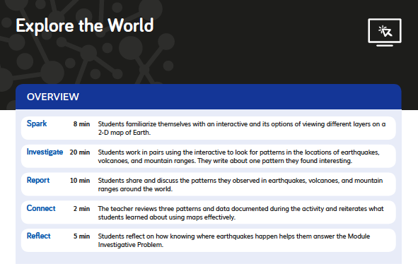  Lesson Overview TE p. 48  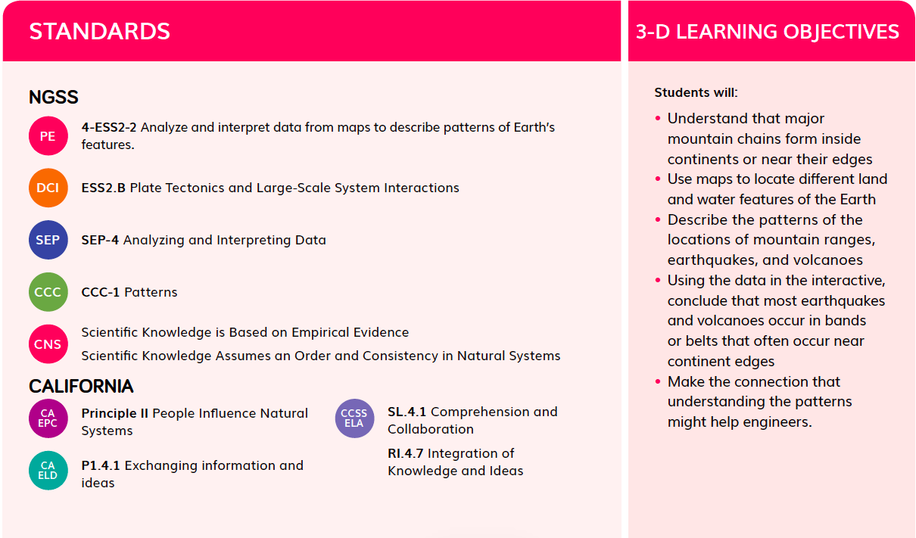  Standards and 3-D Learning Objectives TE p.48
Flow of DCIs
The DCIs follow a logical sequence, supporting students to gain the knowledge they need to address the Module Investigative Problem.

DQ1: Students explore natural hazards (PS4-1), properties of waves (ESS3.B), and define and develop engineering engineering solutions (ETS1.A, ETS1.B).
DQ2: Students investigate plate tectonics (ESS2.B).
DQ3: Students define, develop and optimize engineering solutions (ETS1.A, ETS1.B, ETS1.C).
DQ4: Students build on those engineering DCIs and revisit natural hazards (ESS3.B, ETS1.A, ETS1.B, ETS1.C).
DQ5: Students revisit natural hazards and design solutions (ESS3.B, ETS1.B).
DQ6: Students revisit natural hazards and define, develop and optimize engineering solutions (ESS3.B, ETS1.A, ETS1.B, ETS1.C).

Flow of SEPs and CCCs
The SEPs and CCC’s follow a logical sequence supporting students to gain expertise of the practices and concepts they need to address the Module Investigative Problem.

- In DQ1, students ask questions and define problems, use models (SEP-1, SEP-2) and apply the concept of patterns (CCC-1).
- In DQ2, students analyze data (SEP-4) and use patterns (CCC-1).
- In DQ3, students ask questions and define problems, construct explanations and design solutions, analyze and interpret data (SEP-1, SEP-6) and explore the influence of science, technology and engineering on society and the natural worlds (CCC-2).
- In DQ4, students gain further experience of asking questions and defining problems, constructing explanations and designing solutions, analyzing and interpreting data (SEP-1, SEP-6), apply the concept of cause and effect and explore the influence of science, technology and engineering on society and the natural worlds (CCC-2).
- In DQ5, students again construct explanations and design solutions (SEP-6), apply the concept of cause and effect and explore the influence of science, technology and engineering on society and the natural worlds (CCC-2).
- In DQ6, students consolidate asking questions and defining problems, constructing explanations and designing solutions, analyzing and interpreting data (SEP-1, 4 and 6), applying cause and effect and exploring the influence of science, technology and engineering on society and the natural worlds (CCC-2).

