5.2 Yellowstone: Uncovered
Assessment Overview

In this module, students become park rangers to investigate the Module Phenomenon: How do matter and energy move through an ecosystem?

Students begin by reflecting on prior ideas about what plants need in order to grow. They plan and set up two investigations to gather evidence in support of their ideas about what plants need to grow and where they get their matter. Students then model the movement of matter through a food chain and a food web, and also create an ecosystem model. Students review and analyze data from their investigations, and draw conclusions about plants’ needs and where plants get their matter.

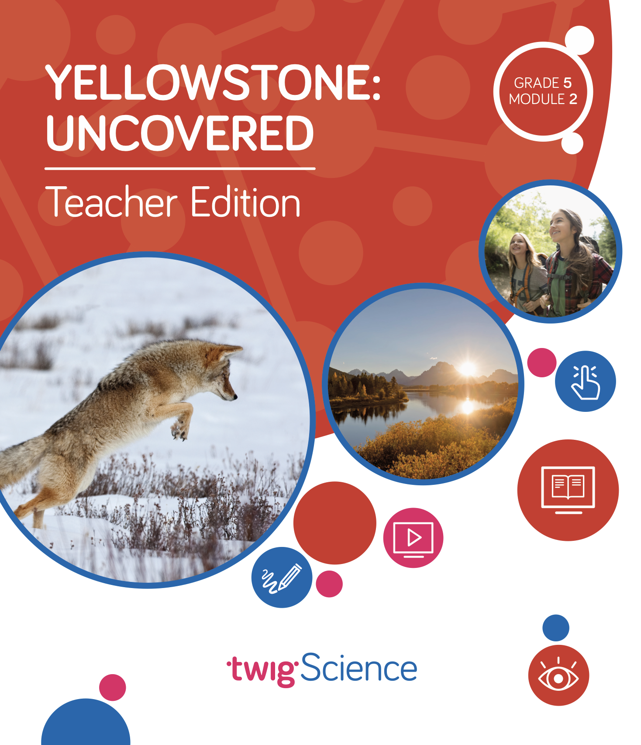
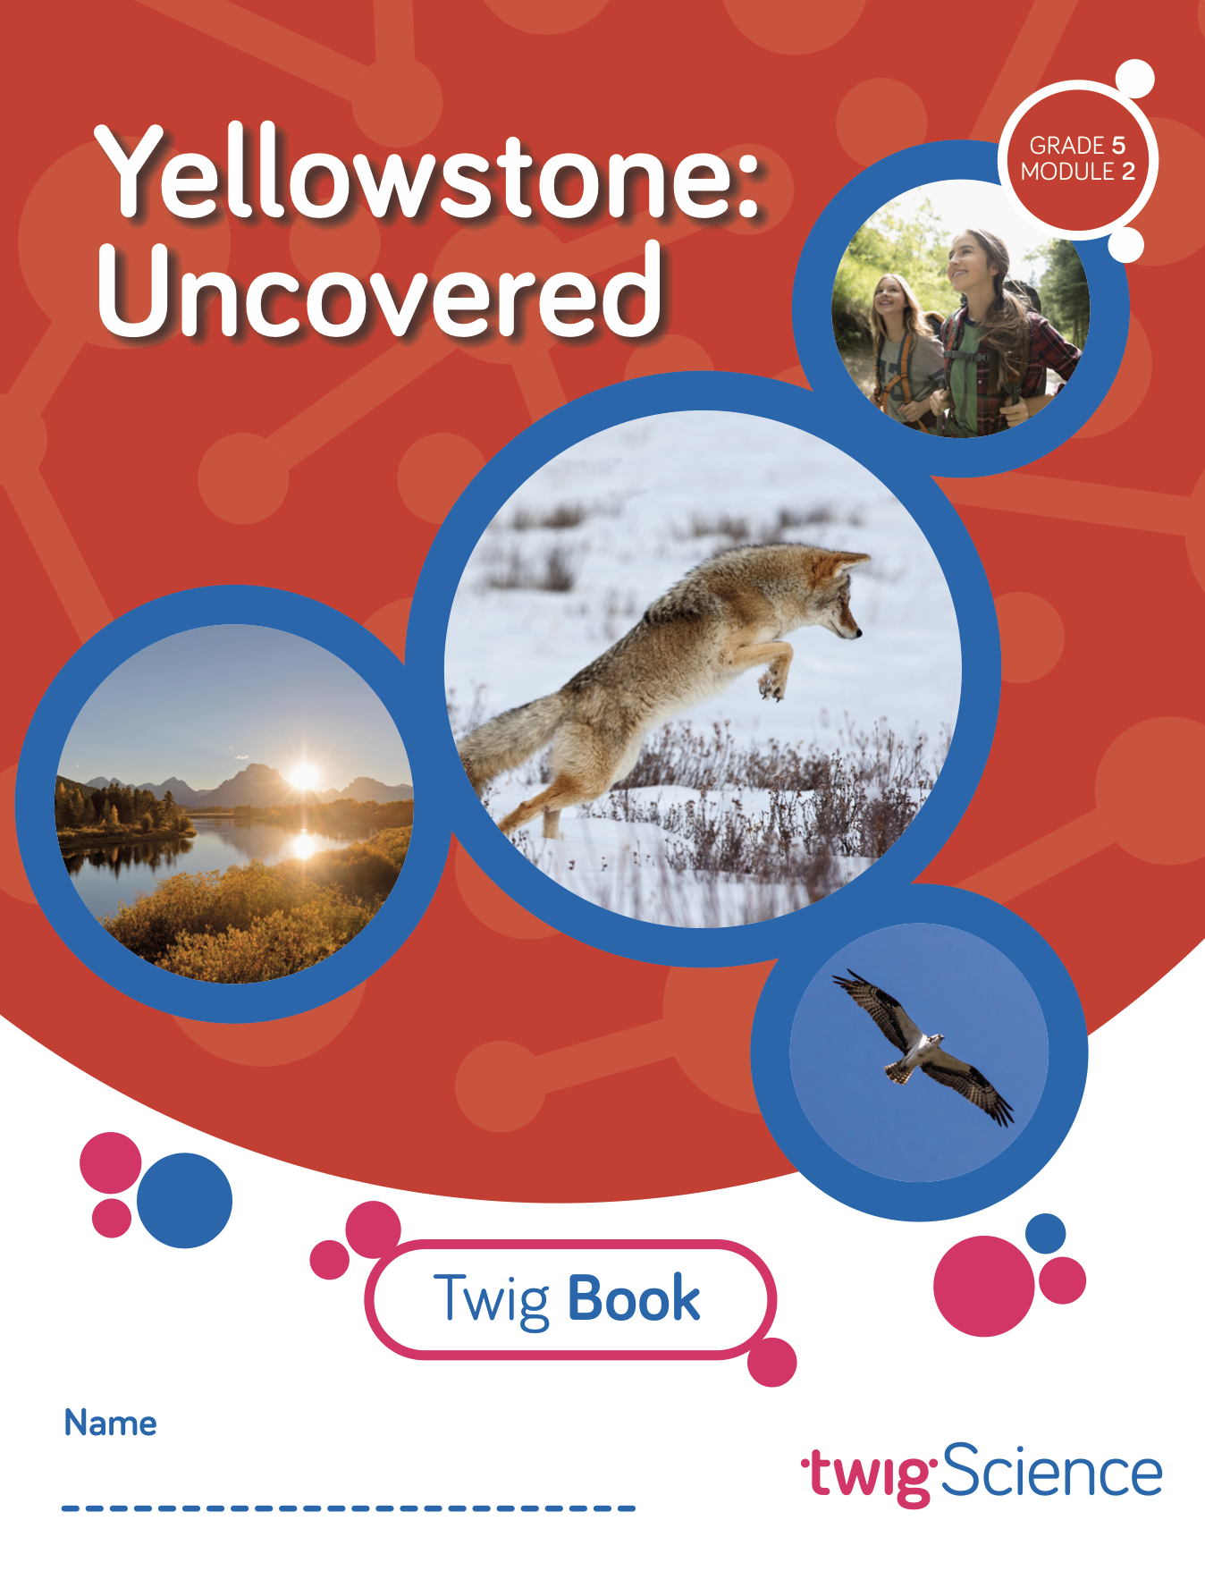
Students use a text, an interactive, and kinesthetic models to investigate and communicate ideas about how energy moves through the organisms in an ecosystem. Through field observation, controlled experiment, and informational text, students discover what happens to the matter that makes up organisms when they die. Students apply their learning about decomposers as they develop a model showing the cycling of matter in a food chain.

Students use everything they have learned to investigate what can happen if changes are made to the organisms in an ecosystem. Students are assessed on their ability to identify the living and non-living components of an ecosystem and describe how these components interact to cycle matter through the ecosystem.

Pre-Explorations (Diagnostic Pre-Assessment)
Key: Driving Question (DQ) Lesson (L) Teacher Edition (TE) Twig Book (TB)
Reference | Assessment Tool | Description | Type | Misconceptions identified
DQ1L1 Reflect (TE p. 13) | What Plants Need Progress Tracker | Students read about an investigation and observe the data that was gathered. They then explain whether they agree with the conclusion that was drawn, providing reasoning. | Constructed response  Written (TB p. 4) | - Plants get their matter from soil.
DQ1L3 Reflect (TE p. 25) | Matter Progress Tracker | Students read four statements and decide if they are true or false. | Constructed response  Written (TB p. 16) | - Animals only need water; they do not need food.  - Humans and other animals get their matter from somewhere other than food.
DQ2L7 Reflect (TE p. 86) | Plant Growth Progress Tracker | Students read four statements and decide if they are true or false. | Constructed response  Written (TB p. 40) | - Sunlight is helpful for plants, but it is not necessary.  - Soil provides food for plants.  - Plants cannot survive without help from humans.
DQ3L4 Reflect (TE p. 118) | Energy in Ecosystems Progress Tracker | Students answer one question about where humans and other animals get the energy they need to move, grow,  heal, and maintain their body temperature. | Constructed response  Written (TB p. 66) | - Humans and other animals get the energy they need from somewhere other than food.
DQ4L4 Reflect (TE p. 149) | Matter Cycling in Ecosystems Progress Tracker | Students observe two images and then answer two prompts about them. | Multiple choice  Written (TB p. 88) | - If something is non-living, it is dead.  - Dead matter disappears on its own.

Formative Assessment (Informal Assessment)
Key: Driving Question (DQ) Lesson (L) Teacher Edition (TE) Twig Book (TB)
Page | Assessment Tool | Description | Type | What’s being assessed?
DQ1L2 Connect (TE p. 19) | What Plants Need Progress Tracker | Students set up their Plant Needs Investigation, and discuss control and variable elements. | Hands-on/constructed response  Filling in an investigation plan (TB pp. 5–7) | Student ability to plan an investigation to gather  evidence about what plants need to  grow. (5-LS1-1, LS1.C, SEP-3, CCC-2)
DQ1L2 Reflect (TE p. 19) | Twig Book | Students make predictions about their Plant Needs Investigation and the Van Helmont Experiment. | Constructed response  Written (TB p. 9) | Student ability to set up an investigation that will provide evidence to support an  argument about where plants get  the matter they need to grow.
DQ2L1 Reflect (TE p. 43) | Teacher Observation and Twig Book | Students watch a video about plants and animals in Yellowstone National Park and discuss their observations. | Group discussion and constructed response  Written answer to 1 prompt (TB p. 71) | Student ability to engage in the scientific practice of making careful observations.
DQ2L2 Reflect (TE p. 50) | Teacher Observation and Twig Book | Students read an article about how mother cougar’s teach their kittens to hunt, and then answer a question about why kittens need to learn to hunt. | Class discussion and constructed response  Written (TB p. 28) | Students ability to draw inferences from a text to determine how animals grow.
DQ2L3 Reflect (TE p. 57) | Teacher Observation | Student pairs reflect on their experience conducting research. | Self-reflect  Oral response | Student ability to synthesize research and discuss it.
DQ2L4 Reflect (TE p. 61) | Matter Progress Tracker | Students draw a model with arrows to show how matter moves from one organism to the next. | Constructed response  Drawn (TB p. 31) | Student ability to develop a model that shows the movement of matter through a food chain. (5-LS2-1, LS2.A, CCC-4, SEP-2)
DQ2L5 Report (TE p. 71) | Matter Progress Tracker | Students draw a food web model. | Constructed response  Drawn (TB p. 34) | Student ability to develop a model showing the relationships between organisms in a food web. (5-LS2-1, LS2.A, CCC-4, SEP-2)
DQ2L6 Reflect (TE p. 79) | Twig Book | Students reflect on the new ideas they have learned about what animals need in order to grow and heal, and what they still wonder. | Self-reflect and constructed response  Written answer to 2 questions (TB p. 37) | Student ability to review evidence and understand the movement of matter among organisms and their environment.
DQ3L2 Investigate (TE p. 19) | Plant Growth Progress Tracker | Students carry out their Van Helmont Experiment, and collect and analyze data. | Constructed response/hands-on  Filling in an investigation plan (TB pp. 49–50) | Student ability to conduct an investigation to gather evidence to support an argument that plants get the materials they need for growth chiefly from air and water. (5-LS1-1, LS1.C, SEP-3, CCC-5)
DQ3L3 Reflect (TE p. 110) | Twig Book | Students describe how a rabbit and a willow tree get matter, and state whether this is in the same way or in different ways. | Constructed response  Written (TB p. 61) | Student ability to read a text and compare and contrast information.
DQ4L2 Reflect (TE p. 135) | Twig Book | Students reflect on where they get the energy they need to grow, move, heal, and keep warm. | Constructed response  Written (TB p. 80) | Student ability to collect evidence of energy in animals' bodies was once energy from the Sun.
DQ4L3 Reflect (TE p. 143) | Energy in Ecosystems Progress Tracker | Students answer one question about where organisms get energy, and then draw a diagram that shows the movement of matter and energy through an ecosystem, starting with the Sun. | Constructed response  Written and drawn (TB pp. 81–82) | Student ability to use models to describe that energy in animals’ food (used for growth, motion, to heal, and to maintain body temperature) was once energy from the Sun. (5-PS3-1, PS3.D, LS1.C, CCC-4, CCC-5, SEP-2)
DQ5L1 Reflect (TE p. 161) | Twig Book | Students answer a true or false question about whether a rock is dead matter. | Constructed response  Written (TB p. 94) | Student ability to construct explanations.
DQ5L3 Investigate (TE p. 174) | Matter Cycling in Ecosystems | Students make a model to show how matter and nutrients flow through an ecosystem. | Hands-on and discussion  (TB p. 104) | Student ability to develop models to describe that decomposers recycle materials back into the soil and that matter cycles through an ecosystem. (5-LS2-1, LS2.A, SEP-2, CCC-4, CCC-5)
DQ6L1 Investigate (TE p. 199) | Causes and Effects in Ecosystems Pre-Exploration Tracker | Students use an interactive to investigate (and make predictions about) what happens when an organism is added to or taken from an ecosystem. | Constructed response  Filling in a chart (TB pp. 116–118) | Student ability to use a model to demonstrate that newly introduced species can damage the balance of an ecosystem. (5-LS2-1, LS2.A, CCC-2, CCC-4, SEP-2)
DQ6L2 Reflect (TE p. 208) | Twig Book | Students reflect on the module and answer three questions. | Self-reflect and constructed response  Written (TB p. 131) | Student ability to engage in self-reflection as they evaluate their own learning.

English Language Proficiency Assessment
Key: Driving Question (DQ) Lesson (L) Teacher Edition (TE) Twig Book (TB)
Page | Description | Type | Standards
DQ3L1 Extension  TE p. 111 | Students look at illustrations in a text and write a brief description of what they show. | Written constructed response | Writing Domain
DQ3L1 Extension  TE p. 111 | Students read aloud keywords, then use the keywords to talk about illustrations. | Oral response | Reading Domain
DQ3L1 Extension  TE p. 111 | Teacher records students’ use of academic vocabulary and connecting words when answering the three questions in the Listening Domain task. | Oral response | Speaking Domain
DQ3L1 Extension  TE p. 111 | Students answer three questions about a text. | Oral response | Listening Domain
DQ4L2 Extension  TE p. 137 | Students look at an illustration in a text and write a brief description of what it shows. | Written constructed response | Writing Domain
DQ4L2 Extension  TE p. 137 | Students read aloud a page of text and answer questions. | Oral response | Reading Domain
DQ4L2 Extension  TE p. 137 | Teacher records students’ use of academic vocabulary and connecting words when answering the four questions in the Listening Domain task. | Oral response | Speaking Domain
DQ4L2 Extension  TE p. 137 | Students answer four questions about a text. | Oral response | Listening Domain
Leveled Reader Lesson, Chapter 3, Second Read TE p. 231 | Students look at a map and write a brief description of what is happening. | Written constructed response | Writing Domain
Leveled Reader Lesson, Chapter 3, Second Read TE p. 225 | Students read aloud three sentences, and then match each to the correct photo or part of a photo. | Oral response | Reading Domain
Leveled Reader Lesson, Chapter 3, Second Read TE p. 225 | Students listen to some text and then answer three questions. | Oral response | Listening Domain
Leveled Reader Lesson, Chapter 3, Second Read TE p. 225 | Teacher records students’ use of academic vocabulary and ability to summarize the key details when answering the three questions in the Listening Domain task. | Oral response | Speaking Domain

Summative Assessment
Performance Tasks
Key: Driving Question (DQ) Lesson (L) Teacher Edition (TE) Twig Book (TB)
Page | Assessment Tool | Description | Type | Standards
DQ2L6 (TE pp. 74–79) | Where Animals Get Matter: Writing a Scientific Explanation Rubric | Students make a claim about how animals get their matter, citing sources and giving evidence to support this claim. | Constructed written response | 5-LS2-1, LS1.C, SEP-2, SEP-6, SEP-8, CCC-5
DQ3L4 (TE pp. 112–118) | Where Plants Get Matter: Writing a Scientific Argument Rubric | Students write a scientific argument that answers where plants get the matter they need to grow. | Constructed written response | 5-LS1-1, SEP-7,SEP-8, CCC-5, CCC-4
DQ4L4 (TE pp. 144–149) | The Role of the Sun: Writing a Scientific Argument Rubric | Students write a scientific argument supporting a claim of their choice and draw and label a diagram to strengthen their work. | Constructed (written and drawn) response | 5-PS3-1, PS3.D, LS1.C, CCC-4, CCC-5, SEP-2, SEP-7, SEP-8
DQ5L4 (TE pp. 178–183) | Matter in an Ecosystem: Writing a  Scientific Argument Rubric | Students make a claim, support it with evidence, and write a scientific argument for it. | Constructed written response | 5-LS2-1, LS2.A, SEP-2, SEP-7, SEP-8, CCC-4, CCC-5

Summative Assessment
Benchmark Assessment and 3-D Multiple Choice
Key: Driving Question (DQ) Lesson (L) Teacher Edition (TE) Twig Book (TB)
Page | Assessment Tool | Description | Type | Standards
DQ5, Benchmark Assessment  TE pp. 184–188 | From Matter to Organisms Rubric | Students identify the living and non-living components of an ecosystem and describe how these components interact to cycle matter through the ecosystem. | Written constructed response | 5-LS2-1, 5-PS3-1, LS2.A, PS3.D, SEP-2, CCC-5, CCC-4
Multiple  Choice Assessment, Part A (online only) | Assessment Answer Key | Students read through a series of statements about where plants and animals get matter and energy, and decide which statements are true and which are false. | Multiple choice | LS1.C, LS2.C, PS3.D
Multiple  Choice Assessment, Part B (online only) | Assessment Answer Key | Students answer a series of questions about where plants and animals get matter and energy. | Multiple choice | LS1.C, LS2.A, LS2.B, PS3.D

