Designed for the NGSS: Foundations Teacher Support Evidence Chart

Teacher materials… | Strong | Adequate | Weak
F1. Presence of Phenomena/Problems. Identify and provide background information about the phenomena/problems in the unit and how they match the targeted learning goals. | ✓
F2. Presence of Three Dimensions. Identify and provide background information about the each of the three dimensions in the unit. Also take note of any support for nature of science and engineering, technology, and applications of science.  - the SEPs  - the DCIs (including engineering)  - the CCCs  - also note NoS and ETS | ✓
F3. Presence of Logical Sequence. Identify and provide background information on the sequence of learning in the unit. | ✓

Strengths related to these Teacher Supports
F1. Presence of Phenomena/Problems.
The module is strong at identifying and providing background information about the phenomena/problems in the unit and how they match the targeted learning goals.
Evidence  - An overview online and in print (TE pi) sets out at high level how students will solve the Module Phenomenon.  - Teacher Background Knowledge on the phenomena/problems and DCIs addressed in every Driving Question is explained simply in Q&A format with supporting diagrams and visuals. A glossary of scientific terms is also provided. For example, DQ3 provides background information on ‘nature vs nurture’ and how environmental factors alter organisms, while DQ4 explains conservation and the factors that cause a species to become endangered. | 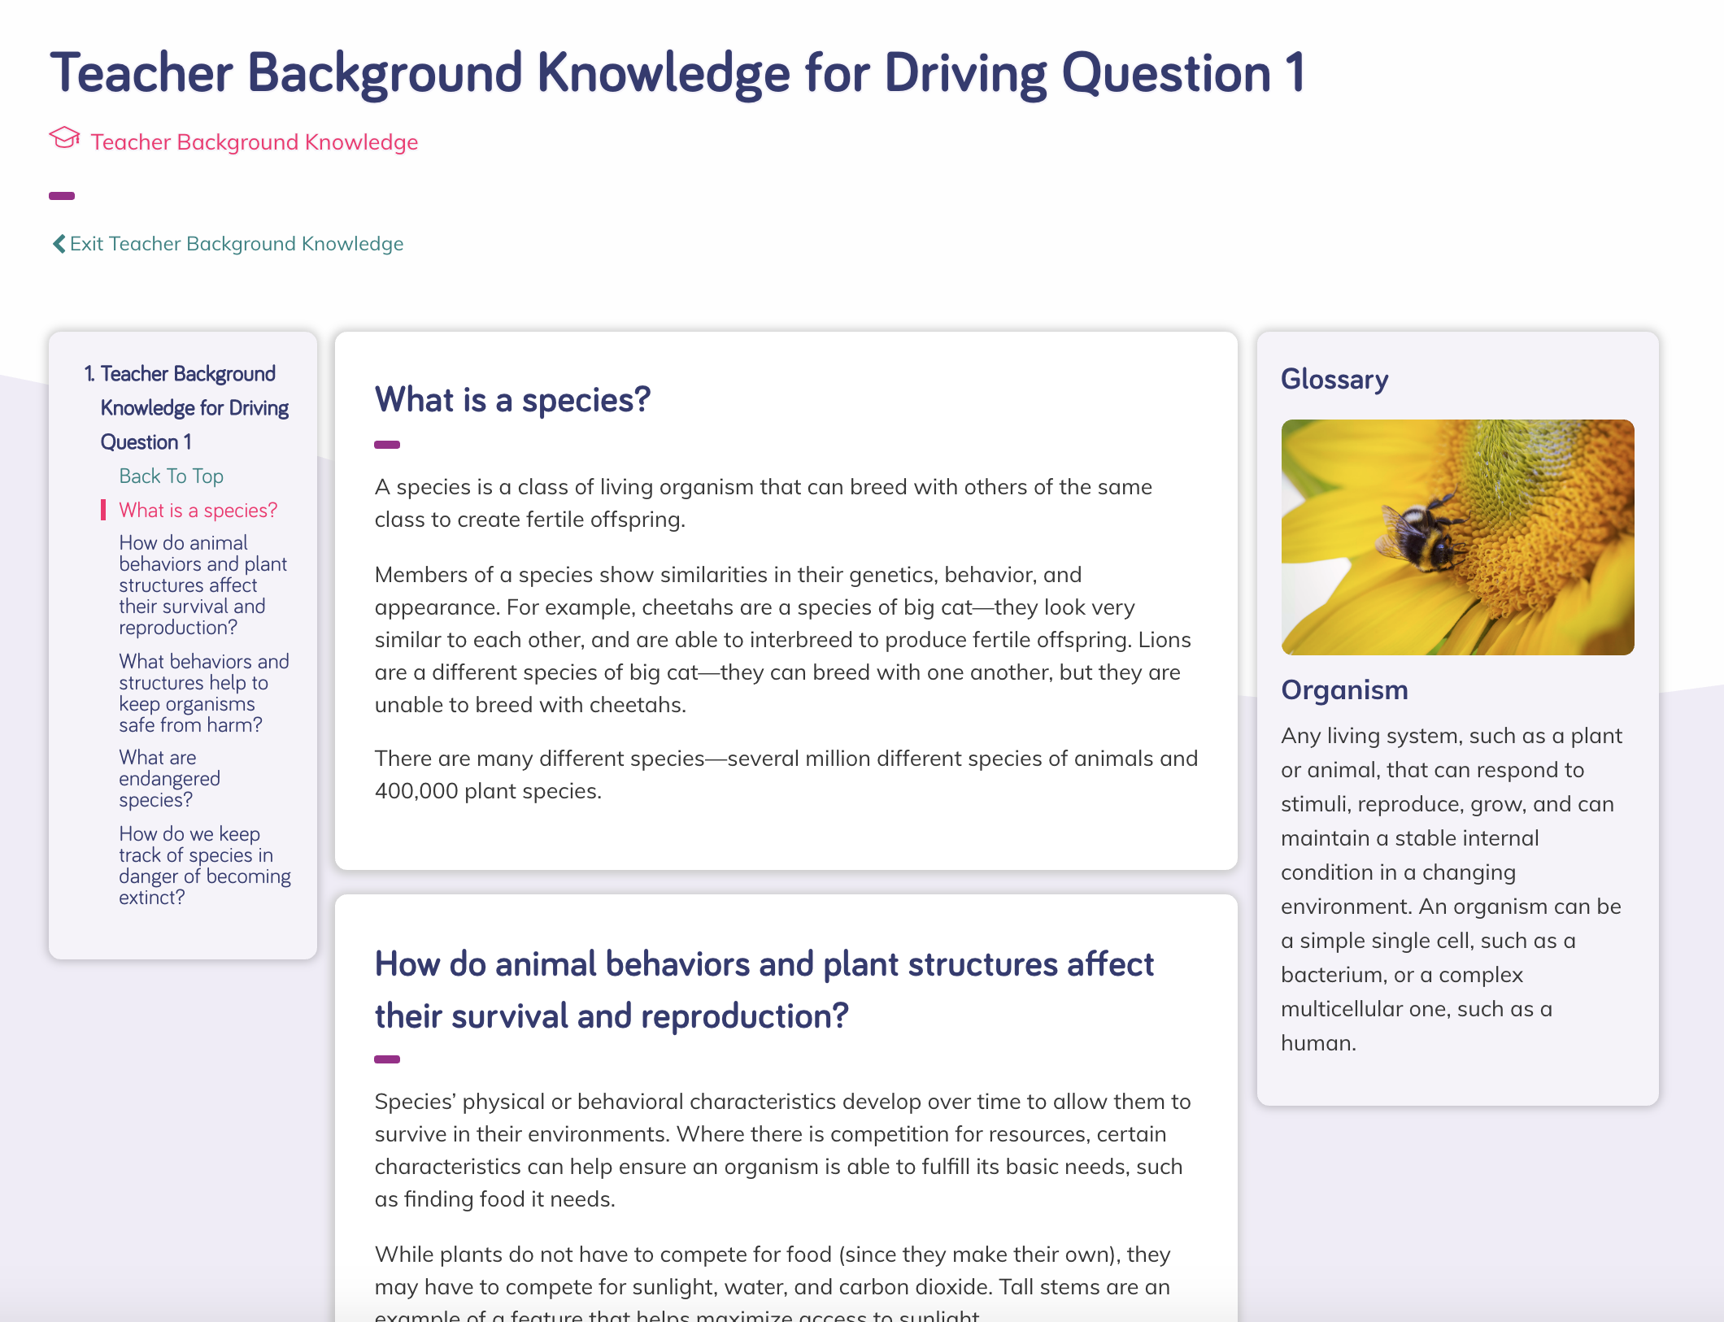  Teacher Background Knowledge
F2. Presence of Three Dimensions.
The module is strong at identifying and providing background information about each of the three dimensions in the unit. It also supports opportunities to connect to the nature of science and engineering, technology, and applications of science.
Evidence
- A digital guide to SEPs and CCCs provides a clear explanation for each practice and concept with guidance on what these skills should look like in a 6th grade classroom, with specific reference to how students use mathematics and computational thinking (SEP-5), engage in argument from evidence (SEP-7), and consider cause and effect (CCC-2) in Grade 6 Module 3.
- Additional module-specific support is frequently given at point of use in the instructional materials for all dimensions, often in the Connect. For example, the teacher is guided to connect to LS1.B (Growth and Development of Organisms) in DQ2L9 TE p. 167, and SEP-6 (Constructing Explanations and Designing Solutions) in DQ3L5 TE p. 221. The teacher is also guided to connect to the Nature of Science (Science Is Based on Empirical Evidence) in DQ2L2 TE p. 110. | 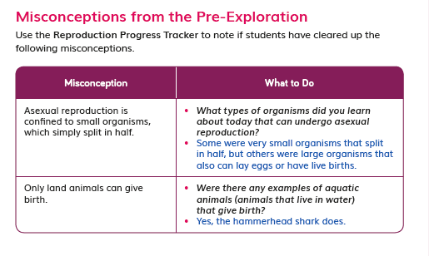  DQ2L9 TE p. 167  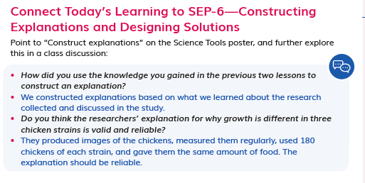  DQ3L5 TE p. 221  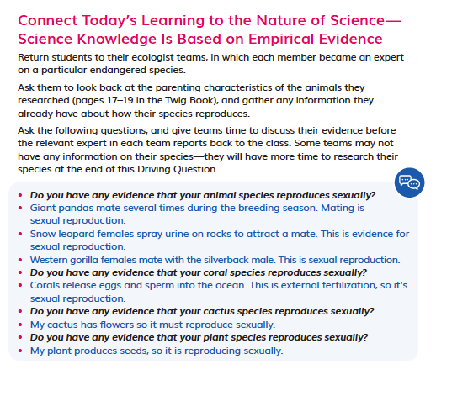  DQ2L2 TE p. 110
F3. Presence of Logical Sequence.
The module is strong at identifying and providing background information on the sequence of learning in the unit.
Evidence  - A Module Introduction video provides the teacher with an engaging overview on the phenomenon explored in The Red List, the sequence of learning, and an explanation of how the Performance Expectations are addressed and how they build on each other. | 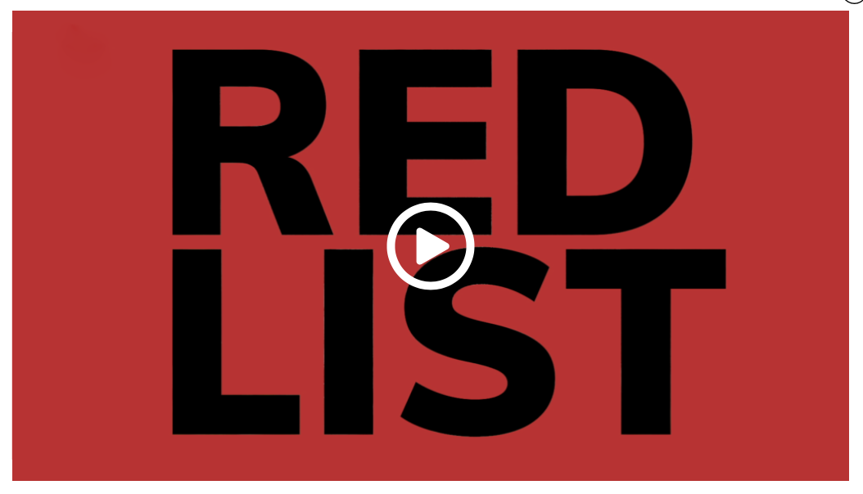  Module Introduction video
- The Module Contents helps teachers identify the sequence of three dimensions addressed in The Red List and states how they build on each other. For example, students begin by researching patterns of behavior that increase the likelihood of successful reproduction. They go on to learn about genetics and heredity, creating a chromosome model of a butterfly, and understand how parents pass traits to their offspring. They analyze scientific studies showing how environmental factors affect growth in populations, and finally use their learning from the module to develop a conservation plan for their chosen species. | 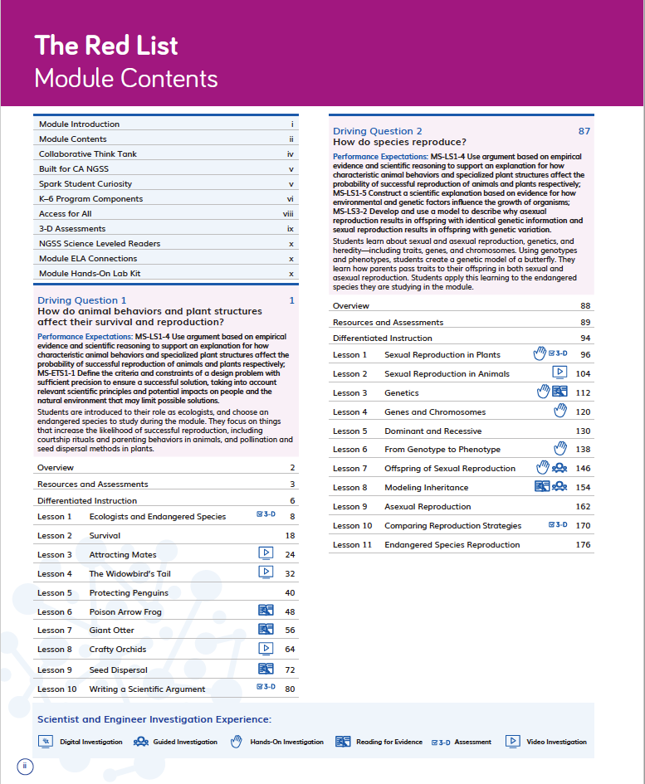  Table of Contents
- More detail is provided in each Driving Question Overview which tells the story of how the students will sequentially use the three dimensions in each lesson in the Driving Question to answer the question posed. For example, in DQ2, students use texts and videos to learn about the structure and function of reproductive parts, and build chromosome models that help them understand about the inheritance of traits. This knowledge prepares them for obtaining, evaluating, and communicating information about how their endangered species reproduces. | 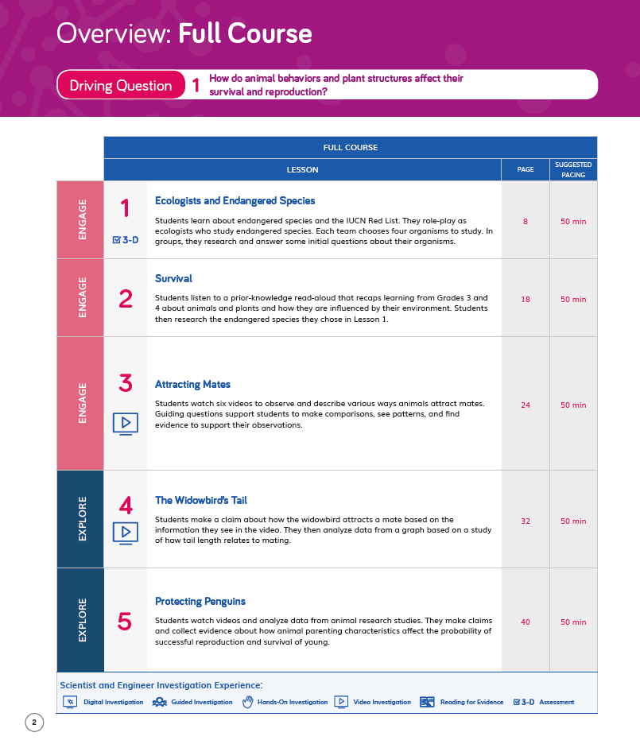  Driving Question Overview
- The Lesson Overview page identifies the dimensions used in each lesson, while the graphic organizer details how the dimensions relate to the learning experience. For example, in DQ2L3 TE p. 112, the overview explains that students will develop a model of Mendel’s pea plant breeding experiments. They will share their models, discuss how genetics affect plants and animals, and reflect on whether Mendel’s pea plants reproduce sexually or asexually. | 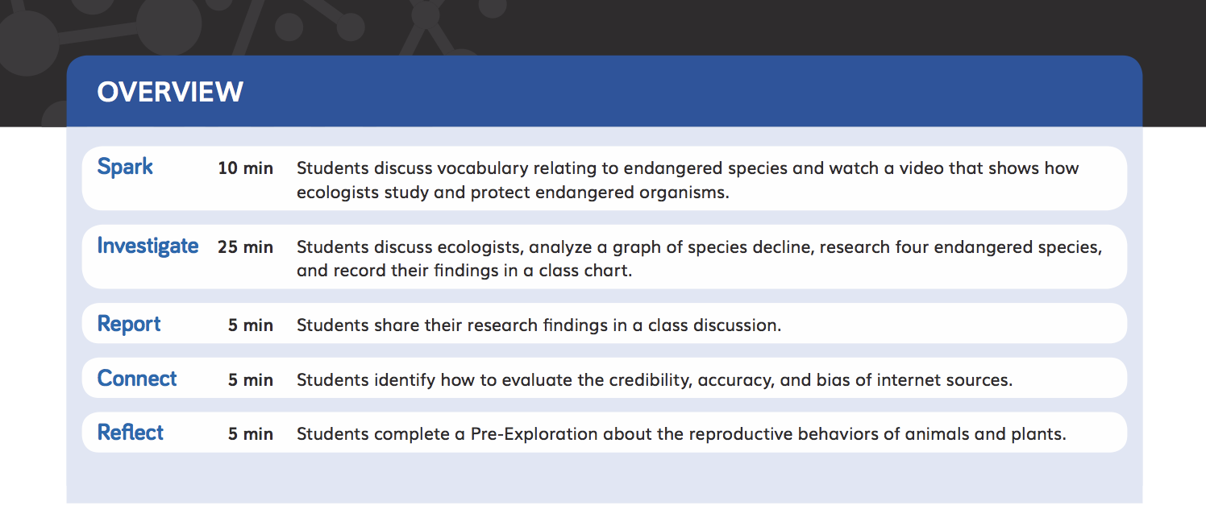  Lesson Overview TE p. 112

Designed for the NGSS: Foundations Teacher Support Evidence Chart

Teacher materials… | Strong | Adequate | Weak
SW1. Phenomena/Problems. Provide support and strategies for how to help students figure out/solve authentic and relevant phenomena/problems using the three dimensions. | ✓
SW2. Three-dimensional Conceptual Framework. Provide support and strategies for how teachers  help students develop a conceptual framework of scientifically accurate understandings and abilities related to  - DCIs, SEPs, and CCCs  - NoS and ETS  - ELA and math  - create a learning environment that values students’ ideas, motivates learning, and helps students negotiate new meaning as they interact with others’ ideas, new information, and new experiences. | ✓
SW3. Prior Knowledge. Provide support and strategies to leverage students’ prior knowledge and experiences to motivate learning. | ✓
SW4. Metacognitive Abilities. Provide support and strategies for how to help students develop metacognitive abilities. | ✓
SW5. Equitable Learning Opportunities. Provide resources and strategies for how to ensure that all students, including those from non-dominant groups and with diverse learning needs, have access to the targeted learning goals and experiences. | ✓

Strengths related to these Teacher Supports
SW1. Phenomena/Problems.
The module is strong at providing support and strategies for how to help students figure out authentic and relevant phenomena using the three dimensions.
Evidence
- The instructional materials have been designed to support the teacher to guide students on a scaffolded learning journey to solve the Module Phenomenon: How do the environment and genetics affect animals and plants? They tackle the problem one Driving Question at a time, applying the three dimensions with increasing sophistication, building the skills and knowledge they need through a series of investigations.
- The teacher is supported in the instructional material to connect their learning experiences back to the central problem at strategic points, culminating in a class symposium where students present research on endangered species, addressing the Module Phenomenon.
SW2. Three-Dimensional Conceptual Framework.
The module provides strong support and strategies for how teachers help students build conceptual flow and creates a positive learning environment for students.
Evidence
- The instructional materials are designed to elicit students’ understanding of how the environment and genetics affect animals and plants and develop their understanding over time, through hands-on, text, and video investigations. Students follow a sequence of Driving Questions designed to progressively build their skills and scientifically accurate understandings.
- Opportunities for students to articulate, question, and revise their conceptual framework are woven into the instructional resources supporting teachers to assess the progression of their scientifically accurate understandings. Strategies on how to tailor instruction for students requiring more support is provided for teachers. For example, in DQ4 students consider the question: How do we protect endangered or threatened species? They research their chosen endangered species and apply what they learned during the module about reproduction, genetics, and environmental factors to devise conservation plans. They share their plans in their teams, evaluate which of the approaches is strongest and why, and work together to create a list of ways to protect their species. Each team presents their collaborate conservation plan to the class. Students assess their own work and that of two classmates. Once the teacher has completed their own assessment, they compare their rubric to students’ evaluations, checking if students could identify strengths and weaknesses in their and their classmates’ work. This all allows teachers to gain an understanding of how much progress students have made.
- Support is given for how to create a positive learning environment where all contributions are valued along with activities that support teamwork and collaboration. Many of the activities involve students working in pairs and teams and they understand what effective teamwork looks and feel like having completed the 3-D Team Challenge at the start of Grade 6 (contained within Module 1, Biotech Systems Worldwide, TE p. 1). Throughout The Red List, students are given many opportunities to support each other. For example, students provide feedback as classmates present their models, and the teacher is supported to emphasize that constructive comments can improve models and that students should always be respectful of their classmates and their work (DQ2L3 TE p. 118).

SW3. Prior Knowledge.
The module provides strong support and strategies to leverage students’ prior knowledge and experiences to motivate learning.
Evidence  - Teachers are supported with strategies to leverage prior knowledge of the relationship between living things and their environment through resources such as a Prior Knowledge Read-Aloud in DQ1L2 TE p. 20. | 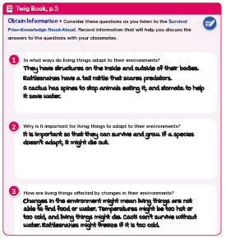  DQ1L2 TE p. 20
- Additional support is provided at point of use for strategies to leverage prior knowledge and solve the Module Phenomenon. For example, the teacher is prompted to remind students that what they have learned today will help them as they further investigate the traits caused by inherited genes (DQ2L4 TE p. 128). | 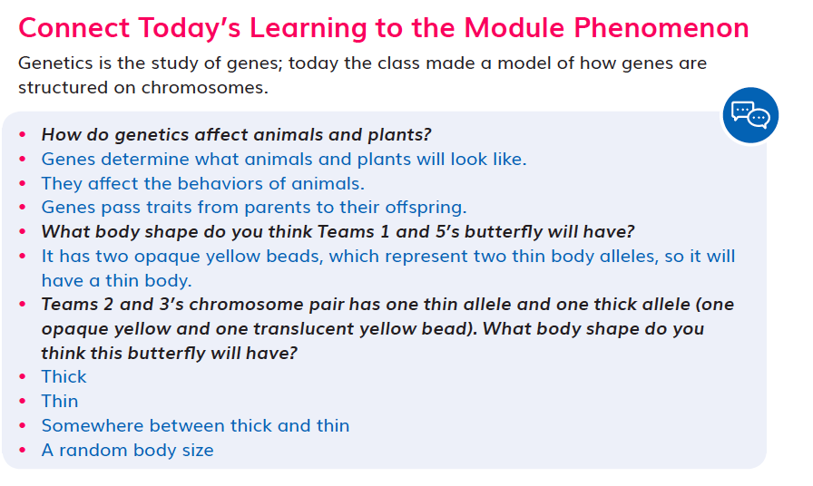  DQ2L4 TE p. 128
SW4. Metacognitive Abilities.
The module provides strong support and strategies for how to help students develop metacognitive abilities.
Evidence  - Support is given at point of use for how to develop students’ metacognitive abilities. The Connect of the lesson often guides the teacher to draw students’ attention to their growing use of the SEPs and CCCs, understanding of the Driving Question, or ability to solve the Module Phenomenon. For example, the teacher is supported to help students identify their use of SEP-8 (DQ1L8 TE p. 70) and their use of SEP-2 (DQ2L6 TE p. 144), and in DQ2 L9 students connect their learning to the Driving Question (DQ2L9 TE p. 168). | 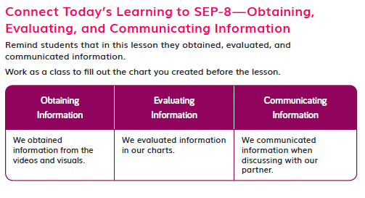  DQ1L8 TE p. 70  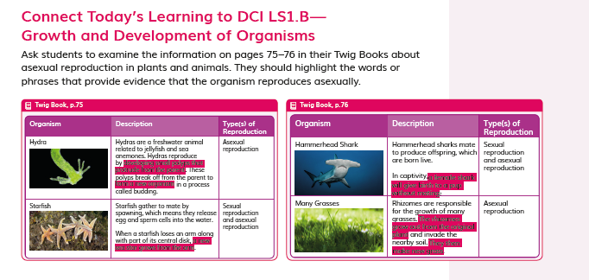  DQ2L9 TE p. 168
- Discussions following diagnostic pre-assessments (Pre-Explorations) in DQ1L1, DQ2L1, and DQ3L1 support teachers to track students’ understanding of the three dimensions that make up the module’s Performance Expectations. See for example DQ1L8 Investigate TE p. 68, DQ2L9 Connect TE p. 167, DQ3L7 Report TE p. 234. | DQ2L9 Connect TE p. 167
- Meta-Think-Aloud language routines support teachers in helping students develop an understanding of how they learn particular concepts or why they approach activities in certain ways. For example, guidance is provided to help the teacher show how a reader might figure out the meaning of the word gestation (DQ1L7 TE p. 59). | 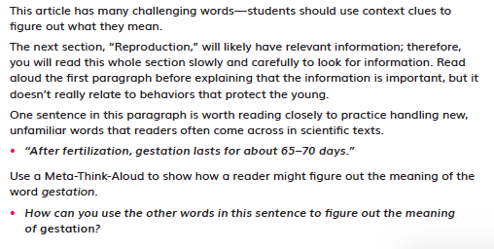  DQ1L7 TE p. 59
SW5. Equitable Learning Opportunities.
This module provides strong resources and strategies to ensure that all students have access to the targeted learning goals and experiences.
Evidence  - Frequent support is given at point of use in all lessons on strategies to ensure that all students have access to the targeted learning goals. Numerous scaffolds are provided for Special Needs, English Learner, and Standard English Learner students, for example, in DQ1L8 TE p. 68, DQ2L8 TE p. 157, and DQ3L5 TE p. 218. | 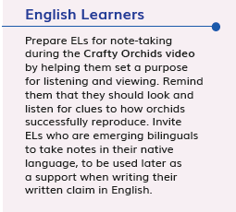  DQ1L8 TE p. 68
- The Biomes Leveled Reader that complements the module is provided at four levels—Above, On, Below and English Learner—with matching lesson instruction in the TEs/online.  - Digital versions of the Twig Book and readers have text to speech functions. | 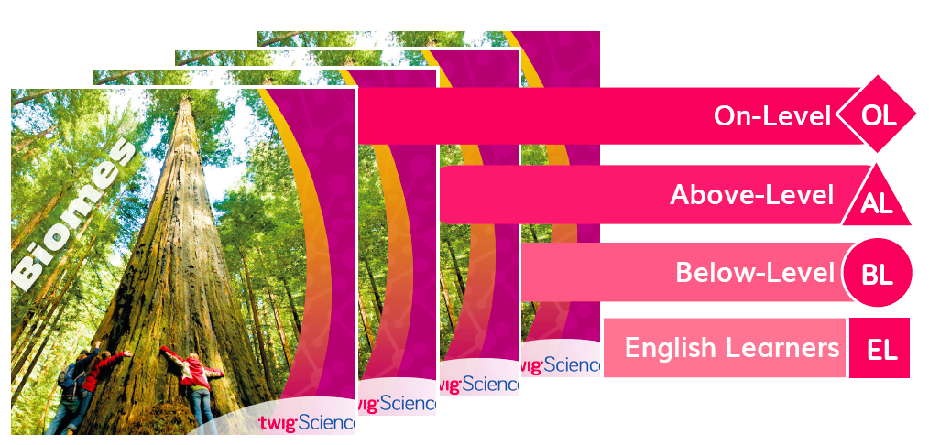  Biomes Leveled Reader (Front Cover)
- Short, high quality films that will engage and support learners with diverse learning needs are frequently provided to spark interest, summarize key concepts, and make the ideas relevant to this age group. For example, Courtship Rituals: Puffer Fish (DQ1L3), Whitebark Pine Tree (DQ1L9), Asexual Reproduction in Animals (DQ2L9), and Saving Sea Turtles (DQ4L3). | 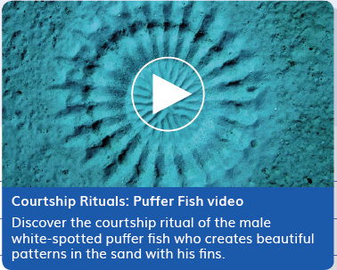Courtship Rituals: Puffer Fish  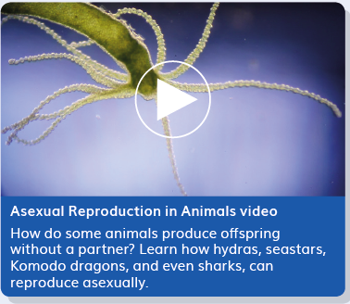  Asexual Reproduction in Animals

Designed for the NGSS: Foundations Teacher Support Evidence Chart

Teacher materials… | Strong | Adequate | Weak
SP1. Three-dimensional Performances. Provide support with a range of sample student responses and/or rubrics for interpreting evidence of student learning across the three dimensions, specific to the element of each dimension, and related to the phenomenon/problem that provides context for the student performance. | ✓
SP2. Variety of Measure. Provide guidance and scoring tools for using a variety of measures matched to the targeted learning goals to help students monitor their progress toward learning goals and reflect on what they have learned, how they learn it, and how to use metacognition productively. | ✓
SP3. Student Progress Over Time. Provide guidance for using formative and summative assessments to monitor student progress over time. Examples include support for: capturing student growth; interpreting results; adjusting instruction and planning for future instruction; providing feedback to students; prompting students to consider what and how they’ve learned. | ✓
SP4. Equitable Access. Provide support and strategies for ensuring that assessments are accessible to students from diverse backgrounds and with diverse learning needs. | ✓

Strengths related to these Teacher Supports
SP1. Three-dimensional Performances.
The module provides strong support with a range of sample student responses and rubrics for interpreting evidence of student learning across the three dimensions. These are specific to the element of each dimension and related to the Module Phenomenon that provides the context for the student performance.
Evidence
- Rubrics are provided for the Performance Tasks and the Benchmark Assessment. The rubrics provide sample answers in the form of “Look Fors” that support teachers to interpret evidence of student attainment of the four different levels—Emerging, Developing, Proficient, and Advanced. The rubrics are specific to certain Performance Expectations with the assessed dimensions highlighted. The assessment tasks are well connected to the problems, phenomena, and dimensions being assessed. For example, in the Benchmark Assessment Survival of the Fittest Flower ( TE pp. 236–243), Rubric 1 assesses all three dimensions of PE MS-LS1-4 (SEP-7, LS1.B, CCC-2), Rubric 3 assesses all three dimensions of PE MS-LS1-5 (SEP-6, LS1.B, CCC-2), and Rubrics 2 and 4 between them assess SEP-2, LS3.A, LS3.B, and CCC-2 (all part of PE MS-LS3-2). Rubric 2 details that a student with developing mastery of these dimensions would create a partial model, with some inaccuracies. It says that, for example, the student might accurately use arrows to show where the offspring gets their petal alleles, but misplace the arrows for the root system alleles.
SP2. Variety of Measure.
The module provides strong guidance and scoring tools for using a variety of measures matched to the targeted learning goals to help students monitor their progress toward learning goals and reflect on what they have learned, how they learn it, and how to use metacognition productively.
Evidence  - Teacher support for guidance and scoring tools matched to the learning goals is integrated through the module. In addition to the rubrics mentioned above and answer guides for the module multiple choice assessment, the printed Teacher Edition contains Twig Book reduxes with sample student answers, so at a glance teachers have guidance on what student understanding looks like (for example, DQ1L9 TE p. 77, DQ2L3 TE p. 119, DQ2L11 TE p. 182, DQ3L1 TE p. 193, DQ4L2 TE p. 265). A digital version of this completed Twig Book is available online. | 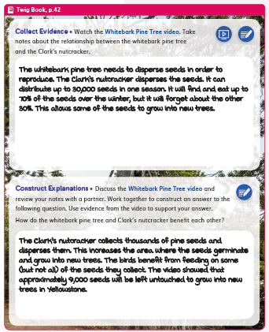  DQ1L9 TE p. 77  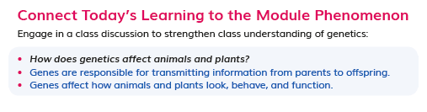  DQ2L3 TE p. 119
- Assessments are multimodal and support a variety of learning styles and abilities. They include:  - Performance Tasks (constructed response, written and filling in charts DQ1L10 TB pp. 47–48, DQ2L10 TE pp. 78–79, DQ3 L3–5 TE pp. 140–148) | 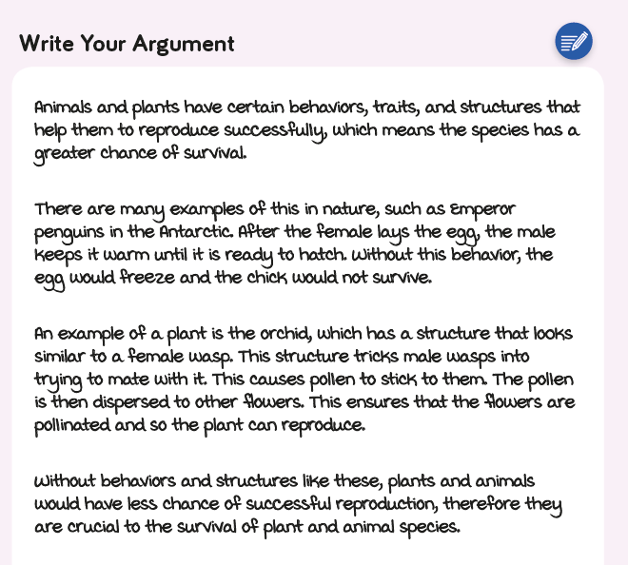  DQ1L10 TB pp. 47–48
- Discussions (TE DQ1 L1 p. 16, DQ1L6 TE p. 55, DQ1L8 TE p. 69, DQ2L7 TE p. 152) | 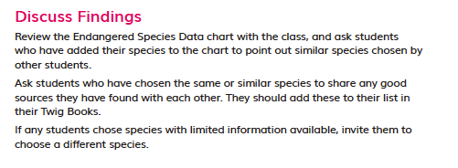  TE DQ1 L1 p. 16
- Constructed response (written, filling in charts, drawn, and multiple choice DQ1L3 TB pp. 8–11, DQ1L6 TB p. 24, DQ2L4 TB pp. 61–62, DQ2L8 TB pp. 72–73, DQ3L1 TB p. 90) | 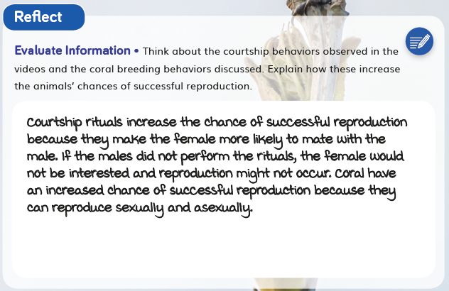  DQ1L3 TB pp. 8–11
- Self and peer assessment (DQ1L10 TE p. 86, DQ4L3 TB p. 143, DQ4L5 TE p. 280) | 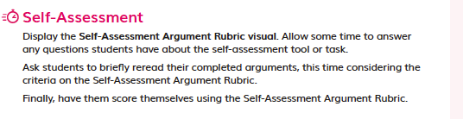  DQ1L10 TE p. 86
- Multiple Choice Assessment (DQ4 digital) | 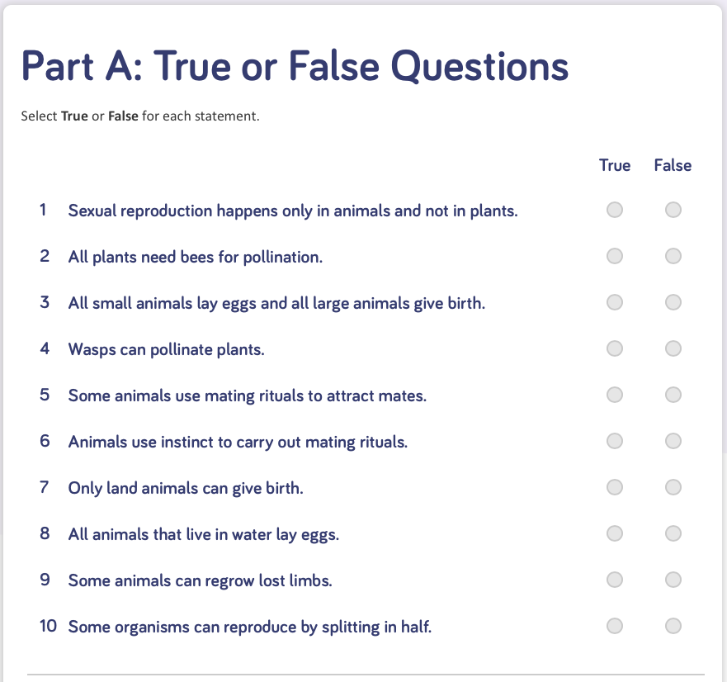  Multiple Choice Assessment (DQ4 digital)
- Text to speech function is provided for all digital assets.  - Class discussions are supported with suggested question scaffolds and sample answers (for example, DQ1L2 TE p. 20, DQ1L8 TE p. 66, DQ2L2 TE p. 108, DQ2L4 TE p. 128, DQ4L1 TE p. 255) | 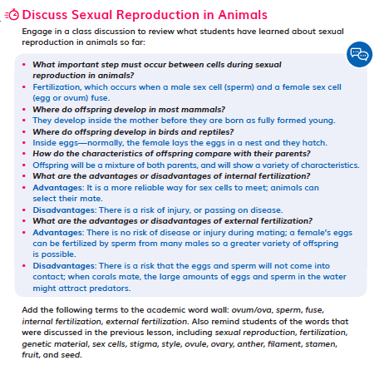  DQ2L2 TE p. 108
- The Reflect of most lessons integrates assessment opportunities for students to reflect on what they have learned and how they used the three dimensions to grow their understanding of the module phenomena and problems (DQ1L3 TB p. 11, DQ1L9 TB p. 44, DQ2L4 TB p. 63, DQ4TB p. 73, DQ3L5 TB p. 114). | DQ1L3 TB p. 11,
SP3. Student Progress Over Time.
The module provides strong guidance for using formative and summative assessments to monitor student progress over time. Examples include support for: capturing student growth; interpreting results; adjusting instruction and planning for future instruction; providing feedback to students; prompting students to consider what and how they’ve learned.
Evidence
- Teachers can elect to administer the Pre-Explorations, Benchmark Assessment, and Multiple Choice assessment digitally or in print. As answers are tagged to specific dimensions, if administered digitally, teachers will be able to track student growth in level of attainment of the dimensions over time and tailor instruction accordingly. Teachers can feedback to students digitally. Teachers can opt to add the scores manually for all non-digital assessment tasks.

- The downloadable Progress Trackers support teachers to track students’ mastery of their misconceptions assessed in the Pre-Explorations and the results of Formative Assessment of the three dimensions across the DQs. Guidance for teachers on how to adjust instruction for students who need more support to dispel their misconceptions is provided at point of use in the instructions (DQ1L5 TE p. 42, DQ2L3 TE p. 117, DQ2L9 TE p. 167, DQ3L7 TE p. 234). | DQ2L9 TE p. 167
SP4. Equitable Access.
The module provides strong support and strategies for ensuring that assessments are accessible to students from diverse backgrounds and with diverse learning needs.
Evidence
- Assessments of the three dimensions are multimodal and include multiple choice, writing, drawing, physical models, and oral presentations, allowing all students to access a range of assessment types to suit their learning style and/or reading level.
- The digital Twig Book and digital assessment items (Benchmark, Multiple Choice, Rubrics) have a text to speech function allowing students of all reading levels to access the assessments.
- The rubrics for the Performance Tasks (DQ1L10 TE pp. 80–86, DQ2L10 TE pp. 170–175, DQ4L3–5 TE pp. 266–280) and Benchmark Assessment (DQ3 TE pp. 236–243 and online) have four levels—Emerging, Developing, Proficient, and Advanced—allowing all students to demonstrate their current level of attainment. | 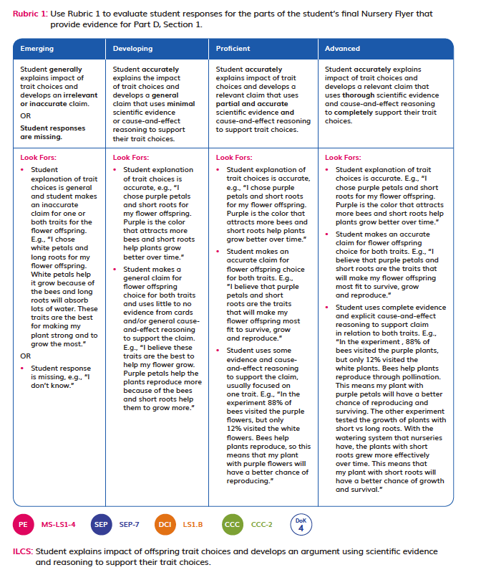
- The Multiple Choice Assessment Part C (DQ4 digital) (DQ4) contains questions targeting different DOK levels, with an extended section available to further challenge GATE students. | 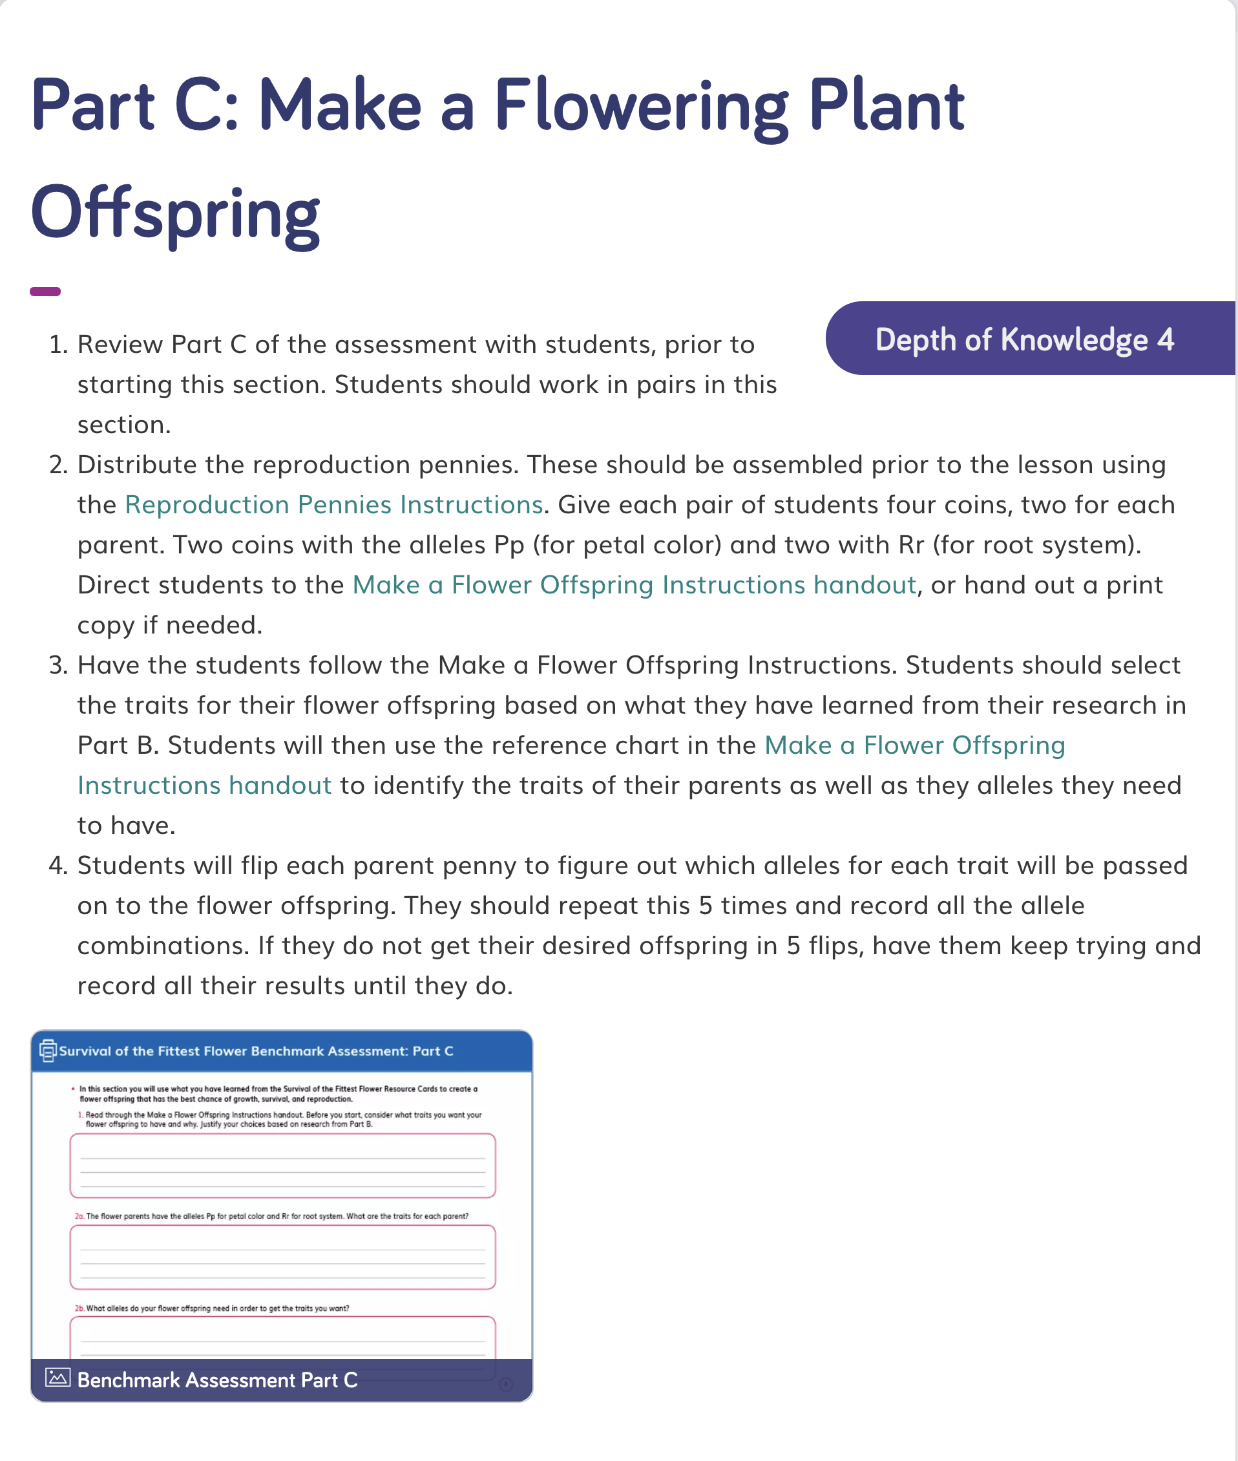  Multiple Choice Assessment Part C (DQ4 digital)
- Writing, Reading, Listening, and Speaking domain tasks dedicated to assessing science-relevant English language development are integrated into the core instructional resources (DQ1L7 TE p. 63, DQ3L3 TE p. 209) and the On-Level reader lessons (Chapter 3 Second Read TE p. 299). | 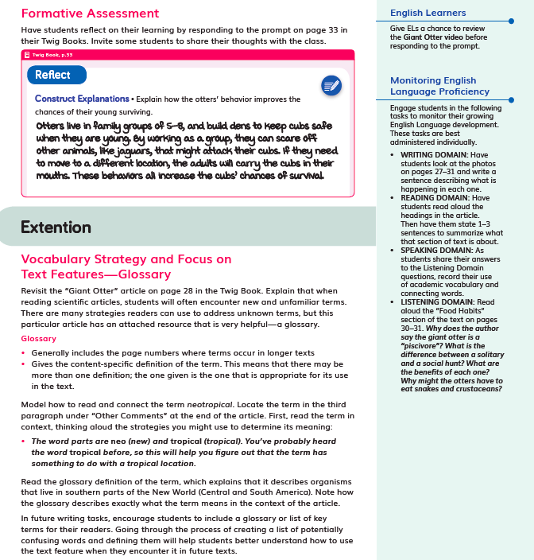  DQ1L7 TE p. 63  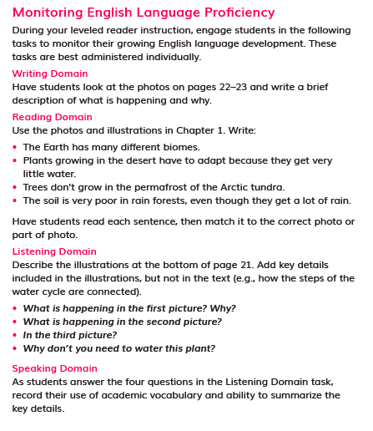  Chapter 3 Second Read TE p. 299

Designed for the NGSS: Teacher Support | High Quality  5 | Medium Quality  3 | Low Quality  1
TS1. Phenomenon/Problem Driven Three-Dimensional Learning. Teacher materials provide:  - background information about the phenomena or problems included in the learning sequence and across sequences.  - an explanation of the role of phenomena or problems in driving student learning.  - rationale for why the unit phenomena or problems were selected for the targeted DCIs, SEPs, and CCCs.  - Refer to F1, F2, SW1, SW2, SP1 | Materials provide clear guidance to teachers on how students develop, use, and integrate the three dimensions to make sense of phenomena or design solutions to problems. | Materials provide some guidance to teachers about how students develop, use, and integrate the three dimensions. | Materials provide little guidance on developing, using, or integrating them to make sense of phenomena or design solutions to problems.
TS2. Coherence. Teacher materials describe and provide a rationale for:  - the conceptual framework and sequence of ideas, practices, and learning experiences in the learning sequences and across sequences.  - strategies for linking student experiences across lessons to ensure student sense- making and/or problem-solving focused on phenomena or problems is linked to learning across all three dimensions.  - Connections to other science domains, nature of science, engineering, technology, and applications of science, math, and ELA.  Refer to F2, F3, SW2, SP2 | Materials provide strong support for understanding unit coherence and helping students link experiences to learning across all three dimensions and to phenomena or problems. | Materials provide some support for understanding unit coherence and helping students link experiences to learning across all three dimensions and to phenomena or problems. | Materials provide little support for understanding unit coherence and helping students link experiences to learning across all three dimensions and to phenomena or problems.
TS3. Effective Teaching. Teacher materials support the use of and provide a rationale and evidence of effectiveness for strategies that:  - support students in learning through authentic and meaningful phenomena or design problems.  - support student learning across the three dimensions.  - make student thinking visible; promote reasoning, sense-making, and problem-solving; challenge student thinking; and develop metacognitive abilities.  Refer to SW1, SW2, SW3, SW4, SP3 | Materials provide rationale and robust support for implementing strategies that enhance student performances, thinking, and metacognition. | Materials provide some rationale and support for implementing strategies that enhance student performances, thinking, and metacognition. | Materials provide little rationale and support for teachers to implement strategies that enhance student performances, thinking, and metacognition.
TS4. Support for Students with Diverse Learning Needs. Teacher materials provide an array of strategies:  - to support student access to the targeted learning goals, experiences, and performances.  - that help teachers differentiate instruction.  Refer to SW5, SP4 | Materials include robust and comprehensive strategies for supporting learners with diverse needs. | Materials include some robust strategies for supporting learners with diverse needs. | Materials include few robust strategies for supporting learners with diverse needs.
TS5. Support to Monitor Student Progress. Materials provide support for teachers to:  - monitor student learning and progress over time.  - make decisions about instruction and provide feedback to students.  Refer to SW3, SW4, SP1, SP2, SP3 | Materials provide robust support for interpreting and using data generated from assessments. | Materials provide some support for interpreting and using data generated from assessments. | Materials provide little support for interpreting and using data generated from assessments.

Designed for NGSS: Teacher Support Rubric
Analyze Evidence
Directions:
- Review the Designed for NGSS: Teacher Support Rubric.
- Reflect on the evidence (or lack of evidence) that you and your team gathered and represented.
- Record strengths and limitations for each criterion based on your evidence. Cite specific examples.

Strengths
TS1. Phenomenon/Problem Driven Three-Dimensional Learning.
The Module materials are High Quality 5 in regards to TS1.
They provide clear guidance to teachers on how students develop, use, and integrate the three dimensions to make sense of phenomena or design solutions to problems.
Evidence
- The flow of DCIs, SEPs, and CCCs follow a logical sequence supporting students to gain expertise of the practices and concepts they need to address the Module Phenomenon.
- DQ1: How do animal behaviors and plant structures affect their survival and reproduction? Students obtain information from texts and videos about animal courtship rituals (SEP-8, LS1.B, CCC-1, CCC-2). They consider the question “How do animals help their offspring survive?” (LS1.B, CCC-2) and develop an answer through video observations, analysis of scientific data, and discussions (SEP-4, SEP-7, SEP-8).
- DQ2: How do species reproduce? Students develop genetic models to demonstrate how traits are passed from both plant and animal parents to offspring (LS3.A, SEP-2, CCC-2), compare asexual and sexual reproduction (LS1.B, LS3.A, LS3.B, SEP-7, CCC-2), and research the reproductive strategies of their chosen endangered species (SEP-8, CCC-6).
- DQ3: How do environmental and genetic factors influence the growth of an organism? Students consider patterns (CCC-1), cause and effect (CCC-2), and scale, proportion, and quantity (CCC-3) as they analyze several scientific studies (SEP-4, SEP-5) to determine how environmental and genetic factors influence the growth of an organism (LS1.B).
- DQ4: How do we protect endangered species? Students research their chosen endangered species and devise conservation plans to improve the growth and reproduction of members in the species, considering how genetics might be affected (SEP-1, SEP-6, SEP-7, SEP-8, CCC-2, LS1.B, ETS1.A). Students close the module with a ‘World Conservation Symposium,’ working with teammates to evaluate their individual plans and create a collaborative conservation plan (ETS1.B, SEP-6, SEP-8).
TS2. Coherence.
The Module materials are High Quality 5 in regards to TS2.
They provide teachers with a clear conceptual framework in a logical sequence, strategies for linking student experiences across lessons, and connections to other science domains, CNS (NoS), CETAS (ETS), math, and ELA.
Evidence
- The Module Phenomenon challenges students to be creative problem solvers, immersing them in engaging challenges that require mastery of the three dimensions of NGSS to solve. The instructional materials have been designed to support the teacher to guide students on a scaffolded learning journey to solve the Module Phenomenon: How do the environment and genetics affect animals and plants? They tackle the problem one Driving Question at a time, applying the three dimensions with increasing sophistication, building the skills and knowledge they need through a series of investigations.
- The Module Phenomenon targets the DCIs, SEPs, and CCCs explicitly stated in MS-LS1-4, MS-LS1-5, MS-LS3-2, MS-ETS1-1, and MS-EST1-2.
- Links are made to previous grades, such as Grade 5 Module 2 where students also explored the relationships between living things and the environment.
- A digital guide to SEPs and CCCs provides a clear explanation for each practice and concept with guidance on what these skills should look like in a third grade classroom, with specific reference for how students ask questions and develop investigations in Grade 6 Module 3.

- Additional module-specific support is frequently given at point of use in the instructional materials for all dimensions, often in the Connect. For example, the teacher is guided to connect to LS1.B (Growth and Development of Organisms) in DQ2L9 TE p. 167, and SEP-6 (Constructing Explanations and Designing Solutions) in DQ3L5 TE p. 221. The teacher is also guided to connect to the Nature of Science (Science Is Based on Empirical Evidence) in DQ2L2 TE p. 110. | DQ2L9 TE p. 167  DQ3L5 TE p. 221  DQ2L2 TE p. 110
- Opportunities for students to articulate, question, and revise their conceptual framework are woven into the instructional resources supporting teachers to assess the progression of their scientifically accurate understandings. Strategies on how to tailor instruction for students requiring more support is provided for teachers. (DQ1L1 TE p. 17) | 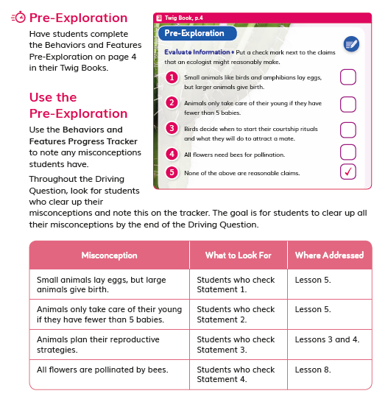  DQ1L1 TE p. 17
- The assessment tasks are well connected to the phenomena and dimensions being assessed. For example, in the DQ3 Benchmark Assessment Survival of the Fittest Flower, students gather evidence about factors that affect plant survival, and identify advantageous traits and how to recreate them. | 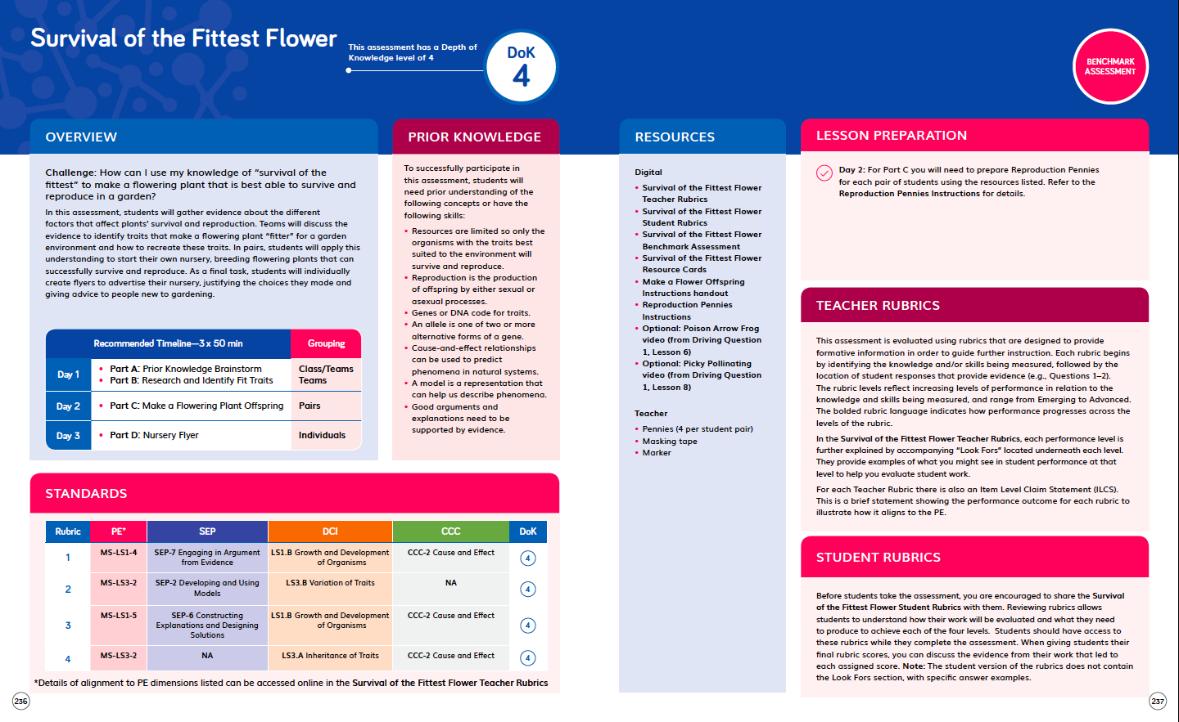  Benchmark Assessment TE pp. 236–243
- Driving Question Dividers and Driving Question Overviews show the sequence of learning, the rationale behind it, and the three-dimensional aspect of the activities. | 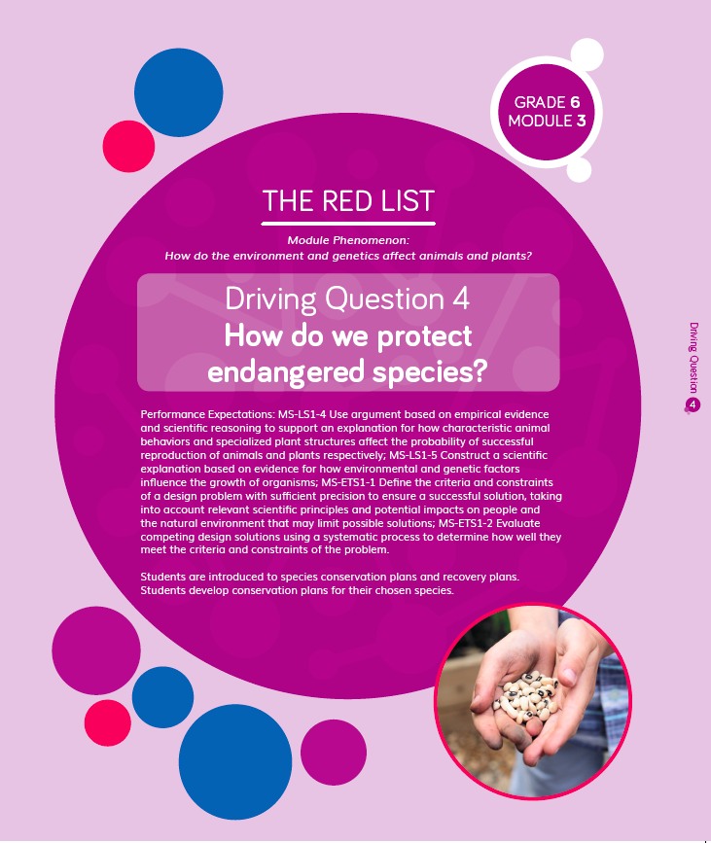  Driving Question Divider TE p. 245  Driving Question Overview
- Throughout the module, students use their class Science Tools poster to track their growing use of the SEPs. The poster is blank at the start of the year, and the eight SEPs are added when each one is used for the first time. In this module, students add “Use math and computational thinking” (SEP-5) and “Ask questions” (SEP-1) to their poster, and revisit:  - Obtain and evaluate information (SEP-8)  - Analyze and interpret data (SEP-4)  - Communicate information (SEP-8)  - Develop and use models (SEP-2)  - Construct explanations (SEP-6)  - Design solutions (SEP-6).  - This metacognitive activity grows students' awareness of which skills they are using. | 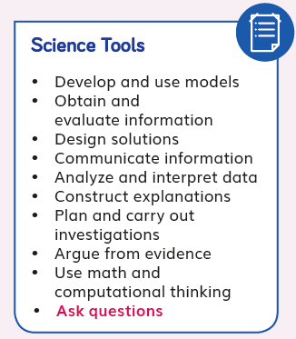  Science Tools poster
- Engineering practices are fully embedded in this module. Students engage with science and engineering practices at the very start of the module, defining and delimiting their problem by choosing an endangered species to focus on during the module. By DQ4, they have enough knowledge of key concepts to further define their problem and develop possible solutions. (DQ4L3 Performance Task TE pp.266-280) | 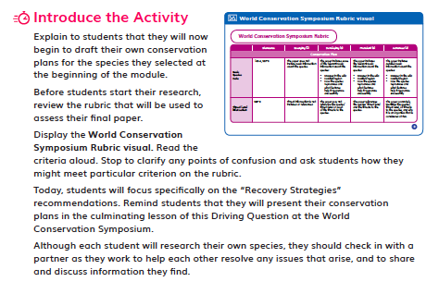  DQ4L3 Performance Task TE pp.266-280
TS3. Effective Teaching.
The Module materials are High Quality 5 in regards to TS3.
They provide strong guidance to support students in learning through authentic and meaningful phenomena/problems, support student learning across the three dimensions, and develop students’ metacognitive abilities.
Evidence  - Instructional materials support authentic and meaningful learning experiences. Teacher support includes scaffolded discussion questions in the Teacher Edition (with sample answers), notes, background, Professional Learning videos, and Progress Trackers.  - 3-D Learning Objectives in each lesson provide teachers with information of how students will learn across the three dimensions, while lesson preparation provides further information on how to support students’ learning. DQ1L1 TE p. 9, DQ2L5 3-D Learning Objectives TE p. 130 | 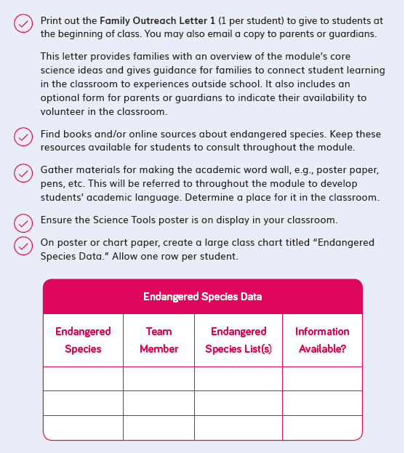  DQ1L1 TE p. 9  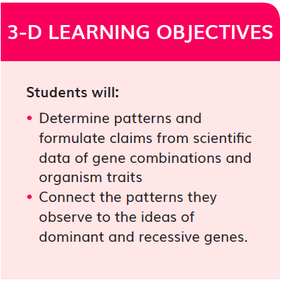DQ2L5 3-D Learning Objectives TE p. 130
- The teacher is supported in the instructional material to connect their learning experiences back to the Module Phenomenon at strategic points with discussions where students share their ideas and evidence for how to approach this problem. For example, DQ2L3 TE p. 119, DQ2L4 TE p. 128. | DQ2L3 TE p. 119  DQ2L4 TE p. 128
- Teachers use a number of Language Routines, discussions, and metacognitive strategies to ensure that students are reflecting on what they are learning and how they are learning it. For example, the teacher uses a Meta-Think-Aloud to show how a reader might figure out the meaning of the word gestation (DQ1L7 TE p. 59). | DQ1L7 TE p. 59
TS4. Support for Students with Diverse Learning Needs.
The Module materials are High Quality 5 in regards to TS4.
They provide a strong array of strategies to support student access to the targeted learning goals and help teachers differentiate instruction.
Evidence  - Integrated English Learner sidebars offer teachers guidance to support students’ engagement with the material (DQ1L8 TE p. 67, DQ2L3 p. 118, DQ2L11 TE p. 179, DQ3L5 TE p. 218, DQ4L2 TE p. 261). | DQ1L8 TE p. 67  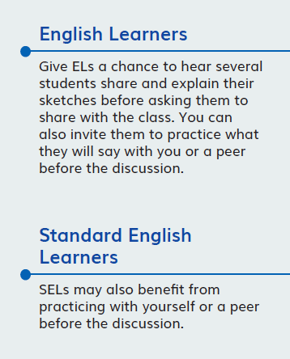  DQ2L3 p. 118
- Integrated Cultural Connection sidebars offer teachers guidance to engage students of all backgrounds and abilities (DQ1L2 TE p. 20, DQ1L6 TE p. 50, DQ1L9 TE p. 76, DQ2L7 TE p. 149, DQ4L1 TE p. 252). | DQ1L2 TE p. 20  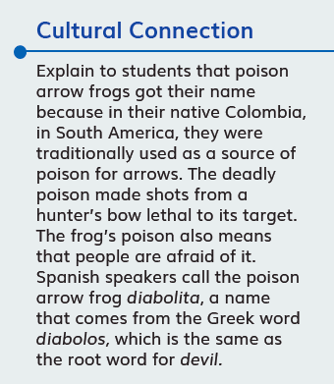  DQ1L6 TE p. 50
- Integrated Special Needs sidebars offer teachers guidance to support students of all abilities as they participation in class activities and grasp key concepts (DQ2L7 TE p. 151, DQ2L8 TE p. 157, DQ3L1 TE p. 193, DQ3L3 TE p. 207, DQ4L4 TE p. 275). | 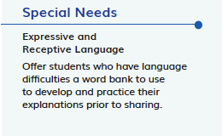DQ2L7 TE p. 151
- Integrated Challenges interspersed throughout the TB support GATE students who have met the learning goals (DQ1L3 TB p. 11, DQ2L3 TB p. 59, DQ2L5 TB p. 65, DQ2L7 TB p. 71, DQ3L3 TB p. 100). | 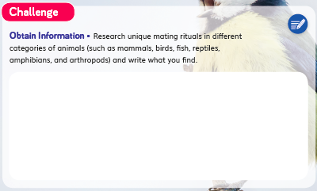  DQ1L3 TB p. 11  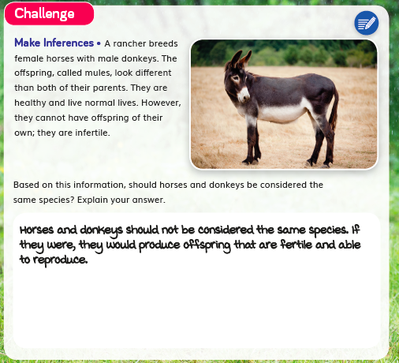  DQ2L3 TB p. 59
- Videos like Courtship Rituals: Puffer Fish (DQ1L3), Whitebark Pine Tree (DQ1L9), Asexual Reproduction in Animals (DQ2L9), and Saving Sea Turtles (DQ4L3) bring phenomena and concepts to life for all students. | Courtship Rituals: Puffer Fish (DQ1L3)
- Assessments of the three dimensions are multimodal and include multiple choice, writing, drawing, physical models, and oral presentations, allowing all students to access a range of assessment types to suit their learning style and/or reading level.
- The digital Twig Book and digital assessment items (Benchmark, Multiple Choice, Rubrics) have a text to speech function allowing students of all reading levels to access the assessments.
- The rubrics for the Performance Tasks (DQ1L10 TE pp. 80–86, DQ2L10 TE pp. 170–175, DQ4L3–5 TE pp. 266–280) and Benchmark Assessment (DQ3 TE pp. 236–243 and online) have four levels—emerging, developing, proficient, and advanced—allowing all students to demonstrate their current level of attainment.
- The Multiple Choice Assessment (DQ4) contains questions targeting different DOK levels, with an extended section available to further challenge GATE students. | Multiple choice (DQ4 digital)
- Writing, Reading, Listening, and Speaking domain tasks dedicated to assessing science-relevant English language development are integrated into the core instructional resources (DQ1L7 TE p. 63, DQ3L3 TE p. 209) and the On-Level reader lessons (Chapter 3 Second Read TE p. 299). | DQ1L7 TE p. 63  Chapter 3 Second Read TE p. 299
TS5. Support to Monitor Student Progress.
The Module materials are High Quality 5 in regards to TS5.
They provide strong support for teachers to monitor student learning and progress over time, and make decisions about instruction and provide feedback.
Evidence  - There are three diagnostic pre-assessments (Pre-Explorations) at strategic points in the module that assess prior knowledge and misconceptions (DQ1L1 TB p. 4, DQ2L1 TB p. 54, DQ3L1 TB p. 90). Notes in the Teacher Edition and the Progress Tracker support teachers to monitor students' mastery of their misconceptions and the three dimensions and give suggestions for how to tailor instruction accordingly (DQ1L5 TE p. 42, DQ2L3 TE p. 117, DQ2L9 TE p. 167, DQ3L7 TE p. 234).  - Progress Trackers, digital assessment trackers, and rubrics support teachers in monitoring students progress. Pre-Exploration and regular Formative Assessments inform teacher at the point of use as to which students require further support. | 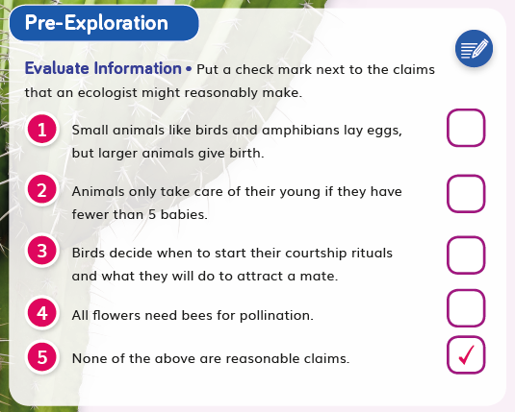  DQ1L1 TB p. 4  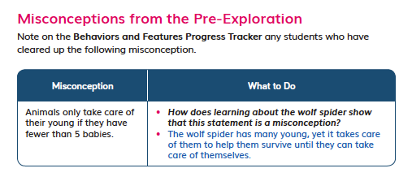  DQ1L5 TE p. 42

