Designed for NGSS: Foundations
Analyze Evidence
Directions:
- Review your assigned materials to describe the path of student thinking.
- Represent your answers to the questions in the space provided.
- Be prepared to share the path of student thinking visually on a public chart.

Answer (in words, graphics, or both)
Answer the following questions as you describe the path of student thinking in the materials. Consider what you would expect students to be thinking about through the learning experiences.
What are students figuring out/solving?
- What is driving student learning (e.g., question, scenario, problem, phenomenon, etc.)?
- What ideas and practices do students develop through these experiences?
- How do students access, engage, and use prior knowledge to further their thinking?
- How do students develop metacognitive abilities?
SW1. Phenomena/Problems.
Student learning is driven by figuring out a solution to the Module Investigative Problem: How can we reduce the damage caused by earthquake?
Students work through a series of Driving Questions (DQs) that require them to make sense of a subset of smaller phenomena/problems and then connect what they now know to the central problem. The skills and knowledge gained over these investigations culminate in a final class discussion where they address the Module Investigative Problem.  - DQ1: How are waves involved in earthquakes?  - DQ2: How can patterns help us predict where earthquakes and volcanoes will occur?  - DQ3: How can building materials and shapes affect the severity of earthquake damage?  - DQ4: How can our understanding of earthquakes and materials help us build safer buildings?  - DQ5: What can we learn from engineers that will help us revise our designs?  - DQ6: How can we redesign our buildings to make them safer during earthquakes?  Interwoven with this science narrative is a storyline that requires students to take on the role of engineers and design their own earthquake-proof structure. They are introduced to the storyline through a movie-style module trailer.  The Module is complemented with Shake, Rattle, and Roll, a magazine-style leveled reader (available in four levels and Spanish) that provides additional exposure to relevant phenomena/problems as well as an interview with a seismologist. Packed with stunning images, cartoons, and jokes, it’s designed to appeal to students with a diverse range of learning abilities. | 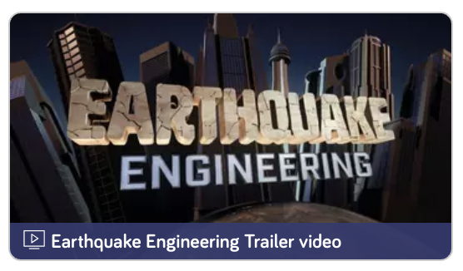  Module trailer
Evidence of Phenomena/Problems.  - In DQ1 (TB pp. 5-12), students investigate into the phenomenon of wave amplitude and wavelength using water, ropes and an interactive. | 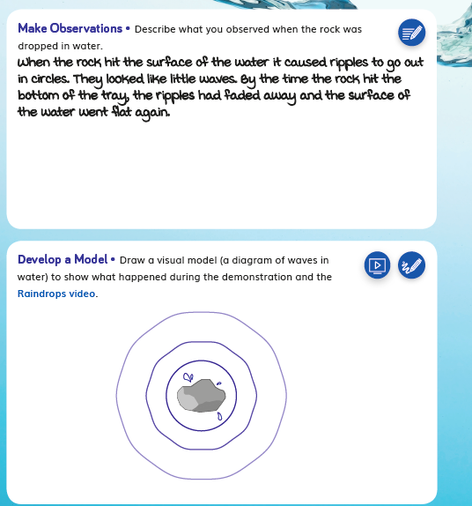  DQ1 TB pp. 5-12
- In DQ2 (TB pp. 21-32), students explore the phenomenon of patterns in earthquake locations using an interactive map. | 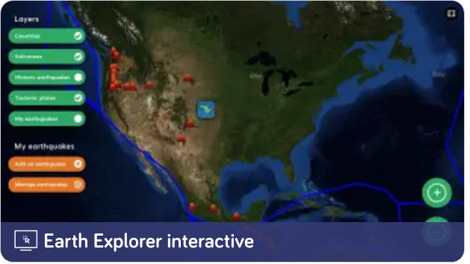  Earth Explorer Interactive  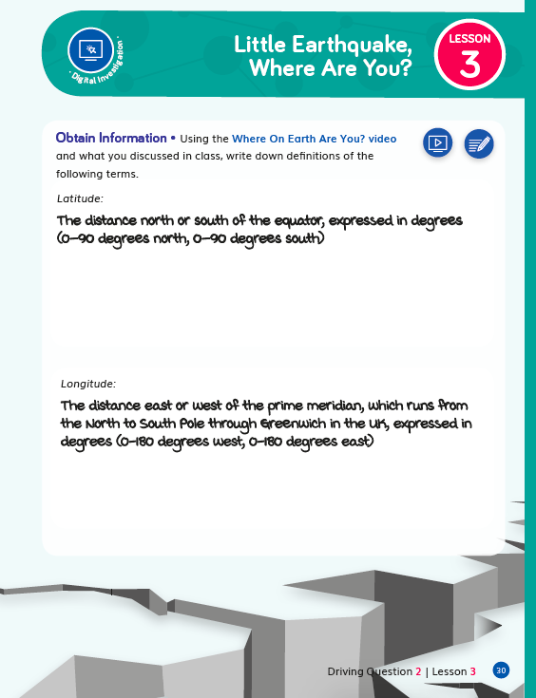  DQ2 TB pp. 21-32
- In DQ2 (TB pp. 39- 46), students read and analyze the phenomena of earthquakes in Oklahoma | 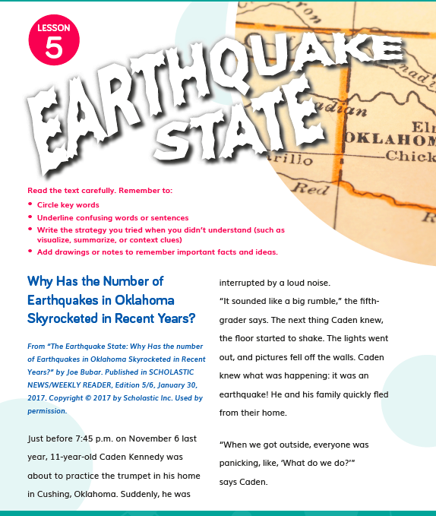  DQ2 TB pp. 39- 46
- Over DQs 3-6, students solve the problem of how to make buildings earthquake-proof by investigating different materials, real-world engineering solutions and by designing, building, testing and revising their own earthquake-proof structure.  - In DQ6L5 Connect (TE p. 205), the class summarizes their solutions to the Module Investigative Problem. | 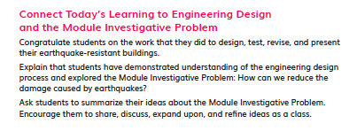  DQ6L5 Connect TE p. 205
SW2. Three-dimensional Conceptual Framework.
Students experiences consistently support them to use their prior knowledge to negotiate new understandings and abilities, and apply their understandings in a variety of ways.
In DQ1, students start by exploring natural disasters and what causes earthquakes. They questions what they already know about these phenomena and what they still wonder about. They investigate and model the phenomenon of waves looking for patterns (CCC) in amplitude and wavelength (DCIs). They explore wave properties, how waves move objects (CCC) and use that understanding to make the connection between wave amplitude and earthquake magnitude.

Reading informational texts, they explore the phenomenon of earthquake damage and analyse data (SEP) to work out that earthquakes of a higher magnitude cause more damage. They again practice analyzing data (SEP) in an interactive map to explore patterns (CCC) in the locations of earthquakes. They ask what could be causing these patterns and figure out that earthquakes appear in bands along plate boundaries, and that earthquakes are caused when the plates move releasing waves of energy (DCI and CCC).

They start an engineering project to investigate how the shape, structure and materials of a building affects its ability to withstand forces. They apply what they learned to an engineering challenge to design, build and test their own earthquake-resistant structures. They share their designs and problems with their peers, learn from each other and brainstorm solutions (DCIs, CCC).

Next, they compare and contrast different engineering solutions used by real engineers around the world (CCC). They watch a video of what happens to a bedroom during an earthquake and are encouraged to work with their families to identity potential hazards in their own homes.

They revisit their earlier designs, applying their new knowledge to make improvements, still adhering to the criteria for success and constraints (DCIs, SEP). They wrap this final Performance Task with a presentation of their designs and have a class discussion to summarize their solutions for the problem of how to reduce earthquake damage (DCIs, SEP).
The SEPs and CCCs that the students are using in each learning activity are labeled at point of use in the student addition, called the Twig Book, in grade appropriate language (DQ3L1 TB pp. 21-22). | DQ3L1 TB pp. 21-22
Evidence  - In DQ1L2 (TB p. 5-12), students draw a model of waves and use reasoning to explain their model, building on their use of models of energy transfer in Grade 4 Modules 1 and 2. | DQ1L2 TB p. 5-12
- In DQ2L3 (TB p. 21-32), students argue from evidence, and explain which parts of the world are the most dangerous from earthquakes based on patterns they noticed. | DQ3L1 TB pp. 21-22
- In DQ6L3 (TB p. 98), students learn from their peers as they observe their tests. | 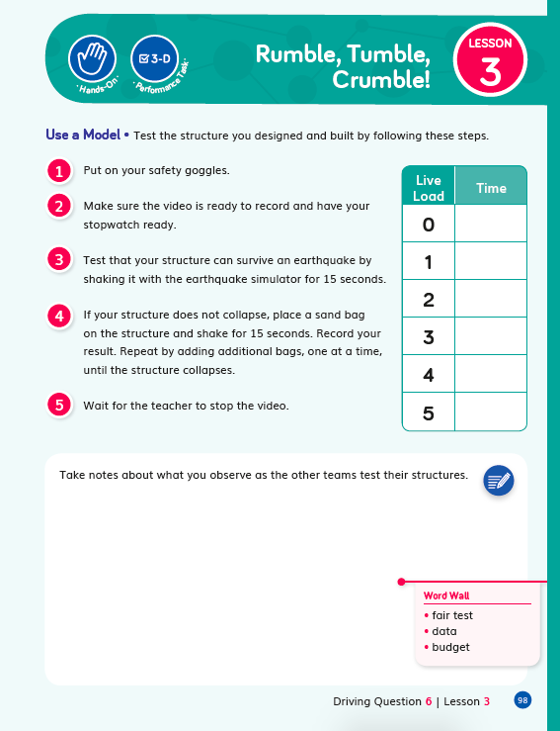  DQ6L3 TB p. 98
- In DQ6L4 (TB p. 100-101), students apply their new understandings and ideas to explain how their design changed as they learned from their failures and challenges. | 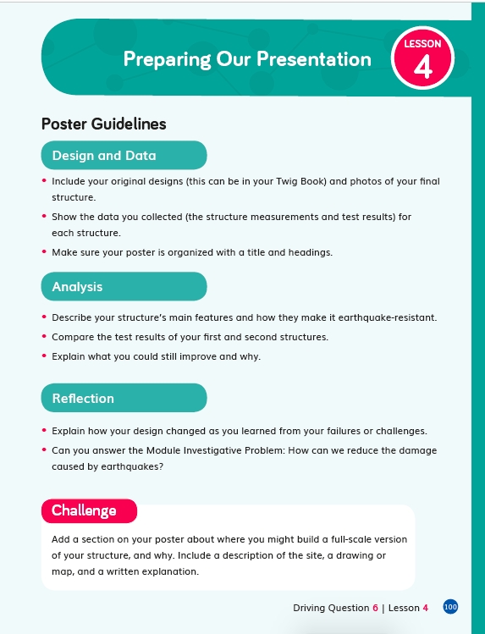  DQ6L4 TB p. 100-101
SW3. Prior Knowledge
Materials consistently leverage student prior knowledge and experiences to motivate their learning.
Across Program
Earthquake Engineering builds on prior knowledge of engineering tasks completed in previous grades—Grade K Module 2 Marble Run Engineer, Grade 2 Module 2 Master of Materials, Grade 3 Module 4 Weather Warning HQ, natural hazards—Grade K Module 3 Be Prepared, Grade 2 Module 3 Save the Island, Grade 3 Module 4 Weather Warning HQ, and use of maps—Grade 2 Module 1 My Journey West, Grade 4 Module 3 Time-Travelling Tour Guides.

Within Module
In DQ1L1, students activate their prior knowledge of natural disasters through video footage and a Prior-Knowledge Read-Aloud. They are prompted to think back to the landscape changes they explored in Grade 4 Module 3 and see how they compare to changes caused by natural disasters (CCC-5).

Throughout the module students are consistently supported to revise their claims and relate their new understandings to answering the Driving Questions and solving the Module Investigative Problem.

Throughout the module students refer to and add to their classroom Science Tools Poster, which explicitly details their growing use of the SEPs, and motivates them by helping them visualise their progression.

Evidence  - In DQ1L1 (TE p. 8), students watch footage of natural disasters and share their thinking. | 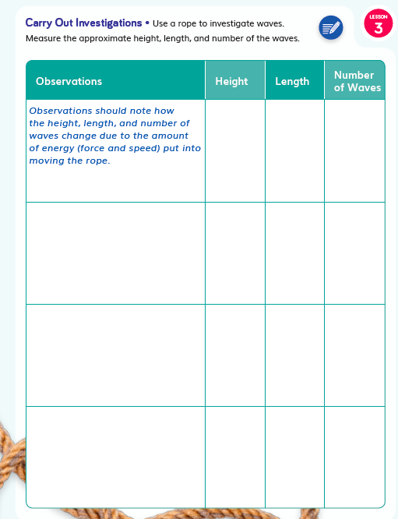  DQ1L1 TE p. 8
- In DQ1L1 (TE p. 10), students engage with a Prior-Knowledge Read-Aloud about earthquakes, tsunamis and volcanoes. | 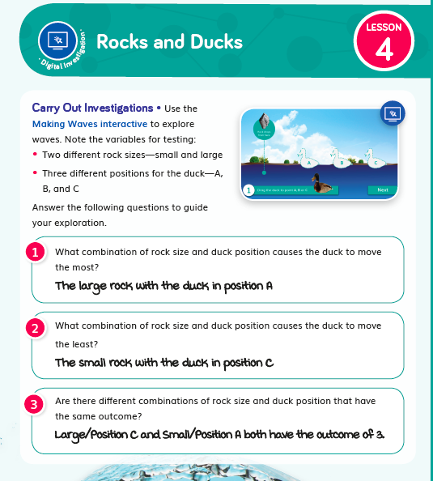  DQ1L1 TE p. 10
- In DQ1L1 (TB p. 4), students complete a KLEW chart and note what they already know about natural disasters. | 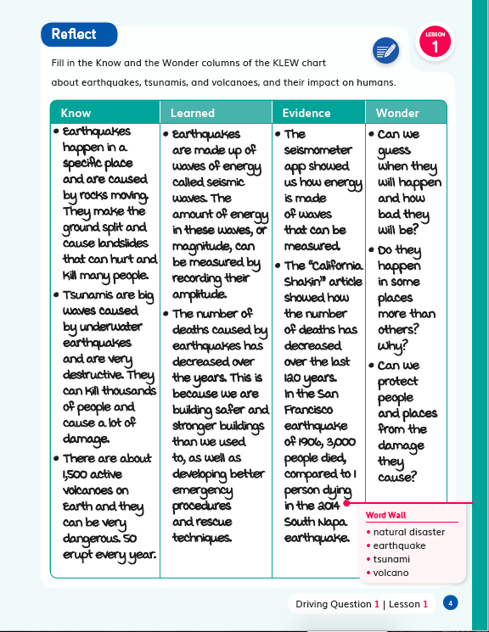  DQ1L1 TB p. 4
- In DQ1L2 (TB p. 6), students revise their wave model and explain their thinking. | 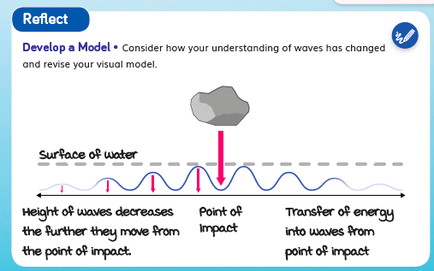  DQ1L2 TB p. 6
- In DQ1L5 (TB p. 19), and DQ3L1 (TB p. 51), students complete a Pre-Exploration (diagnostic pre-assessment) to elicit awareness of their prior knowledge and misconceptions. | 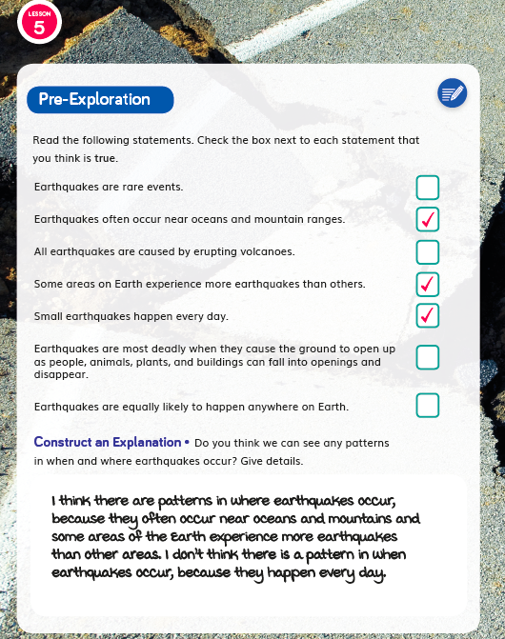  DQ1L5 TB p. 19  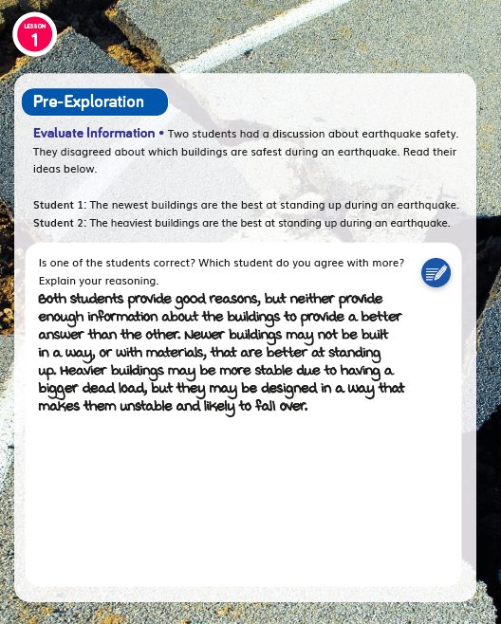  DQ3L1 TB p. 51
- In DQ2L2 (TB p. 27), students revise their claim about what causes earthquakes following an investigation. | 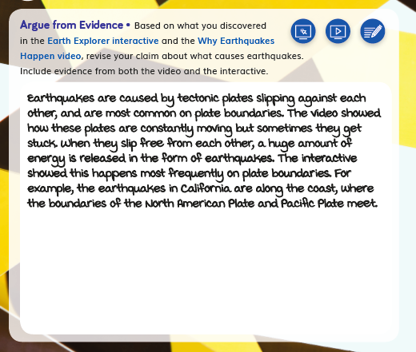  DQ2L2 TB p. 27
- In DQ2L3 Connect (TE p. 62), students add “Analyze data” to their Science Tools Poster. | 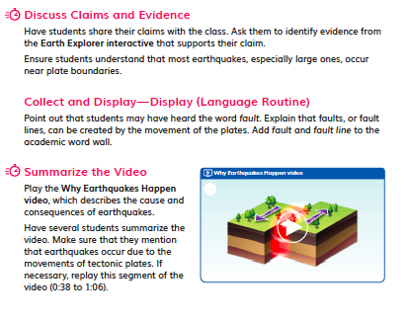  DQ2L3 Connect TE p. 62
- In DQ6L4 (TB p. 100-101), students reflect on their new understandings and ideas about engineering solutions to reduce earthquake damage, and apply them to their building design. They also explain how their design changed as they learned from their failures and challenges. | DQ6L4 TB p. 100-101
SW4. Metacognitive Abilities.
Earthquake Engineering regularly provides students with explicit opportunities to consider how their learning experiences have changed their thinking.
Diagnostic pre-assessments (Pre-Explorations) in DQ1L5 and DQ3L1 support students to think about the three dimensions they are already familiar with and those they are not.  'I can…’ statements written in grade-appropriate language are detailed for each DQ, supporting student awareness of their growing skills and knowledge and of the three dimensions that they will use to figure out phenomenon/solve problems. See: DQ2 (TB p. 22) 'I can... use an interactive to explore earthquakes and volcanoes and interpret data to understand relationships between earthquakes and tectonic plates’. | 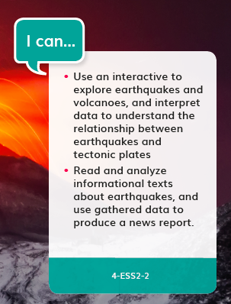  DQ2 TB p. 22
The five-part Twig Science lesson structure has been designed to support students to develop their metacognitive abilities on a daily basis and monitor what and how they have learned across the three dimensions.  Spark: An engaging hook activity motivates students for the investigations ahead.  Investigate: Students think like scientists and design like engineers through hands-on, digital, video and information text investigations.  Report: Students articulate what they’ve learned today citing evidence and their use of the three dimensions.  Connect: Students make connections to the Driving Questions and Module Investigative Problem while building knowledge of CCCs and SEPs.  Reflect: Students use different means to think about what they have learned so far and how they can use their new understandings to better figure out phenomena/problems. For example, in DQ1L1 students complete the Know and Wonder section of a Know-Learn-Evidence-Wonder (KLEW) chart to which they return later in the module to complete the Learn and Evidence sections. | Know-Learn-Evidence-Wonder  (KLEW) chart
Evidence  - In DQ2 (TB p. 22), the ‘I can...’ statement details use of the three dimensions students will use in this DQ. 'I can... use an interactive to explore earthquakes and volcanoes and interpret data to understand relationships between earthquakes and tectonic plates’. | DQ2 TB p. 22
- In DQ1L2 (TB p. 6) and DQ1L4 (TB p. 12), students consider how their learning experiences have changed their understanding of waves. | DQ1L2 TB p. 6  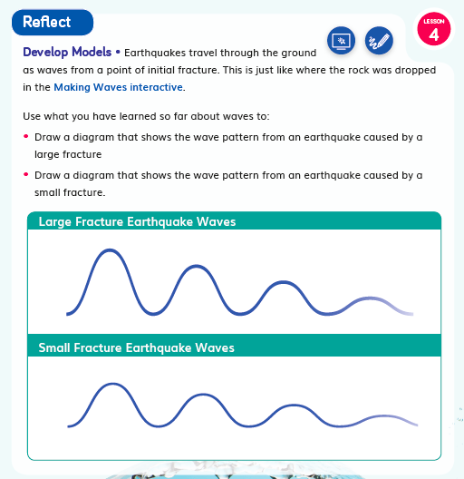  DQ1L4 TB p. 12
- In DQ2L2 (TB p. 27), after a digital investigation students are invited to revise their claim about what causes earthquakes citing evidence. | DQ2L2 TB p. 27
- In DQ3L3 (TB p. 58), students reflect on how effectively they worked today and why they think they worked at that level. | 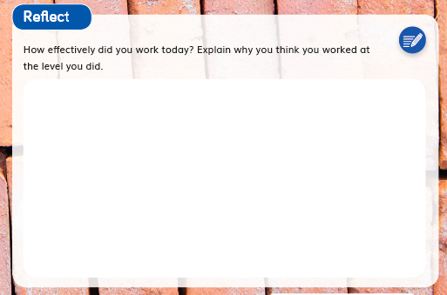  DQ3L3 TB p. 58
- In DQ3L4 (TB p. 66), students evaluate information and summarize what they have learned so far about building materials. | 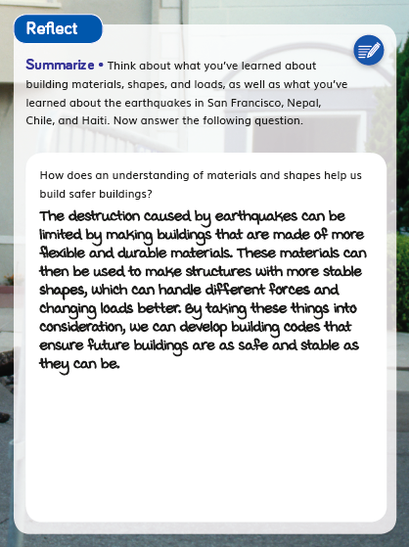  DQ3L4 TB p. 66
- In DQ5L4 (TB p. 90), following research tasks, students reflect what they need to change in their design and how they will do that. | 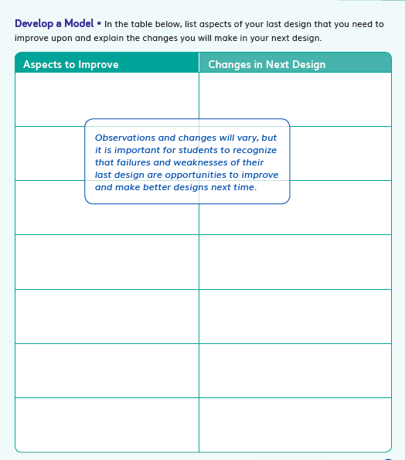  DQ5L4 TB p. 90
SW5. Equitable Learning Opportunities
Most learning experiences across Earthquake Engineering are multimodal in approach with numerous cross curricular connections, designed to engage students meaningfully in a variety of ways, with multiple access points, and with supports for students.
The learning experiences in the module are designed to appeal to students of all learning styles and abilities and include tasks in all domains—writing, reading, listening (read-alouds and videos), speaking (discussion and presentations), drawing, plus digital, text, video as well as hands-on investigations.

Instructional materials frequently provide support for language scaffolding for English learner students at point of use in the Teacher Editions, as well as research-based integrated language routines to support all students to “talk science” using grade-level appropriate scientific vocabulary. The digital version of the Twig Book (TB) includes a text to speech function.

Suggestions for extra access points for students with special needs are provided frequently at point of use.

Culturally relevant content is core to the module e.g. students investigate engineering solutions in California, as well as examples from around the world e.g Nepal, Japan, with additional culturally-relevant contexts, added at point of use.

Higher Order Challenges for GATE student that have already met the learning goals are interspersed through the learning activities.

The frequent use of videos helps all students access and engage with phenomena and science concepts. Key words are overlaid as on-screen text. Students can access the ideas visually as well as via the spoken and written word. Captions are provided in both English and Spanish.

The Shake Rattle and Roll reader has been designed to capture the imagination of young readers with jokes and cartoons. It provides an alternative means to access the scientific content. The reader is available in four levels (Below, On, Above, EL) and Spanish, with complementary lessons to build language acquisition and develop informational text reading skills. On level lessons are in the TE, other levels available digitally. The reader features many positive role models in the field of science and engineering, designed to cultivate interest in STEM careers for all students. Chapter 2 is dedicated to an interview with a young female volcanologist. The digital version of the reader includes a text to speech function.

Evidence  - See DQ1L1 (TE p. 8), DQ1L2 (TE p. 17), DQ1L3 (TE p. 25), DQ1L4 (TE p. 30) for support for ELs. | DQ1L1 TE p. 8  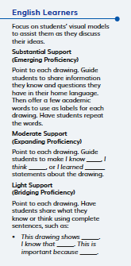  DQ1L2 TE p. 17  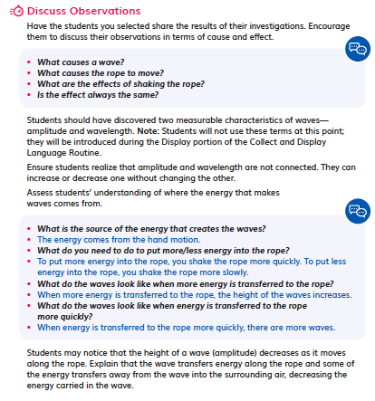  DQ1L3 TE p. 25
- See DQ1L1 (TE p. 8), DQ2L2 (TE p. 58), DQ2L3 (TE p. 67), DQ5L1 (TE p. 153) for Cultural Connections. | DQ1L1 TE p. 8  DQ2L2 TE p. 58  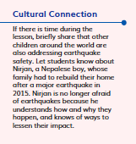  DQ5L1 TE p. 153
- See DQ1L1 (TE p. 9), DQ1L2 (TE p. 14), DQ1L3 (TE p. 23, 25) for support for students with special needs. | 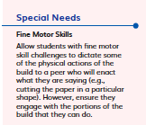  DQ1L1 TE p. 9  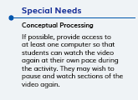  DQ1L2 TE p. 14  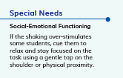  DQ1L3 TE p. 23
- See DQ3L1 GATE (TE p. 101), DQ3L3 (TE p. 113), DQ5L1 (TE p. 152) for challenges for GATE students. | 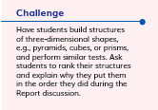  DQ3L1 GATE TE p. 101  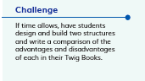  DQ3L3 TE p. 113  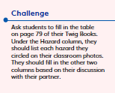  DQ5L1 TE p. 152
- Films such as Building Loads (DQ3L1), LAX Engineer (DQ5L2), and Earthquakes around the World (DQ3L4) bring phenomena and concepts to life for all students. | 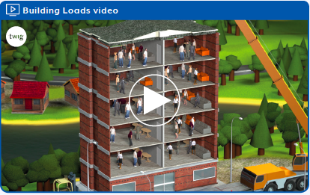  Building Loads (DQ3L1)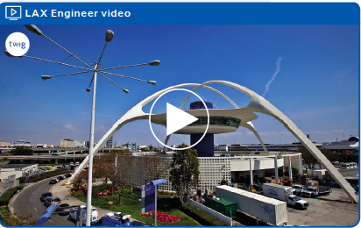  LAX Engineer (DQ5L2)  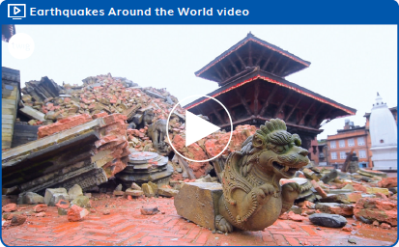  Earthquakes around the World (DQ3L4)

Designed for the NGSS: Foundations | High Quality  5 | Medium Quality  3 | Low Quality  1
SW1. Phenomena/Problems. Materials provide phenomena/problems that:  - engage students as directly as possible in authentic and relevant experiences;  - are matched to targeted learning goals;  - can be figured out/solved using scientifically accurate understandings and abilities;  - make connections beyond and to their daily lives including to their homes, neighborhoods, communities, and/or cultures. | Materials consistently offer quality phenomena/problems sufficient to motivate and drive student learning. | Materials sometimes offer quality phenomena/problems sufficient to motivate and drive student learning. | Materials rarely offer quality phenomena/ problems sufficient to motivate and drive student learning.
SW2. Three-dimensional Conceptual Framework. Materials include learning experiences that help students to build scientifically accurate understandings and abilities through opportunities for students to:  - link prior knowledge to negotiate new understanding and abilities;  - use reasoning to connect grade-appropriate SEP, DCI, and CCC elements;  - ask and answer questions that link learning over time;  - negotiate new understandings and abilities by comparing their ideas, their peers’ ideas, and ideas encountered in the learning experiences;  - apply their understandings and abilities in a variety of ways. | Materials consistently include learning experiences that help students build from prior experiences to negotiate new understandings and abilities and apply their understandings in a variety of ways. | Materials sometimes include learning experiences that help students build from prior experiences to negotiate new understandings and abilities and apply their understandings in a variety of ways. | Materials rarely include learning experiences that help students build from prior experiences to negotiate new understandings and abilities and apply their understandings in a variety of ways.
SW3. Prior Knowledge. Materials leverage students’ prior knowledge and experiences to motivate student learning in ways that:  - make visible students’ prior knowledge and experiences related to the phenomena/problems and relevant SEPs, DCIs, and CCCs.  - revisit students’ early ideas to see how they have changed (or not) as they figure out phenomena/solve problems.  - make explicit links to new ideas and practices being developed by students. | Materials consistently leverage student prior knowledge and experiences to motivate their learning. | Materials sometimes leverage student prior knowledge and experiences to motivate their learning. | Materials rarely leverage student prior knowledge and experiences, and when included, they do not relate to the phenomena or problems.
SW4. Metacognitive Abilities. Materials include learning experiences for students to:  - set and monitor their learning in light of the targeted learning goals;  - consider, over time, what and how they have learned across the three dimensions;  - articulate how the three dimensions helped them figure out phenomena/solve problems. | The materials provide students with regular, explicit opportunities to consider how their learning experiences changed their thinking. | The materials provide students with some opportunities to consider how their learning experiences changed their thinking. | The materials provide few opportunities for students to consider how their learning experiences changed their thinking.
SW5. Equitable Learning Opportunities: Materials ensure that all students, including those from non-dominant groups and with diverse learning needs, have access to the targeted learning goals and experiences, including:  - appropriate reading, writing, listening, and/or speaking alternatives for students who are English language learners, have special needs, read below the grade level, or have high interest and have already met the intended learning goals.  - culturally-relevant contexts and examples that support all students.  - opportunities to cultivate interest and confidence as scientists and engineers for all students. | Most learning experiences in materials are designed such that students can engage meaningfully in a variety of ways, with multiple access points, and with supports for students. | Some learning experiences in materials are designed such that students can engage meaningfully in a variety of ways, with multiple access points, and with supports for students. | Few learning experiences in materials are designed such that students can engage meaningfully in a variety of ways, with multiple access points, and with supports for students.

Designed for NGSS: Student Work

Analyze Evidence
Directions:
- Review the Designed for NGSS: Foundations Rubric.
- Reflect on the evidence (or lack of evidence) that you and your team gathered and represented.
- Record strengths and limitations for each criterion based on your evidence. Cite specific examples.

Strengths
SW 1: Phenomena/ Problems
The Student Work is High Quality (5) in terms of SW1
Materials consistently offer quality phenomena/ problems sufficient to motivate and drive student learning.
Evidence  - In DQ1L2-4 (TB pp. 5-12), students investigate into the phenomenon of wave amplitude and wavelength using water, ropes, and an interactive. | DQ1 L2-4 TB pp. 5-12
- In DQ2L1-3 (TB pp. 21-32), students explore the phenomenon of patterns in earthquake locations using an interactive map. | DQ2 L1-3 TB pp. 21-32
- In DQ2L5 (TB p. 39- 46), students read and analyze the phenomena of earthquakes in Oklahoma.  - Over DQs 3-6, students solve the problem of how to make buildings earthquake-proof by investigating different materials, real-world engineering solutions and by designing, building, testing and revising their own earthquake-proof structure. | DQ2L5 TB p. 39- 46
- In DQ6L5 Connect (TE p. 205), the class summarizes their solutions to the Module Investigative Problem. | DQ6L5 Connect TE p. 205
SW 2: Three-Dimensional Conceptual Framework
The Student Work is High Quality (5) in terms of SW2
Materials consistently include learning experiences that help students build from prior experiences to negotiate new understandings and abilities and apply their understandings in a variety of ways.
Evidence  - In DQ1L1 TB pp. 5-6, after an investigation, students draw a model of waves and use reasoning to explain their model, building on their use of models of energy transfer in Grade 4 Modules 1 and 2. Students go on to revise their model and explain their thinking. | 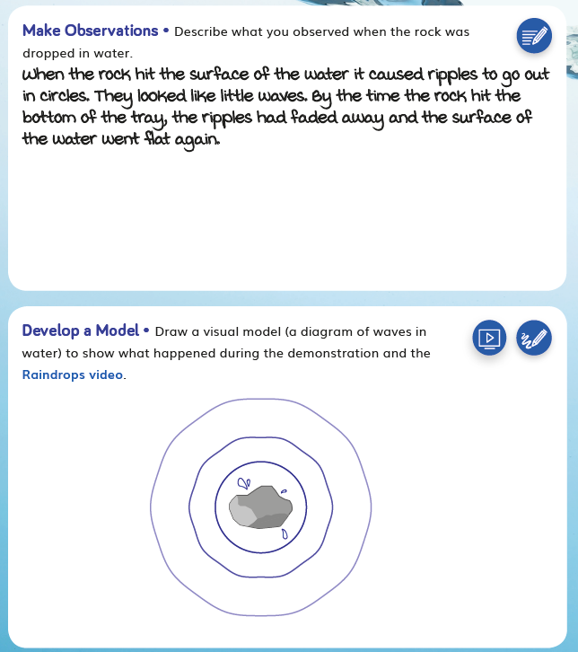  DQ1L1 TB pp. 5
- In DQ2L3 TB p. 32, students argue from evidence, and explain which parts of the world are the most dangerous from earthquakes based on patterns they noticed. | 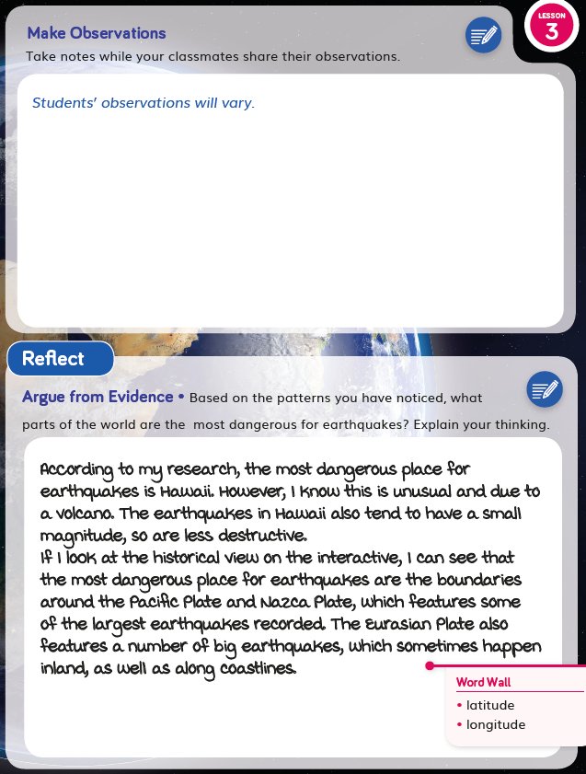  DQ2L3 TB p. 32
- In DQ6L3 TB p. 98, students learn from their peers as they observe their tests. | DQ6L3 TB p. 98
- In DQ6L4 TB p. 100, students apply their new understandings and ideas, and explain how their design changed as they learned from their failures and challenges. | DQ6L4 TB p. 100
SW 3: Prior Knowledge
The Student Work is High Quality (5) in terms of SW3
Materials consistently leverage student prior knowledge and experiences to motivate their learning.
Evidence  - In DQ1L1 TE p. 8, students watch footage of natural disasters and share their thinking. | DQ1L1 TE p. 8
- In DQ1L1 TE p. 10, students engage with a Prior-Knowledge Read-Aloud about earthquakes, tsunamis and volcanoes. | DQ1L1 TE p. 10
- In DQ1L1 TB p. 4, students complete a KLEW chart and note what they already know about natural disasters. | DQ1L1 TB p. 4
- In DQ1L2 TB p. 6, students revise their wave model and explain their thinking. | DQ1L2 TB p. 6
- In D1L5 TB p. 19, and DQ3L1 TB p. 51, students complete a Pre-Exploration (diagnostic pre-assessment) to elicit awareness of their prior knowledge and misconceptions. | D1L5 TB p. 19  DQ3L1 TB p. 51
- In DQ2L2 TB p. 27, students revise their claim about what causes earthquakes following an investigation. | DQ2L2 TB p. 27
In DQ2L3 Connect TE p. 60, students add “Analyze data” to their Science Tools Poster.
- In DQ6L4 TB p. 100, students reflect on their new understandings and ideas about engineering solutions to reduce earthquake damage, apply them to their building design, and explain how their design changed as they learned from their failures and challenges. | DQ6L4 TB p. 100
SW 4: Metacognitive Abilities
The Student Work is High Quality (5) in terms of SW4
The materials provide students with regular, explicit opportunities to consider how their learning experiences changed their thinking.
Evidence  - In DQ1L2 TB p. 6 and DQ1L4 p. 12, students consider how their learning experiences have changed their understanding of waves. | DQ1L2 TB p. 6  DQ1L4 p. 12
- In DQ2L2 TB p. 27, after a digital investigation, students are invited to revise their claim about what causes earthquakes citing evidence. | DQ2L2 TB p. 27
- In DQ3L3 TB p. 58, students reflect on how effectively they worked today and why they think they worked at that level. | DQ3L3 TB p. 58
- In DQ3L4 TB p. 66, students evaluate information and summarize what they have learned so far about building materials. | DQ3L4 TB p. 66
- in DQ5L4TB p. 90, following research tasks, students reflect what they need to change in their design and how they will make those changes. | DQ5L4TB p. 90
SW 5: Equitable Learning Opportunities
The Student Work is High Quality (5) in terms of SW5
Most learning experiences in materials are designed such that students can engage meaningfully in a variety of ways, with multiple access points, and with supports for students.
Evidence  - See TE DQ1L1 p. 8. 10, DQ1L2 p. 17, DQ1L3 p. 25, DQ1L4 p. 30 for support for ELs. | TE DQ1L1 p. 8  DQ1L2 p. 17  DQ1L3 p. 25
- See TE DQ1L1 p. 8, DQ2L2 p. 58, DQ2L3 p. 67, DQ5L1 p. 153 for Cultural Connections. | TE DQ1L1 p. 8  DQ5L1 p. 153
- See TE DQ1L1 p. 9, DQ1L2 p. 14, DQ1L3 p. 23, 25 for support for students with special needs. | TE DQ1L1 p. 9  DQ1L2 p. 14  DQ1L3 p. 23
- See TE DQ1L1 p. 9, DQ3L1 p. 101, DQ3L3 p. 113, DQ5L1 p. 152 for challenges for GATE students . | TE DQ1L1 p. 9  DQ3L1 p. 101  DQ5L1 p. 152
- Films such as Building Loads (DQ3L1), LAX Engineer (DQ5L2), and Earthquakes around the World (DQ3L4) bring phenomena and concepts to life for all students. | Building Loads (DQ3L1)  LAX Engineer (DQ5L2)  Earthquakes around the World (DQ3L4)

