Science Made for the Next Generation

Twig Science was built from the ground up for the California NGSS by award-winning STEM education specialists.
Reviewing our program, you’ll find:

- ​A clear conceptual flow across the program, clearly set out in the program CA NGSS Framework Alignment
- Modules that bundle different scientific disciplines including engineering and environmental principles and concepts (as defined by the CDE), aligned 1:1 with the segments of the California Framework
- Phenomena and investigative problems at the heart of each module, with Grade Scope and Sequence tables that show how the dimensions flow and build in sophistication across each grade
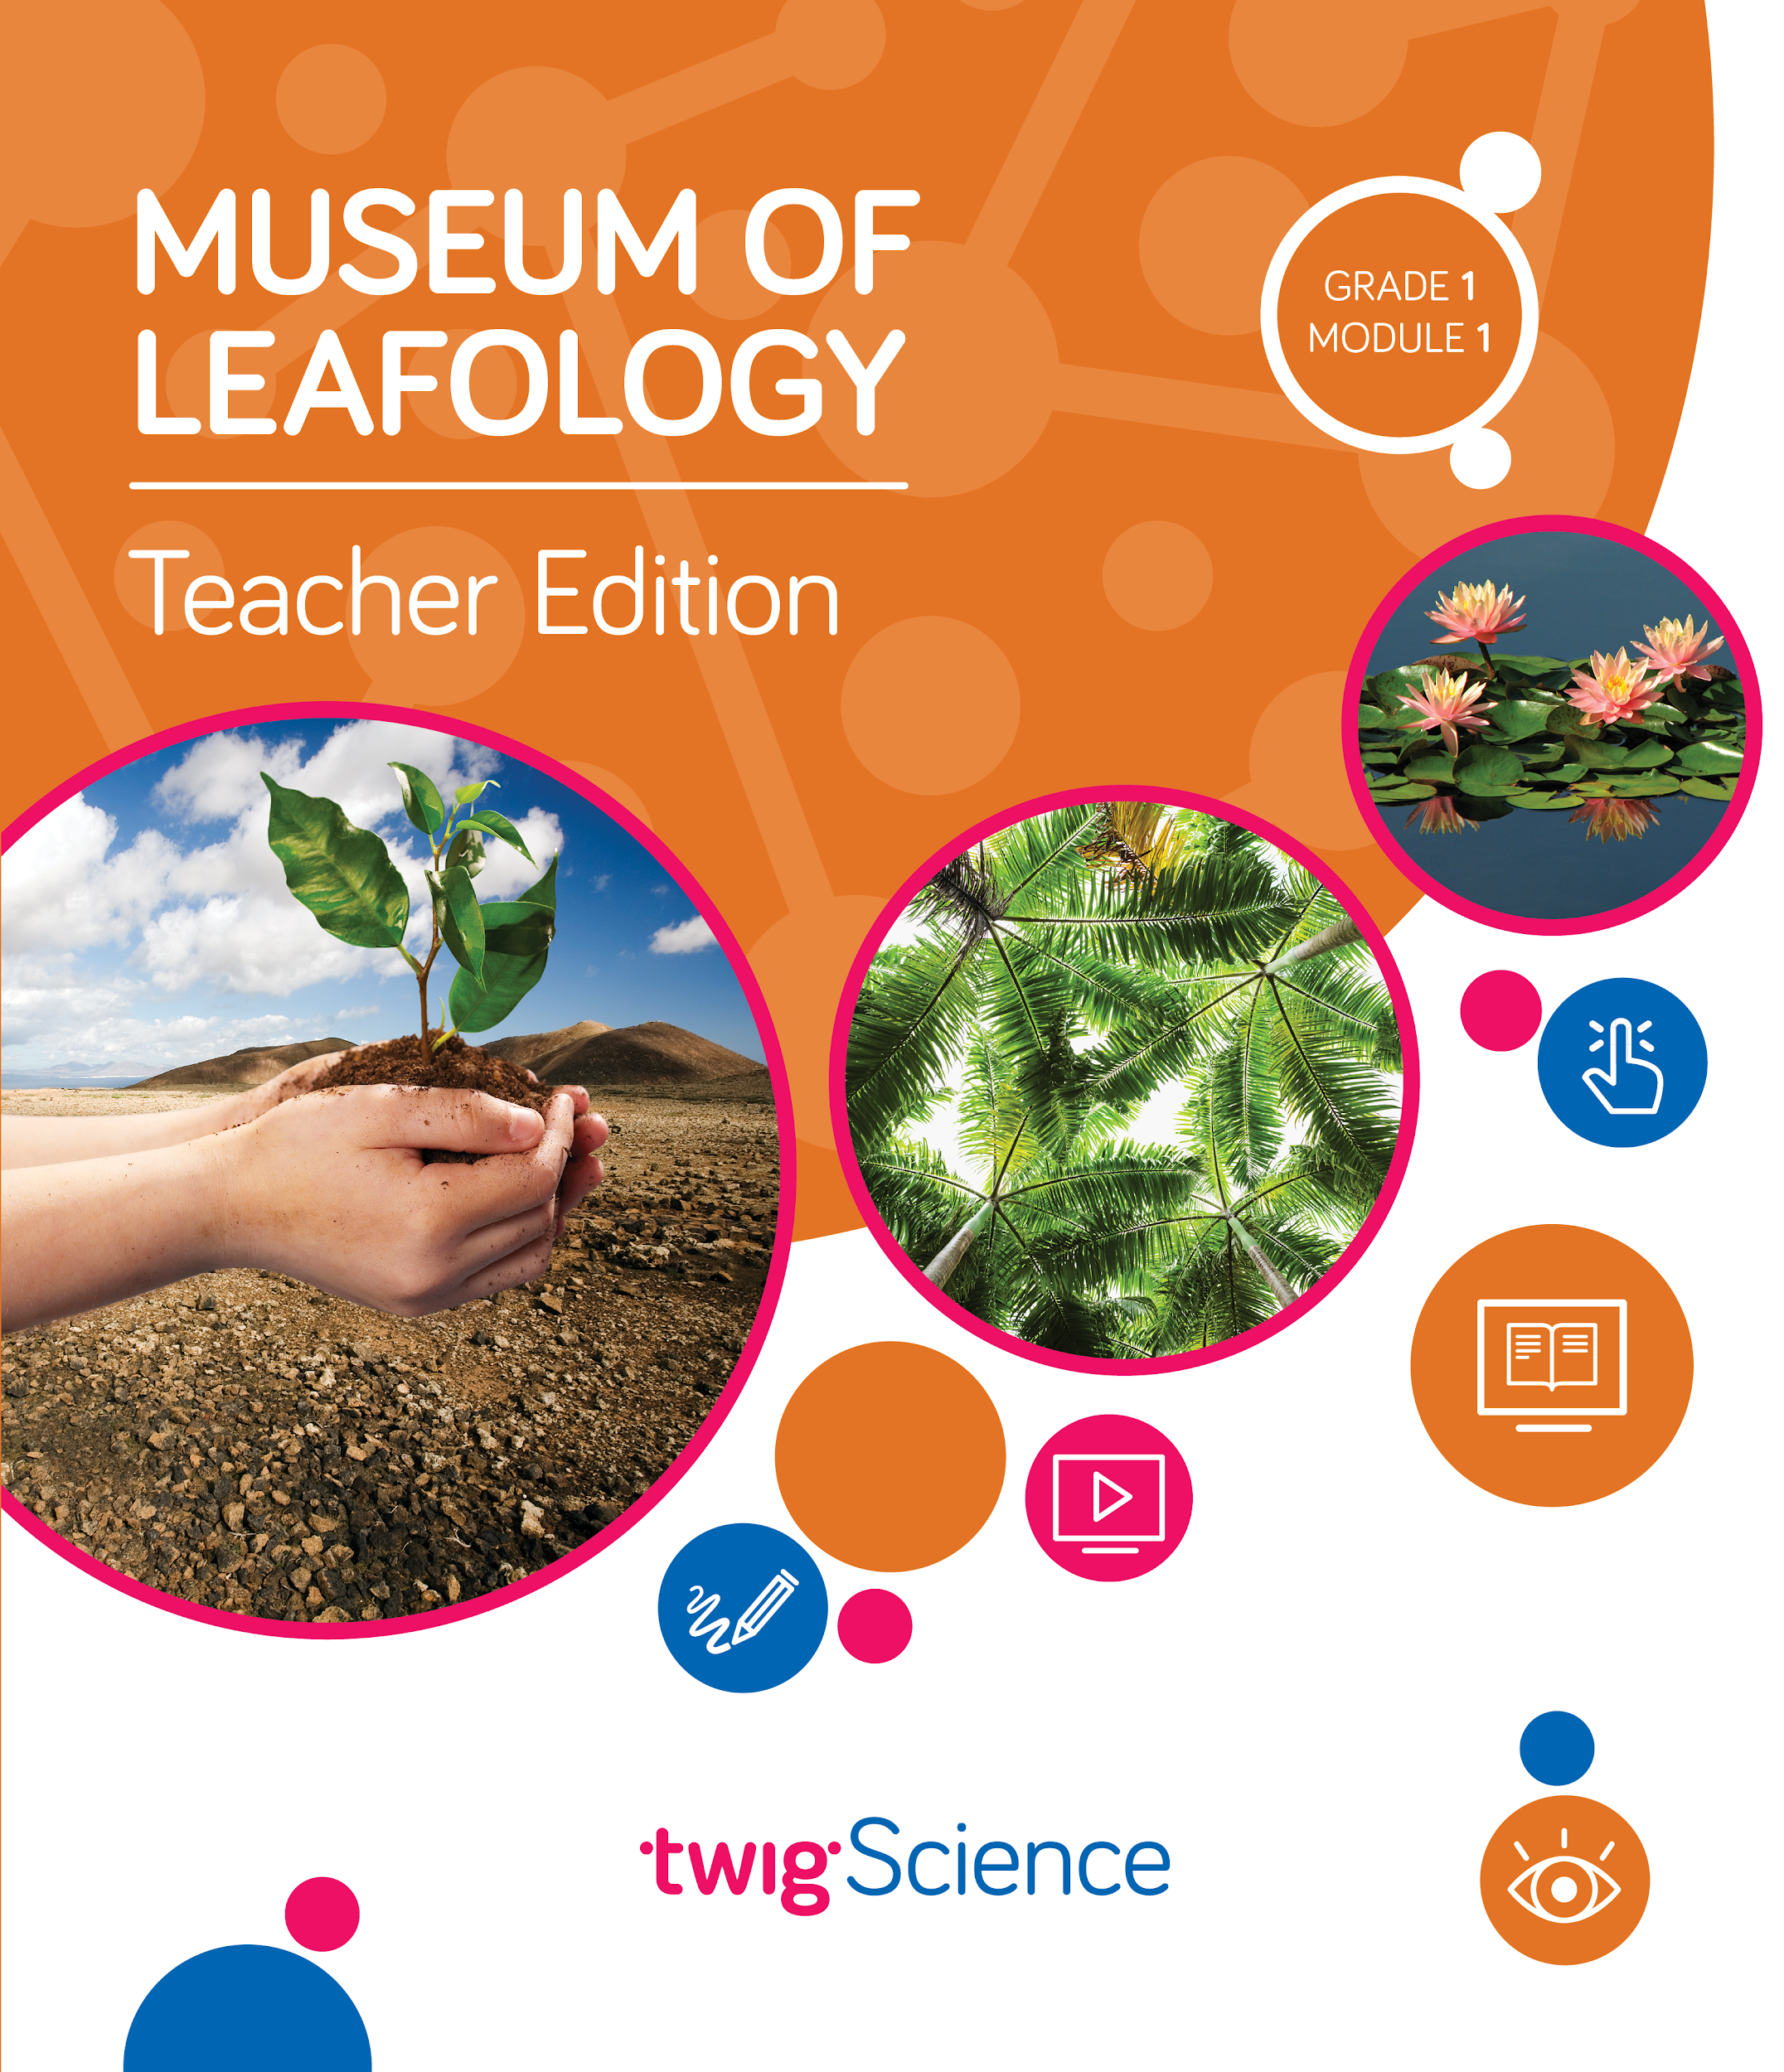
- Module Contents that tell the story of how students apply the three dimensions in a module, with Driving Questions that scaffold their learning journey
- Three-dimensional lessons and assessments that clearly outline the dimensions applied.
​
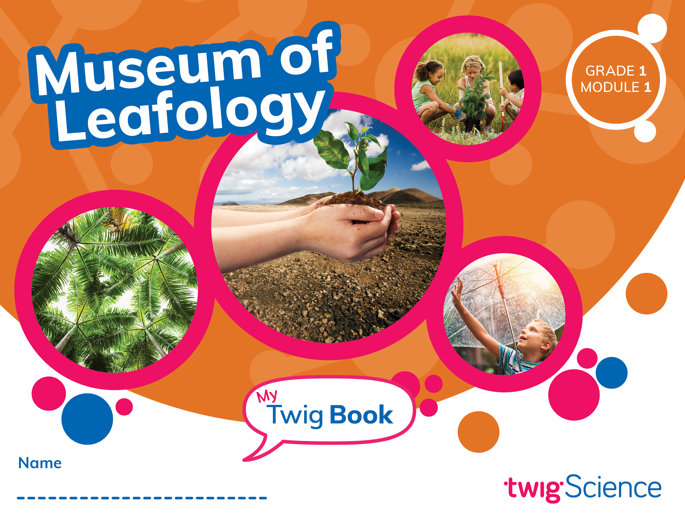
This is why we score so highly on NGSS-based rubrics such as NextGen TIME Paper screen evaluation.

This rubric has been completed for Grade 1 Module 1 Museum of Leafology and is designed to highlight where you can find evidence for the Designed for NGSS: Foundations Rubric. The rubric includes citations to the printed Teachers Edition and Twig Book (Student Edition).

Designed for the NGSS: Foundations | High Quality  5 | Medium Quality  3 | Low Quality  1
F1. Presence of Phenomena/Problem. The materials include phenomena/problems that have the potential to drive students learning toward the targeted learning goals in the following ways:  - phenomena/problems in the materials are to be relevant to students;  - explanations for phenomena connect to the three dimensions;  - solutions to problems connect to the three dimensions. | The materials include phenomena/problems that have strong potential to drive student learning toward the targeted learning goals. | The materials include phenomena/problems that have some potential to drive student learning toward the targeted learning goals. | The materials include phenomena/problems that have limited potential to drive student learning toward the targeted learning goals.
F2. Presence of Three Dimensions. The materials include opportunities for students to develop and use the three dimensions, such that:  - the DCIs, SEPs, and CCCs are present and have the potential to support student learning toward the targeted learning goals for each dimension;  - when engineering design is a learning focus, it is integrated with other appropriate dimensions (i.e., engineering is not isolated). | The materials consistently provide opportunities for students to develop and use the three dimensions. | The materials occasionally provide opportunities for students to develop and use the three dimensions. | The materials rarely provide opportunities for students to use the three dimensions.
F3. Presence of Logical Sequence. Materials demonstrate appropriate sequencing of three dimensions when:  - they include a targeted set of DCIs, SEPs, and CCCs within a sequence;  - the sequence is clear and logical across the DCIs;  - the SEPs and CCCs are potentially sufficient and appropriate for students to figure out the phenomena or problems. | The materials consistently exhibit a clear, logical, and appropriate sequence across the three dimensions. | The materials occasionally exhibit a clear, logical, and appropriate sequence across the three dimensions. | The materials rarely exhibit a clear, logical, and appropriate sequence across the three dimensions.

Designed for NGSS: Foundations Rubric
Analyze Evidence
Directions:
- Review the Designed for NGSS: Foundations Rubric.
- Reflect on the evidence (or lack of evidence) that you and your team gathered and represented.
- Record strengths and limitations for each criterion based on your evidence. Cite specific examples.

Strengths
F1. Presence of Phenomena /Problems
The materials are High Quality 5 with regards to F1.
There is high quality evidence of phenomenon and problems that with a strong potential to drive student learning towards targeted goal. The phenomena/problems are very relevant to students, explanations for phenomena connect to the three dimensions, and solutions to problems connect to the three dimensions.
Evidence
Grade 1 Module 1 Museum of Leafology
Module Phenomenon: How are all plants alike and how are they different?

Students work through a series of Driving Questions (DQs) that require them to make sense of a subset of smaller phenomena/problems and then connect what they now know to the Module Phenomenon.

- DQ1: What is a plant?
- DQ2: How do plants use their parts to grow and survive?
- DQ3: How are seeds dispersed?
- DQ4: How are young and adult plants alike and different?
- DQ5: What special features do some plants have that help them survive and grow?
- DQ6: How can plants inspire humans to solve problems?
- DQ7: How are all plants alike and how are they different?

Over the course of seven DQs, students investigate a series of phenomena/problems, which progressively build in complexity, scaffolding students' acquisition of the necessary DCIs, SEPs, and CCCs until they are able to address the Module Phenomenon.

Evidence of Phenomena/Problems.
- In DQ1L2, student scientists investigate the concept of living and non-living things, with an emphasis on plants.
- In DQ1L4, students begin an observation experiment by planting some seeds.
- In DQ2L2 and L3, students start to investigate what plants need and how a plant’s parts help it to grow and survive.
- In DQ3L1, L2, L4, and L6, students explore the many methods that plants use to distribute seeds away from the parent plant. In teams, students tackle an Engineering Design Challenge to design and build seeds for dispersal by wind.
- In DQ4L3 and L4, students observe the seedlings they planted and record similarities and differences. They sketch plants in nature.
- In DQ5L1, L2, and L3, students investigate the clever strategies plants use to get what they need. They discuss the defenses some plants incorporate, using these ideas to create and sketch their own imaginary plant with special defenses.
- In DQ6L4, student pairs design, build, and present their own plant-inspired solution to a human problem.
- In DQ7L2, students finish preparing the Museum of Leafology, then invite other classes and their own families to visit the museum in order to demonstrate their learning. They then complete the assessment tasks.
F2. Presence of Three Dimensions
The materials are High Quality 5 with regards to F2.
The materials consistently provide opportunities for students to use and develop the three dimensions.
Evidence
In this module, students are supported to use the three dimensions, demonstrating increasing sophistication, to understand the Module Phenomenon, answer the Driving Questions, and complete the assessment tasks.

Use and Development of Dimensions
For example, in DQ3 students are introduced to the structure and function (CCC-6) of seeds, and how they are dispersed by wind, animals, or water. They compare different seeds and gather information about how they disperse. Then they design, make, and test a seed model that can be dispersed by wind (LS1.A, CCC-6, SEP-2, SEP-8).

The 3-D Learning Objectives and dimensions that are addressed in every lesson are clearly identified at the start of each lesson.

Science Tools Poster
Throughout the module, students use their Science Tools poster to track their growing use of the SEPs. The poster is blank at the start of the year, and the eight SEPs are added when each one is used for the first time. In this module, students add “Ask Questions” (SEP-1), “Read, Listen and Watch”, “Explain Ideas” (SEP-6), “Define Problems” (SEP-1), “Design Solutions” (SEP-6), “Make Models” (SEP-2), and “Share Ideas” to their poster. This metacognitive activity develops students' awareness of the skills they are using.

Engineering
Engineering design is fully embedded in this module. Students build and test models in DQ3 (seed models) and DQ6 (inventions that copy plant structures)
F3. Presence of Logical Sequence
The materials are High Quality 5 with regards to F3.
The materials consistently exhibit a clear, logical, and appropriate sequence across the three dimensions.
Evidence  Targeted Three Dimensions in a Logical Sequence  Grade Sequence  The Grade 1 Scope and Sequence clearly identifies the three dimensions targeted in Museum of Leafology.  In Kindergarten, students have encountered K-LS1-1. In Grade 2, they will revisit what living things need to live and grow (2-LS2-1). They also develop models that mimic the function of an animal that disperses seeds or pollinates plants (2-LS2-2). In Grade 3, students cover 3-LS1-1 to figure out how animals’ life cycles help them to survive. In Grade 4, they cover 4-LS1-1 to figure out how the external and internal parts of plants and animals help organisms survive. In Grade 6, students look at the body systems and parts that help humans survive (MS-LS1-1, MS-LS1-2, MS-LS1-3, MS-ETS1-1, MS-ETS1-2).  Program Sequence  The Performance Expectations Progressions table identifies where students have encountered relevant dimensions in previous grades.  Before Grade 1, students have:  - Observed patterns (CCC-1) in what plants and animals need to grow and survive (K-LS1-1).  - In later grades, students will:  - Revisit the structure and function of plant parts to explore the relationship between plants and animals and make models based on how pollinators move seeds/pollen from plant to plant. (CCC-6, SEP-2, LS2.A). |  |  | 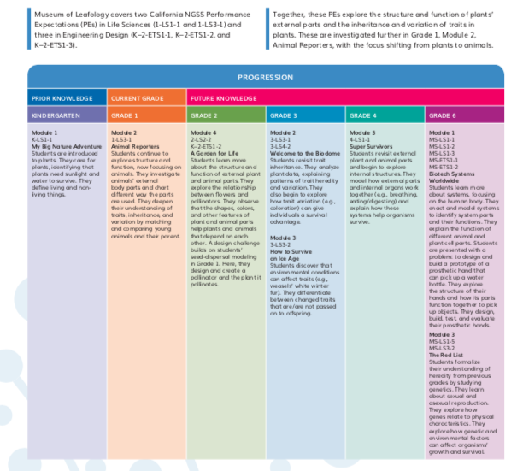  Performance Expectations Progressions table
- Develop models to further their understanding of plant and animal life cycles, and how they help survival. (CCC-1, SEP-2, LS1.B)  - Construct arguments that plants and animals have internal and external structures that help them to survive, reproduce, grow and thrive. (CCC-4, CCC-6, SEP-6, LS1.A) (G4M1DQ1 TE p. 1)  Module Sequence  The Module Contents identifies the sequence of three dimensions addressed in Museum of Leafology and how they build on each other. For example, students observe the parts of a plant, and identify their function. They go on to build an increasingly sophisticated understanding of how plants use these external structures to disperse seeds and defend themselves. They come to understand that plants are alike in some ways, and different in others.  Driving Question Sequence  Each DQ Divider tells the story of how the students will use the three dimensions sequentially to answer the question posed.  - For example, the DQ4 Divider explains that students will observe the seedlings they planted and record the similarities and differences. Students explore plants in nature, sketch model plants (SEP-2), and use the concepts of patterns (CCC-1) and structure and function (CCC-6) to compare and contrast young and adult plants (1-LS3-1). (DQ4 Divider TE p. 125) |  |  | 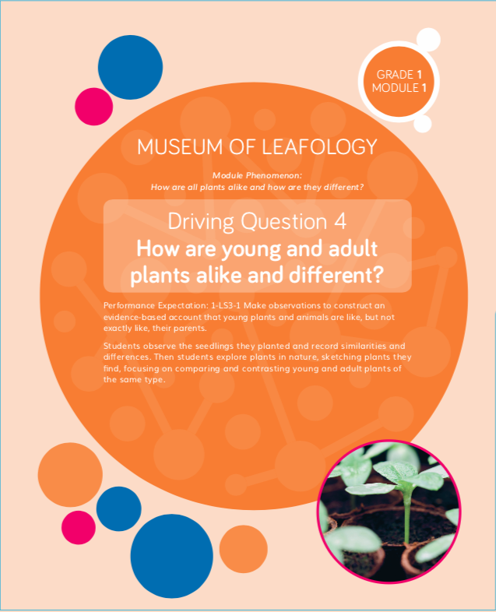  DQ4 Divider TE p. 125
- The Driving Question Overviews and Lesson Overviews identify the dimensions used in each lesson and detail how the dimensions relate to the learning experience. For example, the DQ4 Overview explains that students will observe their seedlings and make drawings of the similarities and differences (L1 and L2). Later, they will compare seedlings and their parents by watching a video and completing a matching activity (L4). (DQ4 Overview TE p. 126)  Lesson Sequence  The five-part Twig Science lesson structure has been designed to support students to monitor what and how they have learned across the three dimensions on a daily basis.  Spark: An engaging hook activity motivates students for the investigations ahead  Investigate: Students think like scientists and design like engineers through hands-on, digital, video and informational text investigations.  Report: Students articulate what they’ve learned, citing evidence and their use of the three dimensions  Connect: Students make connections to the Driving Questions and Module Phenomenon while building knowledge of CCCs and SEPs  Reflect: Students use different means to think about what they have learned so far and how they can use their new understandings to better figure out phenomena/problems. |  |  | 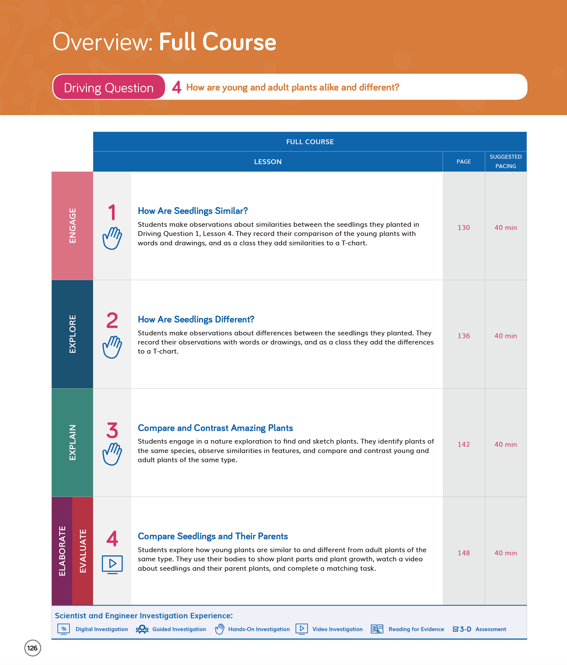  DQ4 Overview TE p. 126
Each Lesson Overview includes the lesson’s targeted standards, the 3-D Learning Objectives, and a brief summary of each lesson section with suggested pacing. For example:  - The DQ4L4 3-D Learning Objectives (TE p. 148) explicitly state that students will identify similarities and differences between young plants and their parents, and construct an explanation of how young plants and their parents are alike but not exactly the same.  Flow of DCIs  The DCIs follow a logical sequence, supporting students to gain the knowledge they need to address the Module Investigative Problem.  - In DQ1L1 and L2, students review their prior knowledge with a class read-aloud about living things, then sort cards into living and non-living things (K-LS1-1).  - In DQ2, students observe seedling roots, and learn about the different parts plants have through hands-on, video, close reading, and interactive investigations. They learn a song about plant parts, then write about what each part does (LS1.1).  - In DQ3, students compare different seeds and gather information about how they disperse. They then design, make and test a seed model that can be dispersed by the wind (LS1.A).  - In DQ4, students compare different plants, listing similarities and differences, through hands-on and video investigations (LS1.A, 1-LS3-1).  - In DQ5, students investigate how different plants use their external structures for defense and protection. They use video and close readings to gather information (LS1.A).  - In DQ6, students apply what they have learned so far in the module to design a solution to a human problem, mimicking the structure of plants (1-LS1-1, LS1.A, ETS1.A, ETS1.B).  - In DQ7, the module culminates in the the class presenting their museum rooms to the public, and share what they have learned about plants over the course of the module. |  |  | 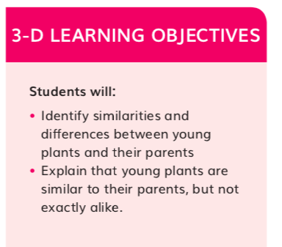  DQ4L4 3-D Learning Objectives TE p. 148
Flow of SEPs and CCCs  The SEPs and CCC’s follow a logical sequence supporting students to gain expertise of the practices and concepts they need to address the Module Phenomenon.  - In DQ1L2 Reflect (TE p. 17), students reflect on the card sorting activity and apply the concept of patterns (CCC-1) to compare and contrast living and non-living things. |  |  | 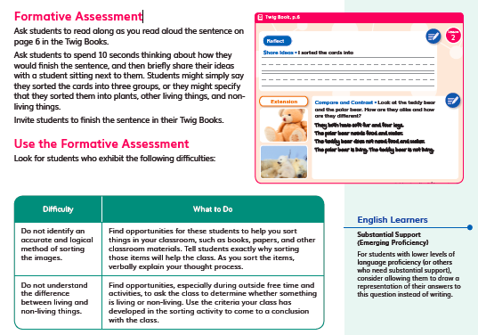  DQ1L2 Reflect TE p. 17
- In DQ2L3, students observe (SEP-3) the roots of their seedlings (DQ2L3 Spark TE p. 58), then use an interactive model (SEP-2) to build a plant from different parts. They complete a multiple choice formative assessment about the function of different plant parts (CCC-6). (DQ2L3 Reflect TE p. 63) |  |  | 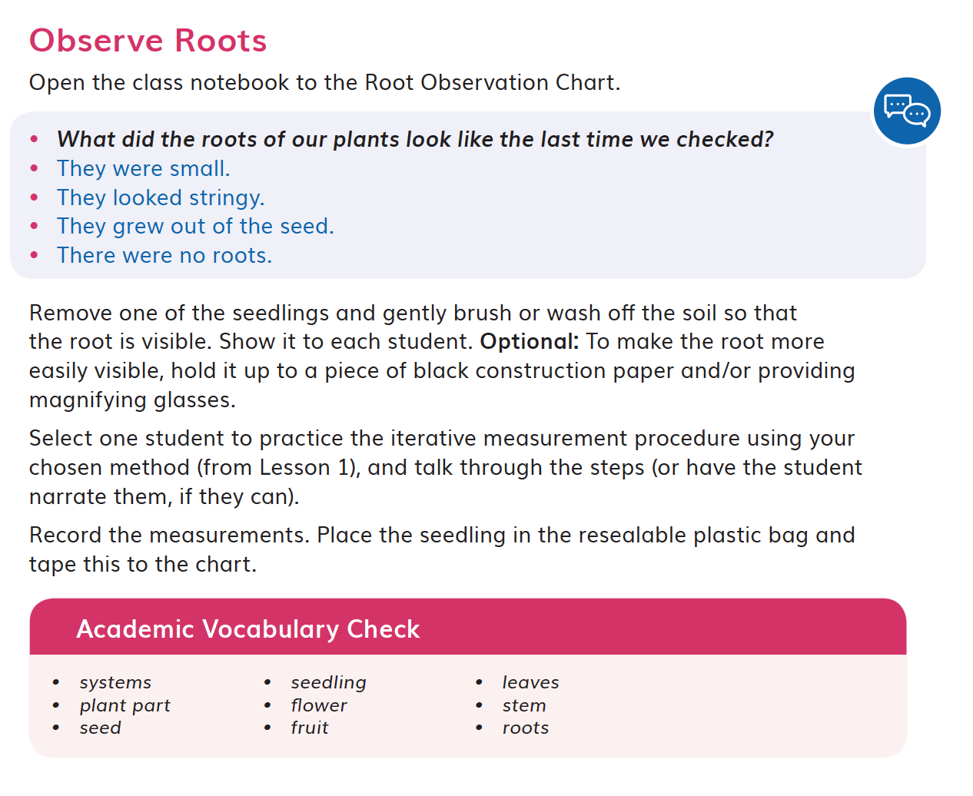  DQ2L3 Spark TE p. 58  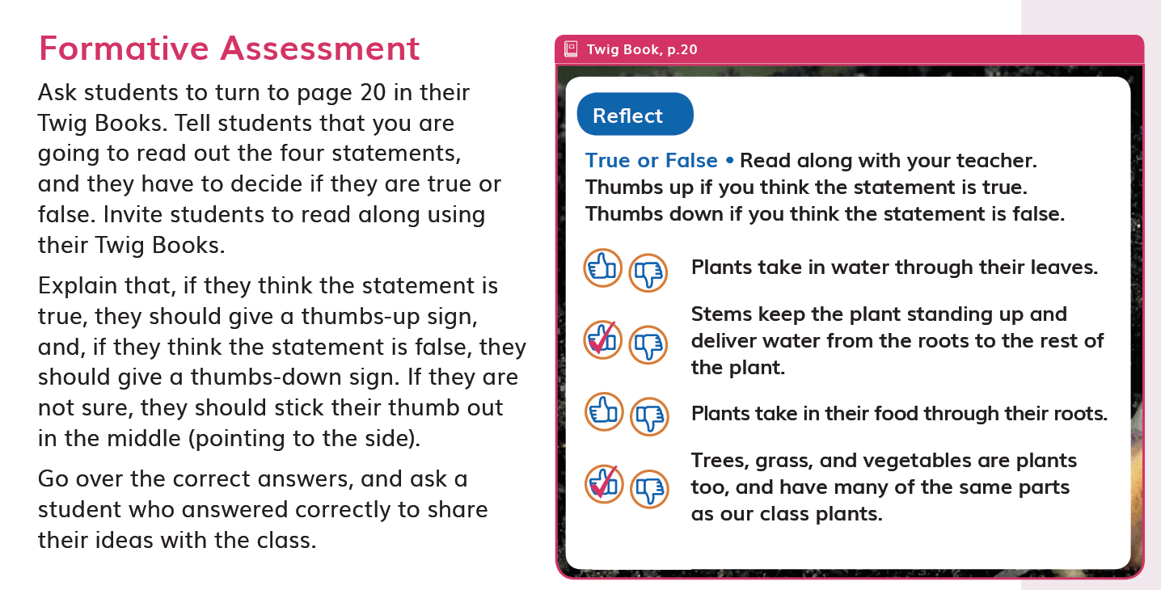  DQ2L3 Reflect TE p. 63
- In DQ3L2, students gather information (SEP-8) from videos, poems, and a class reading about seed dispersal. They draw a model (SEP-2) to show one method of seed dispersal (CCC-2). (DQ3L2 Report TE p. 90) |  |  | 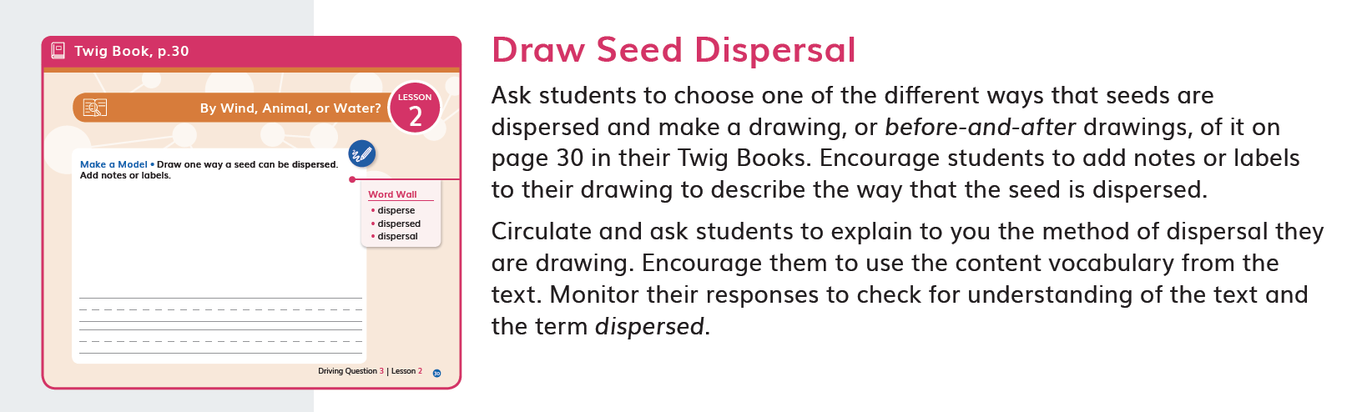  DQ3L2 Report TE p. 90
- In DQ4L3 Spark (TE p. 145), students apply the concept of patterns (CCC-1) to identify similarities and differences between parent plants and seedlings, then use their evidence to construct an oral response (SEP-6). |  |  | 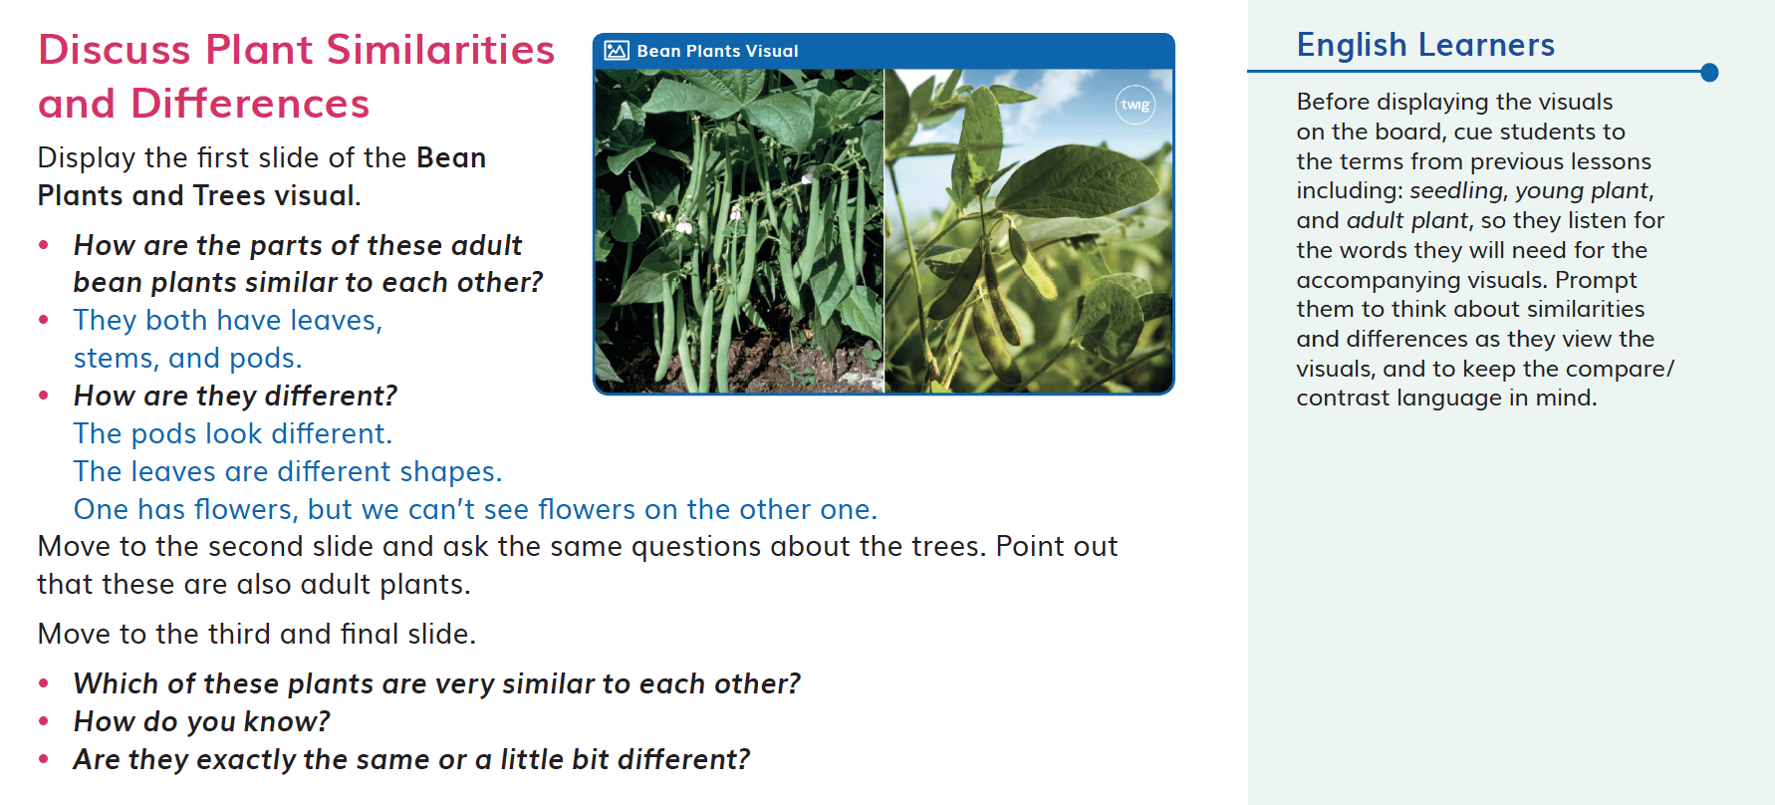  DQ4L3 Spark TE p. 145
- In DQ5L2 Investigate (TE p. 171), students apply what they have learned about how structures help plants defend themselves, and how they function (CCC-6), to make a clay model (SEP-2) of an imaginary plant. |  |  | 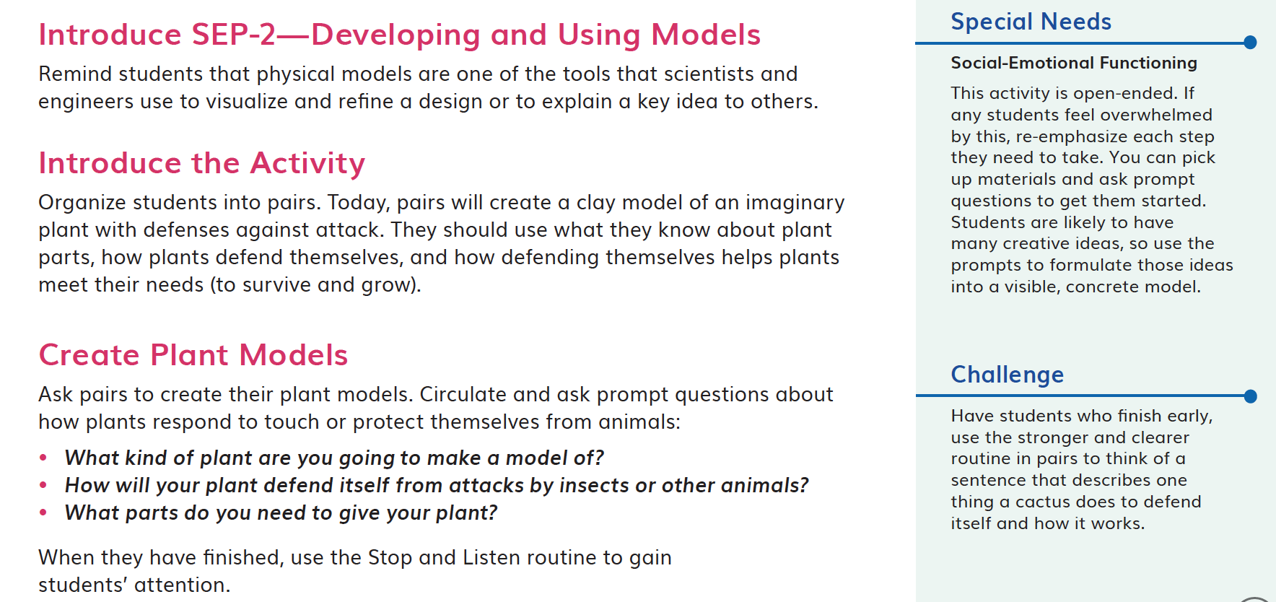DQ5L2 Investigate TE p. 171
- In DQ6 Investigate (TE p. 204), students apply what they have learned about plant structures, and their functions (CCC-6) in the module to design a solution (SEP-1, SEP-6) to a human problem that mimics the plants. |  |  | 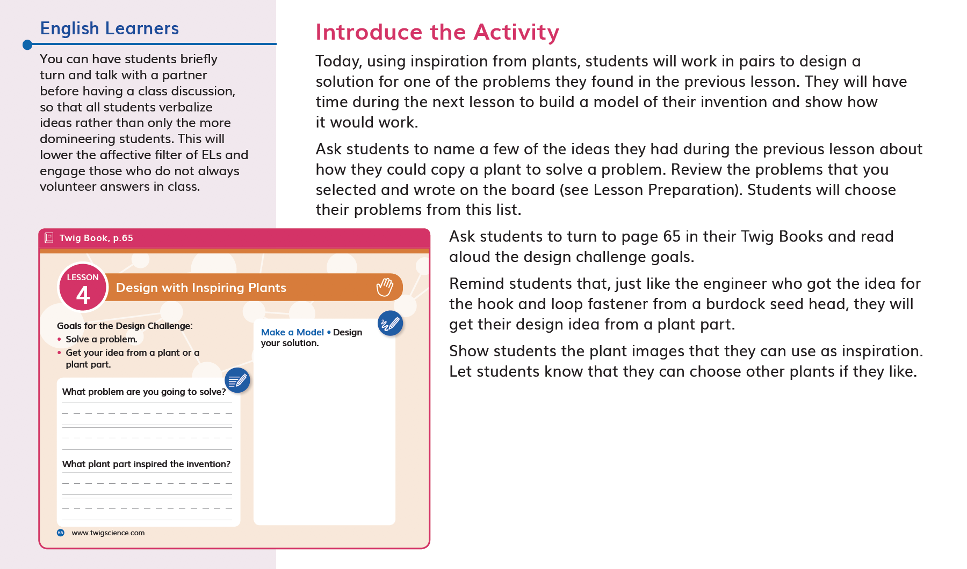DQ6L4 Investigate TE p. 204
- In DQ7, students communicate (SEP-8) everything that they have learned about plants over the course of the module by presenting in a presentation of their museum rooms. They revise their presentations to add the evidence (SEP-7) that they have gathered. (DQ7L1 Connect TE p. 228) |  |  | 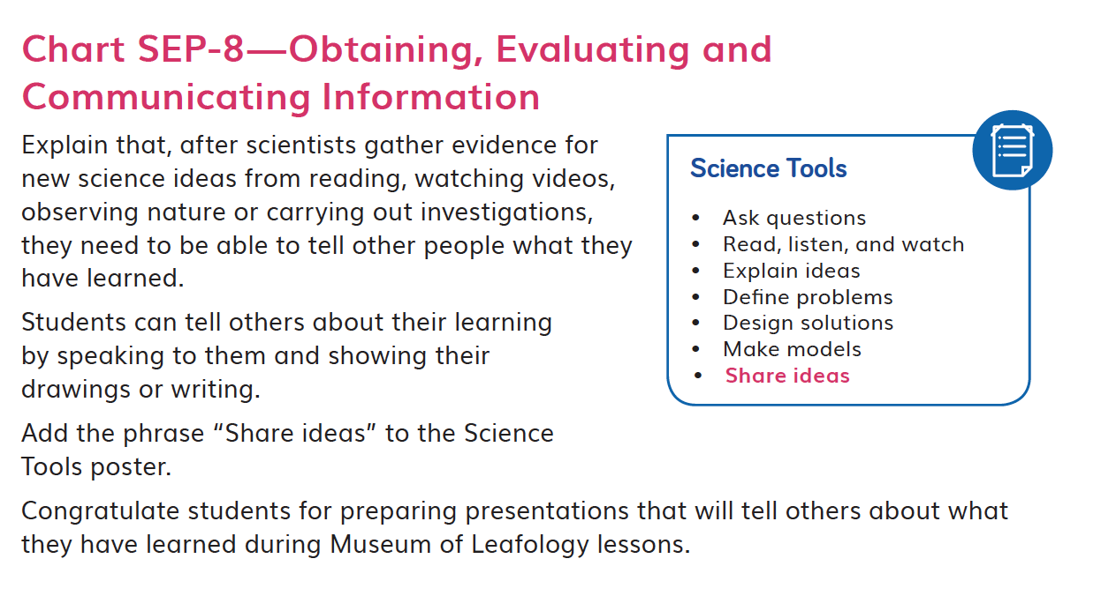  DQ7L1 Connect TE p. 228

