Designed for the NGSS: Foundations Teacher Support Evidence Chart

Teacher materials… | Strong | Adequate | Weak
F1. Presence of Phenomena/Problems. Identify and provide background information about the phenomena/problems in the unit and how they match the targeted learning goals. | ✓
F2. Presence of Three Dimensions. Identify and provide background information about each of the three dimensions in the unit. Also take note of any support for nature of science and engineering, technology, and applications of science.  - the SEPs  - the DCIs (including engineering)  - the CCCs  - also note NoS and ETS | ✓
F3. Presence of Logical Sequence. Identify and provide background information on the sequence of learning in the unit. | ✓

Strengths related to these Teacher Supports
F1. Presence of Phenomena/Problems.
The module is strong at identifying and providing background information about the phenomena/problems in the unit and how they match the targeted learning goals.
Evidence  - A Module Introduction (TE p. i) online and in print sets out at high level how students will solve the Module Phenomenon. | 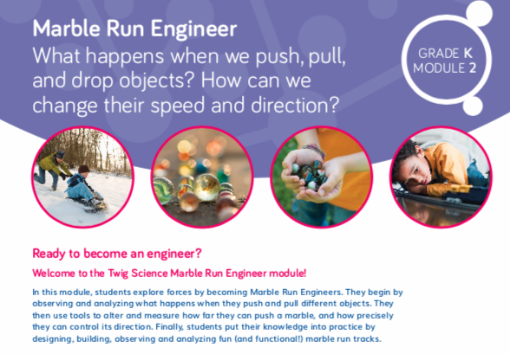  Module Introduction TE p. i
- Teacher Background Information on the phenomena/problems and DCIs addressed in every Driving Question (DQ) is explained simply in Q&A format with supporting diagrams and visuals. A glossary of scientific terms is also provided. For example, DQ2 provides background information on gravity, engineers, and how we can make marbles move in certain ways, while DQ3 explains the design process and how to build a good marble run. | 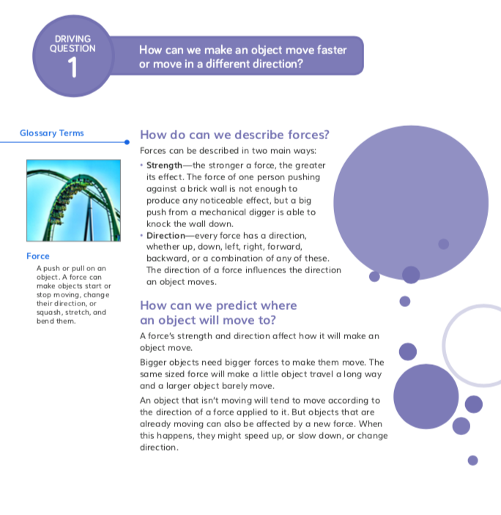  Teacher Background Information
F2. Presence of Three Dimensions.
The module is strong at identifying and providing Teacher Background Information about each of the three dimensions in the unit. It also supports opportunities to connect to the Nature of Science and Engineering, Technology, and Applications of Science.
Evidence  - A digital Guide to SEPs and CCCs provides a clear explanation for each practice and concept with guidance on what these skills should look like in a Kindergarten classroom, with specific reference to how students plan and carry out investigations (SEP-3) and construct explanations and design solutions (SEP-6) in Grade K Module 2.  - Additional module specific support is frequently given at point of use in the instructional materials for all dimensions. For example, in DQ1L2, support is given on connecting the learning activity to SEP-5 (Using Mathematics and Computational Thinking) (DQ1L2 Connect TE p. 18). | 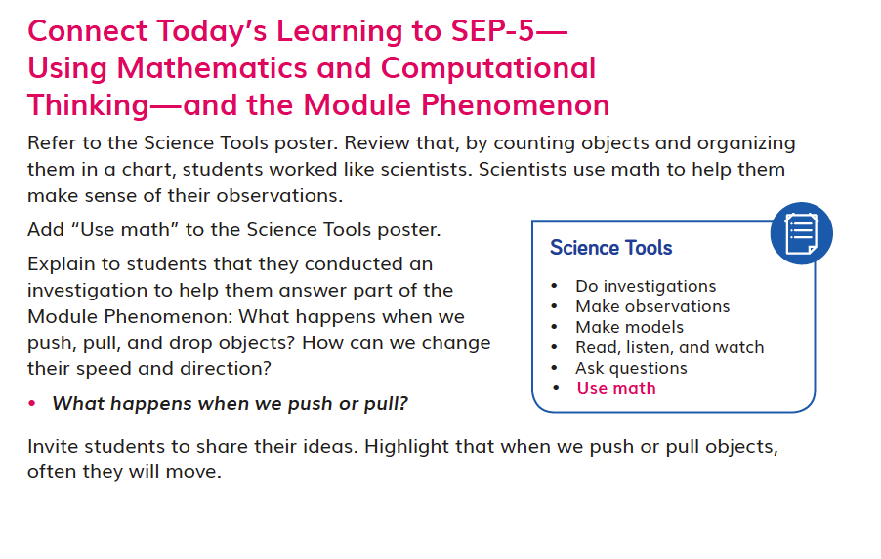  DQ1L2 Connect TE p. 18
F3. Presence of Logical Sequence.
The module is strong at Identifying and providing background information on the sequence of learning in the unit.
Evidence  - A Module Introduction video provides the teacher with an engaging overview on the Module Phenomenon explored in Marble Run Engineer, the sequence of learning, and an explanation of how the PEs are addressed and how they build on each other. | 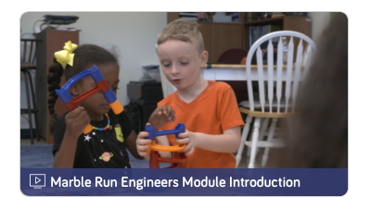  Marble Run Engineers Module Introduction video
- The Module Contents (TE pp. ii–iii) helps teachers identify the sequence of three dimensions addressed in Marble Run Engineer and states how they build on each other. For example, students are introduced to motion and learn about pushes and pulls in DQ1, before they investigate using pushes and pulls to change the speed and direction of an object in DQ2. In DQ3, they use their learning to predict and test how a marble will move in marble runs that they have designed. | 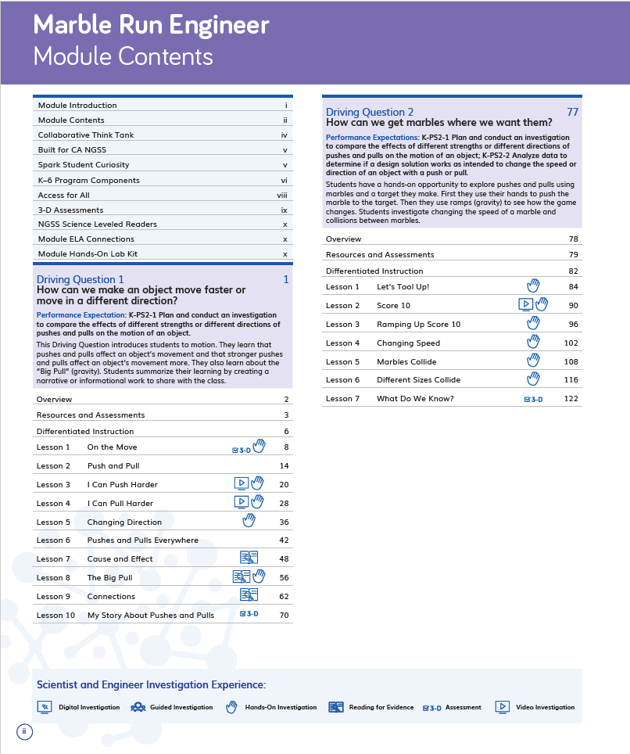  Module Contents TE pp. ii–iii
- More detail is provided in each Driving Question Divider which tells the story of how the students will sequentially use the three dimensions in each lesson in the Driving Question to answer the question posed. For example, in DQ2, students plan and carry out different investigations into pushes and pulls, and analyze their data to see how the results change between investigations. This knowledge helps them establish an answer to the Driving Question: How can we get marbles where we want them? | 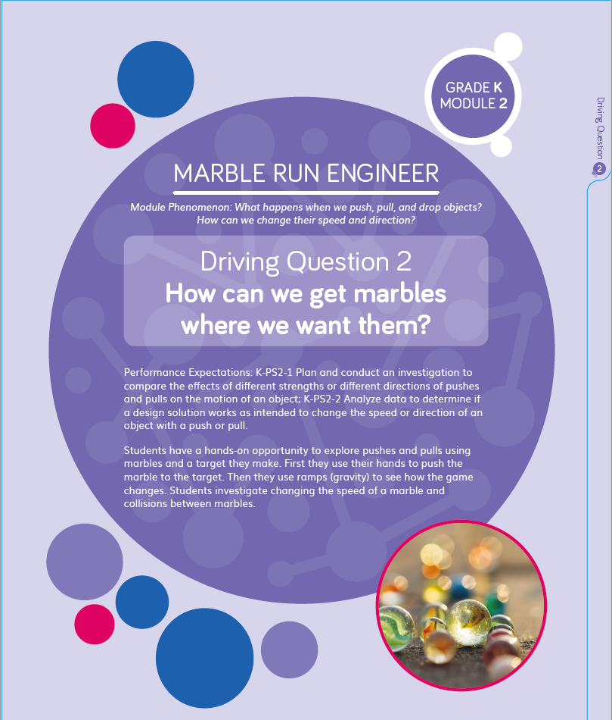  Driving Divider
- The Lesson Overview (DQ3L5 TE p. 158) identifies the dimensions used in each lesson, while the graphic organizer details how the dimensions relate to the learning experience. For example, in DQ3, L5 the overview explains that in this lesson students will use a marble run to define a design problem (ETS1.A), develop a model (SEP-2), conduct a test (SEP-3), and analyze observations (SEP-4). | 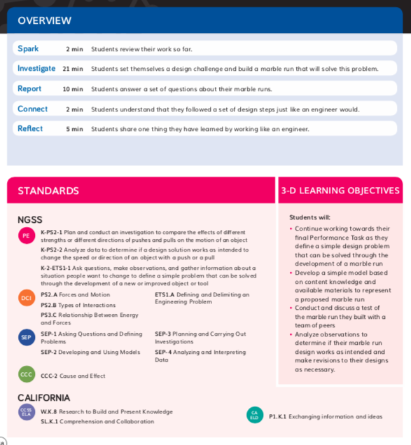  DQ3L5 Lesson Overview TE p. 158

Designed for the NGSS: Foundations Teacher Support Evidence Chart

Teacher materials… | Strong | Adequate | Weak
SW1. Phenomena/Problems. Provide support and strategies for how to help students figure out/solve authentic and relevant phenomena/problems using the three dimensions. | ✓
SW2. Three-dimensional Conceptual Framework. Provide support and strategies for how teachers  - help students develop a conceptual framework of scientifically accurate understandings and abilities related to  - DCIs, SEPs, and CCCs  - NoS and ETS  - ELA and math  - create a learning environment that values students’ ideas, motivates learning, and helps students negotiate new meaning as they interact with others’ ideas, new information, and new experiences. | ✓
SW3. Prior Knowledge. Provide support and strategies to leverage students’ prior knowledge and experiences to motivate learning. | ✓
SW4. Metacognitive Abilities. Provide support and strategies for how to help students develop metacognitive abilities. | ✓
SW5. Equitable Learning Opportunities. Provide resources and strategies for how to ensure that all students, including those from non-dominant groups and with diverse learning needs, have access to the targeted learning goals and experiences. | ✓

Strengths related to these Teacher Supports
SW1. Phenomena/Problems.
The module is strong at providing support and strategies for how to help students figure out authentic and relevant phenomena using the three dimensions.
Evidence  - The instructional materials have been designed to support the teacher to guide students on a scaffolded learning journey to explore the Module Phenomenon: What happens when we push, pull, and drop objects? How can we change their speed and direction? They tackle the questions one Driving Question at a time, applying the three dimensions with increasing sophistication, building the skills and knowledge they need through a series of investigations.  - The teacher is supported in the instructional material to connect their learning experiences back to the big idea at strategic points, with class discussions where students share their ideas and evidence for answering the Driving Questions and Module Phenomenon. For example, in DQ1 L2, students share ideas about what happens when they push or pull objects, answering the first part of the Module Phenomenon (DQ1L2 Connect TE p. 18). | 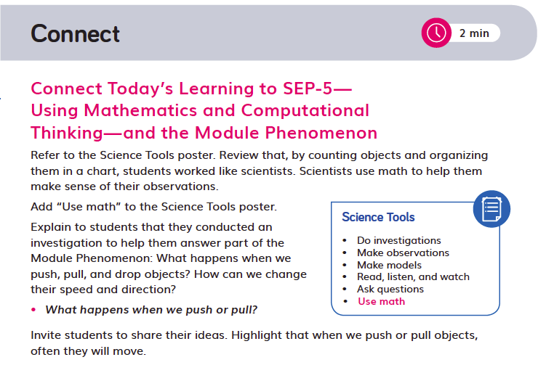  DQ1L2 Connect TE p. 18
SW2. Three-dimensional Conceptual Framework.
The module is strong at providing support for helping students develop a conceptual framework across the dimensions and creating a learning environment that values all students.
Evidence
- The instructional materials are designed to elicit students’ understanding of forces and motion at the start of the module and then develop their understanding over time, through hands-on and reading investigations. Students follow a sequence of Driving Questions designed to progressively build their skills and scientifically accurate understandings.
- Opportunities for students to articulate, question, and revise their conceptual framework are woven into the instructional resources, supporting teachers to assess the progression of their scientifically accurate understandings. Strategies on how to tailor instruction for students who require more support are provided for teachers. For example, in DQ3, students use what they have learned about forces and motion as they predict how a marble will travel through a marble run before testing it. They define a design problem, develop a model based on their learning, and build, test, and revise their marble runs. They present their marble runs to the class and use their understanding of the Module Phenomenon to explain how the marble moves through their design. This allows teachers to gain an understanding of how much progress students have made.
- Support is given for how to create a positive learning environment where all contributions are valued along with activities that support teamwork and collaboration. For example, the teacher is prompted to praise thoughtful answers when students share ideas (DQ1L1 TE p. 10). Many of the activities involve students working in pairs and teams. Students understand what effective teamwork looks and feels like, as they were introduced to the Our Scientist Song video in Grade K Module 1 and learned that they need to share tools and treat each other kindly. Students revisit the song twice in Grade K Module 2, in DQ1L9 TE p. 64 and DQ3L4 TE p. 154. Throughout the module, students are given many opportunities to support each other. For example, students are led to understand that talking through ideas with a partner helped them understand their own ideas better (DQ1L4 TE p. 34). Students are also reminded to listen carefully and quietly, respecting the speaker, as their classmates present their marble runs (DQ3L6 TE p. 166).
SW3. Prior Knowledge.
The module provides strong support and strategies to leverage students’ prior knowledge and experiences to motivate learning.
Evidence
- Teachers are supported with strategies to leverage prior knowledge of movement through resources such as a Prior-Knowledge Read-Aloud in DQ1L2 Spark TE p. 16.
- Additional support at provided at point of use for strategies to leverage prior knowledge and answer the Module Phenomenon. For example, the teacher is prompted to remind students that, in Kindergarten Module 1, they learned about cause and effect (DQ1L5 TE p. 41), and claims and evidence (DQ2L3 TE p. 100).
SW4. Metacognitive Abilities.
The module provides strong support and strategies for how to help students develop metacognitive abilities.
Evidence  - Support is given at point of use for how to develop students’ metacognitive abilities. The Connect of the lesson often guides the teacher to draw students’ attention to their growing use of the SEPs and CCCs, understanding of the Driving Question, or ability to solve the Module Phenomenon. For example, in DQ1L8 the teacher is supported to help students identify their use of SEP-3, SEP-4, and SEP-8 (DQ1L8 Connect TE p. 60), and in DQ1L10 students answer the Driving Question (DQ1L10 TE p. 75). | 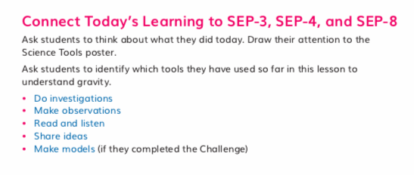  DQ1L8 Connect TE p. 60
- Discussions following a diagnostic pre-assessment (Pre-Exploration) in DQ1 support teachers to track students’ understanding of the three dimensions that make up the module’s PEs. For examples, see: DQ1L5 TE Spark p. 38, DQ1L5 Investigate TE p. 40, and DQ1L9 Connect TE p. 68). | 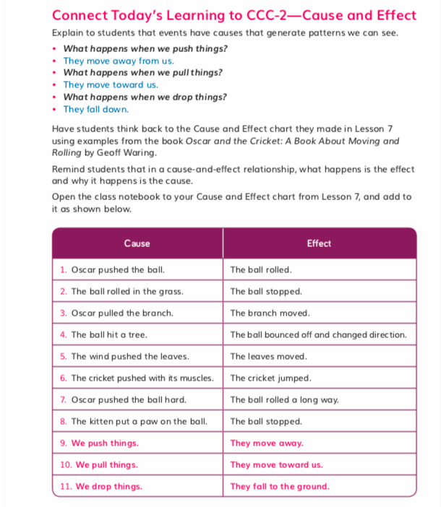  DQ1 L9 Connect TE p. 68
- Meta-Think-Aloud Language Routines (DQ1L6 TE p. 45) support teachers in helping students develop an understanding of how they learn particular concepts or why they approach activities in certain ways. For example, in DQ1L6, guidance is provided to help the teacher analyze the Change Direction visual for students, explicitly pointing out key aspects of the image and their significance. | 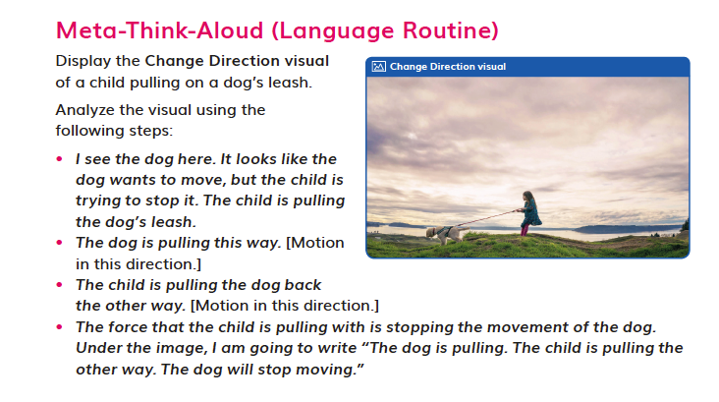  Meta-Think-Aloud (DQ1L6 TE p. 45)
SW5. Equitable Learning Opportunities.
This module provides strong resources and strategies to ensure that all students have access to the targeted learning goals and experiences.
Evidence  - Frequent support is given at point of use in all lessons on strategies to ensure that all students have access to the targeted learning goals. Numerous scaffolds are provided for Special Needs, English Learner, and Standard English Learner students, for example, in DQ1L3 TE p. 27 and DQ1L4 TE p. 34.  - The reader Pushes and Pulls that complements the module is provided at four levels—Above, On, Below, and English Learner—with matching lesson instruction in the TEs/online.  - Digital versions of the Twig Book and readers have text to speech functions.  - Short, high quality videos that engage and support learners with diverse learning needs are frequently provided to spark interest, summarize key concepts, and make the ideas relevant to this age group. For example, the Exploring Forces video in DQ1L4 reinforces key concepts about forces, pushes, and pulls, while the Engineering: Jetpack video in DQ2L2 provides a real-world example of engineering. It also gives context to the idea that failure can be a positive learning experience, helping cultivate confidence as scientists and engineers. | 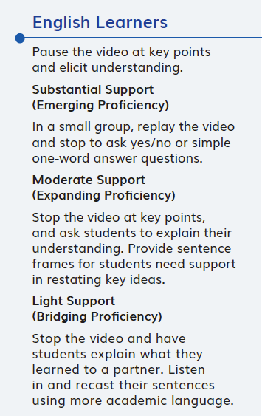  DQ1L4 TE p. 34

Designed for the NGSS: Foundations Teacher Support Evidence Chart

Teacher materials… | Strong | Adequate | Weak
SP1. Three-dimensional Performances. Provide support with a range of sample student responses and/or rubrics for interpreting evidence of student learning across the three dimensions, specific to the element of each dimension, and related to the phenomenon/problem that provides context for the student performance. | ✓
SP2. Variety of Measure. Provide guidance and scoring tools for using a variety of measures matched to the targeted learning goals to help students monitor their progress toward learning goals and reflect on what they have learned, how they learn it, and how to use metacognition productively. | ✓
SP3. Student Progress Over Time. Provide guidance for using formative and summative assessments to monitor student progress over time. Examples include support for: capturing student growth; interpreting results; adjusting instruction and planning for future instruction; providing feedback to students; prompting students to consider what and how they’ve learned. | ✓
SP4. Equitable Access. Provide support and strategies for ensuring that assessments are accessible to students from diverse backgrounds and with diverse learning needs. | ✓

Strengths related to these Teacher Supports
SP1. Three-dimensional Performances.
The module provides strong support with a range of sample student responses and rubrics for interpreting evidence of student learning across the three dimensions. These are specific to the element of each dimension and related to the Module Phenomenon that provides the context for the student performance.
Evidence
- Rubrics are provided for the Performance Tasks. The rubrics are specific to certain Performance Expectations (PEs) with the assessed dimensions highlighted.
SP2. Variety of Measure.
The module provides strong guidance and scoring tools for using a variety of measures matched to the targeted learning goals to help students monitor their progress toward learning goals and reflect on what they have learned, how they learn it, and how to use metacognition productively.
Evidence  - Teacher support for guidance and scoring tools matched to the learning goals is integrated through the module. In addition to the rubrics mentioned above, the printed Teacher Edition contains Twig Book reduxes with sample student answers where appropriate, so at a glance teachers have guidance on what student understanding looks like (for example, DQ1L1 TE p. 13). A digital version of this completed Twig Book is available online.  - Assessments are multimodal and support a variety of learning styles and abilities. They include:  - Performance Tasks (physical, oral, written, and drawn; DQ1L10 TE p. 74, DQ2L7 TE p. 126, DQ3L6 TE p. 167)  - Discussions (DQ1L6 TE p. 44, DQ2L6 TE p. 119)  - Multiple choice (DQ1L6 TE p. 44)  - Constructed responses (written, drawn, and oral; DQ1L5 TB p. 14, DQ2L6 TB p. 43)  - Text to speech function is provided for all digital assets. | 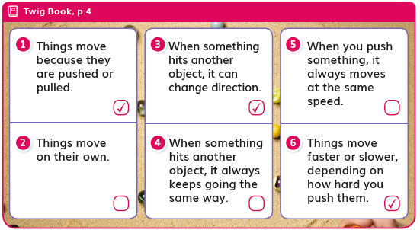  DQ1L1 TE p. 13
- Class discussions are supported with suggested question scaffolds and sample answers (DQ1L4 TE p. 34, DQ1L9 TE p. 66, DQ2L2 TE. p. 88, DQ3L3 TE p. 148). | 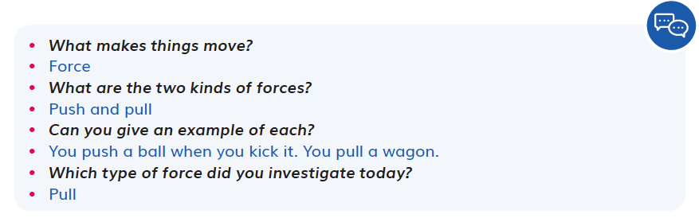  DQ1L4 TE p. 34
- The Reflect of most lessons integrates assessment opportunities for students to reflect on what they have learned and how they used the three dimensions to grow their understanding of the module phenomena and problems (DQ1L3 TB p. 10, DQ1L7 TB p. 20, DQ2L3 TB p. 36, DQ2L4 TB p. 38, DQ3L4 TB p. 62). | 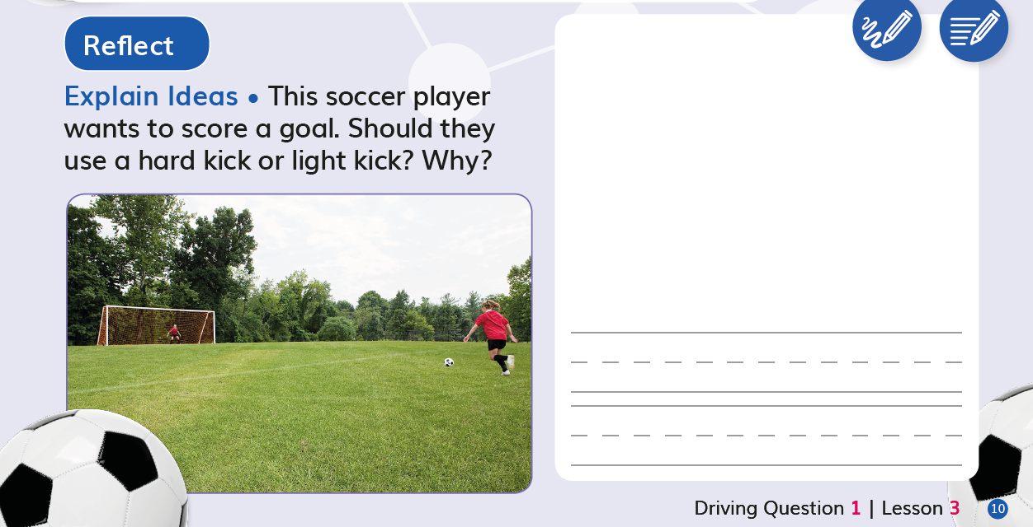  DQ1L3 TB p. 10
SP3. Student Progress Over Time.
The module provides strong guidance for using formative and summative assessments to monitor student progress over time. Examples include support for: capturing student growth; interpreting results; adjusting instruction and planning for future instruction; providing feedback to students; prompting students to consider what and how they’ve learned.
Evidence  - Teachers can elect to administer the Pre-Exploration digitally or in print. Answers are tagged to specific dimensions and, if administered digitally, teachers will be able to track student growth in level of attainment of the dimensions over time and tailor instruction accordingly. Teachers can also provide students with feedback digitally. Teachers can opt to add the scores manually for all non-digital assessment tasks.  - The downloadable Progress Tracker supports teachers to track students' mastery of their misconceptions as assessed in the Pre-Exploration as well as the results of Formative Assessments of the three dimensions across the Driving Questions. For example, DQ1L4 Investigate TE p. 32. Guidance for teachers on how to adjust instruction for students needing more support to clear up their misconceptions is provided at point of use in the instructions (for example, DQ1L4 Spark TE p.30, DQ1L5 Spark TE p. 38, DQ1L5 Investigate TE p. 40). | 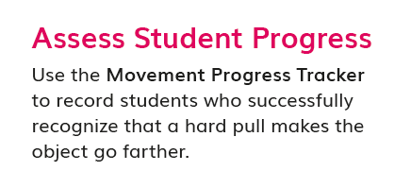  DQ1L4 Investigate TE p. 32
SP4. Equitable Access.
The module provides strong support and strategies for ensuring that assessments are accessible to students from diverse backgrounds and with diverse learning needs.
Evidence  - Assessments of the three dimensions are multimodal and include multiple choice, writing, drawing, physical models, and oral presentations, allowing all students to access a range of assessment types to suit their learning style and/or reading level.  - The digital TB and digital assessment items (Pre-Exploration) have a text to speech function allowing students of all reading levels to access the assessments.  - Writing, Reading, Listening, and Speaking domain tasks dedicated to monitoring science-relevant English language development are integrated into the core instructional resources (DQ1L9 TE p. 66) and the On-Level reader lessons (Chapter 3 Second Read TE p. 185). | 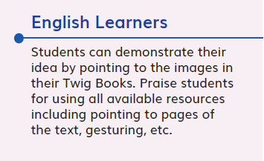  DQ1L9 TE p. 66

Designed for the NGSS: Foundations | High Quality  5 | Medium Quality  3 | Low Quality  1
TS1. Phenomenon/Problem Driven Three-Dimensional Learning. Teacher materials provide:  - background information about the phenomena or problems included in the learning sequence and across sequences.  - an explanation of the role of phenomena or problems in driving student learning.  - rationale for why the unit phenomena or problems were selected for the targeted DCIs, SEPs, and CCCs.  Refer to F1, F2, SW1, SW2, SP1 | Materials provide clear guidance to teachers on how students develop, use, and integrate the three dimensions to make sense of phenomena or design solutions to problems. | Materials provide some guidance to teachers about how students develop, use, and integrate the three dimensions. | Materials provide little guidance on developing, using, or integrating them to make sense of phenomena or design solutions to problems.
TS2. Coherence. Teacher materials describe and provide a rationale for:  - the conceptual framework and sequence of ideas, practices, and learning experiences in the learning sequences and across sequences.  - strategies for linking student experiences across lessons to ensure student sense-making and/or problem-solving focused on phenomena or problems is linked to learning across all three dimensions.  - Connections to other science domains, nature of science, engineering, technology, and applications of science, math, and ELA.  Refer to F2, F3, SW2, SP2 | Materials provide strong support for understanding unit coherence and helping students link experiences to learning across all three dimensions and to phenomena or problems. | Materials provide some support for understanding unit coherence and helping students link experiences to learning across all three dimensions and to phenomena or problems. | Materials provide little support for understanding unit coherence and helping students link experiences to learning across all three dimensions and to phenomena or problems.
TS3. Effective Teaching. Teacher materials support the use of and provide a rationale and evidence of effectiveness for strategies that:  - support students in learning through authentic and meaningful phenomena or design problems.  - support student learning across the three dimensions.  - make student thinking visible; promote reasoning, sense-making, and problem- solving; challenge student thinking; and develop metacognitive abilities.  Refer to SW1, SW2, SW3, SW4, SP3 | Materials provide rationale and robust support for implementing strategies that enhance student performances, thinking, and metacognition. | Materials provide some rationale and support for implementing strategies that enhance student performances, thinking, and metacognition. | Materials provide little rationale and support for teachers to implement strategies that enhance student performances, thinking, and metacognition.
TS4. Support for Students with Diverse Learning Needs. Teacher materials provide an array of strategies:  - to support student access to the targeted learning goals, experiences, and performances.  - that help teachers differentiate instruction.  Refer to SW5, SP4 | Materials include robust and comprehensive strategies for supporting learners with diverse needs. | Materials include some robust strategies for supporting learners with diverse needs. | Materials include few robust strategies for supporting learners with diverse needs.
TS5. Support to Monitor Student Progress. Materials provide support for teachers to:  - monitor student learning and progress over time.  - make decisions about instruction and provide feedback to students.  Refer to SW3, SW4, SP1, SP2, SP3 | Materials provide robust support for interpreting and using data generated from assessments. | Materials provide some support for interpreting and using data generated from assessments. | Materials provide little support for interpreting and using data generated from assessments.

Designed for NGSS: Teacher Support Rubric
Analyze Evidence
Directions:
- Review the Designed for NGSS: Foundations Rubric.
- Reflect on the evidence (or lack of evidence) that you and your team gathered and represented.
- Record strengths and limitations for each criterion based on your evidence. Cite specific examples.

Strengths
TS1. Phenomenon/Problem Driven Three-Dimensional Learning.
The Module materials are High Quality 5 in regards to TS1.
They provide clear guidance to teachers on how students develop, use, and integrate the three dimensions to make sense of phenomena or design solutions to problems.
Evidence
The flow of DCIs, SEPs and CCCs follow a logical sequence supporting students to gain expertise of the practices and concepts they need to address the Module Phenomenon.

- DQ1: How can we make an object move faster or move in a different direction? Students ask questions and define problems (SEP-1) relating to motion, and plan and carry out investigations into forces and motion (SEP-3, PS2.A, PS3.C). They analyze and interpret images and investigation results (SEP-4), and identify cause and effect in their results and in texts (CCC-2). They demonstrate their new understandings of pushes and pulls by writing a short narrative or informational text (SEP-8).
- DQ2: How can we get marbles where we want them? Students conduct a series of investigations into the problem of changing the speed or direction of an object (PS2.A, PS2.B, PS3.C, SEP-3). They analyze and interpret their data (SEP-4), relating their results to cause and effect (CCC-2), and use their investigation results to debate which approach was more effective (SEP-7). Finally, they use their learning from the Driving Question to write and draw how they can change the speed or direction of a marble (SEP-2, SEP-8).
- DQ3: How do we understand and design a marble run? The module culminates in an Engineering Design Challenge. Students define and delimit an engineering problem (ETS1.A, SEP-1) and utilize their knowledge of forces and motion (PS2.A, PS2.B, PS3.C) to solve the problem. They develop and use models (SEP-2) as they design and build their marble runs. They present their marble runs and demonstrate their understanding of the Module Phenomenon (SEP-8).
TS2. Coherence.
The Module materials are High Quality 5 in regards to TS2.
They provide teachers with a clear conceptual framework in a logical sequence, strategies for linking student experiences across lessons, and connections to other science domains, CNS (NoS), CETAS (ETS), math, and ELA.
Evidence
- The Module Phenomenon challenges students to be creative problem solvers, immersing them in engaging challenges that require mastery of the three dimensions of NGSS to solve.
- The instructional materials have been designed to support the teacher to guide students on a scaffolded learning journey to solve the Module Phenomenon: What happens when we push, pull, and drop objects? How can we change their speed and direction? They tackle the problem one Driving Question at a time, applying the three dimensions with increasing sophistication, building the skills and knowledge they need through a series of investigations.
- The Module Phenomenon targets the DCIs, SEPs, and CCCs explicitly stated in K-PS2-1, K-PS2-2, and K–2-ETS1-1.
- A digital guide to SEPs and CCCs provides a clear explanation for each practice and concept with guidance on what these skills should look like in a Kindergarten classroom, with specific reference for how students ask questions and develop investigations in GK M2.
- where students define a problem that they want to solve with their marble run, and then design, build, test, revise, and present their final marble runs.
- Additional module specific support is frequently given at point of use in the instructional materials for all dimensions. For example, in DQ1L2, support is given on connecting the learning activity to SEP-5 Using Mathematics and Computational Thinking (DQ1L2 TE p. 18).  - Opportunities to articulate, question, and revise students’ conceptual framework are woven into the instructional resources with teachers supported with continuous assessment for learning strategies and with support for how to tailor instruction accordingly.  - Assessments are well matched to the phenomena and dimensions being assessed. For example, in the Formative Assessment in DQ1L5, students write, draw, or verbalize to communicate information about what they have learned about forces and motion and cause-and-effect relationships. | DQ1L2 TE p. 18
- Driving Question introductions and overview pages show the sequence of learning, the rationale behind it, and the three-dimensional aspect of the activities.
- Connections to other science domains are covered across the sequence of lessons and Driving Questions.
- Throughout the module, students use their class Science Tools poster to track their growing use of the SEPs. The poster is blank at the start of the year, and the eight SEPs are added when each one is used for the first time. In this module, students add:
- Ask questions (SEP-1)
- Use math (SEP-5)
- Share ideas (SEP-8)
- Make claims, and use evidence (SEP-7)
- Plan investigations (SEP-3)
- Design solutions (SEP-6)
Students also revisit five previous additions to their Science Tools poster. This metacognitive activity grows students' awareness of which skills they are using.
- Engineering design is fully integrated into this module. Students are introduced to the role of an engineer and the concept of design in DQ1L1. The first several lessons of DQ3 involve students investigating available materials, designing, predicting, building, and testing various marble run designs. The Driving Question, and module, culminates in an Engineering Design Challenge,
TS3. Effective Teaching.
The Module materials are High Quality 5 in regards to TS3.
They provide strong guidance to support students in learning through authentic and meaningful phenomena/problems, support student learning across the three dimensions, and develop students’ metacognitive abilities.
Evidence  - Instructional materials support authentic and meaningful learning experiences. Teacher support includes scaffolded discussion questions in the Teacher Edition (with sample answers), notes, Lesson Preparation, background, Professional Learning videos, and the Progress Tracker.  - 3-D Learning Objectives in each lesson provide teachers with information of how students will learn across the three dimensions, while Lesson Preparation provides further information on how to support students’ learning.  - The teacher is supported in the instructional material to connect their learning experiences back to the Module Phenomenon at strategic points with discussions where students share their ideas and evidence for how to approach this problem. For example, in DQ1L2, students share ideas about what happens when they push or pull objects, answering the first part of the Module Phenomenon (DQ1L2 TE p. 18).  - Teachers use a number of Language Routines, discussions, and metacognitive strategies to ensure that students are reflecting on what they are learning and how they are learning it. For example, students reflect on what they learned during a marble game and what useful information they could give someone who wanted to play the game (DQ2L2 TB p. 35), and guidance is provided to help the teacher analyze the Change Direction visual for students, explicitly pointing out key aspects of the image and their significance (DQ1L6 TE p.45). | DQ1L2 TE p. 18
TS4. Support for Students with Diverse Learning Needs.
The Module materials are High Quality 5 in regards to TS4.
They provide a strong array of strategies to support student access to the targeted learning goals and help teachers differentiate instruction.
Evidence  - Integrated EL sidebars offer teachers guidance to support students’ engagement with the material (DQ1L1 TE p. 11, DQ1L2 TE p. 18, DQ1L8 TE p. 59, DQ2L5 TE p. 110, DQ3L5 TE p. 161).  - Integrated Special Needs sidebars offer teachers guidance to support students of all abilities as they participation in class activities and grasp key concepts (DQ1L2 TE p. 17, DQ1L3 TE p. 27, DQ2L1 TE p. 88, DQ3L2 TE p. 142, DQ3L6 TE p. 166).  - Integrated Cultural Connections sidebars offer support for how to make learning experiences relevant for students from all backgrounds (DQ2L1 TE p. 86, DQ2L5 TE p. 114, DQ3L6 TE p. 168).  - Integrated Challenges interspersed throughout the TB support GATE students who have met the learning goals (DQ1L1 TB p3, DQ1L8 TB p. 21, DQ2L3 TB p. 35, DQ2L5 TB p. 42, DQ3L4 TB p. 61).  - Videos like What Makes Things Move? (DQ1L3), Exploring Forces (DQ1L4), Gravity (DQ1L8), and Speed (DQ2L4) bring phenomena and concepts to life for all students.  - Assessments of the three dimensions are multimodal and include multiple choice, writing, drawing, physical models, and oral presentations, allowing all students to access a range of assessment types to suit their learning style and/or reading level.  - The digital TB and digital assessment items (Pre-Exploration) have a text to speech function allowing students of all reading levels to access the assessments.  - Writing, Reading, Listening, and Speaking domain tasks dedicated to monitoring science-relevant English language development are integrated into the core instructional resources (DQ1L9 TE p. 66) and the On-Level reader lessons (Chapter 3 Second Read TE p. 185). | 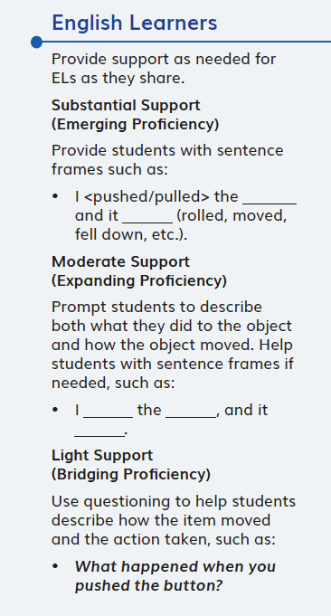  DQ1L2 TE p. 18
TS5. Support to Monitor Student Progress.
The Module materials are High Quality 5 in regards to TS5.
They provide strong support for teachers to monitor student learning and progress over time, and make decisions about instruction and provide feedback.
Evidence  - There is a Pre-Exploration (diagnostic pre-assessment) at the start of the module that assesses prior knowledge and misconceptions (DQ1L1 TB p. 4). Notes in the Teacher Edition and the Movement Progress Tracker support teachers to monitor students' mastery of their misconceptions and the three dimensions and give suggestions for how to tailor instruction accordingly (DQ1L4 Spark TE p. 30, DQ1L5 Spark TE p. 38, DQ1L5 Investigate TE p. 40).  - The Pre-Exploration and regular Formative Assessments inform teacher at point of use as to which students require further support. The Progress Tracker and rubrics support teachers in monitoring students’ progress. | 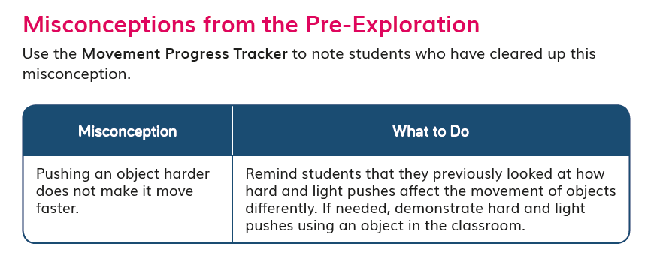  DQ1L5 Spark TE p. 38

