Designed for NGSS: Student Work Rubric
Analyze Evidence
Directions:
- Review your assigned materials to describe the path of student thinking.
- Represent your answers to the questions in the space provided.
- Be prepared to share the path of student thinking visually on a public chart.

Answer (in words, graphics, or both)
Answer the following questions as you describe the path of student thinking in the materials. Consider what you would expect students to be thinking about through the learning experiences.
What are students figuring out/solving?
- What is driving student learning (e.g., question, scenario, problem, phenomenon, etc.)?
- What ideas and practices do students develop through these experiences?
- How do students access, engage, and use prior knowledge to further their thinking?
- How do students develop metacognitive abilities?

SW1. Phenomena/Problems.
Student learning is driven by figuring out a solution to the Module Phenomenon: How do the environment and genetics affect animals and plants?
Students work through a series of Driving Questions (DQs) that require them to make sense of a subset of smaller phenomena/problems and then connect what they now know to the central problem. The skills and knowledge gained over these investigations culminate in a class symposium where they address present research on endangered species, addressing the Module Phenomenon.

- DQ1: How do animal behaviors and plant structures affect their survival and reproduction?
- DQ2: How do species reproduce?
- DQ3: How do environmental and genetic factors influence the growth of an organism?
- DQ4: How do we protect endangered species?
Interwoven with this science narrative is a storyline that requires students to take on the role of ecologists who devise a plan to safeguard an endangered species. They are introduced to the storyline through a movie-style Module Trailer.  The Module is complemented with Biomes, a magazine-style leveled reader (available in four levels and Spanish) that provides additional exposure to relevant phenomena/problems as well as an interview with an ecologist. Packed with stunning images, cartoons, and jokes, it’s designed to appeal to students with a diverse range of learning abilities. | 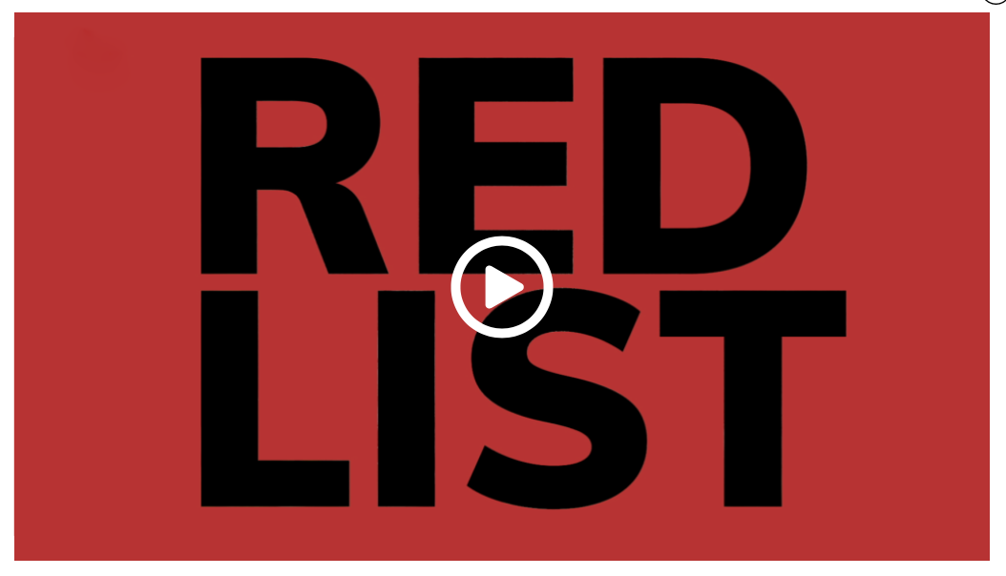  The Red List Module Trailer video
Evidence of Phenomena/Problems.  - Students investigate the phenomenon of animal behaviors that affect the success of reproduction by observing videos of different courtship rituals and analyzing data (DQ1L3–4 TE p. 24–39). | 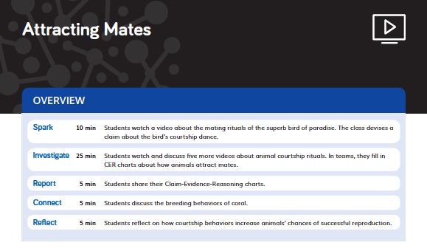  DQ1L3–4 TE p. 24–39
- Students read a text, dissect a flower, and watch a video to understand the phenomenon of sexual reproduction in plants (DQ2L1 TE pp. 96–103). | 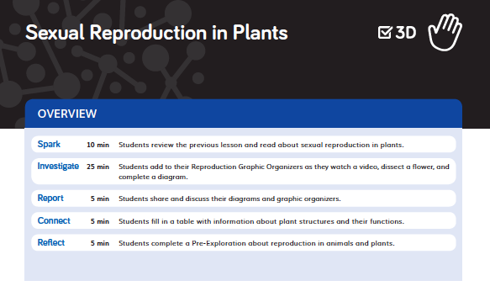  DQ2L1 TE pp. 96–103
- The class use their knowledge of genetics to answer part of the Module Phenomenon (DQ2L3 TE p. 119, DQ2L4 TE p. 128). | 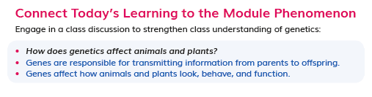  DQ2L3 TE p. 119
- Students use videos and visuals to learn about the phenomenon of asexual reproduction, linking this to the Driving Question (DQ2L9 TE pp. 162–169). | 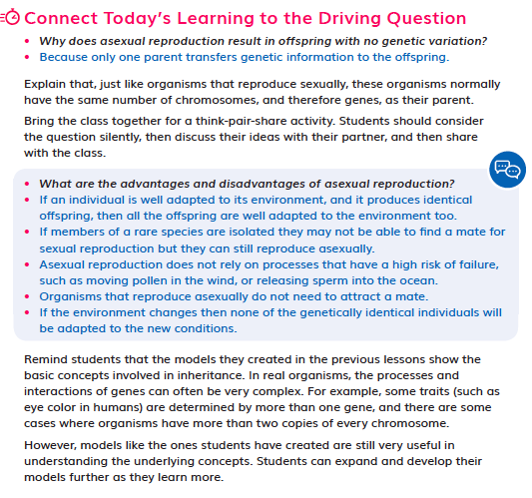  DQ2L9 TE pp. 162–169
- Students consider the phenomenon of environmental factors affecting the growth of an organism, analyzing a study about Atlantic salmon (DQ3L1 TE pp. 193–194). | 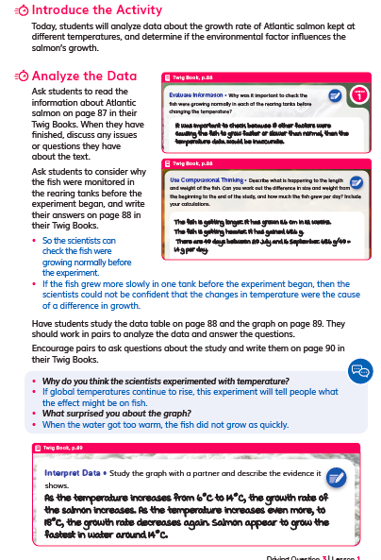  DQ3L1 TE pp. 193–194
- Students devise solutions to the problem of protecting endangered species, using their learning from the module (DQ4L3 TE p. 270). | 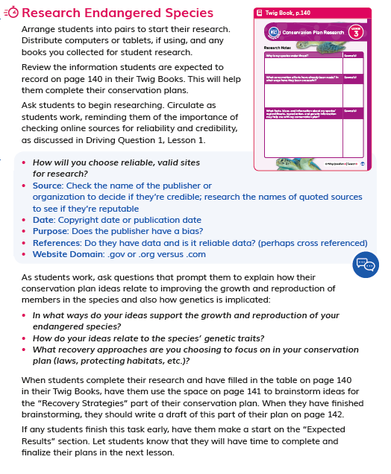  DQ4L3 TE p. 270
SW2. Three-Dimensional Conceptual Framework.
Students’ experiences consistently support them to use their prior knowledge to negotiate new understandings and abilities and apply their understandings in a variety of ways.
In DQ1, students are introduced to the concept of ecology, and activate their prior knowledge of the relationship between living things and their environment with a read-aloud. They obtain information from texts and videos about animal courtship rituals (SEP-8, LS1.B, CCC-1, CCC-2), analyzing and interpreting data (SEP-4) and using mathematics and computational thinking (SEP-5). They consider the question “How do animals help their offspring survive?” (LS1.B, CCC-2) and, over three lessons, develop an answer using claim, evidence, and reasoning through video observations, analysis of scientific data, and discussions (SEP-4, SEP-7, SEP-8). They make claims about plants’ characteristics that affect successful reproduction, and use texts and videos to investigate seed dispersal. At the end of DQ1, they write a scientific argument that answers the Driving Question (LS1.B, SEP-7, SEP-8).  In DQ2, students move onto the topic of reproduction itself, using a text, video, visual, and hands-on investigation to identify the parts of a flower (CCC-6) and a text and video to learn about sexual reproduction in animals. They question why offspring sometimes look different to their parents (SEP-1) and develop visual and physical genetic models to demonstrate how traits are passed from both plant and animal parents to offspring (LS3.A, SEP-2, CCC-2). After showing how variation results from sexual reproduction (LS3.B), students observe videos and create models of asexual reproduction. They complete graphic organizers to compare asexual and sexual reproduction (LS1.B, LS3.A, LS3.B, SEP-7, CCC-2) and research the reproductive strategies of their chosen endangered species (SEP-8, CCC-6).  In DQ3, students consider patterns (CCC-1), cause and effect (CCC-2), and scale, proportion, and quantity (CCC-3) as they analyze several scientific studies (SEP-4, SEP-5) to determine how environmental and genetic factors influence the growth of an organism (LS1.B).  In DQ4, students consider the question: How do we protect endangered or threatened species? They observe videos about conservation efforts and evaluate conservation plans. They research their chosen endangered species and devise conservation plans to improve the growth and reproduction of members in the species, considering how genetics might be affected (SEP-1, SEP-6, SEP-7, SEP-8, CCC-2, LS1.B, ETS1.A). Students close the module with a ‘World Conservation Symposium,’ working with teammates to evaluate their individual plans and create a collaborative conservation plan (ETS1.B, SEP-6, SEP-8).  The SEPs and CCCs that the students are using in each learning activity are labeled at point of use in the student edition (Twig Book) in grade-appropriate language. (DQ1L1 TB p. 4) | 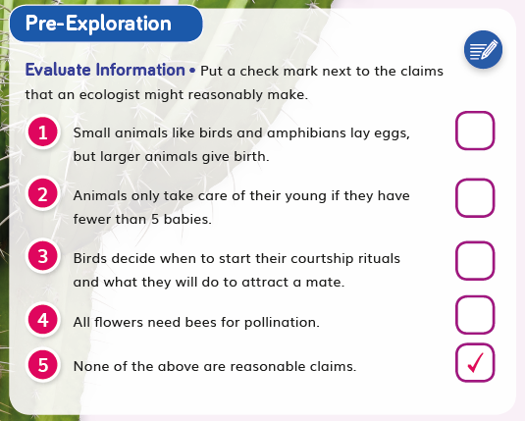  DQ1L1 TB p. 4
Evidence  - Students write a claim about how animals attract mates and then identify evidence for their claim. They revise their claim in light of the evidence and explain their reasoning, considering how the evidence changed or strengthened their claim (DQ1L3 TB p. 10). | 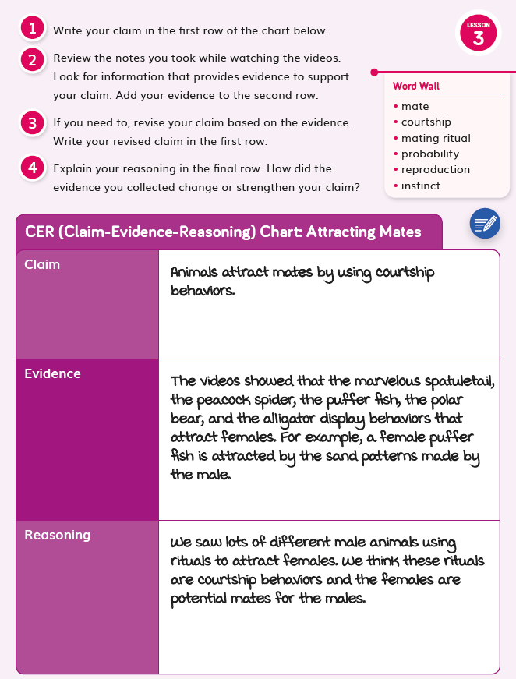  DQ1L3 TB p. 10
- Students write a scientific explanation about growth rates of different strains of chicken, drawing on learning from Grade 5 Module 2 where they learned that animals gain matter from plants or other animals (DQ3L5 TE p. 220). | 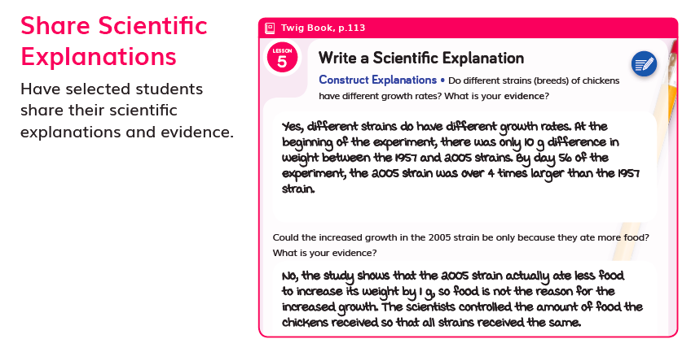  DQ3L5 TE p. 220
- Students peer-review a partner’s claim-evidence-reasoning organizer, giving positive comments, asking questions, and suggesting potential changes (DQ1L10 TB p. 46). | 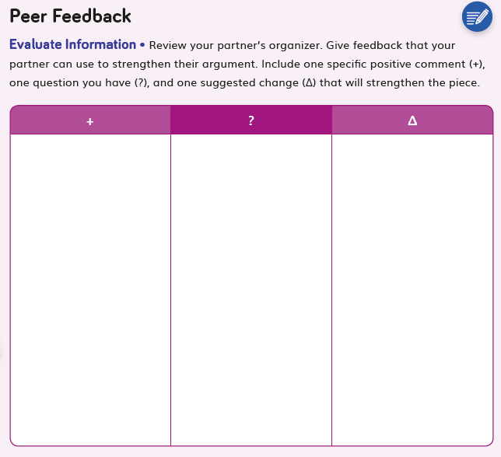  DQ1L10 TB p. 46
- Students dissect a flower and draw a model of the various flower parts (DQ2L1 TB p. 52). | 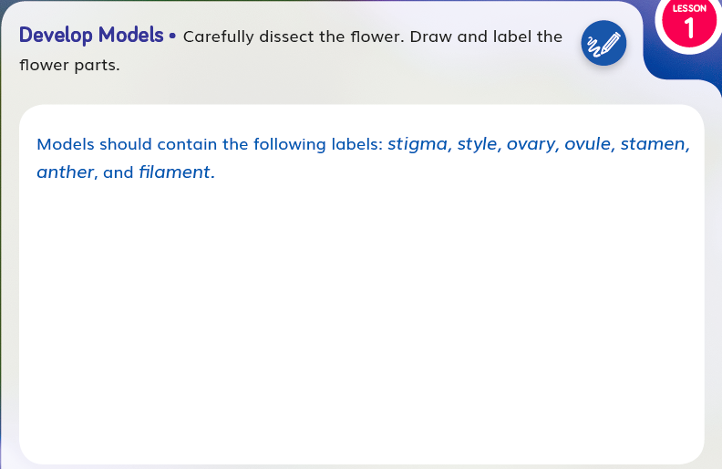  DQ2L1 TB p. 52
- Students make a claim about a pattern in the wing color of butterflies, providing evidence (DQ2L5 TB p. 64). | 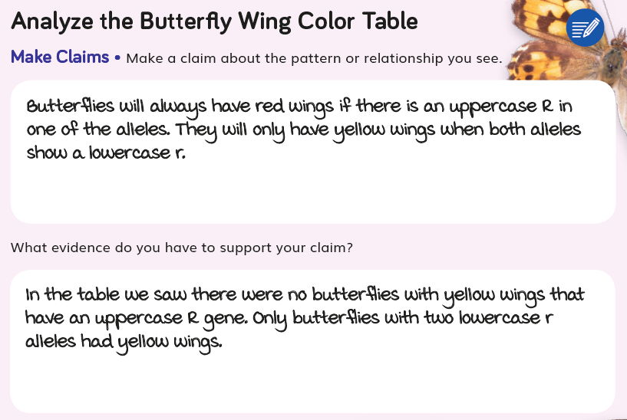  DQ2L5 TB p. 64
SW3. Prior Knowledge.
Materials consistently leverage student prior knowledge and experiences to motivate their learning.
Evidence

Across Program
The Red List builds on prior knowledge of relationships between living things and the environment (Grade K Module 1, Grade 5 Module 2), the structure and function of plant parts (Grade 1 Module 1, Grade 2 Module 4), and genetics (Grade 1 Module 1, Grade 1 Module 2, Grade 3 Module 2, Grade 3 Module 3).

Within Module  Students activate their prior knowledge of the relationship between living things and their environment through a Prior Knowledge Read-Aloud (DQ1L2 TE p. 20). They are prompted to think back to Grade 5 Module 2, in which they learned that animals gain matter from plants or other animals (DQ3L5 TE p. 220).  Throughout the module, students are consistently supported to revise their claims and relate their new understandings to answering the Driving Questions and solving the Module Phenomenon.  Throughout the module, students refer and add to their classroom Science Tools poster, which explicitly details their growing use of the SEPs, and motivates them by helping them visualize their progression. | 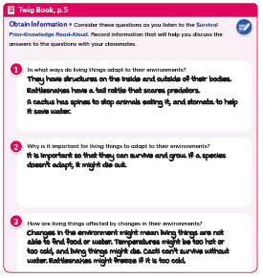  Prior Knowledge Read-Aloud (DQ1L2 TE p. 20)  DQ3L5 TE p. 220
Evidence  - Students engage with a Prior Knowledge Read-Aloud about how living things adapt to their environments and are affected by environmental changes (DQL1 Survival PKRA p. 19, DQ1L2 TE p. 20). | 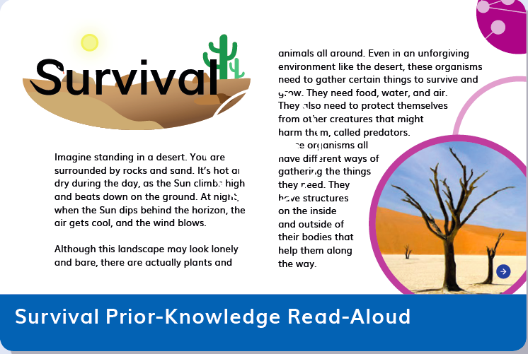  DQL1 Survival PKRA p. 19  DQ1L2 TE p. 20
- Students complete Pre-Explorations (diagnostic pre-assessments) to elicit awareness of their prior knowledge and misconceptions (DQ1L1 TB p. 4, DQ2L1 TB p. 54, and DQ3L1 TB p. 90). | DQ1L1 TB p. 4  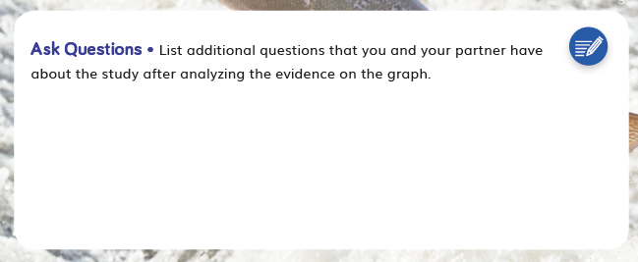  DQ3L1 TB p. 90
- Students revisit “Analyze and interpret data” (SEP-4) on their Science Tools poster (DQ1L5 TE p. 47). | 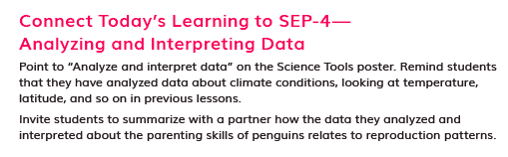  DQ1L5 TE p. 47
- Students revise their model of how genes and traits are passed from butterfly parents to offspring, or describe a way they could change their model (DQ2L8 TE p. 161). | 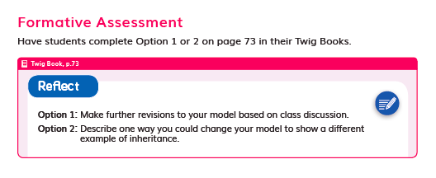  DQ2L8 TE p. 161
SW4. Metacognitive Abilities.
The Ultimate Playground regularly provides students with explicit opportunities to consider how their learning experiences have changed their thinking.
Diagnostic pre-assessments (Pre-Explorations) in DQ1L1, DQ2L1, and DQ3L1 support students to think about the three dimensions they are already familiar with and those they are not.

Meta-Think-Aloud language routines help students develop an understanding of how they learn particular concepts or why they approach activities in certain ways.

'I Can’ statements written in grade-appropriate language are detailed for each Driving Question, supporting student awareness of their growing skills and knowledge and of the three dimensions that they will use to figure out phenomenon/solve problems.

The five-part Twig Science lesson structure has been designed to support students to monitor what and how they have learned across the three dimensions on a daily basis.

Spark: An engaging hook activity motivates students for the investigations ahead.
Investigate: Students think like scientists and design like engineers through hands-on, digital, video, and informational text investigations.
Report: Students articulate what they’ve learned citing evidence and their use of the three dimensions.
Connect: Students make connections to the Driving Questions and Module Phenomenon while building knowledge of CCCs and SEPs.
Reflect: Here students use different means to think about what they have learned so far and how they can use their new understandings to better figure out phenomena/problems.
Evidence  - The ‘I Can’ statement details use of the three dimensions students will use in this Driving Question. “I can… create models to show my understanding of genes and chromosomes.” (DQ2 TB p. 50) | 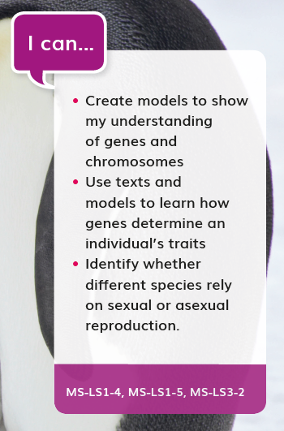  DQ2 TB p. 50
- The teacher uses a Meta-Think-Aloud to show how a reader might figure out the meaning of the word gestation (DQ1L7 TE p. 59). | 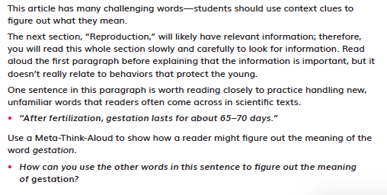  DQ1L7 TE p. 59
- Students consider how the evidence they collected provided scientific reasoning to support their claim, and, if applicable, explain why they revised their claim (DQ1L5, TB p. 17, DQ1L5 TB p. 22). | 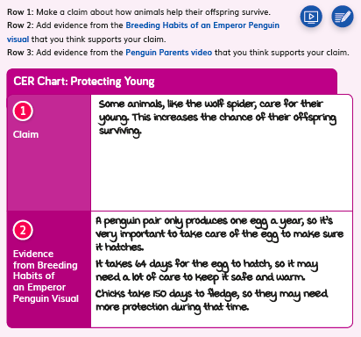  DQ1L5, TB p. 17  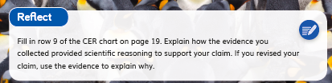  DQ1L5, TB p. 17
- Students revise their model of how genes and traits are passed from butterfly parents to offspring, or describe a way they could change their model (DQ2L8 TB p. 73). | DQ2L8 TB p. 73
- Students edit or rewrite their explanation about how the dam has affected the lake sturgeon, using peer feedback to make their response stronger and clearer (DQ3L7 TB p. 128). | 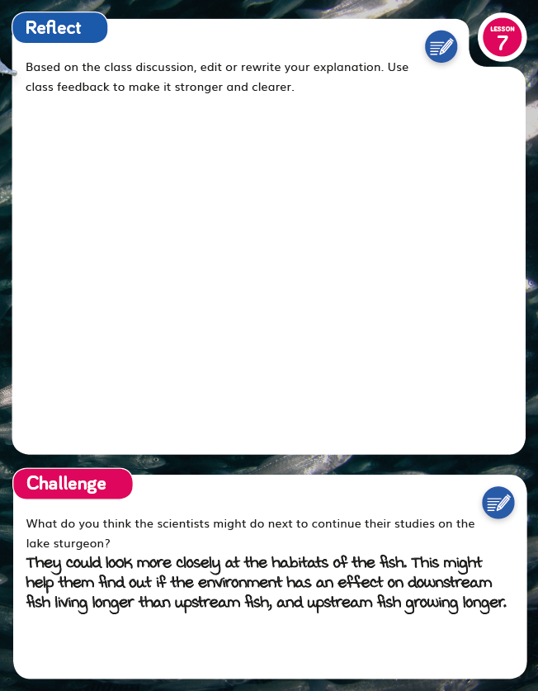  DQ3L7 TB p. 128
- Students reflect on the approach(es) they included in their conservation plan and explain their choice (DQ4L3 TB p. 143). | 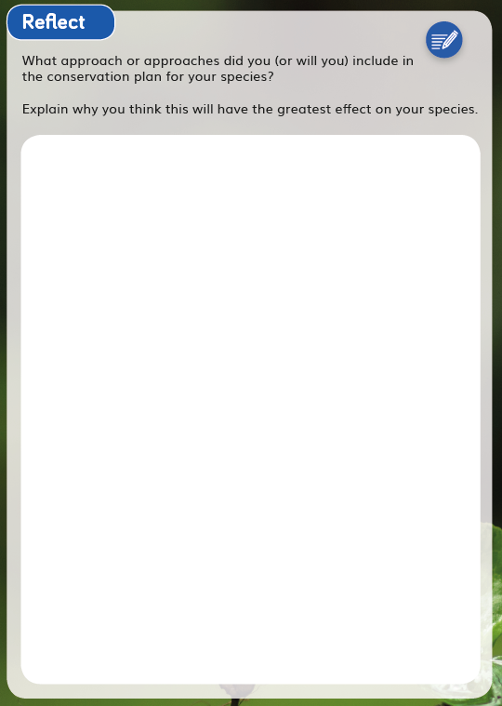  DQ4L3 TB p. 143
SW5. Equitable Learning Opportunities.
Most learning experiences across The Red List are multimodal in approach with numerous cross curricular connections, designed to engage students meaningfully in a variety of ways, with multiple access points, and with supports for students.
The learning experiences in the module are designed to appeal to students of all learning styles and abilities and include tasks in all domains—writing, reading, listening (read-alouds and videos), speaking (discussion and presentations), drawing, plus hands-on, text, and video investigations.  Instructional materials frequently provide support for language scaffolding for EL students at point of use in the Teacher Editions, as well as research-based integrated language routines to support all students to “talk science” using grade-level appropriate scientific vocabulary. The digital version of the Twig Book (TB) includes a text to speech function.  Suggestions for extra access points for students with special needs are provided frequently at point of use.  Culturally-relevant content is core to the module. For example, students research conservation strategies developed for the California condor (DQ4L2 TE pp. 261–263) and watch a video about a species of tree in Yellowstone National Park (DQ1L9 TE p. 76). Additional culturally-relevant contexts are added at point of use. | 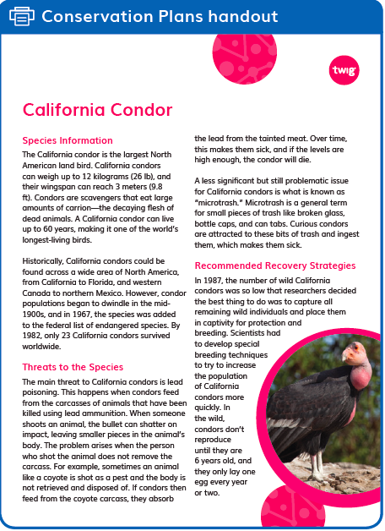  DQ4L2 TE pp. 261–263  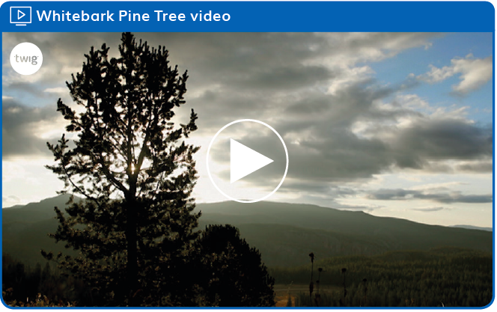  DQ1L9 TE p. 76
Higher Order Challenges for GATE student that have already met the learning goals are interspersed through the learning activities.  The frequent use of videos helps all students access and engage with phenomena and science concepts. Key words are overlaid as on-screen text, so students can access the ideas visually as well as via the spoken and written word. Captions are provided in both English and Spanish.  The Biomes reader has been designed to capture the imagination of young readers with jokes and cartoons and it provides an alternative means to access the scientific content. The reader is available in four levels (Below, On, Above, English Learner) plus Spanish, with complementary lessons to build language acquisition and develop informational text reading skills. On-Level lessons are in the TE, other levels available digitally. The reader features many positive role models in the field of science and engineering, designed to cultivate interest in STEM careers for all students. Chapter 2 is dedicated to an interview with an ecologist. The digital version of the reader includes a text to speech function. (Biomes Leveled Reader) | 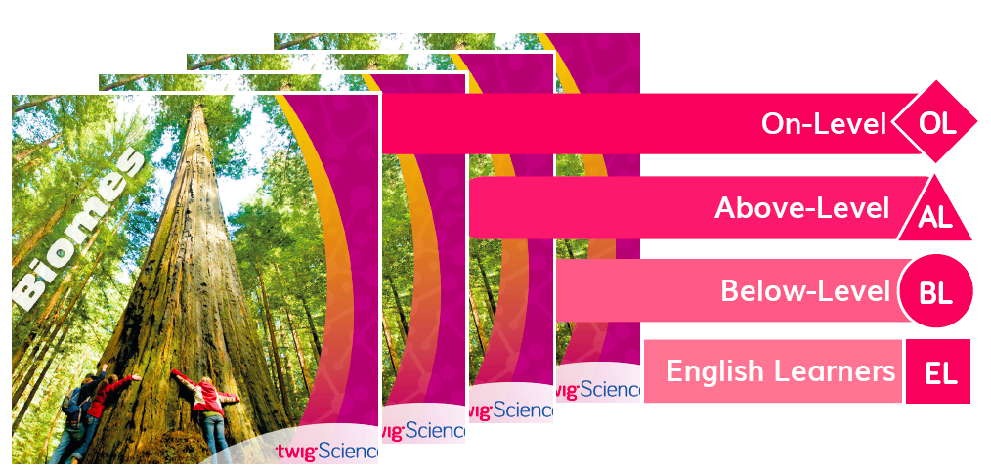  Biomes Leveled Reader
Evidence  - Integrated EL sidebars offer teachers guidance to support students’ engagement with the material (DQ1L8 TE p. 67, DQ2L3 p. 118, DQ2L11 TE p. 179, DQ3L5 TE p. 218, DQ4L2 TE p. 261). | 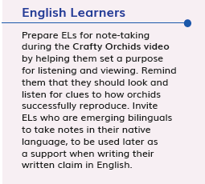  DQ1L8 TE p. 67  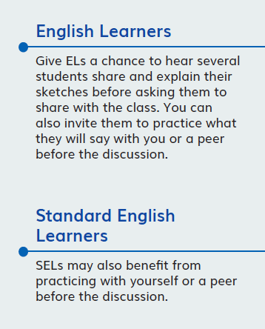  DQ2L3 p. 118
- Integrated Cultural Connection sidebars offer teachers guidance to engage students of all backgrounds and abilities (DQ1L2 TE p. 20, DQ1L6 TE p. 50, DQ1L9 TE p. 76, DQ2L7 TE p. 149, DQ4L1 TE p. 252). | DQ1L2 TE p. 20  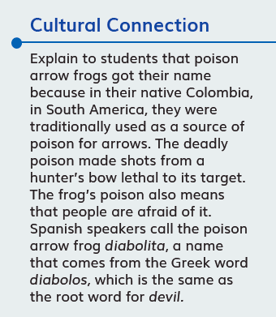  DQ1L6 TE p. 50
- Integrated Special Needs sidebars offer teachers guidance to support students of all abilities as they participation in class activities and grasp key concepts (DQ2L7 TE p. 151, DQ3L1 TE p. 193, DQ3L3 TE p. 207, DQ4L4 TE p. 275). | 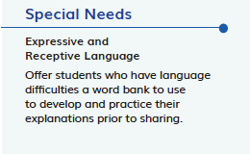  DQ2L7 TE p. 151  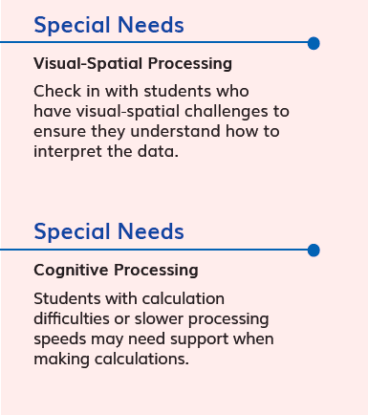  DQ3L1 TE p. 193
- Integrated Challenges interspersed throughout the TB support GATE students who have met the learning goals (DQ1L3 TB p. 11, DQ2L3 TB p. 59, DQ2L5 TB p. 65, DQ2L7 TB p. 71, DQ3L3 TB p. 100). | 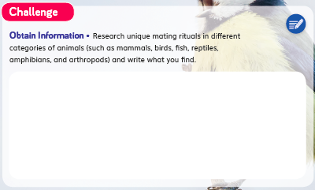  DQ1L3 TB p. 11  DQ2L3 TB p. 59
- Videos like Courtship Rituals: Puffer Fish (DQ1L3), Whitebark Pine Tree (DQ1L9), Asexual Reproduction in Animals (DQ2L9), and Saving Sea Turtles (DQ4L3) bring phenomena and concepts to life for all students. | 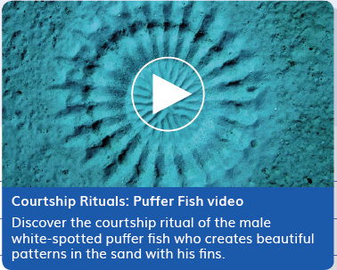Courtship Rituals: Puffer Fish  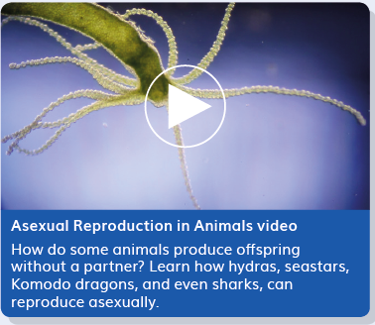  Asexual Reproduction in Animals

Designed for the NGSS: Foundations | High Quality  5 | Medium Quality  3 | Low Quality  1
SW1. Phenomena/Problems. Materials provide phenomena/problems that:  - engage students as directly as possible in authentic and relevant experiences;  - are matched to targeted learning goals;  - can be figured out/solved using scientifically accurate understandings and abilities;  - make connections beyond and to their daily lives, including to their homes, neighborhoods, communities, and/or cultures. | Materials consistently offer quality phenomena/problems sufficient to motivate and drive student learning. | Materials sometimes offer quality phenomena/problems sufficient to motivate and drive student learning. | Materials rarely offer quality phenomena/problems sufficient to motivate and drive student learning.
SW2. Three-dimensional Conceptual Framework. Materials include learning experiences that help students to build scientifically accurate understandings and abilities through opportunities for students to:  - link prior knowledge to negotiated new understanding and abilities;  - use reasoning to connect grade-appropriate SEP, DCI, and CCC elements;  - ask and answer questions that link learning over time;  - negotiate new understandings and abilities by comparing their ideas, their peers’ ideas, and ideas encountered in the learning experience(s);  - apply their understandings and abilities in a variety of ways. | Materials consistently include learning experiences that help students build from prior experiences to negotiate new understandings and abilities, and apply their understandings in a variety of ways. | Materials sometimes include learning experiences that help students build from prior experiences to negotiate new understandings and abilities, and apply their understandings in a  variety of ways. | Materials rarely include learning experiences that help students build from prior experiences to negotiate new understandings and abilities, and apply their understandings in a  variety of ways.
SW3. Prior Knowledge. Materials leverage students’ prior knowledge and experiences to motivate student learning in ways that:  - make visible students’ prior knowledge and experiences related to the phenomena/problems and relevant SEPs, DCIs, and CCCs;  - revisit students’ early ideas to see how they have changed (or not) as they figure out phenomena/solve problems;  - make explicit links to new ideas and practices being developed by students. | Materials consistently leverage student prior knowledge and experiences to motivate their learning. | Materials sometimes leverage student prior knowledge and experiences to motivate their learning. | Materials rarely leverage student prior knowledge and experiences, and when included, they do not relate to the phenomena or problems.
SW4. Metacognitive Abilities. Materials include learning experiences for students to:  - set and monitor their learning in light of the targeted learning goals;  - consider, over time, what and how they have learned across the three dimensions;  - articulate how the three dimensions helped them figure out phenomena/solve problems. | The materials provide students with regular, explicit opportunities to consider how their learning experiences  changed their thinking. | The materials provide students with some opportunities to consider how their learning experiences changed  their thinking. | The materials provide few opportunities for students to consider how their learning experiences changed their thinking.
SW5. Equitable Learning Opportunities. Materials ensure that all students, including those from non-dominant groups and with diverse learning needs, have access to the targeted learning goals and experiences, including:  - appropriate reading, writing, listening, and/or speaking alternatives for students who are English language learners, have special needs, read below the grade level, or have high interest and have already met the intended learning goals;  - culturally-relevant contexts and examples that support all students;  - opportunities to cultivate interest and confidence as scientists and engineers for all students. | Most learning experiences in materials are designed such that students can engage meaningfully in a variety of ways, with multiple access points, and with supports for students. | Some learning experiences in materials are designed such that students can engage meaningfully in a variety of ways, with multiple access points, and with supports for students. | Few learning experiences in materials are designed such that students can engage meaningfully in a variety of ways, with multiple access points, and with supports for students.

Designed for NGSS: Student Work
Analyze Evidence
Directions:
- Review your assigned materials to describe the path of student thinking.
- Represent your answers to the questions in the space provided.
- Be prepared to share the path of student thinking visually on a public chart.

Strengths
SW 1: Phenomena/ Problems
The Student Work is High Quality (5) in terms of SW1
Materials consistently offer quality phenomena/ problems sufficient to motivate and drive student learning.
Evidence  - Students investigate the phenomenon of animal behaviors that affect the success of reproduction by observing videos of different courtship rituals and analyzing data (DQ1L3–4 TE p. 24–39).  - Students read a text, dissect a flower, and watch a video to understand the phenomenon of sexual reproduction in plants (DQ2L1 TE pp. 98–103). | DQ1L3–4 TE p. 24–39
- The class use their knowledge of genetics to answer part of the Module Phenomenon (DQ2L3 TE p. 119, DQ2L4 TE p. 128). | DQ2L3 TE p. 119  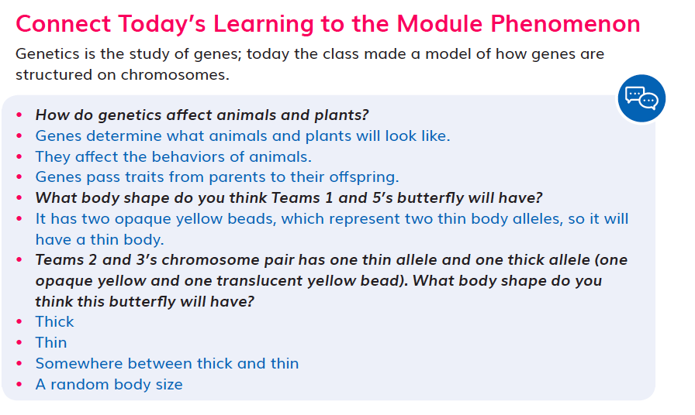  DQ2L4 TE p. 128
- Students use videos and visuals to learn about the phenomenon of asexual reproduction, linking this to the Driving Question (DQ2L9 TE pp. 164–169). | DQ2L9 TE pp. 164–169
- Students consider the phenomenon of environmental factors affecting the growth of an organism, analyzing a study about Atlantic salmon (DQ3L1 Investigate TE p. 193). | DQ3L1 Investigate TE p. 193
- Students devise solutions to the problem of protecting endangered species, using their learning from the module (DQ4L3 TE p. 270). | DQ4L3 TE p. 270
SW 2: Three-Dimensional Conceptual Framework
The Student Work is High Quality (5) in terms of SW2
Materials consistently include learning experiences that help students build from prior experiences to negotiate new understandings and abilities and apply their understandings in a variety of ways.
Evidence  - Students write a claim about how animals attract mates and then identify evidence for their claim. They revise their claim in light of the evidence and explain their reasoning, concerning how the evidence changed or strengthened their claim (DQ1L3 TB p. 10). | DQ1L3 TB p. 10
- Students write a scientific explanation about growth rates of different strains of chicken, drawing on learning from Grade 5 Module 2 where they learned that animals gain matter from plants or other animals (DQ3L5 TE p. 220). | DQ3L5 TE p. 220
- Students peer-review a partner’s claim-evidence-reasoning organizer, giving positive comments, asking questions, and suggesting potential changes (DQ1L10 TB p. 46). | DQ1L10 TB p. 46
- Students dissect a flower and draw a model of the various flower parts (DQ2L1 TB p. 52).
- Students make a claim about a pattern in the wing color of butterflies, providing evidence (DQ2L5 TB p. 64). | DQ2L5 TB p. 64
SW 3: Prior Knowledge
The Student Work is High Quality (5) in terms of SW3
Materials consistently leverage student prior knowledge and experiences to motivate their learning.
Evidence  - Students engage with a Prior Knowledge Read-Aloud about how living things adapt to their environments and are affected by environmental changes (DQ1L2 TE p. 20). | DQ1L2 TE p. 20
- Students complete Pre-Explorations (diagnostic pre-assessments) to elicit awareness of their prior knowledge and misconceptions (DQ1L1 TB p. 4, DQ2L1 TB p. 54, and DQ3L1 TB p. 90). | DQ1L1 TB p. 4  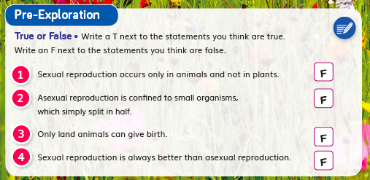  DQ2L1 TB p. 54  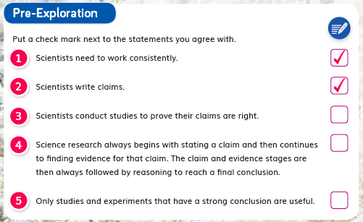  DQ3L1 TB p. 90
- Students revise their model of how genes and traits are passed from butterfly parents to offspring, or describe a way they could change their model (DQ2L8 TB p. 73). | DQ2L8 TB p. 73
- Students revisit “Analyze and interpret data” (SEP-4) on their Science Tools poster (DQ1L5 TE p. 47).

SW 4: Metacognitive Abilities
The Student Work is High Quality (5) in terms of SW4
The materials provide students with regular, explicit opportunities to consider how their learning experiences changed their thinking.
Evidence  - The ‘I Can’ statement details use of the three dimensions students will use in this Driving Question. “I can… create models to show my understanding of genes and chromosomes.” (DQ2 TB p. 50) | DQ2 TB p. 50
- The teacher uses a Meta-Think-Aloud to show how a reader might figure out the meaning of the word gestation (DQ1L7 TE p. 59). | DQ1L7 TE p. 59
- Students consider how the evidence they collected provided scientific reasoning to support their claim, and, if applicable, explain why they revised their claim (DQ1L5 TB p. 22). | DQ1L5 TB p. 22
- Students revise their model of how genes and traits are passed from butterfly parents to offspring, or describe a way they could change their model (DQ2L8 TB p. 73). | DQ2L8 TB p. 73
- Students edit or rewrite their explanation about how the dam has affected the lake sturgeon, using peer feedback to make their response stronger and clearer (DQ3L7 TB p. 128). | DQ3L7 TB p. 128
- Students reflect on the approach(es) they included in their conservation plan and explain their choice (DQ4L3 TB p. 143). | DQ4L3 TB p. 143
SW 5: Equitable Learning Opportunities
The Student Work is High Quality (5) in terms of SW5
Most learning experiences in materials are designed such that students can engage meaningfully in a variety of ways, with multiple access points, and with supports for students.
Evidence  - Integrated EL sidebars offer teachers guidance to support students’ engagement with the material (DQ1L8 TE p. 67, DQ2L3 p. 118, DQ2L11 TE p. 179, DQ3L5 TE p. 218, DQ4L2 TE p. 261). | DQ1L8 TE p. 67  DQ2L3 p. 118
- Integrated Cultural Connection sidebars offer teachers guidance to engage students of all backgrounds and abilities (DQ1L2 TE p. 20, DQ1L6 TE p. 50, DQ1L9 TE p. 76, DQ2L7 TE p. 149, DQ4L1 TE p. 252). | DQ1L2 TE p. 20  DQ1L6 TE p. 50
- Integrated Special Needs sidebars offer teachers guidance to support students of all abilities as they participation in class activities and grasp key concepts (DQ2L7 TE p. 151, DQ2L8 TE p. 157, DQ3L1 TE p. 193, DQ3L3 TE p. 207, DQ4L4 TE p. 275). | DQ2L7 TE p. 151
- Integrated Challenges interspersed throughout the TB support GATE students who have met the learning goals (DQ1L3 TB p. 11, DQ2L3 TB p. 59, DQ2L5 TB p. 65, DQ2L7 TB p. 71, DQ3L3 TB p. 100). | 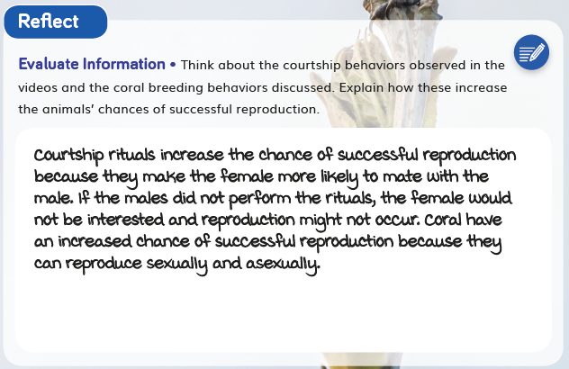  DQ1L3 TB p. 11  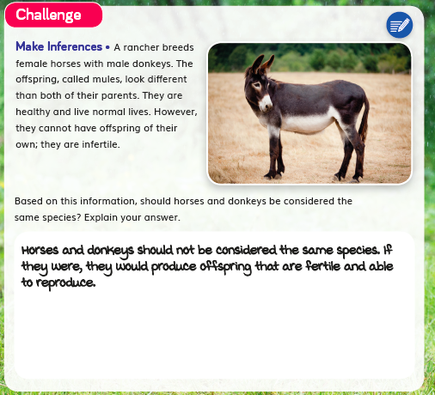  DQ2L3 TB p. 59
- Videos like Courtship Rituals: Puffer Fish (DQ1L3), Whitebark Pine Tree (DQ1L9), Asexual Reproduction in Animals (DQ2L9), and Saving Sea Turtles (DQ4L3) bring phenomena and concepts to life for all students. | Courtship Rituals: Puffer Fish  Asexual Reproduction in Animals

