Designed for NGSS: Student Work Rubric
Analyze Evidence

Directions
- Review your assigned materials to describe the path of student thinking.
- Represent your answers to the questions in the space provided.
- Be prepared to share the path of student thinking visually on a public chart.

Answer (in words, graphics, or both)
Answer the following questions as you describe the path of student thinking in the materials. Consider what you would expect students to be thinking about through the learning experiences.
What are students figuring out/solving?
- What is driving student learning (e.g., question, scenario, problem, phenomenon, etc.)?
- What ideas and practices do students develop through these experiences?
- How do students access, engage, and use prior knowledge to further their thinking?
- How do students develop metacognitive abilities?
SW1. Phenomena/Problems.
Student learning is driven by figuring out the Module Phenomenon: How are objects affected by the forces of push and pull?
In order to understand the phenomenon, students work through a series of DQs that require them to make sense of a subset of smaller phenomena/problems and then connect what they now know to the central problem. The skills and knowledge gained over these investigations culminate in a final class discussion where they address the Module Phenomenon.  DQ1: What do plants need to grow?  DQ2: What do animals need in order to grow and heal?  DQ3: Where do plants get their matter?  DQ4: Where do organisms get the energy they need to grow, heal, move, and maintain their body temperature?  DQ5: What happens to matter in an ecosystem?  DQ6: How can ecosystems change?  Evidence  - Students investigate the phenomenon of what plants need to grow by observing a series of visuals and then planning and carrying out a hands-on investigation. They close read an informational text that treats this phenomenon, which they summarize (DQ1 TB pp. 3–16). | 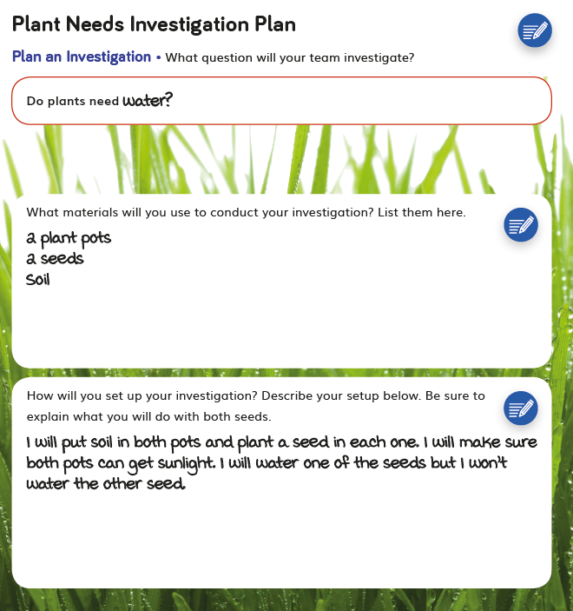  DQ1 TB pp. 3-16
- Students explore the phenomenon of interdependent relationships in ecosystems by carrying out a video investigation (DQ2L1 TB p. 19), close reading an informational text (DQ2L2 TB pp. 23), and conducting collaborative research (DQ2L3 TB pp. 29–30). They then focus on the phenomenon of cycles of matter and energy transfer in ecosystems, modeling food chains (DQ2L4 TB p. 31) and food webs (DQ2L5 TB p. 34) before constructing scientific explanations using evidence and reasoning that answer the Driving Question (DQ2L6 TB pp. 35–36). | 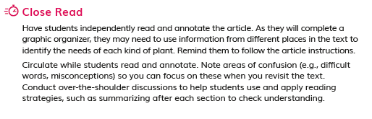  DQ2L2 TB pp. 23  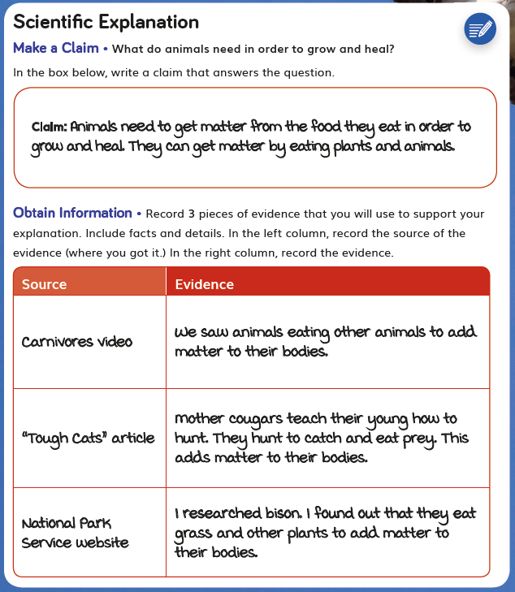  DQ2L6 TB pp. 35–36
- Students explore the phenomenon of energy in chemical processes and everyday life by going on an energy hunt around the school before reflecting on the Driving Question (DQ4L1 TB pp. 69–70). | 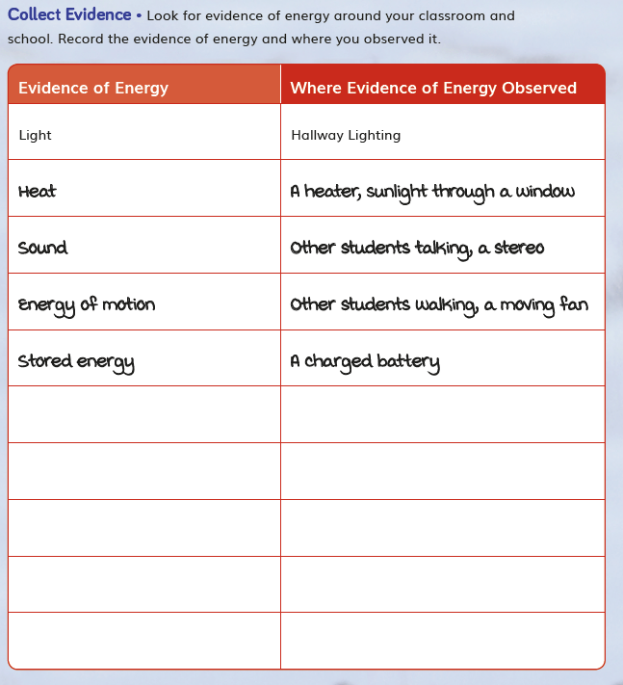  DQ4L1 TB pp. 69–70
- Students investigate the phenomenon of matter and energy flow in ecosystems using an interactive, exploring how energy flows from the Sun to producers, herbivores, and carnivores (DQ4L3 TB p. 81). | 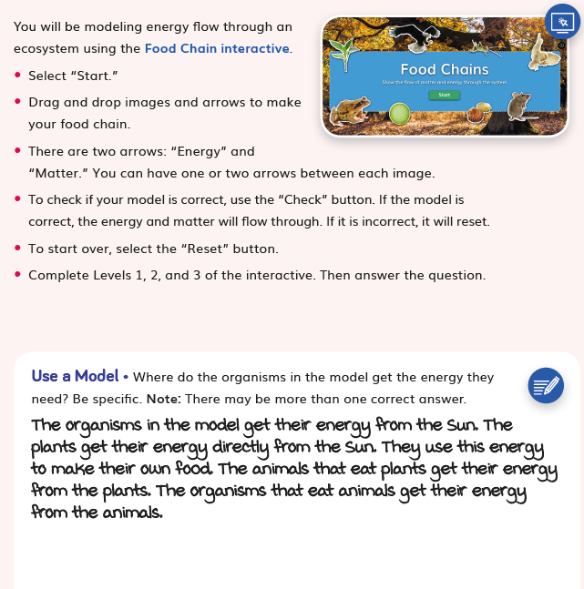  DQ4L3 TB p. 81
Interwoven with this science narrative is a storyline that requires students to take on the role of ecologists working in Yellowstone National Park, observing plants and animals in order to understand this diverse ecosystem. They are introduced to the storyline through a movie-style module trailer.  The Module is complemented with The Galápagos Islands Leveled Reader, a magazine-style leveled reader (available in four levels and Spanish) that provides additional exposure to relevant phenomena/problems, as well as an interview with an entomologist. Packed with stunning images, cartoons, and jokes, it’s designed to appeal to students with a diverse range of learning abilities. | 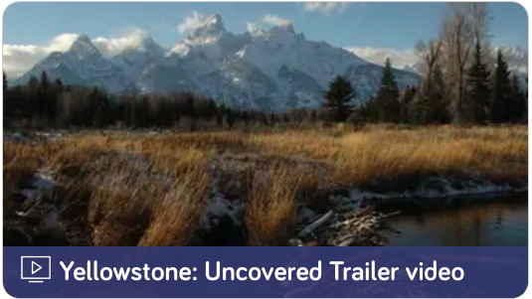  Yellowstone Uncovered Module Trailer video
The Module is complemented with The Galápagos Islands Leveled Reader, a magazine-style leveled reader (available in four levels and Spanish) that provides additional exposure to relevant phenomena/problems, as well as an interview with an entomologist. Packed with stunning images, cartoons, and jokes, it’s designed to appeal to students with a diverse range of learning abilities. | 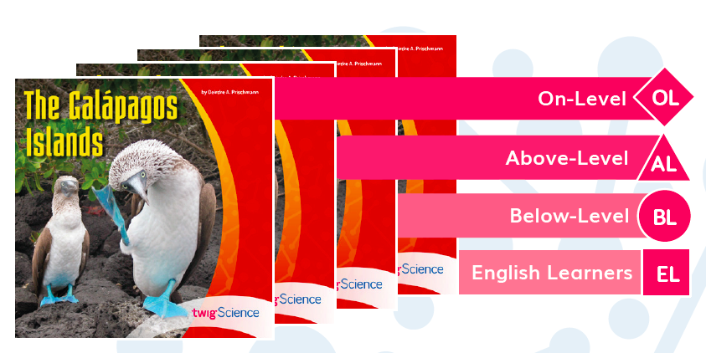  The Galapagos Islands Leveled Reader (Front Cover)  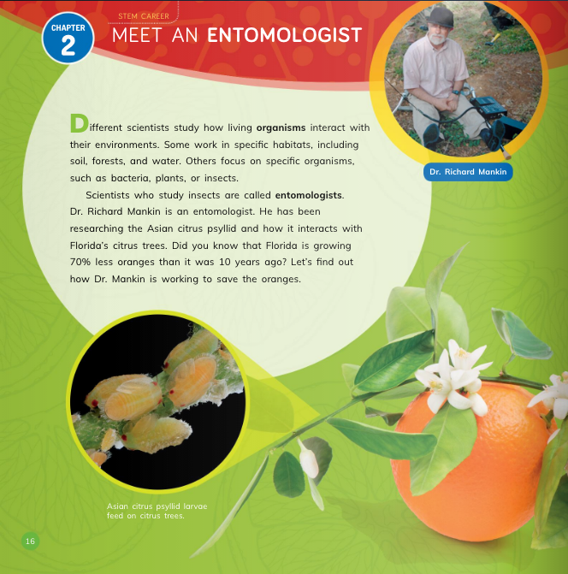  The Galapagos Islands Leveled Reader pp. 16-17
SW2. Three-Dimensional Conceptual Framework.
Students experiences consistently support them to use their prior knowledge to negotiate new understandings and abilities and apply their understandings in a variety of ways.
In DQ1, students start by exploring what plants need to grow. They set up an investigation into plant needs, applying the concepts of scale, proportion, and quantity (CCC-3), and observe the Van Helmont experiment set up in Module 1. Through observations and reading an informational text, they explore the phenomena of matter and energy flow in organisms (LS1.C).

In DQ2, students explore the phenomenon of matter and energy flow in ecosystems, engaging in video and reading investigations. They apply the concepts of energy and matter (CCC-5) and systems and system models (CCC-4) to model food chains and food webs. This culminates in students writing scientific explanations to answer the Driving Question.

In DQ3, students review and analyze the data from their two hands-on plant investigations and evaluate their findings. They consolidate their learning of matter and energy flow in organisms (LS1.C) by writing arguments from evidence that explain where plants get matter to grow.

In DQ4, students activate prior knowledge of energy, exploring the phenomenon of energy in chemical processes and everyday life (PS3.D). They close read an informational text and use an interactive to model food chains, and apply the concept of cause and effect (CCC-2) to construct explanations about how energy moves through the food chain.

In DQ5, students turn to decomposition. They apply the concept of energy and matter (CCC-5) as they observe a guided experiment and then embark on a hands-on investigation to observe decomposition in the field. Their explorations and data collection culminate in written arguments they share with the class, demonstrating their understanding of cycles of matter and energy transfers in an ecosystem (LS2.B).

In DQ6, students close the module with a focus on the interdependent relationships in ecosystems (LS2.A). They apply the concepts of cause and effect (CCC-2) and stability and change (CCC-7) to examine what happens when a non-native species is introduced to an ecosystem. They explore this idea using an interactive and a final digital and video investigation.

The SEPs and CCCs that the students are using in each learning activity are labeled at point of use in the student addition called the Twig Book in grade-appropriate language.
Evidence  - Students build physical ecosystem models (DQ2L7 TB p. 38) which they return to throughout the module, connecting their models to concepts like dead matter and decomposition. | 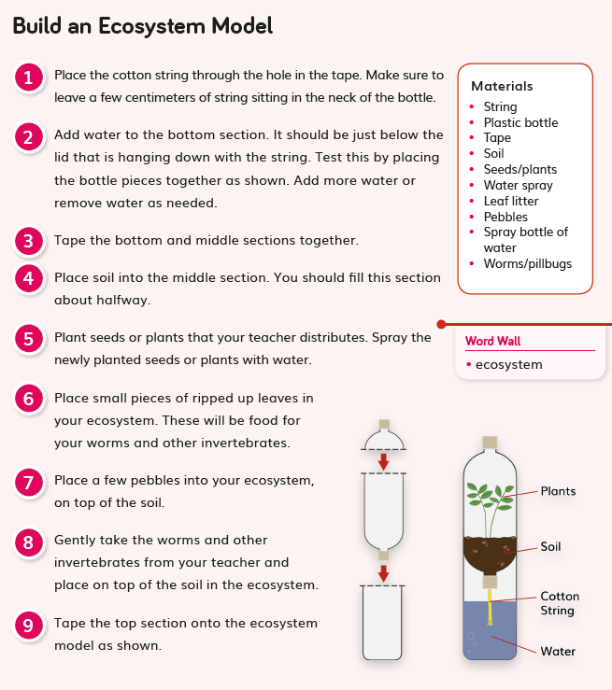  DQ2L7 TB p. 38
- Students revisit their plant needs investigation, set up in DQ1, analyzing and interpreting data before representing that data in a bar graph (DQ3L1 TB pp. 45–48). | 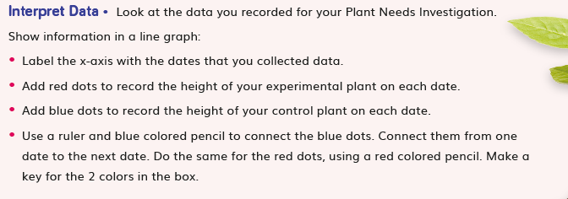  DQ3L1 TB pp. 45–48
- Student pairs create physical models of matter cycling in an ecosystem (DQ5L3 TB p. 104) and observe a guided experiment (DQ5L4 TB p. 107) in order to understand the concept of decomposition. | 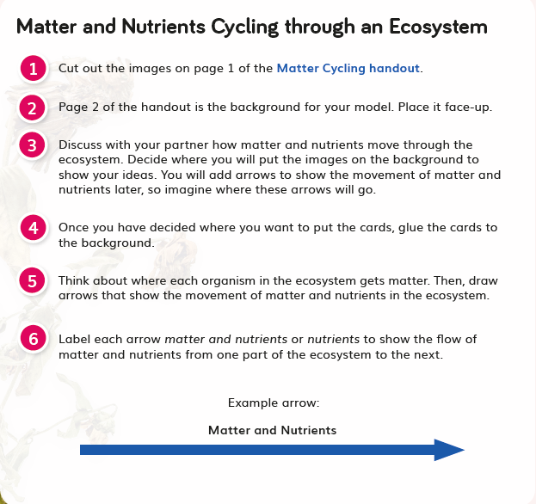  DQ5L3 TB p. 104  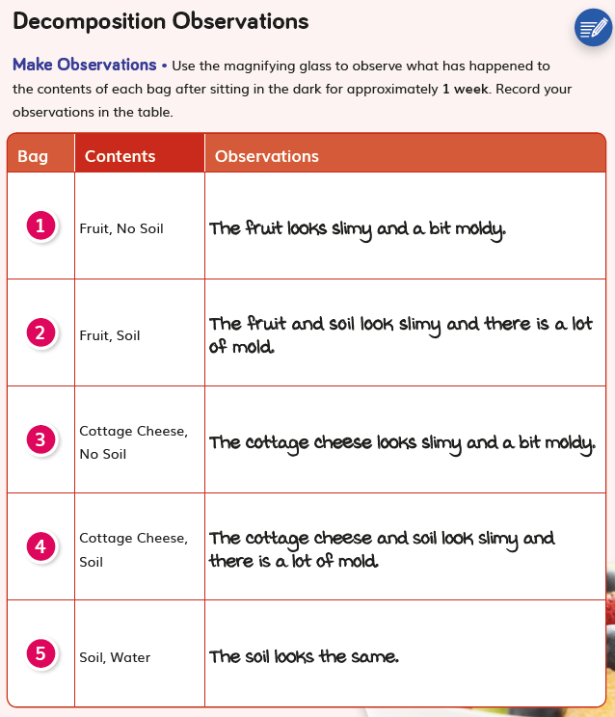  DQ5L4 TB p. 107
- Students use an interactive to model what happens when a non-native species is introduced to an ecosystem (DQ6L1 TB pp. 115–118), consolidating their understanding of the Module Phenomenon. | 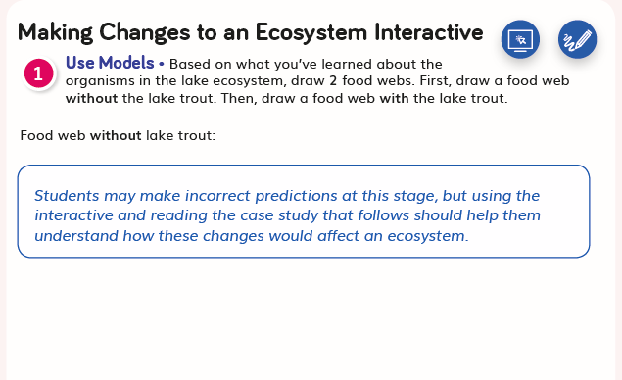  DQ6L1 TB pp. 115–118
SW3. Prior Knowledge.
Materials consistently leverage student prior knowledge and experiences to motivate their learning.
Across Program
Yellowstone: Uncovered builds on prior knowledge of how plants and animals live and survive in their environments in Grade K Module 1, Grade 2 Module 4, and Grade 3 Module 3.

Within Module
In DQ1L1, students activate their prior knowledge of Yellowstone as well as plants, animals, and matter by observing a visual featuring scenes from Yellowstone and reading a Prior-Knowledge Read-Aloud. They are prompted to think back to their exploration of energy and matter in Grade 5, Module 1, Matter Mysteries Hotline (CCC-5).

Throughout the module students are consistently supported to revise their claims and relate their new understandings to answering the Driving Questions and solving the Module Phenomenon.

Throughout the module students refer and add to their classroom Science Tools Poster, which explicitly details their growing use of the SEPs, and motivates them by helping them visualise their progression.
Evidence  - Students engage with a Prior-Knowledge Read-Aloud about animals, plants, and matter (DQ1L1 TE p. 8). | 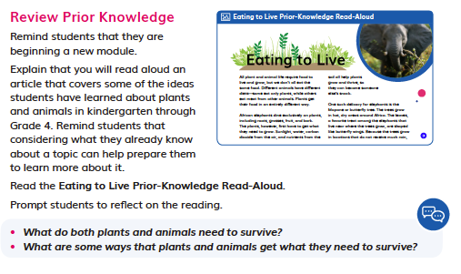  DQ1L1 TE p. 8
- Students observe a series of slides from Yellowstone, activating their prior knowledge of the national park, its features, and some of the organisms that live in it (DQ1L1 TE p. 9). | 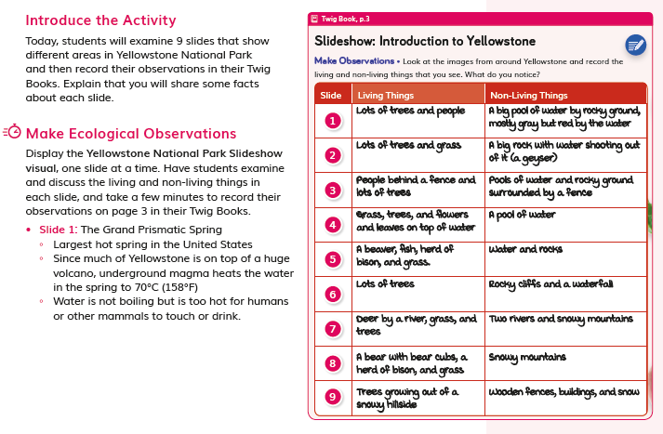  DQ1L1 TE p. 9
- Students review all the evidence they have gathered throughout the Driving Question and use it to construct scientific explanations (DQ2L6 TE p. 78, TB pp. 35–36). | 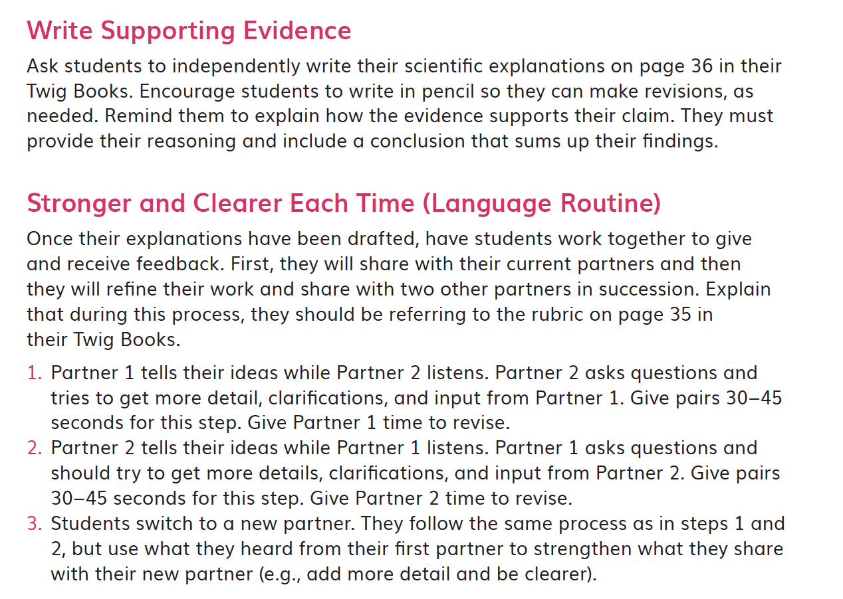  DQ2L6 TE p. 78
- Students review the science tools they’ve used and add “Ask questions” to the Science Tools poster (DQ3L1 TE p. 97). | 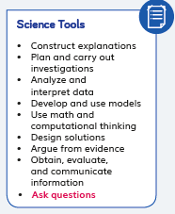  DQ3L1 TE p. 97
- Students complete a diagnostic pre-assessment to elicit awareness of their prior knowledge and misconceptions of dead matter and decomposition (DQ4L4 TB p. 88). | 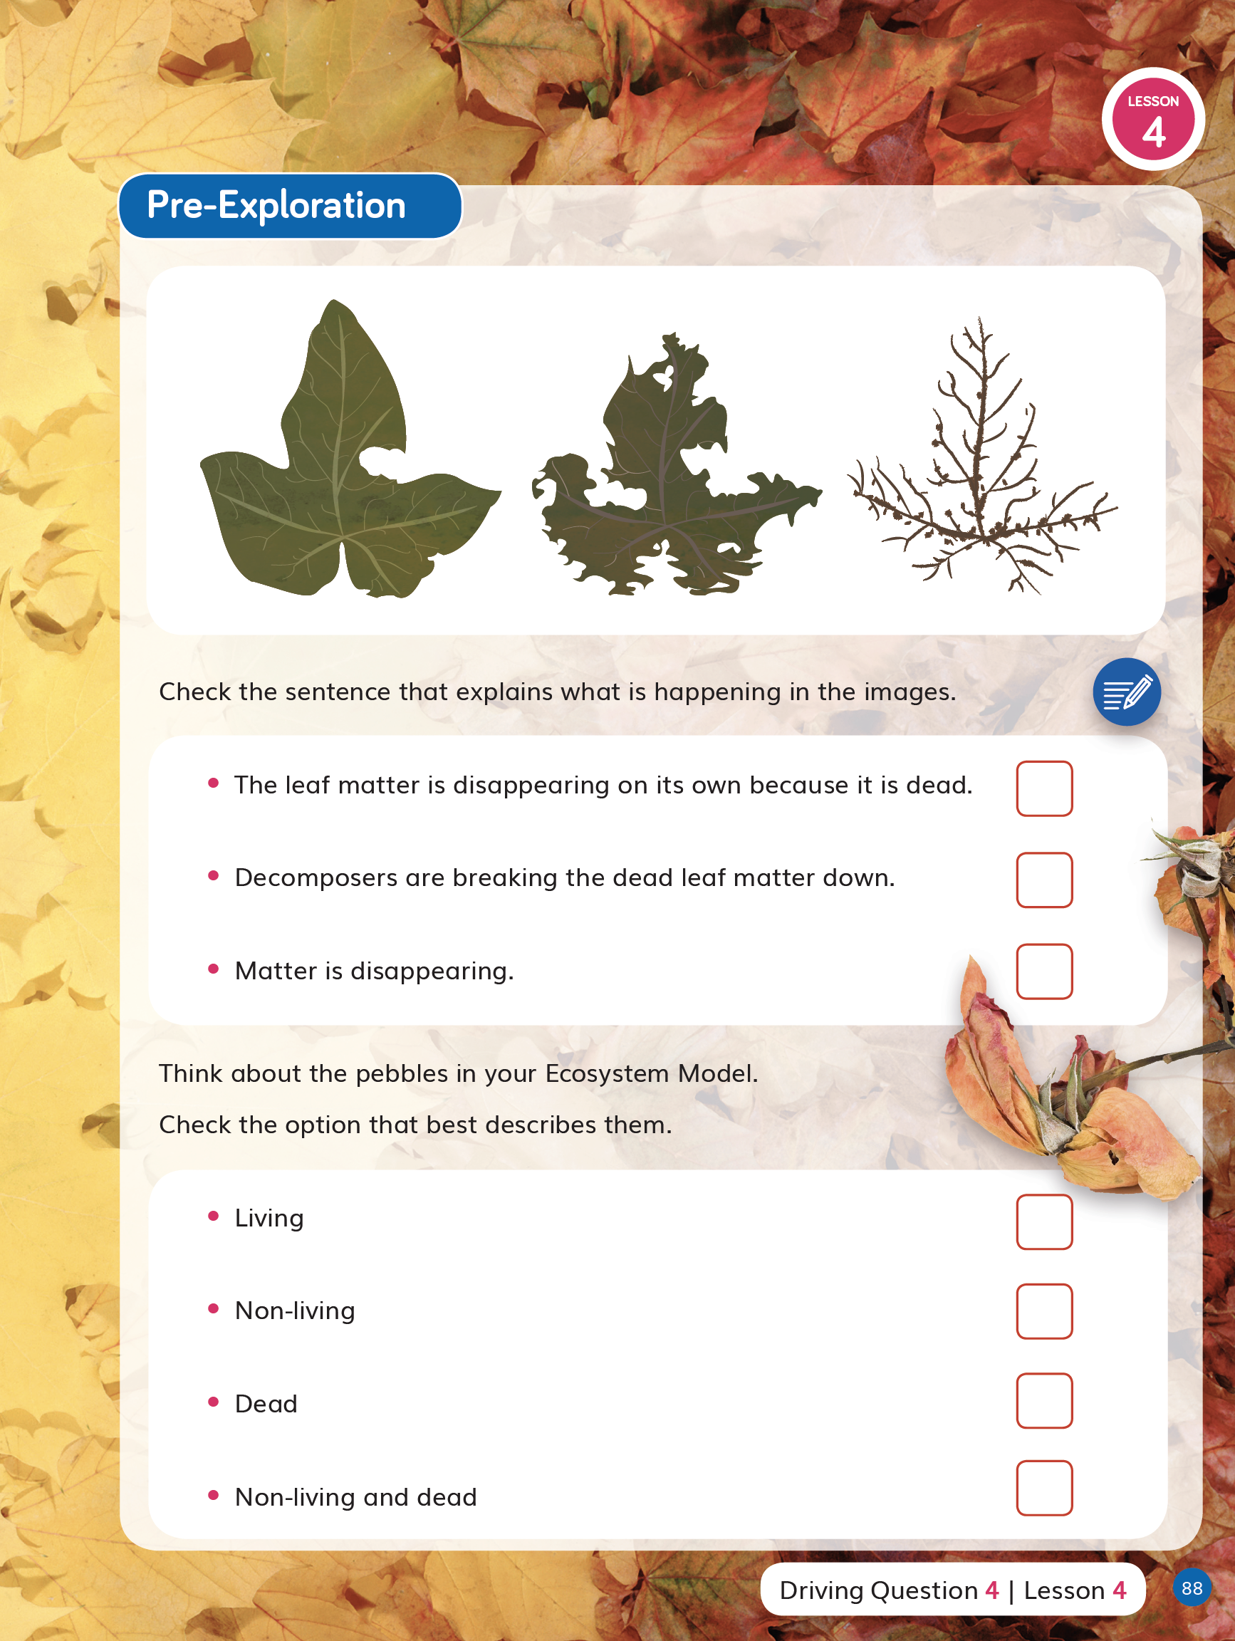  DQ4L4 TB p. 88
- Following a collaborative language routine, students revise their explanations about how matter moves through an ecosystem (DQ5L4 TE p. 182, TB p. 110). | 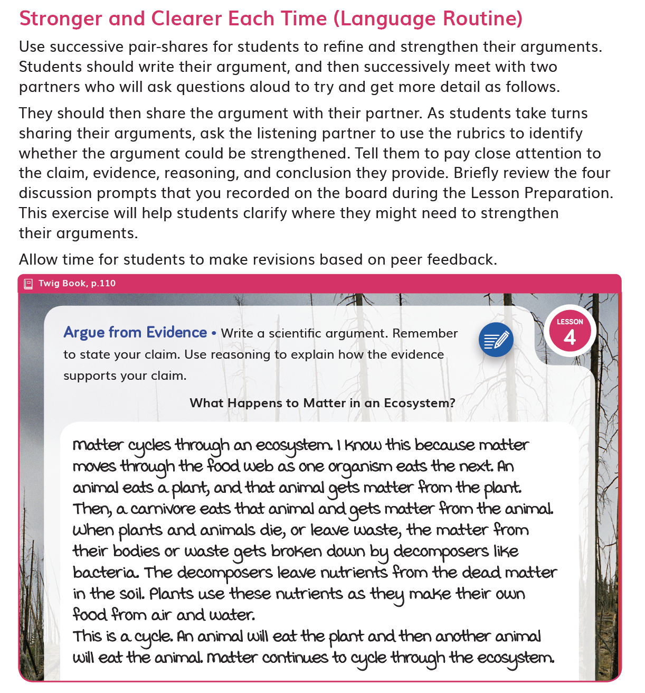  DQ5L4 TE p. 182
- Students reflect on their new understandings and ideas about ecosystems, comparing and contrasting the Yellowstone ecosystem with other ecosystems they’ve studied in science class (DQ6L2 TE p. 208, TB p. 132). | 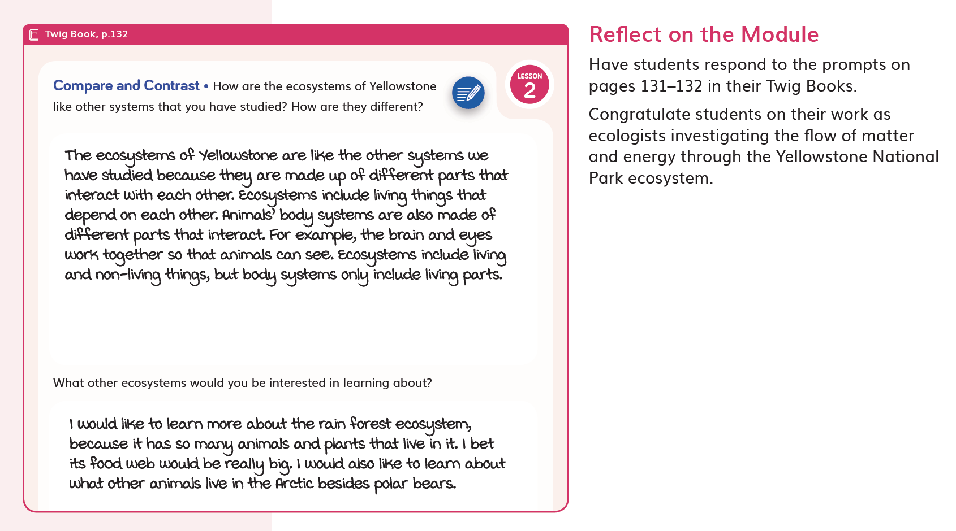  DQ6L2 TE p. 208
SW4. Metacognitive Abilities.
Yellowstone: Uncovered regularly provides students with explicit opportunities to consider how their learning experiences have changed their thinking.
Diagnostic pre-assessments (Pre-Explorations) in DQ1–DQ4 support students to think about the three dimensions they are already familiar with and those they are not.  Additional opportunities to develop students' metacognitive abilities are frequently found in the Reflect of each lesson. Here, students use different means to think about what they have learned so far and how they can use their new understandings to figure out phenomena/problems. For example, in DQ4, students reflect on why animals need energy and then share their ideas with the class (DQ4L1 TE p. 129). | 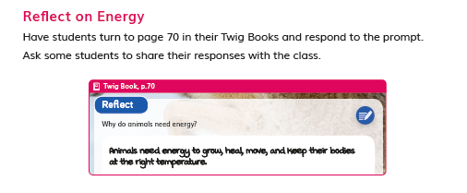  DQ4L1 TE p. 129
"I can" statements written in grade appropriate language are detailed for each DQ, supporting students' awareness of their growing skills and knowledge and of the three dimensions that they will use to figure out phenomenon/solve problems. For example, in DQ5, "I can... Investigate where dead matter goes in an ecosystem" (DQ5 TB p. 90). | 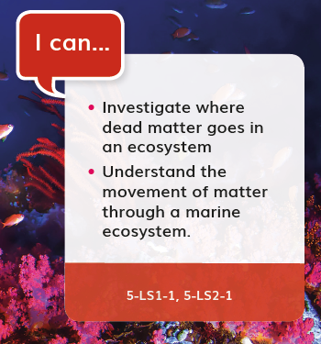  DQ5 TB p. 90
Evidence  - Students close read and annotate an informational text, which the class works to summarize following a discussion (DQ1L3 TE pp. 23–24). | DQ1L3 TE pp. 23–24
- Students consider how their learning experiences have changed their understanding of what animals need to grow and heal, and share what they still wonder (DQ2L6 TB p. 37). | 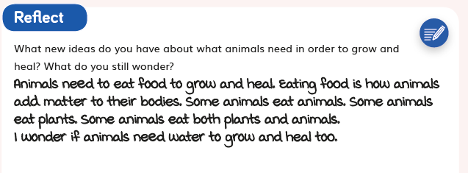  DQ2L6 TB p. 37
- Students reflect on their two hands-on plant investigations as they consider how they know if a plant has grown or not (DQ3L2 TE pp. 100–101, TB p. 52). | 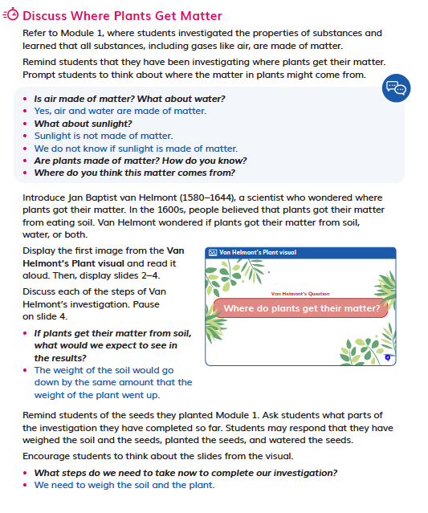
- The “I can” statement details use of the three dimensions students will use in this DQ. "I can... Investigate where dead matter goes in an ecosystem" (DQ5 TB p. 90). | DQ5 TB p. 90
- Students use a rubric to reflect on and self-assess their scientific arguments, writing how they think they could improve them (DQ5L4 TB p. 112). | 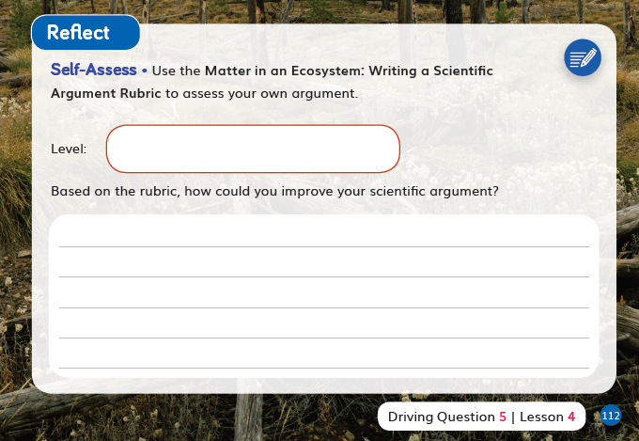  DQ5L4 TB p. 112
- Students reflect on all they learned in the module, sharing their favorite learning (DQ6L2 TB p. 131). | 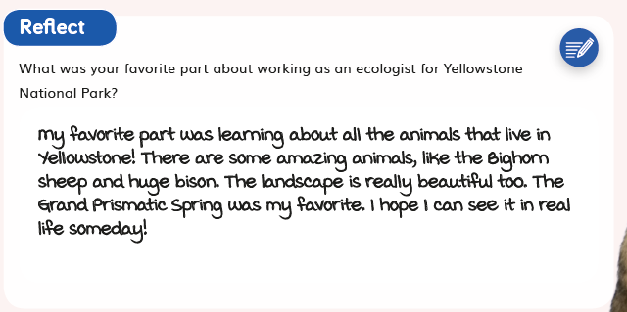  DQ6L2 TB p. 131
SW5. Equitable Learning Opportunities.
Most learning experiences across Yellowstone: Uncovered are multimodal in approach with numerous cross curricular connections, designed to engage students meaningfully in a variety of ways, with multiple access points, and with supports for students.
The learning experiences in the module are designed to appeal to students of all learning styles and abilities and include tasks in all domains—writing, reading, listening (read-alouds and videos), speaking (discussion and presentations), drawing, as well as digital, text, video, and hands-on investigations.

Instructional materials frequently provide support for language scaffolding for EL students at point of use in the Teacher Edition, as well as research-based integrated language routines to support all students to “talk science” using grade level appropriate scientific vocabulary. The digital version of the Twig Book (TB) includes a text to speech function.

Suggestions for extra access points for students with special needs are provided frequently at point of use.

Culturally-relevant content is core to the module, as students explore matter and energy through the prism of one of the United States' most magnificent national parks, with additional Cultural Connections added at point of use in the Teacher Edition (TE).

Higher Order Challenges for GATE student that have already met the learning goals are interspersed through the learning activities.

The frequent use of videos helps all students access and engage with phenomena and science concepts. Key words are overlaid as on-screen text. They can access the ideas visually as well as via the spoken and written word. Captions are provided in both English and Spanish.

The Galápagos Islands Leveled Reader has been designed to capture the imagination of young readers with jokes and cartoons and it provides an alternative means to access the scientific content. The reader is available in four levels (Below, On, Above, EL) and in Spanish, with complementary lessons to build language acquisition and develop informational text reading skills. On level lessons are in the TE, while other levels are available digitally. The reader features many positive role models in the field of science and engineering, designed to cultivate interest in STEM careers for all students. Chapter 2 is dedicated to an interview with an entomologist who advocates for disabled scientists. The digital version of the reader includes a text to speech function.
Evidence  - Integrated EL sidebars offer teachers guidance to support students’ engagement with the material (DQ1L1 TE p. 8, DQ2L3 TE p. 54, DQ3L4 TE p. 115, DQ4L4 TE p. 147). | DQ1L1 TE p. 8  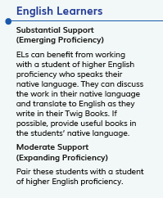  DQ2L3 TE p. 54  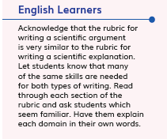  DQ3L4 TE p. 115  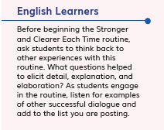  DQ4L4 TE p. 147
- Integrated Cultural Connection sidebars offer teachers guidance to engage students of all backgrounds (DQ1L1 TE p. 8, DQ2L3 TE p. 55, DQ3L3 TE p. 106, DQ5L3 TE p. 172). | DQ1L1 TE p. 8
- Integrated Special Needs sidebars offer teachers guidance to support students of all abilities as they participation in class activities and grasp key concepts (DQ1L2 TE p. 18, DQ2L3 TE p. 56, DQ4L4 TE p. 148). | 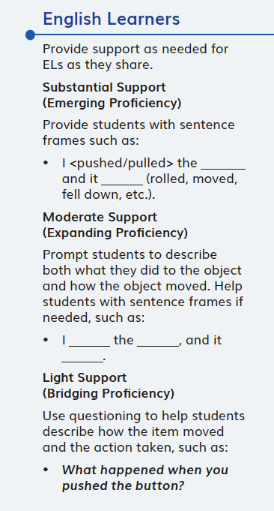  DQ1L2 TE p. 18  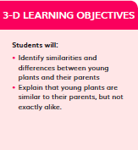  DQ4L4 TE p. 148
- Integrated Challenges interspersed throughout the TB support GATE students who have met the learning goals (DQ1L1 TB p. 4, DQ2L2 TB p. 28, DQ3L2 TB p. 51, DQ5L2 TB p. 103). | 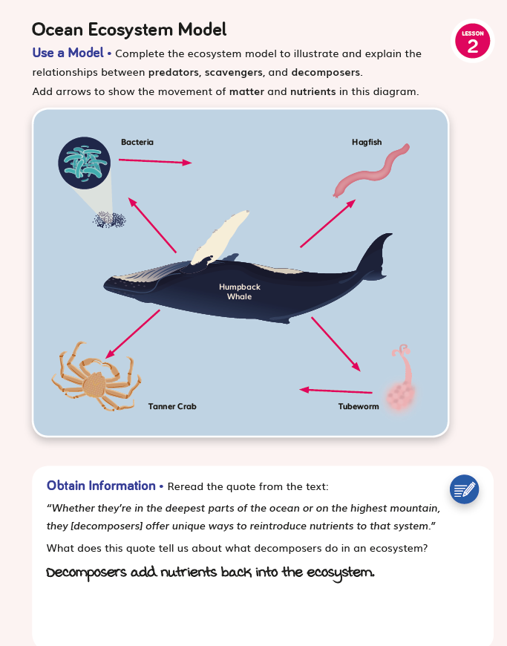  DQ5L2 TB p. 103
- Videos like Time-Lapse of a Plant (DQ1L1), Butterfly’s Breakfast (DQ2L5), Decomposers: Breaking it Down (DQ5L2), and Wolves in Yellowstone (DQ6L2) bring phenomena and concepts to life for all students. | 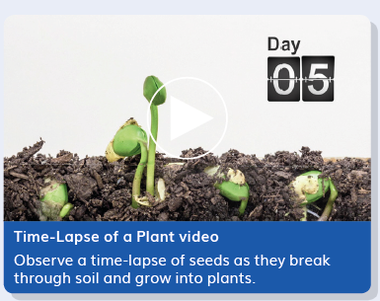  Time-Lapse of a Plant (DQ1L1)

Designed for the NGSS: Foundations | High Quality  5 | Medium Quality  3 | Low Quality  1
SW1. Phenomena/Problems. Materials provide phenomena/problems that:  - engage students as directly as possible in authentic and relevant experiences;  - are matched to targeted learning goals;  - can be figured out/solved using scientifically accurate understandings and abilities;  - make connections beyond and to their daily lives, including to their homes, neighborhoods, communities, and/or cultures. | Materials consistently offer quality phenomena/problems sufficient to motivate and drive student learning. | Materials sometimes offer quality phenomena/problems sufficient to motivate and drive student learning. | Materials rarely offer quality phenomena/problems sufficient to motivate and drive student learning.
SW2. Three-dimensional Conceptual Framework. Materials include learning experiences that help students to build scientifically accurate understandings and abilities through opportunities for students to:  - link prior knowledge to negotiated new understanding and abilities;  - use reasoning to connect grade-appropriate SEP, DCI, and CCC elements;  - ask and answer questions that link learning over time;  - negotiate new understandings and abilities by comparing their ideas, their peers’ ideas, and ideas encountered in the learning experience(s);  - apply their understandings and abilities in a variety of ways. | Materials consistently include learning experiences that help students build from prior experiences to negotiate new understandings and abilities, and apply their understandings in a variety of ways. | Materials sometimes include learning experiences that help students build from prior experiences to negotiate new understandings and abilities, and apply their understandings in a variety of ways. | Materials rarely include learning experiences that help students build from prior experiences to negotiate new understandings and abilities, and apply their understandings in a variety of ways.
SW3. Prior Knowledge. Materials leverage students’ prior knowledge and experiences to motivate student learning in ways that:  - make visible students’ prior knowledge and experiences related to the phenomena/problems and relevant SEPs, DCIs, and CCCs;  - revisit students’ early ideas to see how they have changed (or not) as they figure out phenomena/solve problems;  - make explicit links to new ideas and practices being developed by students. | Materials consistently leverage student prior knowledge and experiences to motivate their learning. | Materials sometimes leverage student prior knowledge and experiences to motivate their learning. | Materials rarely leverage student prior knowledge and experiences, and when included, they do not relate to the phenomena or problems.
SW4. Metacognitive Abilities. Materials include learning experiences for students to:  - set and monitor their learning in light of the targeted learning goals;  - consider, over time, what and how they have learned across the three dimensions;  - articulate how the three dimensions helped them figure out phenomena/solve problems. | The materials provide students with regular, explicit opportunities to consider how their learning experiences  changed their thinking. | The materials provide students with some opportunities to consider how their learning experiences changed  their thinking. | The materials provide few opportunities for students to consider how their learning experiences changed their thinking.
SW5. Equitable Learning Opportunities. Materials ensure that all students, including those from non-dominant groups and with diverse learning needs, have access to the targeted learning goals and experiences, including:  - appropriate reading, writing, listening, and/or speaking alternatives for students who are English language learners, have special needs, read below the grade level, or have high interest and have already met the intended learning goals;  - culturally-relevant contexts and examples that support all students;  - opportunities to cultivate interest and confidence as scientists and engineers for all students. | Most learning experiences in materials are designed such that students can engage meaningfully in a variety of ways, with multiple access points, and with supports for students. | Some learning experiences in materials are designed such that students can engage meaningfully in a variety of ways, with multiple access points, and with supports for students. | Few learning experiences in materials are designed such that students can engage meaningfully in a variety of ways, with multiple access points, and with supports for students.

Designed for NGSS: Student Work
Analyze Evidence
Directions:
- Review your assigned materials to describe the path of student thinking.
- Represent your answers to the questions in the space provided.
- Be prepared to share the path of student thinking visually on a public chart.

Strengths
SW 1: Phenomena/ Problems
The Student Work is High Quality (5) in terms of SW1
Materials consistently offer quality phenomena/ problems sufficient to motivate and drive student learning.
Evidence  - Students investigate the phenomenon of what plants need to grow by observing a series of visuals and then planning and carrying out a hands-on investigation (DQ1 TB p. 5). They close read an informational text that treats this phenomenon, which they summarize (DQ1 TB pp. 10–16). | DQ1 TB p. 5
- Students explore the phenomenon of interdependent relationships in ecosystems by carrying out a video investigation (DQ2L1 TB p. 19), close reading an informational text (DQ2L2 TB pp. 22–26), and conducting collaborative research (DQ2L3 TB pp. 29–30). They then focus on the phenomenon of cycles of matter and energy transfer in ecosystems, modeling food chains (DQ2L4 TB p. 31) and food webs (DQ2L5 TB p. 34) before constructing scientific explanations using evidence and reasoning that answer the Driving Question (DQ2L6 TB pp. 35–36). | 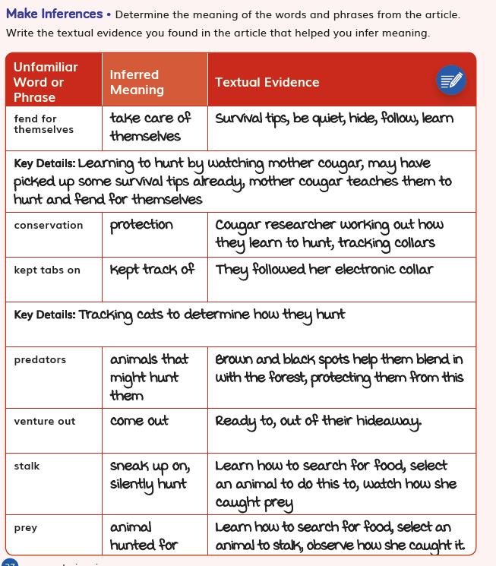  DQ2L2 TB pp. 22–26
- Students explore the phenomenon of energy in chemical processes and everyday life by going on an energy hunt around the school before reflecting on the Driving Question (DQ4L1 TB pp. 69–70). | DQ4L1 TB pp. 69–70
- Students explore the phenomenon of matter and energy flow in ecosystems using an interactive, discovering that energy flows from the Sun to producers, herbivores, and carnivores (DQ4L3 TB p. 81). | DQ4L3 TB p. 81
SW 2: Three-Dimensional Conceptual Framework
The Student Work is High Quality (5) in terms of SW2
Materials consistently leverage student prior knowledge and experiences to motivate their learning.
Evidence  - Students build physical ecosystem models (DQ2L7 TB p. 38) which they return to throughout the module, connecting their models to concepts like dead matter and decomposition. | DQ2L7 TB p. 38
- Students revisit their plant needs investigation set up in DQ1, analyzing and interpreting data before representing that data in a bar graph (DQ3L1 TB pp. 45–48). | DQ3L1 TB pp. 45–48
- In pairs, students create physical models of matter cycling in an ecosystem (DQ5L3 TB p. 104) and observe a guided experiment (DQ5L4 TB p. 107) in order to understand the concept of decomposition. | DQ5L3 TB p. 104  DQ5L4 TB p. 107
- Students use an interactive to model what happens when a non-native species is introduced to an ecosystem (DQ6L1 TB pp. 115–118), consolidating their understanding of the Module Phenomenon. | DQ6L1 TB pp. 115–118
SW 3: Prior Knowledge
The Student Work is High Quality (5) in terms of SW3
Materials consistently leverage student prior knowledge and experiences to motivate their learning.
Evidence  - Students engage with a Prior-Knowledge Read-Aloud about animals, plants, and matter (DQ1L1 TE p. 8). | DQ1L1 TE p. 8
- Students observe a series of slides from Yellowstone, activating their prior knowledge of the national park, its features, and some of the organisms that live in it (DQ1L1 TE p. 9). | DQ1L1 TE p. 9
- Students review all the evidence they have gathered throughout the Driving Question and use it to construct scientific explanations (DQ2L6 TE p. 78, TB pp. 35–36). | DQ2L6 TE p. 78
- Students review the science tools they’ve used and add “Ask questions” to the Science Tools poster (DQ3L1 TE p. 97). | DQ3L1 TE p. 97
- Students complete a diagnostic pre-assessment to elicit awareness of their prior knowledge and misconceptions of dead matter and decomposition (DQ4L4 TB p. 88). | DQ4L4 TB p. 88
- Following a collaborative language routine, students revise their explanations about how matter moves through an ecosystem (DQ5L4 TE p. 182, TB p. 110). | DQ5L4 TE p. 182
- Students reflect on their new understandings and ideas about ecosystems, comparing and contrasting the Yellowstone ecosystem with other ecosystems they’ve studied in science class (DQ6L2 TE p. 208, TB p. 132). | DQ6L2 TE p. 208
SW 4: Metacognitive Abilities
The Student Work is High Quality (5) in terms of SW4
The materials provide students with regular, explicit opportunities to consider how their learning experiences changed their thinking.
Evidence  - Students close read and annotate an informational text, which the class works to summarize following a discussion (DQ1L3 TE pp. 23–24). | DQ1L3 TE pp. 23–24
- Students consider how their learning experiences have changed their understanding of what animals need to grow and heal, and share what they still wonder (DQ2L6 TB p. 37). | DQ2L6 TB p. 37
- Students reflect on their two hands-on plant investigations as they consider how they know if a plant has grown or not (DQ3L2 TE pp. 100–101, TB p. 52). | DQ3L2 TE pp. 100–101
- The “I can” statement details use of the three dimensions students will use in this DQ. "I can... Investigate where dead matter goes in an ecosystem" (DQ5 TB p. 90).
- Students use a rubric to reflect on and self-assess their scientific arguments, writing how they think they could improve them (DQ5L4 TB p. 112). | DQ5L4 TB p. 112
- Students reflect on all they learned in the module, sharing their favorite learning (DQ6L2 TB p. 131). | DQ6L2 TB p. 131
SW 5: Equitable Learning Opportunities
The Student Work is High Quality (5) in terms of SW5
Most learning experiences in materials are designed such that students can engage meaningfully in a variety of ways, with multiple access points, and with supports for students.
Evidence  - Integrated EL sidebars offer teachers guidance to support students’ engagement with the material (DQ1L1 TE p. 8, DQ2L3 TE p. 54, DQ3L4 TE p. 115, DQ4L4 TE p. 147). | DQ1L1 TE p. 8  DQ2L3 TE p. 54  DQ3L4 TE p. 115  DQ4L4 TE p. 147
- Integrated Cultural Connection sidebars offer teachers guidance to engage students of all backgrounds (DQ1L1 TE p. 8, DQ2L3 TE p. 55, DQ3L3 TE p. 106, DQ5L3 TE p. 172). | DQ1L1 TE p. 8
- Integrated Special Needs sidebars offer teachers guidance to support students of all abilities as they participation in class activities and grasp key concepts (DQ1L2 TE p. 18, DQ2L3 TE p. 56, DQ4L4 TE p. 148). | DQ1L2 TE p. 18  DQ4L4 TE p. 148
- Integrated Challenges interspersed throughout the TB support GATE students who have met the learning goals (DQ1L1 TB p. 4, DQ2L2 TB p. 28, DQ3L2 TB p. 51, DQ5L2 TB p. 103). | DQ2L2 TB p. 28
- Videos like Time-Lapse of a Plant (DQ1L1), Butterfly’s Breakfast (DQ2L5), Decomposers: Breaking it Down (DQ5L2), and Wolves in Yellowstone (DQ6L2) bring phenomena and concepts to life for all students. | Time-Lapse of a Plant (DQ1L1)

