Science Made for the Next Generation

Twig Science was built from the ground up for the California NGSS by award-winning STEM education specialists.
Reviewing our program, you’ll find:

- ​A clear conceptual flow across the program, clearly set out in the program CA NGSS Framework Alignment
- Modules that bundle different scientific disciplines including engineering and environmental principles and concepts (as defined by the CDE), aligned 1:1 with the segments of the California Framework
- Phenomena and investigative problems at the heart of each module, with Grade Scope and Sequence tables that show how the dimensions flow and build in sophistication across each grade
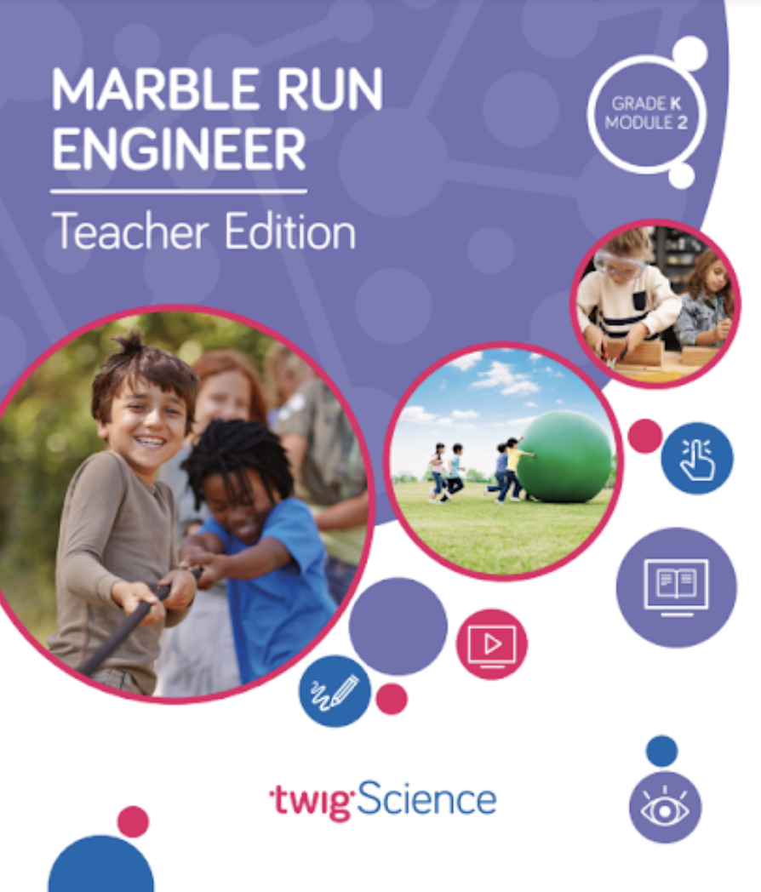
- Module Contents that tell the story of how students apply the three dimensions in a module, with Driving Questions that scaffold their learning journey
- Three-dimensional lessons and assessments that clearly outline the dimensions applied.
​
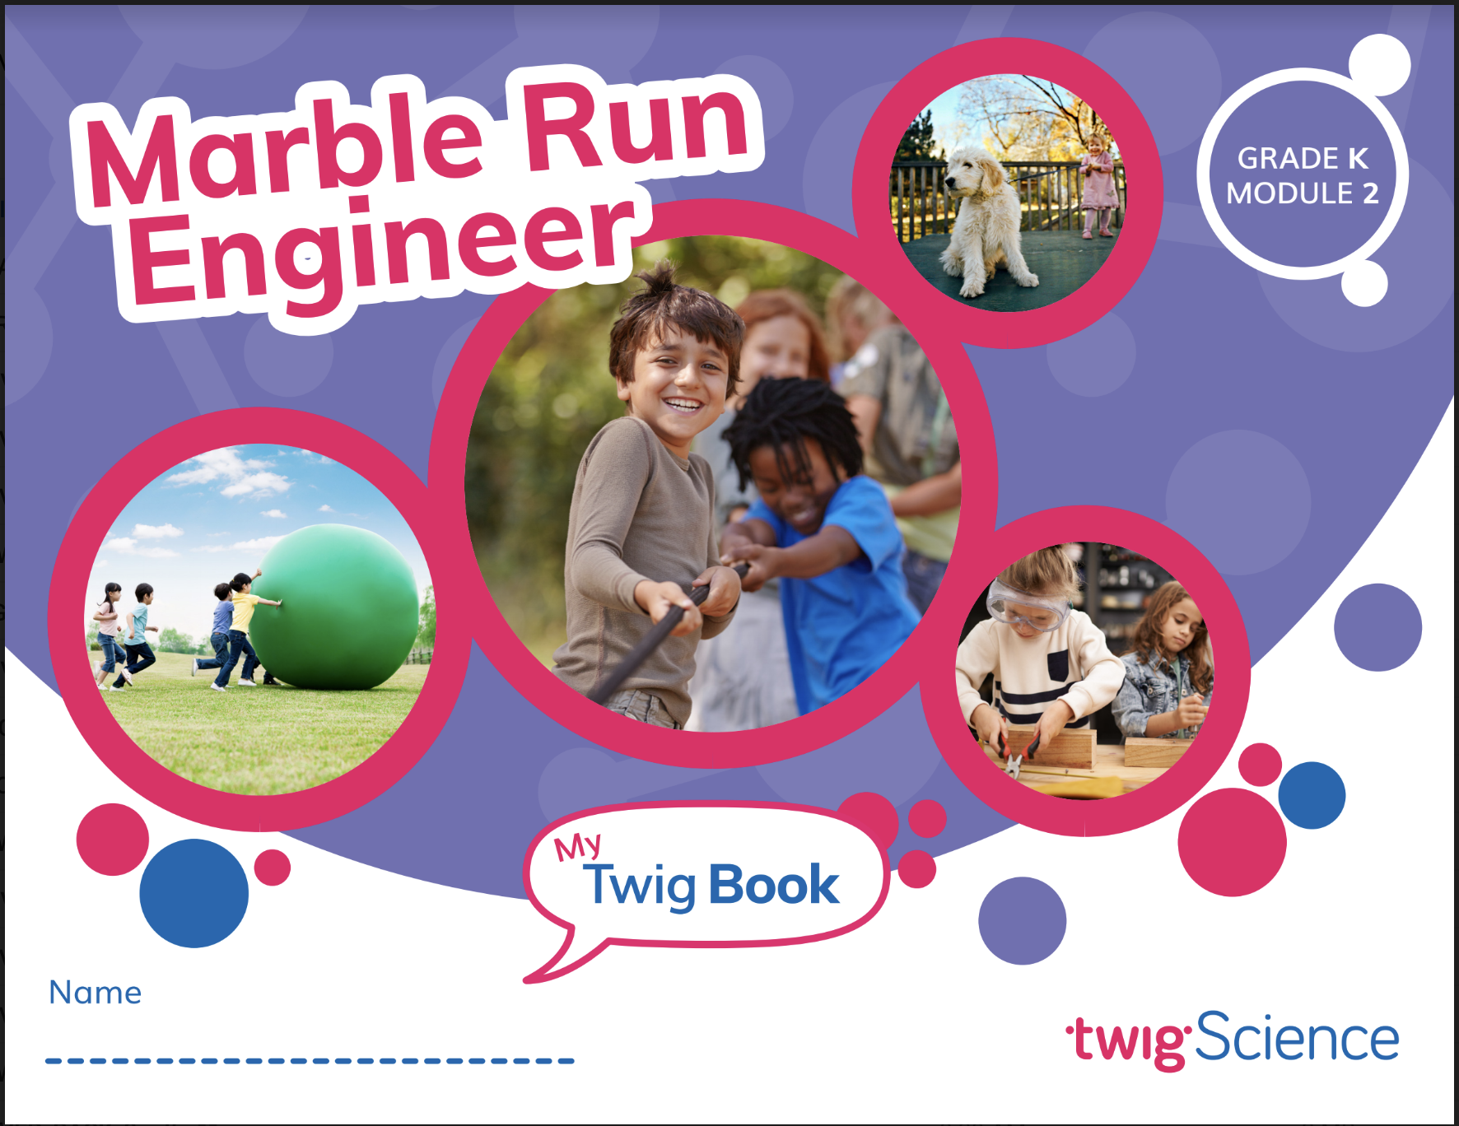
This is why we score so highly on NGSS-based rubrics such as NextGen TIME Paper screen evaluation.

This rubric has been completed for Kindergarten Module 2 Marble Run Engineers and is designed to highlight where you can find evidence for the Designed for NGSS: Foundations Rubric. The rubric includes citations to the printed Teachers Edition and Twig Book (Student Edition).

Designed for the NGSS: Foundations | High Quality  5 | Medium Quality  3 | Low Quality  1
F1. Presence of Phenomena/Problem. The materials include phenomena/problems that have the potential to drive student learning toward the targeted learning goals in the following ways:  - phenomena/problems in the materials are to be relevant to students;  - explanations for phenomena connect to the three dimensions; and,  - solutions to problems connect to the three dimensions. | The materials include phenomena/problems that have strong potential to drive student learning toward the targeted learning goals. | The materials include phenomena/problems that have some potential to drive student learning toward the targeted learning goals. | The materials include phenomena/problems that have limited potential to drive student learning toward the targeted learning goals.
F2. Presence of Three Dimensions. The materials include opportunities for students to develop and use the three dimensions, such that:  - the DCIs, SEPs, and CCCs are present and have the potential to support student learning toward the targeted learning goals for each dimension; and,  - when engineering design is a learning focus, it is integrated with other appropriate dimensions (i.e., engineering is not isolated). | The materials consistently provide opportunities for students to develop and use the three dimensions. | The materials occasionally provide opportunities for students to develop and use the three dimensions. | The materials rarely provide opportunities for students to use the three dimensions.
F3. Presence of Logical Sequence. Materials demonstrate appropriate sequencing of three dimensions when:  - they include a targeted set of DCIs, SEPs, and CCCs within a sequence;  - the sequence is clear and logical across the DCIs; and,  - the SEPs and CCCs are potentially sufficient and appropriate for students to figure out the phenomena or problems. | The materials consistently exhibit a clear, logical, and appropriate sequence across the three dimensions. | The materials occasionally exhibit a clear, logical, and appropriate sequence across the three dimensions. | The materials rarely exhibit a clear, logical, and appropriate sequence across the three dimensions.

Designed for NGSS: Foundations Rubric
Analyze Evidence
Directions:
- Review the Designed for NGSS: Foundations Rubric.
- Reflect on the evidence (or lack of evidence) that you and your team gathered and represented.
- Record strengths and limitations for each criterion based on your evidence. Cite specific examples.

Strengths
F1. Presence of Phenomena /Problems
The materials are High Quality 5 with regards to F1.
There is high quality evidence of phenomenon and problems that with a strong potential to drive student learning towards targeted goal. The phenomena/problems are very relevant to students, explanations for phenomena connect to the three dimensions, and solutions to problems connect to the three dimensions.
Evidence
Kindergarten Module 2: Marble Run Engineer
Module Phenomenon: What happens when we push, pull, and drop objects? How can we change their speed and direction?

Students tackle the problem in stages by following a sequence of Driving Questions (DQs) that drive a conceptual flow.

- DQ1: How can we make an object move faster or move in a different direction?
- DQ2: How can we get marbles where we want them?
- DQ3: How do we understand and design a marble run?

Over the course of all three DQs, students investigate a series of phenomena/problems, which progressively build in complexity, scaffolding students' acquisition of the necessary DCIs, SEPs, and CCCs until they are able to address the central problem.

For example, in DQ1, students explore forces by observing and analyzing what happens when they push and pull different objects. Then, in DQ2, they investigate how they can use tools to alter and control the direction of a marble. In DQ3, students apply their learning by designing, building, testing, and revising marble runs.

By the end of DQ3, students have figured out the answer to the Module Phenomenon. They understand what happens when objects are pushed, pulled, and dropped, and they have learned ways of changing an object’s speed and direction of motion.
F2. Presence of Three Dimensions
The materials are High Quality 5 with regards to F2.
They consistently provide opportunities for students to use and develop the three dimensions.
Evidence  In this module, students are supported to use the three dimensions with increasing sophistication to solve the Module Phenomenon, answer the DQ, and complete the assessment tasks.  Use and Development of Dimensions  For example, in DQ1 students explore the question: How can we make an object move faster or move in a different direction? Over ten lessons, students carry out hands-on investigations (SEP-3) into the motion of objects (PS2.A) and the relationship between energy and forces (PS3.C). They analyze and interpret their data (SEP-4), interrogate texts, watch videos, and apply the concept of cause and effect (CCC-2) to figure out the answer to the DQ—that they can make an object move, change direction, and stop with pushes and pulls, and that the strength of a push or pull affects the speed and distance an object will travel.  The 3-D Learning Objectives and dimensions that are addressed in every lesson are clearly identified at the start of each lesson. For example, in DQ2L6—where students are working to answer the DQ: How can we get marbles where we want them?—students use PS2.A, PS2.B, SEP-3, SEP-4, and CCC-2 to plan, carry out, and interpret the results of investigations into forces and motion (Standards and 3-D Learning Objectives TE p. 116).  Science Tools Poster  Throughout the module, students use their class Science Tools poster to track their growing use of the SEPs. The poster is blank at the start of the year, and the eight SEPs are added when each one is used for the first time. In this module, students add:  - Ask questions (SEP-1)  - Use math (SEP-5)  - Share ideas (SEP-8)  - Make claims, and use evidence (SEP-7)  - Plan investigations (SEP-3)  - Design solutions (SEP-6)  Students revisit:  - Do investigations (SEP-3)  - Make observations (SEP-4)  - Read and listen (SEP-8)  - Share ideas (SEP-8)  - Make models (SEP-2) | 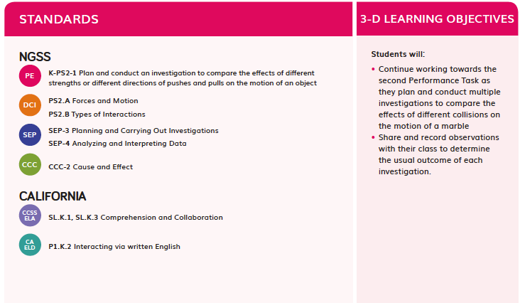  Standards and 3-D Learning Objectives TE p. 116
This metacognitive activity grows students' awareness of which skills they are using (DQ3L3 Science Tools poster TE p. 151).  Engineering  Engineering design is fully integrated into this module. Students are introduced to the role of an engineer and the concept of design in DQ1L1. After learning about and investigating forces in DQ1 and DQ2, students begin DQ3 and work towards answering the Driving Question: How do we understand and design a marble run? The first several lessons of DQ3 involve students investigating available materials, designing, predicting, building, and testing various marble run designs. The DQ, and module, culminates in an Engineering Design Challenge, where students define a problem that they want to solve with their marble run, and then design, build, test, revise, and present their final marble runs. | 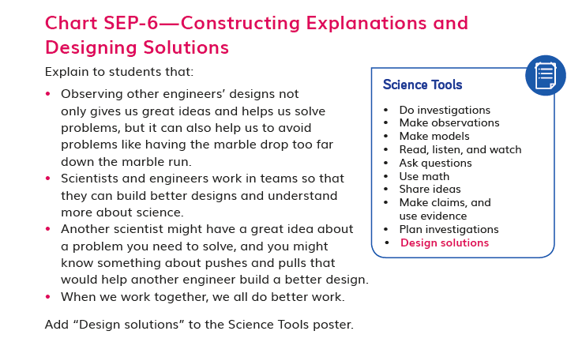  DQ3L3 Science Tools poster TE p. 151
F3. Presence of Logical Sequence
The materials are High Quality 5 with regards to F3.
The materials consistently exhibit a clear, logical, and appropriate sequence across the three dimensions.
Evidence  Targeted Three Dimensions in a Logical Sequence  Grade Sequence  The Kindergarten Scope and Sequence clearly identifies the three dimensions targeted in Marble Run Engineer and where they fit into the sequence of dimensions that are addressed across the entire grade. For example, students will go on to revisit K–2-ETS1-1 in Module 3 and Module 4. The sequence of all the DCIs, SEPs, and CCCs targeted at Grade K is easy to see at a glance. | 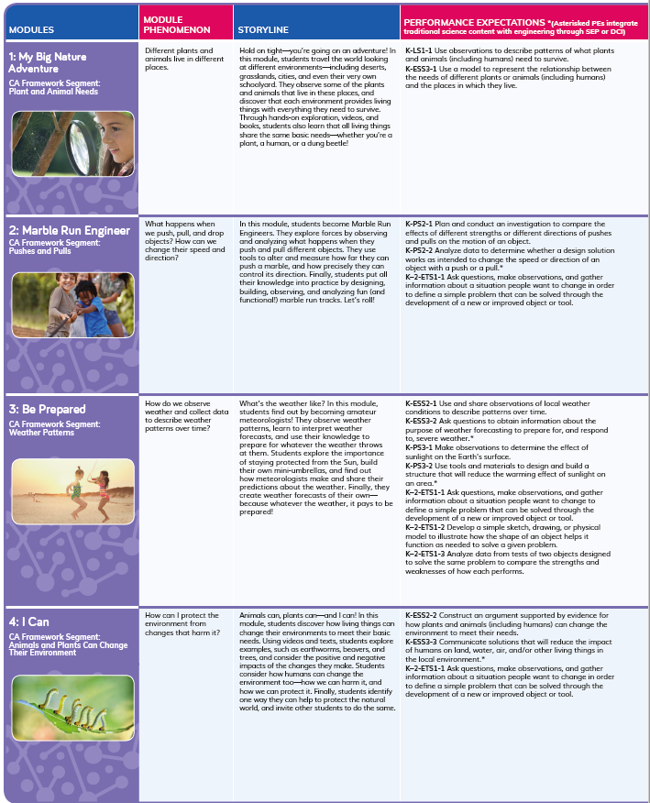  Kindergarten Scope and Sequence
Program Sequence  The Performance Expectations Progressions table identifies where students will revisit dimensions in future grades. For example, students will revisit engineering in Grade 4 Module 4, and forces in Grade 3 Module 1, Grade 4 Module 1, and Grade 6 Module 2. | 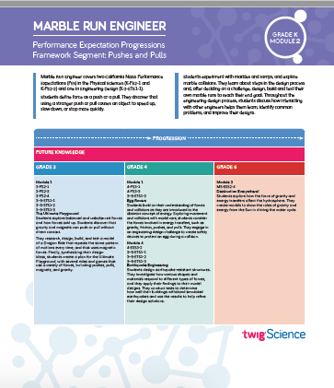  Performance Expectations Progressions table
Module Sequence  The Module Contents (TE pp. ii–iii) identifies the sequence of three dimensions addressed in GK M2 and how they build on each other. For example, students are introduced to motion and learn about pushes and pulls in DQ1, before they investigate using pushes and pulls to change the speed and direction of an object in DQ2. In DQ3, they use their learning to predict and test how a marble will move in marble runs that they have designed. | 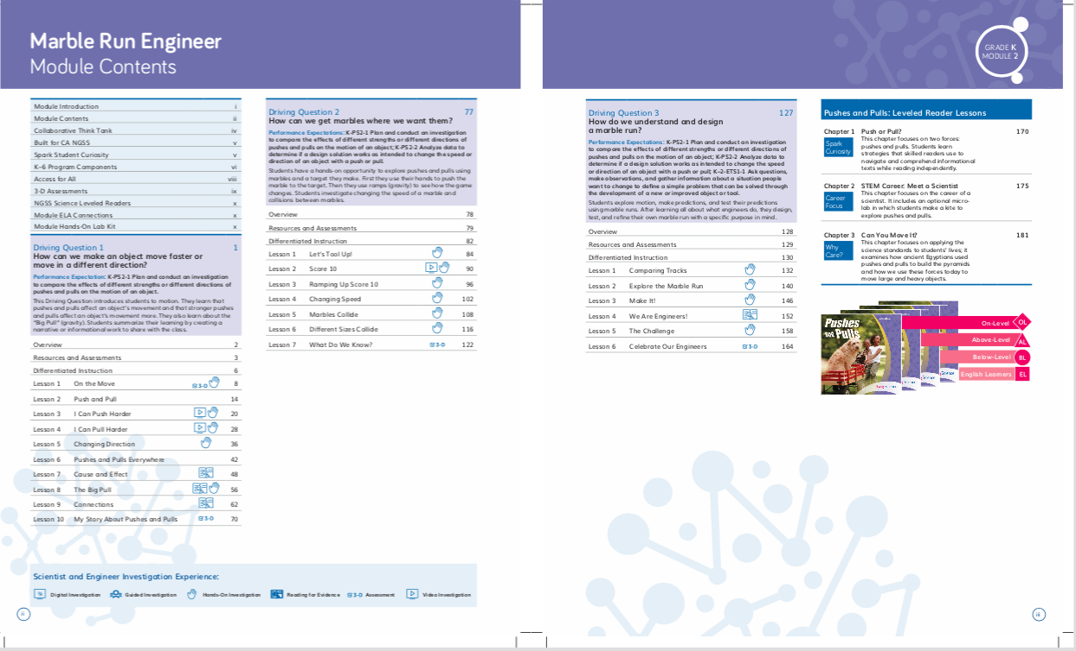  Module Contents (TE pp. ii–iii)
Driving Question Sequence  Each Driving Question Divider tells the story of how the students will sequentially use the three dimensions to answer the question posed. For example, in DQ2, students plan and carry out different investigations into pushes and pulls, and analyze their data to see how the results change between investigations. This knowledge helps them establish an answer to the DQ: How can we get marbles where we want them? | 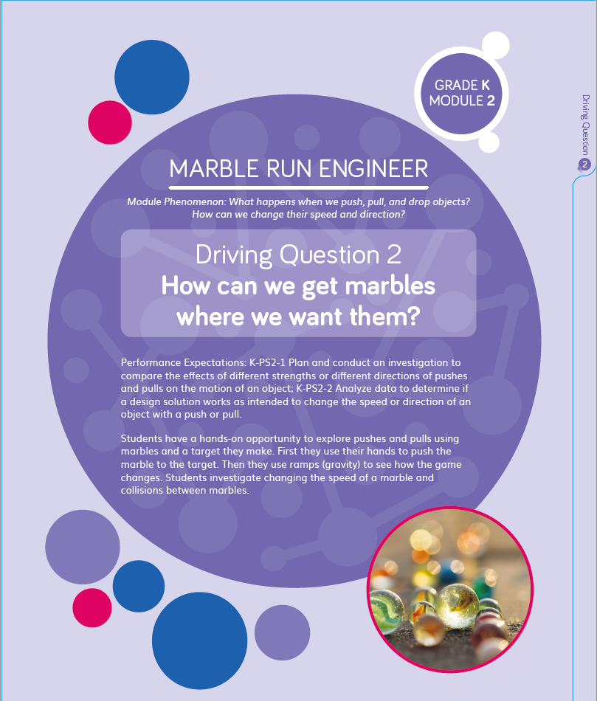  Driving Question Divider
Lesson Sequence  The five-part Twig Science Lesson Overview has been designed to support students to monitor what and how they have learned across the three dimensions on a daily basis.  Spark: An engaging hook activity motivates students for the investigations ahead.  Investigate: Students think like scientists and design like engineers through hands-on, digital, video, and informational text investigations.  Report: Students articulate what they’ve learned, citing evidence and their use of the three dimensions.  Connect: Students make connections to the DQs and Module Phenomenon while building knowledge of CCCs and SEPs.  Reflect: Here students use different means to think about what they have learned so far and how they can use their new understandings to better figure out phenomena/problems. | 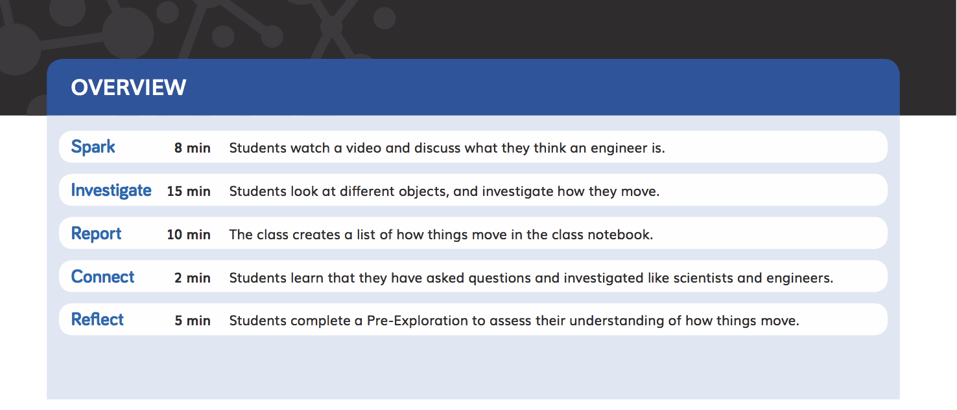  Lesson Overview
Each Lesson Overview includes the lesson’s targeted standards, the 3-D Learning Objectives, and a brief summary of each lesson section with suggested pacing.  For example, in DQ1L2 (TE p. 14) students will become motivated by listening to a read-aloud in the Spark, before they Investigate objects in the classroom that can be pushed or pulled. They will Report their findings to the class, Connect their learning to the Module Phenomenon and SEP-5, and use what they have learned to Reflect on which of two images shows a pull.  Flow of DCIs  The DCIs follow a logical sequence, supporting students to gain the knowledge they need to address the Module Phenomenon.  - In DQ1, students define and delimit an engineering problem (ETS1.A), before investigating forces and motion (PS2.A) and the relationship between energy and forces (PS3.C).  - In DQ2, students continue investigating forces and motion (PS2.A) and the relationship between energy and forces (PS3.C). They also investigate and analyze different types of interactions (PS2.B).  - In DQ3, students define and delimit an engineering problem (ETS1.A) and utilize their knowledge of forces and motion (PS2.A), types of interactions (PS2.B), and the relationship between energy and forces (PS3.C) to solve the problem.  Flow of SEPs and CCCs  The SEPs and CCCs follow a logical sequence supporting students to gain expertise of the practices and concepts they need to address the Module Phenomenon.  - In DQ1, students ask questions and define problems (SEP-1) relating to motion, and plan and carry out investigations (SEP-3). They analyze and interpret their data (SEP-4), using mathematics and computational thinking (SEP-5), and consider cause and effect (CCC-2). They obtain, evaluate, and communicate information (SEP-8) about forces and motion.  - In DQ2, students plan and carry out further investigations (SEP-3) into forces and motion. They analyze and interpret their data (SEP-4), relating their results to cause and effect (CCC-2). They use their investigation results to engage in argument from evidence (SEP-7). Finally, they develop and use models (SEP-2) to communicate information (SEP-8) that they have learned during the DQ.  - In DQ3, students plan and carry out investigations (SEP-3) and analyze and interpret their data (SEP-4), relating it to cause and effect (CCC-2). They use their learning to construct explanations and design solutions (SEP-6). They ask questions and define problems (SEP-1) and develop and use models (SEP-2) as they design and build their marble runs. Finally, they communicate their learning (SEP-8). | 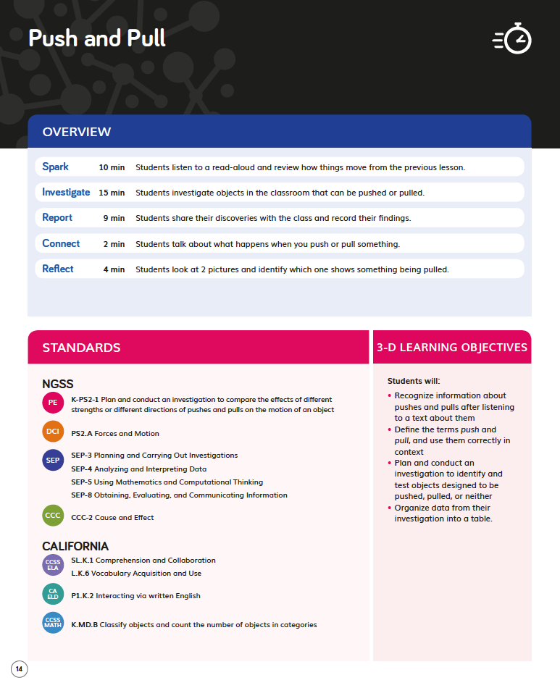  DQ1L2 TE p. 14

