Science made for the Next Generation

Twig Science was built from the ground up for the California NGSS by award-winning STEM education specialists.

Reviewing our program, you’ll find:

- ​A clear conceptual flow across the program, clearly set out in the program CA NGSS Framework Alignment
- Modules that bundle different scientific disciplines including engineering and environmental principles and concepts (as defined by the CDE), aligned 1:1 with the segments of the California Framework
- Phenomena and investigative problems at the heart of each module, with Grade Scope and Sequence tables that show how the dimensions flow and build in sophistication across each grade
- Module Contents that tell the story of how students apply the three dimensions in a module, with Driving Questions that scaffold their learning journey
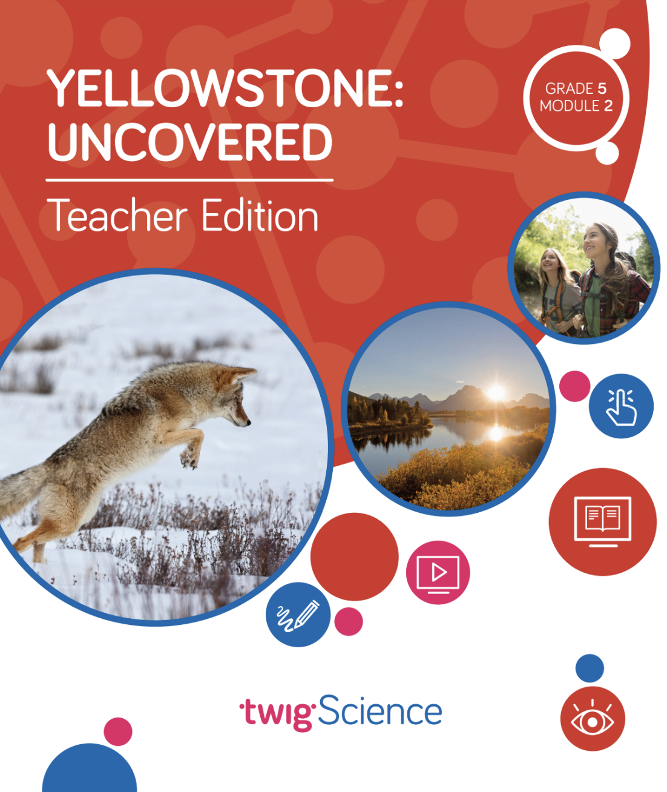
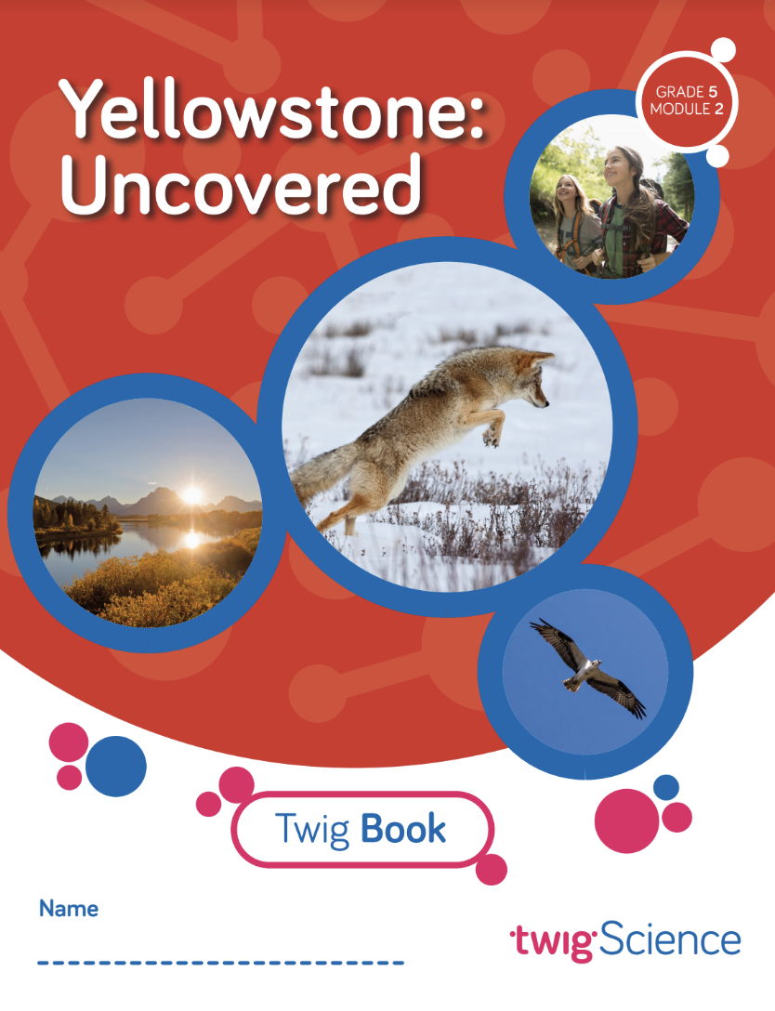
- Three-dimensional lessons and assessments that clearly outline the dimensions applied.
​
This is why we score so highly on NGSS-based rubrics such as NextGen TIME Paper screen evaluation.

This rubric has been completed for Grade 5 Module 2 Yellowstone: Uncovered and is designed to highlight where you can find evidence for the Designed for NGSS: Foundations Rubric. The rubric includes citations to the printed Teachers Edition and Twig Book (Student Edition).

Designed for the NGSS: Foundations | High Quality  5 | Medium Quality  3 | Low Quality  1
F1. Presence of Phenomena/Problem. The materials include phenomena/problems that have the potential to drive student learning toward the targeted learning goals in the following ways:  - phenomena/problems in the materials are to be relevant to students;  - explanations for phenomena connect to the three dimensions;  - solutions to problems connect to the three dimensions. | The materials include phenomena/problems that have strong potential to drive student learning toward the targeted learning goals. | The materials include phenomena/problems that have some potential to drive student learning toward the targeted learning goals. | The materials include phenomena/problems that have limited potential to drive student learning toward the targeted learning goals.
F2. Presence of Three Dimensions. The materials include opportunities for students to develop and use the three dimensions, such that:  - the DCIs, SEPs, and CCCs are present and have the potential to support student learning toward the targeted learning goals for each dimension;  - when engineering design is a learning focus, it is integrated with other appropriate dimensions (i.e., engineering is not isolated). | The materials consistently provide opportunities for students to develop and use the three dimensions. | The materials occasionally provide opportunities for students to develop and use the three dimensions. | The materials rarely provide opportunities for students to use the three dimensions.
F3. Presence of Logical Sequence. Materials demonstrate appropriate sequencing of three dimensions when:  - they include a targeted set of DCIs, SEPs, and CCCs within a sequence;  - the sequence is clear and logical across the DCIs;  - the SEPs and CCCs are potentially sufficient and appropriate for students to figure out the phenomena or problems. | The materials consistently exhibit a clear, logical, and appropriate sequence across the three dimensions. | The materials occasionally exhibit a clear, logical, and appropriate sequence across the three dimensions. | The materials rarely exhibit a clear, logical, and appropriate sequence across the three dimensions.

Designed for NGSS: Foundations
Analyze Evidence
Directions:
- Review the Designed for NGSS: Foundations Rubric.
- Reflect on the evidence (or lack of evidence) that you and your team gathered and represented.
- Record strengths and limitations for each criterion based on your evidence. Cite specific examples.

Strengths
F1. Presence of Phenomena /Problems
The materials are High Quality 5 with regards to F1.
There is high quality evidence of phenomenon and problems that with a strong potential to drive student learning towards targeted goal. The phenomena/problems are very relevant to students, explanations for phenomena connect to the three dimensions, and solutions to problems connect to the three dimensions.
Evidence

Grade 5 Module 2: Yellowstone: Uncovered
Module Phenomenon: How do matter and energy move through an ecosystem?
Students tackle the phenomenon in stages by following a sequence of Driving Questions (DQs) that drive a conceptual flow.

- DQ1: What do plants need to grow?
- DQ2: What do animals need in order to grow and heal?
- DQ3: Where do plants get their matter?
- DQ4: Where do organisms get the energy they need to grow, heal, move, and maintain their body temperature?
- DQ5: What happens to matter in an ecosystem?
- DQ6: How can ecosystems change?

Over the course of all six DQs, students investigate a series of phenomena/problems, which progressively build in complexity, scaffolding students' acquisition of the necessary DCIs, SEPs, and CCCs until they are able to address the central phenomenon.

For example, in DQ1, students explore the phenomenon of plant growth, planning and setting up two hands-on investigations to support their ideas. Then in DQ2, they use a food chain and food web to model the movement of matter, culminating in the creation of a physical ecosystem models which they observe throughout the module. In DQ3, students collect and analyze the data from their two hands-on investigations in order to construct scientific explanations about where plants get their matter. In DQ4, students use an interactive to model matter and energy flow, discovering that plants and animals get their energy to grow from the Sun. In DQ5, students explore the role of decomposers in an ecosystem, observing a guided demonstration and modeling matter cycling in an ecosystem using their learning from close readings. Finally, in DQ6, students use an interactive to model what happens to an ecosystem when a new species is introduced and further consolidate their learning with a reading and video investigation.

By the end of the module, students have figured out how to answer the Module Phenomenon, understanding that the matter plants and animals need to grow and heal was once energy from the Sun, and that it cycles through an ecosystem due to processes like decomposition.
F2. Presence of Three Dimensions
The materials are High Quality 5 with regards to F2.
They consistently provide opportunities for students to use and develop the three dimensions.
Evidence  In this module, students are supported to use the three dimensions with increasing sophistication to solve the Module Phenomenon, answer the DQs, and complete the assessment tasks.  Use and Development of Dimensions  For example, in DQ1, students explore the question: What do plants need to grow? Over three lessons, they are introduced to the phenomena of matter and energy flow in organisms (LS1.C) before setting up and carrying out two hands-on investigations (SEP-3) which enable them to obtain and evaluate data (SEP-8) before communicating their learning in a written argument supported by evidence (SEP-8). They interrogate texts, watch videos, and apply the concepts of energy and matter to figure out the answer to the DQ: plants get the materials they need for growth chiefly from air and water (5-LS2-1). (Module Contents TE p.ii-iii)  The 3-D Learning Objectives and dimensions addressed in every lesson are clearly identified at the start of each lesson.  Science Tools Poster  Throughout the module, students use their class Science Tools poster to track their growing use of the SEPs. The poster is blank at the start of the year, and the eight SEPs are added when each one is used for the first time. In this module, students add “Obtain, evaluate, and communicate information” (SEP-8) and “Ask questions” (SEP-1). Students revisit:  - Argue from evidence (SEP-7)  - Plan and carry out investigations (SEP-3)  - Develop and use models (SEP-2)  - Construct explanations (SEP-6)  - Use math and computational thinking (SEP-5)  This metacognitive activity grows students' awareness of which skills they are using. |  |  |  | 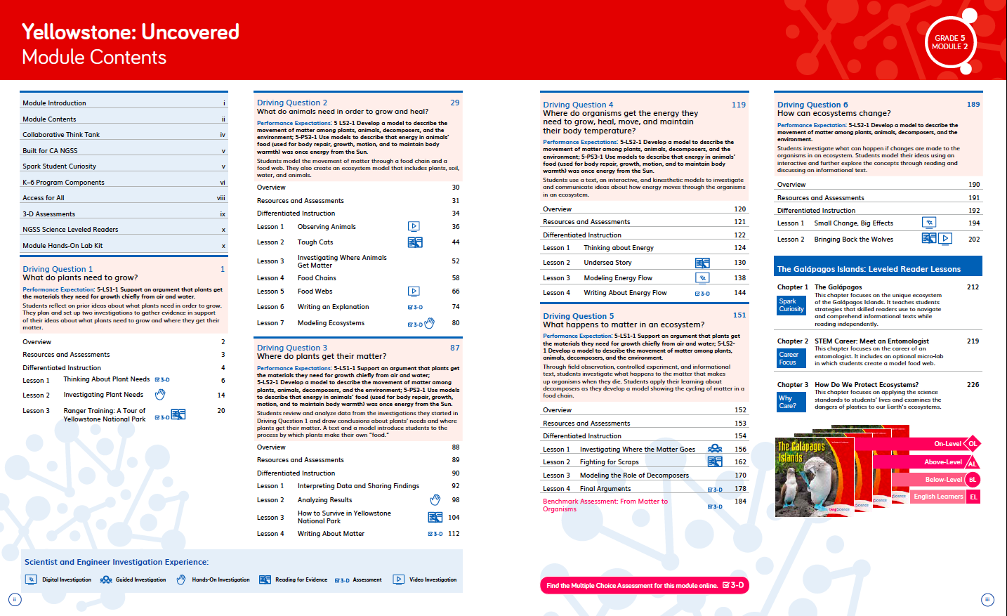  Module Phenomenon TE p. i  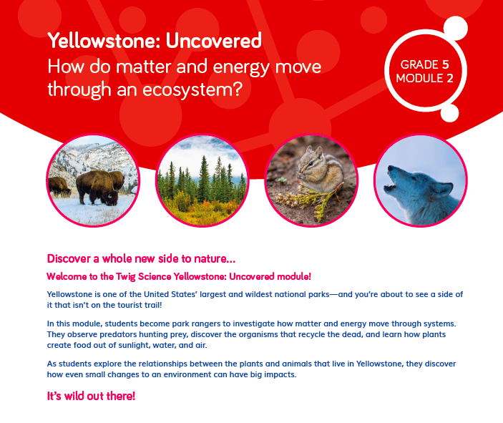  Module Contents TE p.ii-iii  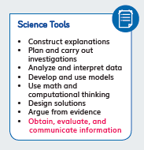  Science Tools poster
Engineering  Engineering practices are fully embedded in this module. Students engage with science and engineering practices at the very start of the module, planning the two investigations that spark their exploration of the Module Phenomenon (DQ1L1 TE p. 14). They build on these practices and develop others over the course of the module. |  |  |  | 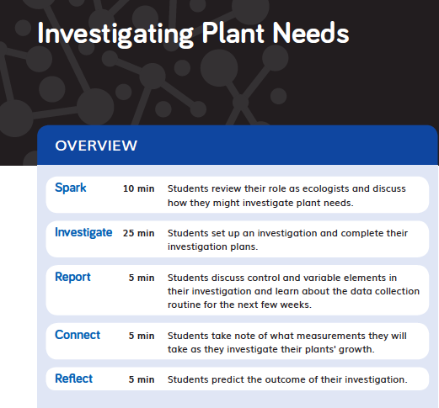  DQ1L1 TE p. 14
F3. Presence of Logical Sequence
The materials are High Quality 5 with regards to F3.
The materials consistently exhibit a clear, logical, and appropriate sequence across the three dimensions.
Evidence  Targeted Three Dimensions in a Logical Sequence  Grade Sequence  The Grade 5 Scope and Sequence clearly identifies the three dimensions targeted in Yellowstone: Uncovered and where they fit into the sequence of dimensions that are addressed across the entire grade. For example, before this module, students have already encountered 3–5-ETS1-3 in Module 1 and will go on to revisit it in Module 3. The sequence of all the DCIs, SEPs, and CCCs targeted at Grade 5 is easy to see at a glance. |  |  | 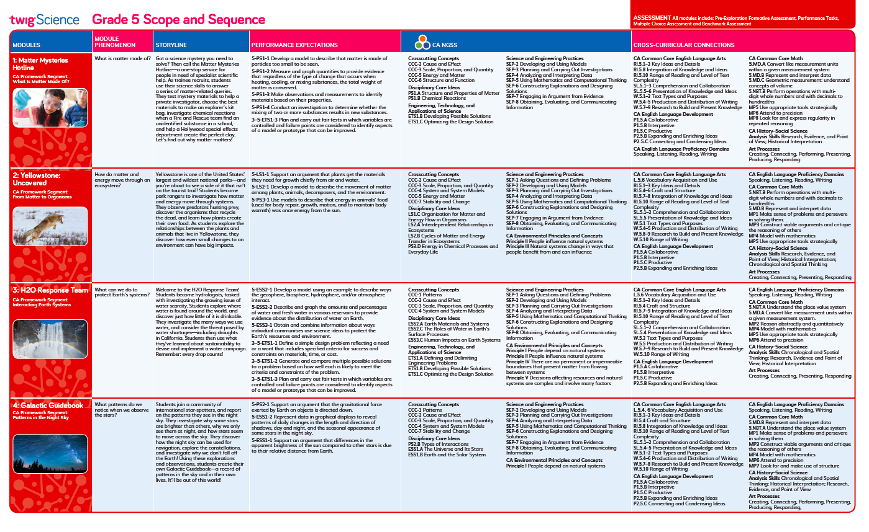  Grade 5 Scope and Sequence
Program Sequence  The Performance Expectations Progressions table identifies where students have encountered relevant dimensions in previous grades, for example, LS2-1 in Grade 2 Module 4. It also identifies where they will revisit dimensions in future grades, for example, how energy from the Sun also affects the water cycle in Grade 6 Module 2. |  |  | 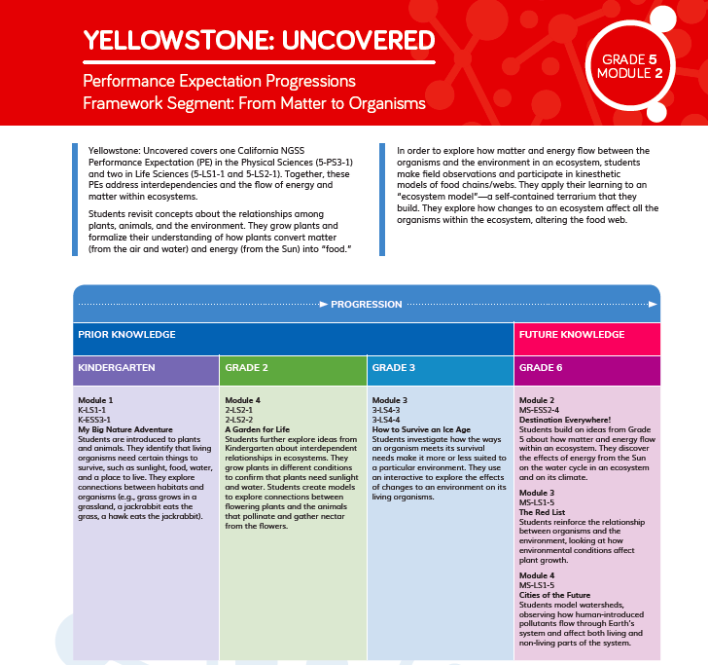  Performance Expectation Progressions
Module Sequence  The Module Contents identifies the sequence of three dimensions addressed in Grade 5 Module 2 and how they build on each other. For example, in DQ2, students investigate and model food chains and food webs. Across DQ3–DQ6, they develop an increasingly sophisticated understanding of how matter and energy flow through ecosystems using a physical ecosystem model that they develop. |  |  | Module Contents TE pp. ii-iii
Driving Question Sequence  The Driving Question Divider and Driving Question Overview tell the story of how students will sequentially use the three dimensions to answer the question posed. For example, in DQ3 students consider the concept of cause and effect to analyze and interpret data, which enables them to develop a model that describes how matter moves among plants, animals, decomposers, and the environment. This knowledge helps them realize that the energy in animal's food was once energy from the Sun. |  |  | 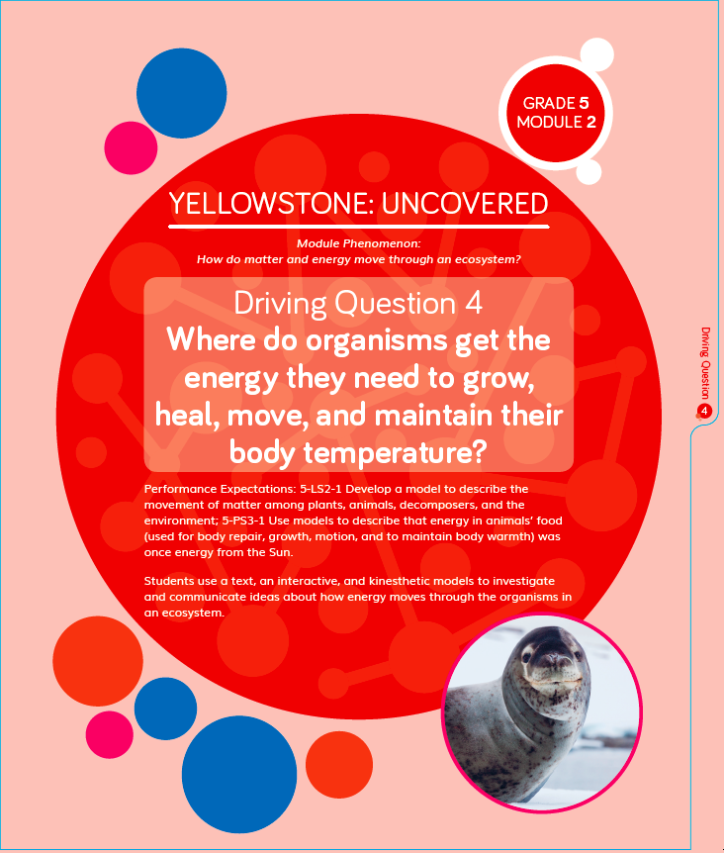Driving Question Divider TE p. 119  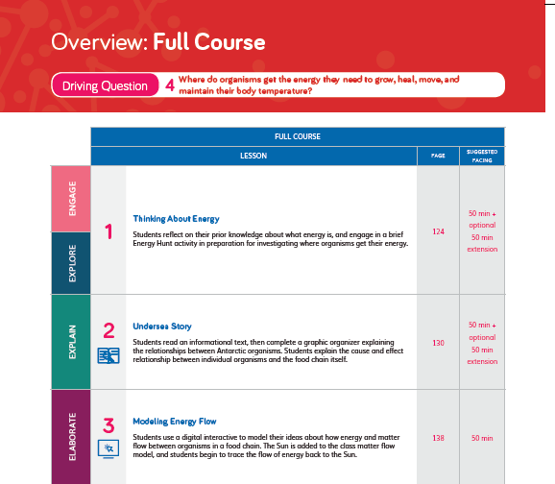  Driving Question Overview TE pp. 120-125
Lesson Sequence  The five-part Twig Science lesson structure has been designed to support students to monitor what and how they have learned across the three dimensions on a daily basis.  Spark: An engaging hook activity motivates students for the investigations ahead.  Investigate: Students think like scientists and design like engineers through hands-on, digital, video, and information text investigations.  Report: Students articulate what they’ve learned, citing evidence and their use of the three dimensions.  Connect: Students make connections to the Driving Questions and Module Phenomenon while building knowledge of CCCs and SEPs.  Reflect: Students use different means to think about what they have learned so far and how they can use their new understandings to better figure out phenomena/problems.  The Lesson Overview summarizes how each part targets the standards and 3-D Learning Objectives.  Each Lesson Overview includes the lesson’s targeted Standards and 3-D Learning Objectives, which identify the dimensions and detail how they relate to the learning experience.  For example, in DQ4L3, the 3-D Learning Objectives explain that in this lesson students will model their ideas about how energy and matter flow in an ecosystem. |  |  | Lesson Overview TE p. 14  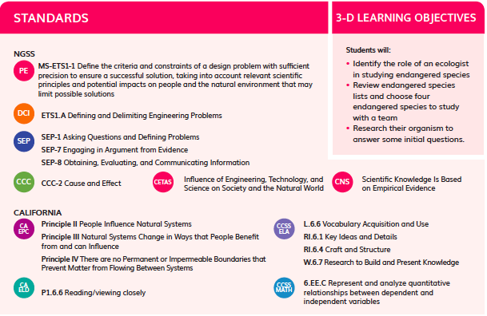  Standards and 3-D Learning  Objectives TE p. 138
Flow of DCIs
The DCIs follow a logical sequence, supporting students to gain the knowledge they need to address the Module Phenomenon.

- DQ1: Students explore matter and energy flow in organisms (LS1.C).
- DQ2: Students continue to explore matter and energy flow in organisms (LS1.C) by investigating interdependent relationships (LS2.A) and cycles of matter and energy transfers in ecosystems (LS2.B).
- DQ3: Students further explore the three DCIs from DQ2 and connect the concepts of matter and energy flow in ecosystems (LS1.C) to energy in chemical processes and everyday life (PS3.D).
- DQ4: Students consolidate their learning by continuing to investigate the four DCIs from DQ3.
- DQ5: Students focus on interdependent relationships (LS2.A) and cycles of matter and energy transfers in ecosystems (LS2.B).
- DQ6: Students focus on interdependent relationships in ecosystems (LS2.A).
Flow of SEPs and CCCs
The SEPs and CCCs follow a logical sequence supporting students to gain expertise of the practices and concepts they need to address the Module Phenomenon.

DQ1: Students rely on the concept of energy and matter (CCC-5) as they plan and carry out investigations (SEP-3). Their investigations lead them to ask further questions (SEP-1), applying the concept of scale, proportion, and quantity (CCC-3). Finally, students obtain, evaluate, and communicate information (SEP-8) which enables them to engage in argument from evidence (SEP-7).
DQ2: Students analyze and interpret data (SEP-4) and obtain, evaluate, and communicate information (SEP-8). They apply the concepts of energy and matter (CCC-5) and systems and system models (CCC-4) as they develop and use models (SEP-2). This work allows them to construct explanations and design solutions (SEP-6) which in turn support them as they plan and carry out investigations (SEP-3).
DQ3: Students ask questions and define problems (SEP-1), analyze and interpret data (SEP-4), and use math and computational thinking (SEP-5). They apply the concepts of cause and effect (CCC-2) and energy and matter (CCC-5) as they plan and carry out investigations (SEP-3) which enable them to obtain, evaluate, and communicate information (SEP-8). Students use their learning to engage in argument from evidence (SEP-7).
DQ4: Students apply the concepts of energy and matter (CCC-5) and systems and system models (CCC-4) as they develop and use models (SEP-2). Students use their learning to engage in argument from evidence (SEP-7).
DQ5: Students develop and use models (SEP-2), applying the concepts of systems and system models (CCC-4) and energy and matter (CCC-5) to plan and carry out investigations (SEP-3). Students obtain, evaluate, and communicate information (SEP-8), analyze and interpret the data they’ve collected (SEP-4), and engage in argument from evidence (SEP-7).
DQ6: Students apply the concepts of cause and effect (CCC-2), systems and system models (CCC-4), and stability and change (CCC-7) as they develop and use models (SEP-2). This supports them to plan and carry out investigations (SEP-3). Students revisit the concept of energy and matter (CCC-5) as they obtain, evaluate, and communicate information (SEP-8), culminating in students constructing explanations and designing solutions (SEP-6).

