Science made for the Next Generation

Twig Science was built from the ground up for the California NGSS by award-winning STEM education specialists.

Reviewing our program, you’ll find:

- ​A clear conceptual flow across the program, clearly set out in the program CA NGSS Framework Alignment
- Modules that bundle different scientific disciplines including engineering and environmental principles and concepts (as defined by the CDE), aligned 1:1 with the segments of the California Framework
- Phenomena and investigative problems at the heart of each module, with Grade Scope and Sequence tables that show how the dimensions flow and build in sophistication across each grade
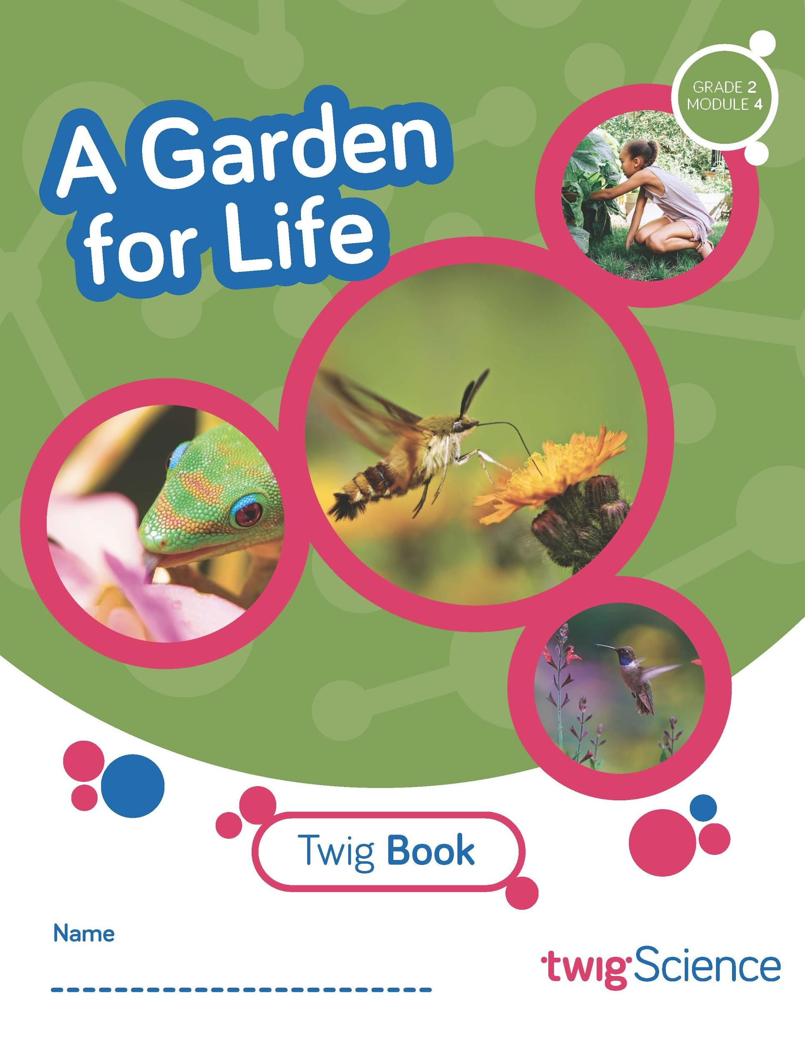
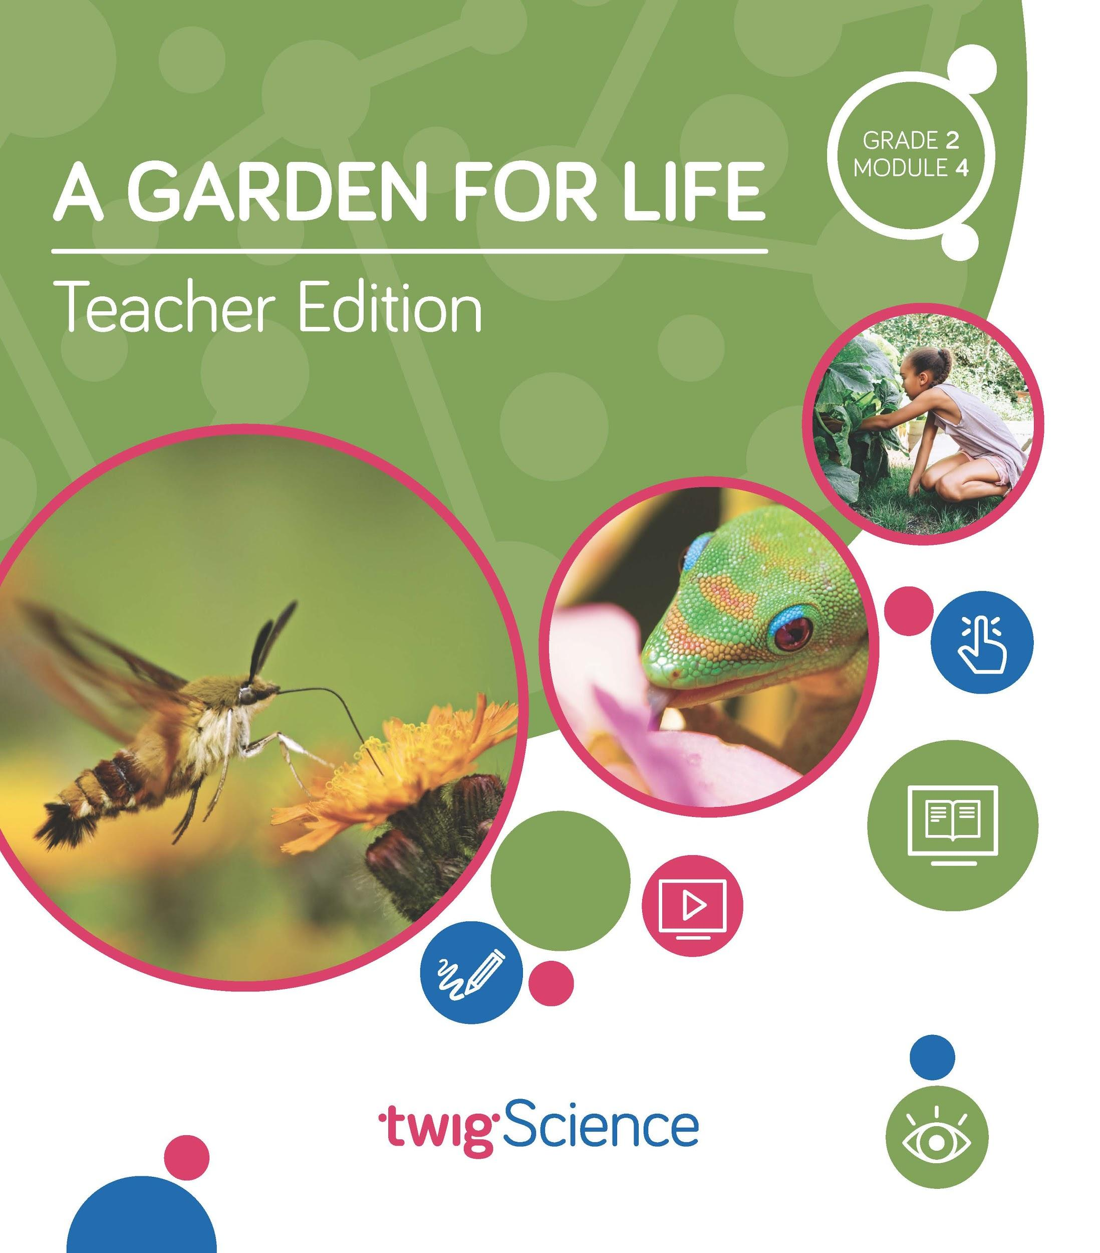
- Module Contents that tell the story of how students apply the three dimensions in a module, with Driving Questions that scaffold their learning journey
- Three-dimensional lessons and assessments that clearly outline the dimensions applied.
​
This is why we score so highly on NGSS-based rubrics such as NextGen TIME Paper screen evaluation.

This rubric has been completed for Grade 2 Module 4 A Garden for Life and is designed to highlight where you can find evidence for the Designed for NGSS: Foundations Rubric. The rubric includes citations to the printed Teachers Edition and Twig Book (Student Edition).

Designed for the NGSS: Foundations | High Quality  5 | Medium Quality  3 | Low Quality  1
F1. Presence of Phenomena/Problem. The materials include phenomena/problems that have the potential to drive student learning toward the targeted learning goals in the following ways:  - phenomena/problems in the materials are to be relevant to students;  - explanations for phenomena connect to the three dimensions;  - solutions to problems connect to the three dimensions. | The materials include phenomena/problems that have strong potential to drive student learning toward the targeted learning goals. | The materials include phenomena/problems that have some potential to drive student learning toward the targeted learning goals. | The materials include phenomena/problems that have limited potential to drive student learning toward the targeted learning goals.
F2. Presence of Three Dimensions. The materials include opportunities for students to develop and use the three dimensions, such that:  - the DCIs, SEPs, and CCCs are present and have the potential to support student learning toward the targeted learning goals for each dimension;  - when engineering design is a learning focus, it is integrated with other appropriate dimensions (i.e., engineering is not isolated). | The materials consistently provide opportunities for students to develop and use the three dimensions. | The materials occasionally provide opportunities for students to develop and use the three dimensions. | The materials rarely provide opportunities for students to use the three dimensions.
F3. Presence of Logical Sequence. Materials demonstrate appropriate sequencing of three dimensions when:  - they include a targeted set of DCIs, SEPs, and CCCs within a sequence;  - the sequence is clear and logical across the DCIs;  - the SEPs and CCCs are potentially sufficient and appropriate for students to figure out the phenomena or problems. | The materials consistently exhibit a clear, logical, and appropriate sequence across the three dimensions. | The materials occasionally exhibit a clear, logical, and appropriate sequence across the three dimensions. | The materials rarely exhibit a clear, logical, and appropriate sequence across the three dimensions.

Designed for NGSS: Foundations
Analyze Evidence
Directions:
- Review the Designed for NGSS: Foundations Rubric.
- Reflect on the evidence (or lack of evidence) that you and your team gathered and represented.
- Record strengths and limitations for each criterion based on your evidence. Cite specific examples.

Strengths
F1. Presence of Phenomena /Problems
The materials are High Quality 5 with regards to F1.
There is high quality evidence of phenomenon and problems that with a strong potential to drive student learning towards targeted goal. The phenomena/problems are very relevant to students, explanations for phenomena connect to the three dimensions, and solutions to problems connect to the three dimensions.
Evidence
Grade 2 Module 4: A Garden for Life
Module Phenomenon: How do living things in an environment depend on one another and what do they need to grow?
Students tackle the phenomenon in stages by following a sequence of Driving Questions (DQs) that drive a conceptual flow.

DQ1: How can we compare different habitats?
DQ2: How can we help the plants in our garden grow?
DQ3: How will the plants and animals in our garden depend on each other?
DQ4: How can we design a garden that will help pollinators?

Over the course of all four DQs, students investigate a series of phenomena/problems, which progressively build in complexity, scaffolding students' acquisition of the necessary DCIs, SEPs, and CCCs until they are able to address the central phenomenon.

For example, in DQ1, students explore different habitats using a digital interactive and a hands-on investigation they plan themselves. Then in DQ2, they begin designing a garden habitat, an activity they work on throughout the module—to do so, students plan and carry out investigations to determine if plants need water and light to grow. In DQ3, students explore the phenomenon of interdependence among species by exploring pollination, culminating in students building physical pollinator models to show their learning. Finally, in DQ4, students design their pollinator gardens, building and presenting dioramas that document all they’ve learned in the module.

By the end of the module, students have figured out how to answer the Module Phenomenon, understanding that plants need water and light to grow, and that living things in an ecosystem are interdependent.
F2. Presence of Three Dimensions
The materials are High Quality 5 with regards to F2.
They consistently provide opportunities for students to use and develop the three dimensions.
Evidence  In this module, students are supported to use the three dimensions with increasing sophistication to solve the Module Phenomenon, answer the Driving Questions, and complete the assessment tasks.  Use and Development of Dimensions  For example, in DQ2, students explore the question, How can we help the plants in our garden grow?  Over five lessons, they are introduced to the phenomenon of interdependent relationships in ecosystem through a reading which inspires them to apply the concept of cause and effect (CCC-2) as they ask questions (SEP-1) about the text. Over two lessons, they plan and carry out an investigation (SEP-3) into plant needs, collecting data they then analyze and interpret (SEP-4). This work enables them to to answer the Driving Question, with students understanding that they can help their plants grow with water and sunlight (2-LS2-1).  The 3-D Learning Objectives and dimensions that are addressed in every lesson are clearly identified at the start of each lesson. | 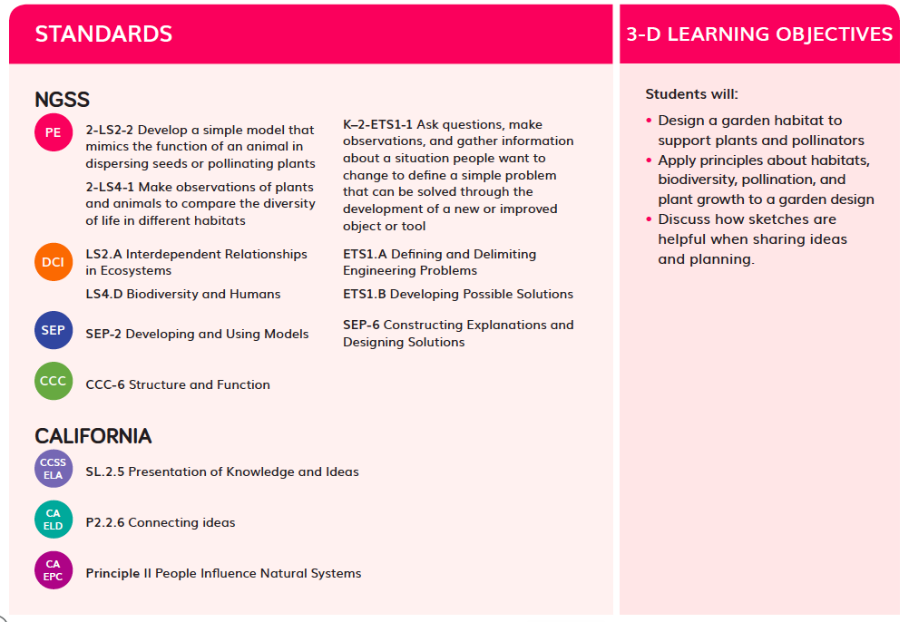  3-D Learning Objectives TE p. 216
Science Tools Poster  Throughout the module, students use their class Science Tools poster to track their growing use of the SEPs. The poster is blank at the start of the year, and the eight SEPs are added when each one is used for the first time. In this module, students revisit:  - Make observations, use data (SEP-4)  - Plan and do investigations (SEP-3)  - Ask questions (SEP-1)  - Make claims and support them with evidence (SEP-7)  - Explain how or why things happen (SEP-6)  - Make and use models (SEP-2)  - Design solutions (SEP-6)  - Get information (SEP-8)  This metacognitive activity grows students' awareness of which skills they are using. | 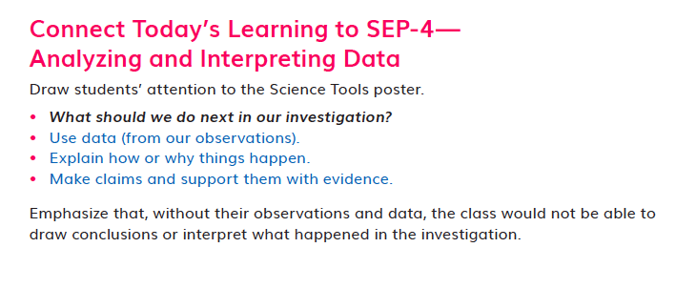Science Tools poster TE p. 114
Engineering
Engineering practices are fully embedded in this module. Students engage with science and engineering practices in every Driving Question. For example, in DQ1, students analyze and interpret data about different habitats, plan and carry out an investigation into biodiversity, analyze and interpret their data, and use this data to engage in argument from evidence. They build on these practices and develop others over the course of the module.
F3. Presence of Logical Sequence
The materials are High Quality 5 with regards to F3.
The materials consistently exhibit a clear, logical, and appropriate sequence across the three dimensions.
Targeted Three Dimensions in a Logical Sequence  Grade Sequence  The Grade 2 Scope and Sequence clearly identifies the three dimensions targeted in A Garden for Life and where they fit into the sequence of dimensions that are addressed across the entire grade. For example, before this module, students have already encountered K–2-ETS1-1 and K–2-ETS1-2 in Modules 2 and 3. The sequence of all the DCIs, SEPs, and CCCs targeted at Grade 2 is easy to see at a glance. | 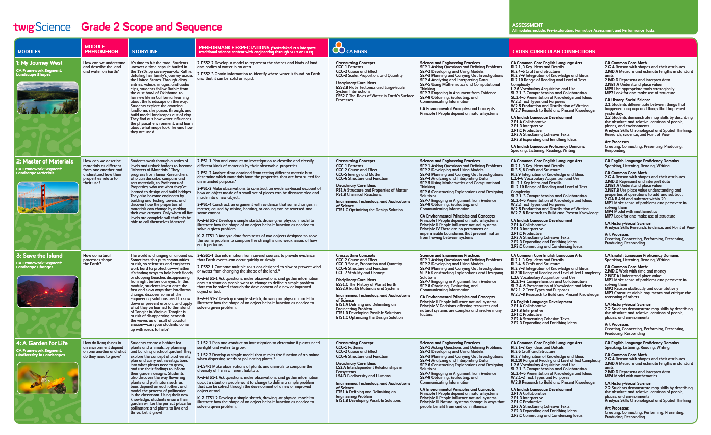  Grade 2 Scope and Sequence
Program Sequence  The Performance Expectations Progressions table identifies where students have encountered relevant dimensions in previous grades, for example, LS1-1 in Grade K Module 1. It also identifies where they will revisit dimensions in future grades, for example, LS2-1 in Grade 5 Module 2. | 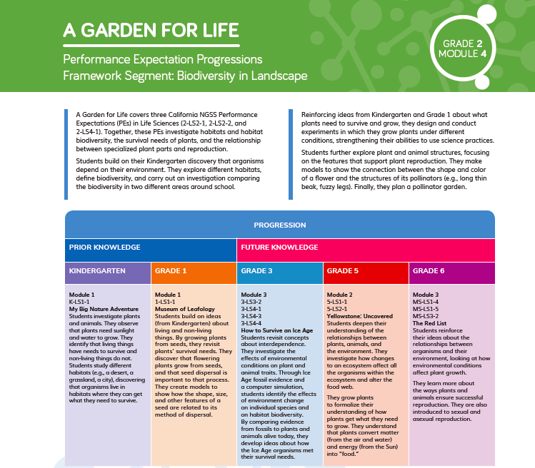  Performance Expectations Progressions
Driving Question Sequence  Each Driving Question Divider tells the story of how the students will sequentially use the three dimensions to answer the question posed. In DQ2, students begin to design a garden habitat for plants and animals. They plan and execute experiments to see if plants need water and light to grow, making predictions, drawing conclusions, and sharing their results with the class. They will apply their findings toward the creation of their garden plan. | 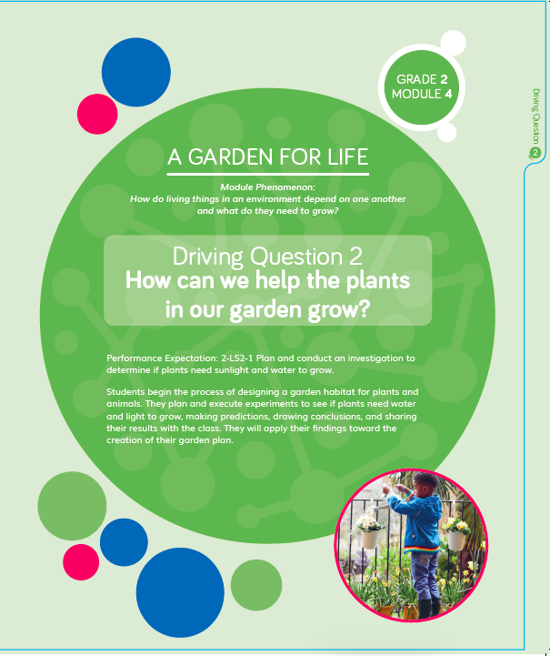Driving Question Divider
Module Sequence  The Module Contents pp. ii-iii identifies the sequence of three dimensions addressed in Grade 2 Module 4 and how they build on each other. For example, in DQ1, students use an interactive to explore different habitats. Across DQ2–4, they develop an increasingly sophisticated understanding of the interdependent relationships in all habitats, which supports them in the final task of designing a pollinator garden. | 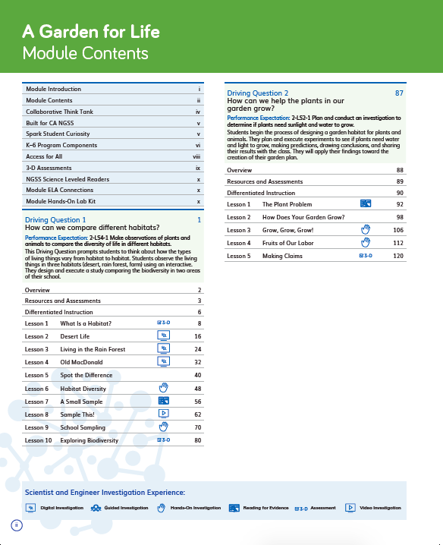Module Contents TE pp. ii-iii
Driving Question Sequence  Each Driving Question Divider tells the story of how students will sequentially use the three dimensions to answer the question posed. For example, in DQ3 students apply the concept of structure and function as they explore pollination. They obtain and evaluate information on pollination and interdependent relationships among plants and animals which supports them to develop and use physical pollinator models. By the end of the Driving Question, they apply their learning to choose the best design solution for their pollinator garden. | Driving Question Divider TE p. 87
Lesson Sequence  The five-part Twig Science lesson structure has been designed to support students to monitor what and how they have learned across the three dimensions on a daily basis.  Spark: An engaging hook activity motivates students for the investigations ahead.  Investigate: Students think like scientists and design like engineers through hands-on, digital, video, and information text investigations.  Report: Students articulate what they’ve learned, citing evidence and their use of the three dimensions.  Connect: Students make connections to the Driving Questions and Module Phenomenon while building knowledge of CCCs and SEPs.  Reflect: Students use different means to think about what they have learned so far and how they can use their new understandings to better figure out phenomena/problems.  The Lesson Overview summarizes how each part targets the standards and 3-D Learning Objectives.  Each Lesson Overview includes the lesson’s targeted Standards and 3-D Learning Objectives, which identify the dimensions and detail how they relate to the learning experience.  For example, in DQ4, the 3-D Learning Objectives explain that in lesson 1 students will design a garden habitat to support plants and pollinators, apply principles about habitats, biodiversity, pollination, and plant growth to a garden design, and discuss how sketches are helpful when sharing ideas and planning. | 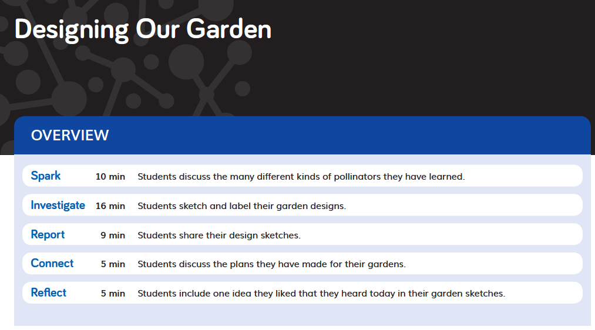  Lesson Overview TE p. 216  Standards and 3-D Learning Objectives TE p. 216
Flow of DCIs
The DCIs follow a logical sequence, supporting students to gain the knowledge they need to address the Module Phenomenon.

DQ1: Students explore biodiversity and humans (LS4.D).
DQ2: Students investigate interdependent relationships in ecosystems (LS2.A).
DQ3: Students further examine these interdependent relationships (LS2.A) and then explore developing possible solutions (ETS1.B).
DQ4: Students continue to explore developing possible solutions (ETS1.B) in the context of biodiversity and humans (LS4.D) and the interdependent relationships in ecosystems (LS2.A).

Flow of SEPs and CCCs
The SEPs and CCC’s follow a logical sequence supporting students to gain expertise of the practices and concepts they need to address the Module Phenomenon.

DQ1: Students apply the concept of patterns (CCC-1) as they plan and carry out investigations (SEP-3) and then analyze and interpret the data they collect (SEP-4). They develop and use models (SEP-2), then move to obtain, evaluate, and communicate information (SEP-8). Finally, they engage in argument from evidence (SEP-7).

DQ2: Students apply the concept of cause and effect (CCC-2) as they ask questions and define problems (SEP-1) which enables them to plan and carry out investigations (SEP-2). They analyze and interpret the data (SEP-4) from these investigations, finally engaging in argument from evidence (SEP-7).

DQ3: Students apply the concepts of structure and function (CCC-6) and cause and effect (CCC-2) as they develop and use models (SEP-2), construct explanations and design solutions (SEP-6), and obtain, evaluate, and communicate information (SEP-8).

DQ4: Students apply the concept of structure and function (CCC-6) as they ask questions and define problems (SEP-1) which support them to develop and use models (SEP-2). Students use their learning to construct explanations and design solutions (SEP-6).

