Designed for the NGSS: Foundations Teacher Support Evidence Chart

Teacher materials… | Strong | Adequate | Weak
F1. Presence of Phenomena/Problems. Identify and provide background information about the phenomena/problems in the unit and how they match the targeted learning goals. | ✓
F2. Presence of Three Dimensions. Identify and provide background information about the each of the three dimensions in the unit.  - the SEPs  - the DCIs (including engineering)  - the CCCs  - also note (NoS/CNS) and Connections to Engineering, Technology and the Applications of Science (ETS/CETAS) | ✓
F3. Presence of Logical Sequence. Identify and provide background information on the sequence of learning in the unit. | ✓

Strengths related to these Teacher Supports
F1. Presence of Phenomena/Problems.
The module is strong at identifying and providing background information about the phenomena/problems in the unit and how they match the targeted learning goals.
Evidence  - An Module Introduction online and in print (TE p. i–iii) sets out at high level how students will solve the Module Phenomenon. | 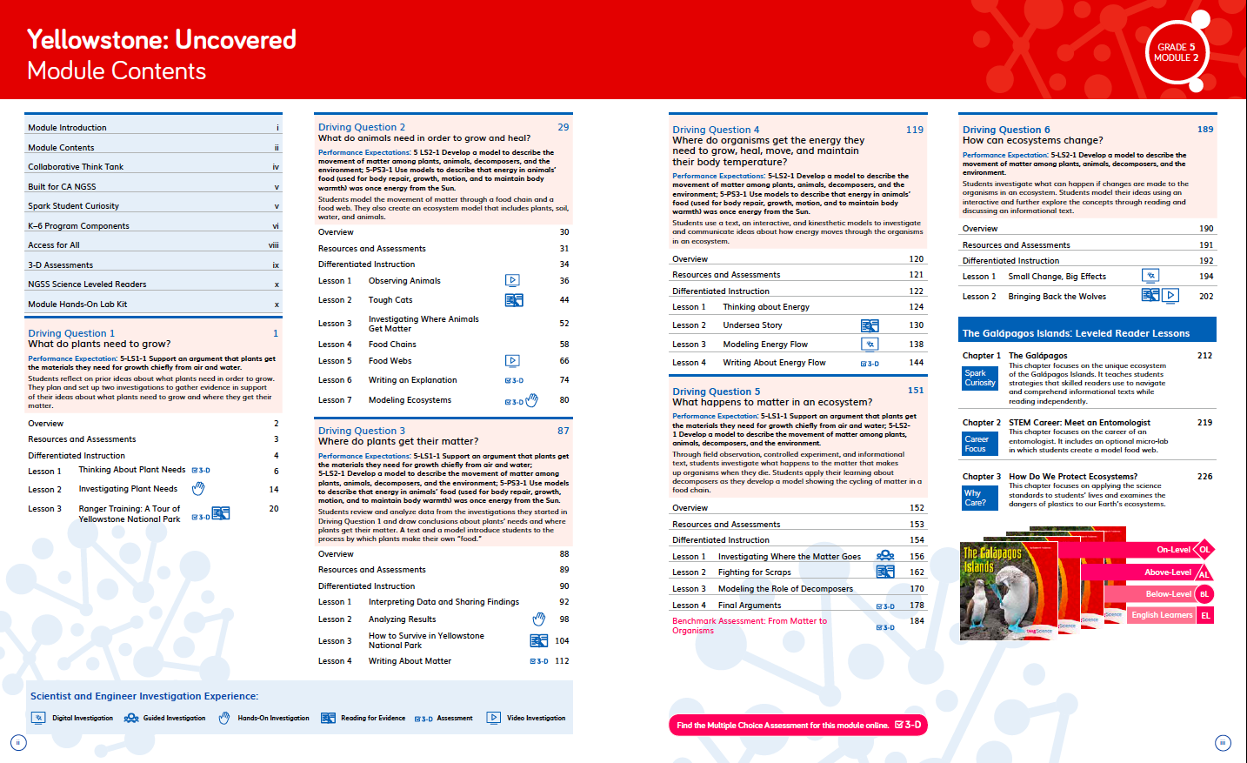  Module Introduction TE p. i–iii
- Teacher Background Knowledge on the phenomena and DCIs addressed in every Driving Question is explained simply in a Q&A format with supporting diagrams and visuals. A glossary of scientific terms is also provided. For example, DQ1 provides background information on matter, what plants need to grow, fair tests, and Jan Baptist van Helmont, while DQ4 explains energy, where it comes from, and why we need it. | 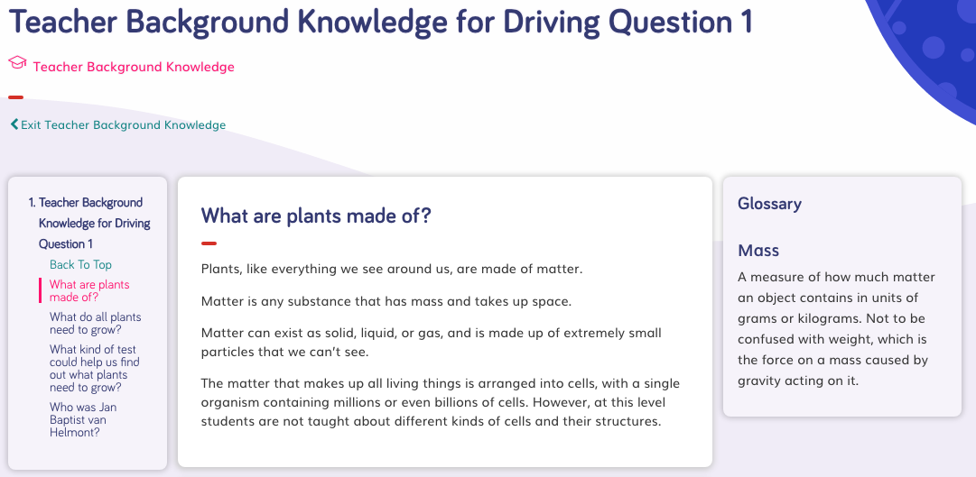  Teacher Background Knowledge
F2. Presence of Three Dimensions.
The module is strong at identifying and providing background information about each of the three dimensions in the unit. It also supports opportunities to connect to the nature of science (CNS) and engineering, technology, and applications of science (CETAS).
Evidence  - A digital guide to SEPs and CCCs provides a clear explanation for each practice and concept with guidance on what these skills should look like in a 5th grade classroom, with specific reference for how students ask questions and develop investigations in Grade 5 Module 2.  - Additional module-specific support is frequently given at point of use in the instructional materials for all dimensions, Connections to the Nature of Science (CNS) and Connecting to Engineering, Technology, and Applications of Science (CETAS), often in the Connect. For example, in DQ1L2 TE Connect p. 19, support is given on connecting the learning activity to CCC-3 Scale, Proportion, and Quantity. | 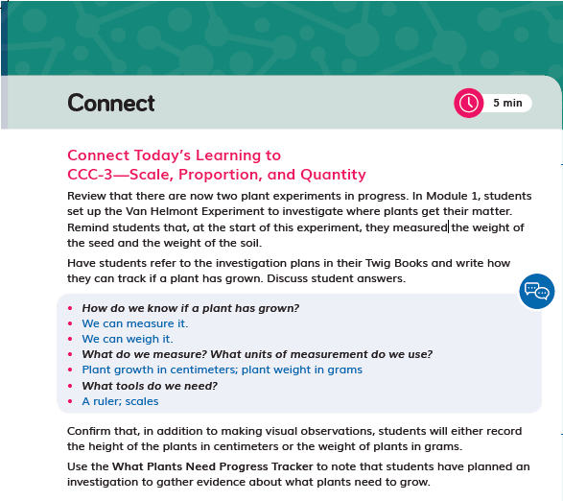  DQ1L2 TE Connect p. 19
F3. Presence of Logical Sequence.
The module is strong at Identifying and providing background information on the sequence of learning in the unit.
Evidence  - A Module Introduction video provides the teacher with an engaging overview on the phenomena explored in Yellowstone: Uncovered, the sequence of learning, and an explanation of how the Performance Expectations are addressed and how they build on each other. | 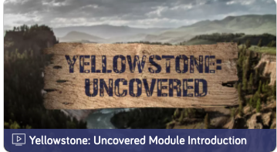  Module Introduction video
- The Module Contents identifies the sequence of three dimensions addressed in Grade 5 Module 2 and states how they build on each other. For example, in DQ2, students investigate and model food chains and food webs. In DQ3–6, they develop an increasingly sophisticated understanding of how matter and energy flow through ecosystems using an ecosystem model that they create. | 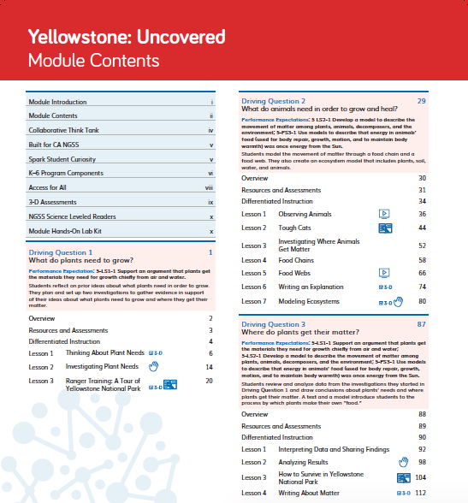  Module Contents
- More detail is provided in the Driving Question Dividers and Driving Question Overviews, which tell the story of how students will sequentially use the three dimensions in each lesson in the DQ to answer the question posed. For example, in DQ3 students analyze and interpret data and consider cause and effect to develop a model that describes how matter moves among plants, animals, decomposers, and the environment. This knowledge helps them realize that the energy in animal's food was once energy from the Sun. | 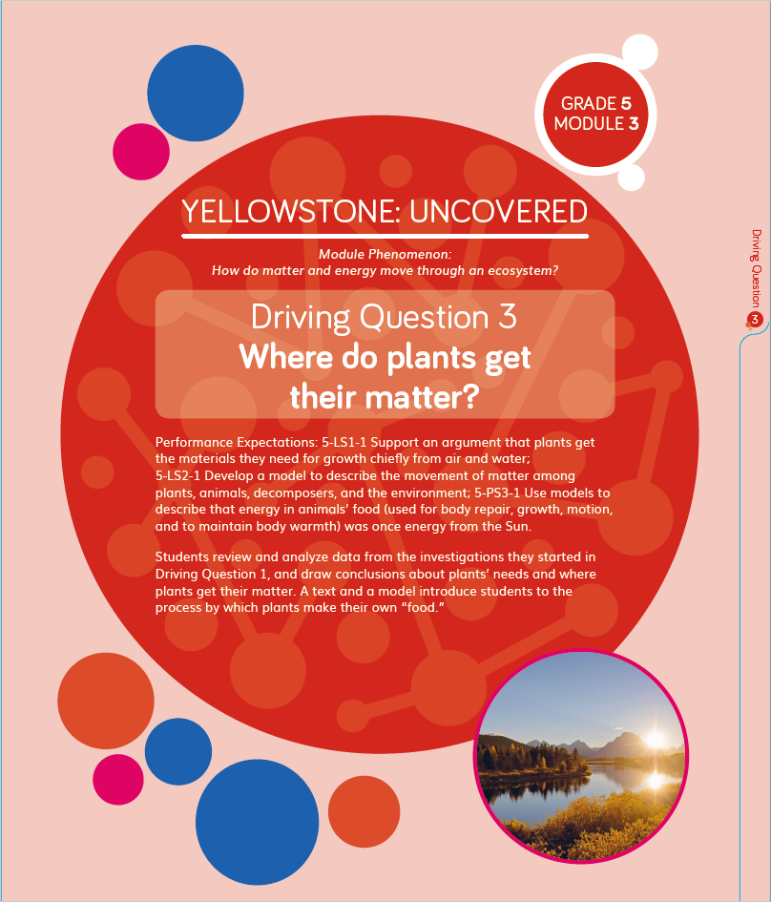  Driving Question Divider TE p. 87  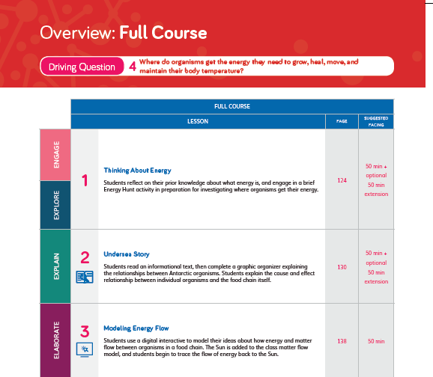  Driving Question Overview TE p. 120
- The Lesson Overview identifies the dimensions used in each lesson, while the graphic organizer details how the dimensions relate to the learning experience. For example, in DQ4L3, the 3-D Learning Objectives explain that in this lesson students will use an interactive to digitally model energy and matter flow. They connect this learning to a video about food chains, make kinesthetic models of energy moving through a food chain, and complete diagrams that show energy movement. | 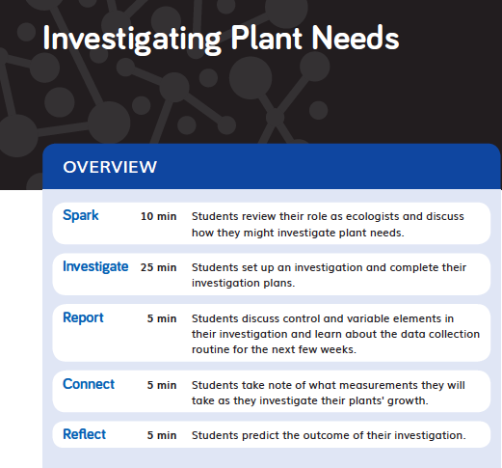  Lesson Overview TE p. 14

Designed for the NGSS: Foundations Teacher Support Evidence Chart

Teacher materials… | Strong | Adequate | Weak
SW1. Phenomena/Problems. Provide support and strategies for how to help students figure out/solve authentic and relevant phenomena/problems using the three dimensions. | ✓
SW2. Three-dimensional Conceptual Framework. Provide support and strategies for how teachers:  - help students develop a conceptual framework of scientifically accurate understandings and abilities related to DCIs, SEPs, and CCCs, CNS and CETAS, ELA and math,  - create a learning environment that values students’ ideas, motivates learning, and helps students negotiate new meaning as they interact with others’ ideas, new information, and new experiences. | ✓
SW3. Prior Knowledge. Provide support and strategies to leverage students’ prior knowledge and experiences to motivate learning. | ✓
SW4. Metacognitive Abilities. Provide support and strategies for how to help students develop metacognitive abilities. | ✓
SW5. Equitable Learning Opportunities. Provide resources and strategies for how to ensure that all students, including those from non-dominant groups and with diverse learning needs, have access to the targeted learning goals and experiences. | ✓

Strengths related to these Teacher Supports
SW1. Phenomena/Problems.
The module is strong at providing support and strategies for how to help students figure out authentic and relevant phenomena using the three dimensions.
Evidence  - The instructional materials have been designed to support the teacher to guide students on a scaffolded learning journey to solve the Module Phenomenon: How do matter and energy move through an ecosystem? They tackle the problem one Driving Question at a time, applying the three dimensions with increasing sophistication, building the skills and knowledge they need through a series of investigations.  - The teacher is supported in the instructional material to connect their learning experiences back to the Module Phenomenon at strategic points with frequent class discussions where students share their ideas and evidence. For example, in DQ4L4 TE p. 149, the teacher leads a discussion of matter and energy flow, encouraging students to connect their learning to a reading investigation from DQ3. | 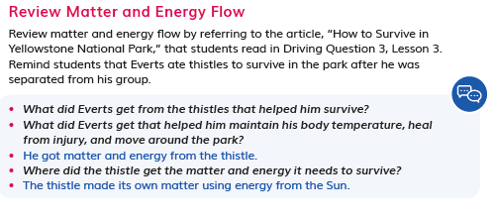  DQ4L4 TE p. 149
SW2. Three-dimensional Conceptual Framework.
The module is strong at providing support for helping students develop a conceptual framework across the dimensions and creating a learning environment that values all students.
Evidence  - The instructional materials are designed to elicit students' understanding of matter and energy at the start of the module and then develop their understanding over time, through hands-on, reading, digital, video and data investigations.  - Opportunities to articulate, question, and revise their conceptual framework are woven into the instructional resources with teachers supported with continuous assessment for learning strategies and with support for how to tailor instruction accordingly.  - Support is given for how to create a positive learning environment where all contributions are valued along with activities that support teamwork and collaboration. Many of the activities involve students working in pairs and teams and they understand what effective teamwork looks and feel like having completed the 3-D Team Challenge at the start of Grade 5 (in Grade 5 Module 1, Matter Mysteries Hotline). Throughout Yellowstone: Uncovered, students are given many opportunities to support each other. For example, in DQ2, students engage in a collaborative language routine, sharing their scientific explanations with a partner and using that feedback to strengthen and clarify their explanations (DQ2L6 TE p. 78). These activities are scaffolded with sidebars that provide additional support for students with special needs, English Learners, and Standard English Learner students. | 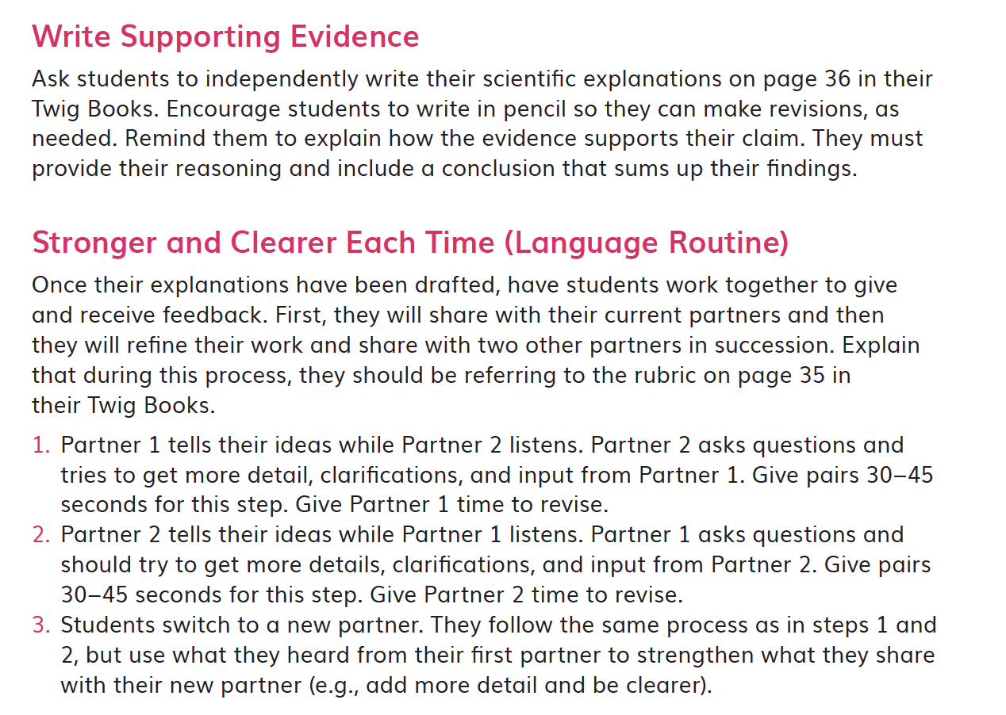  DQ2L6 TE p. 78
SW3. Prior Knowledge.
The module provides strong support and strategies to leverage students’ prior knowledge and experiences to motivate learning.
Evidence  - Teachers are supported with strategies to leverage prior knowledge of energy and matter through resources such as visuals, e.g., the Yellowstone National Park Slideshow visual in DQ1L1 Investigate TE p. 9 and the Eating to Live Prior-Knowledge Read-Aloud in DQ1L1 TE Spark p. 8. Additional support is provided at point of use for strategies to leverage prior knowledge and answer the Module Phenomenon. | 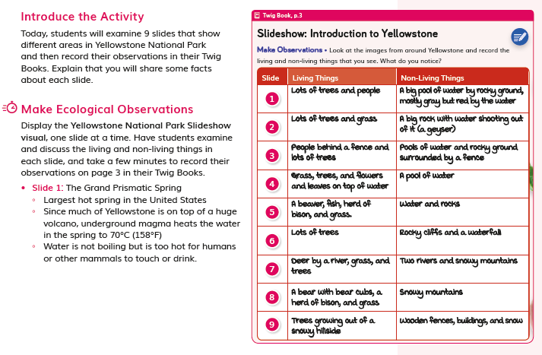  DQ1L1 Investigate TE p. 9  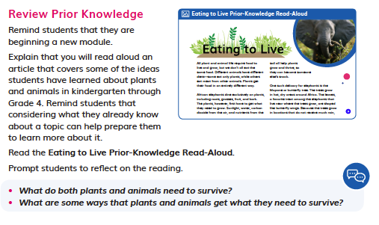  DQ1L1 TE Spark p. 8
For example, in DQ5L3 TE Spark p. 172, the teacher prompts students to recall their background knowledge as they discuss decomposers. | 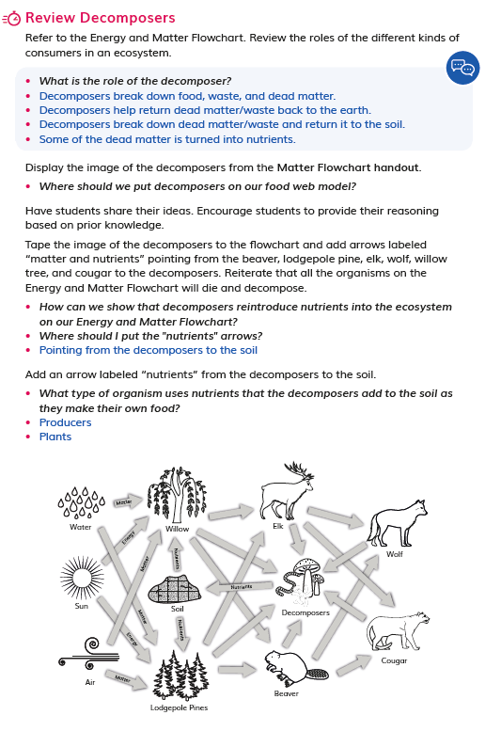  DQ5L3 TE Spark p. 172
SW4. Metacognitive Abilities.
The module provides strong support and strategies for how to help students develop metacognitive abilities.
Evidence  - Support is given at point of use for how to develop students' metacognitive abilities. The Connect of the lesson often guides the teacher to draw students' attention to their growing use of the SEPs and CCCs, understanding of the DQ, or increasing ability to answer the Module Phenomenon (e.g., connecting to CCC-3 in DQ1L2 TE p. 19, and SEP-2 and SEP-3 in DQ6L1 TE p. 200). | 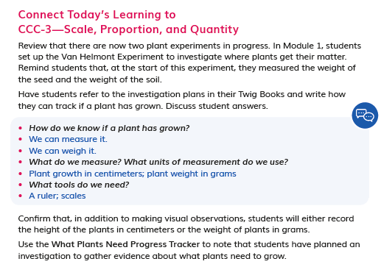DQ1L2 TE p. 19  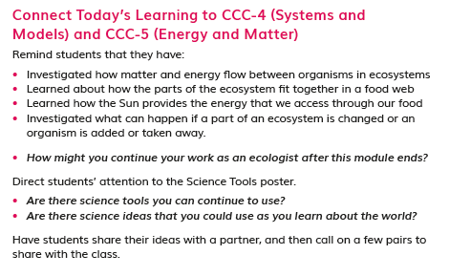  DQ6L1 TE p. 200
- Discussions following diagnostic pre-assessments (Pre-Explorations) in DQ1–4 support teachers to track students' understanding of the three dimensions that make up the module's Performance Expectations, e.g. in DQ2L4 TE Report p. 62. | 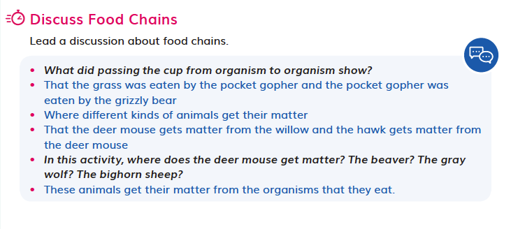  DQ2L4 TE Report p. 62
SW5. Equitable Learning Opportunities.
This module provides strong resources and strategies to ensure that all students have access to the targeted learning goals and experiences.
Evidence  - Frequent support is given at point of use in all lessons on strategies to ensure that all students have access to the targeted learning goals. Numerous scaffolds are provided for Special Needs, English Learner, and Standard English Learner students, for example in DQ2L5 TE p. 69 and DQ4L1 p. 128.  - The reader that complements the module is provided at four levels—Above, On, Below, and EL, with on-level lesson instruction embedded in the TEs and above-, below-, and EL lesson instruction available online.  - Digital versions of the TB and readers have text-to-speech functionality. | 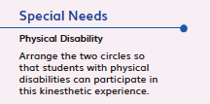  DQ2L5 TE p. 69  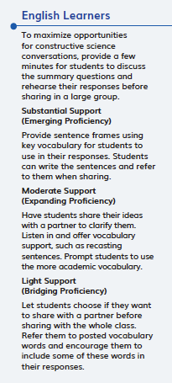  DQ4L1 p. 128
- Short, high quality videos that engage and support learners with diverse learning needs are frequently provided to spark interest, summarize key concepts, and make ideas relevant to Grade 5 students. For example, the A Year in Yellowstone video (in DQ2L1) lets students explore the plants and animals in the national park from the classroom, while the Decomposers: Breaking It Down video (DQ5L2) helps students connect their learning about matter to the concept of decomposition. | 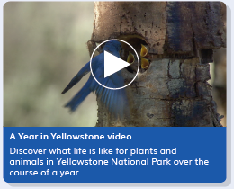  A Year in Yellowstone  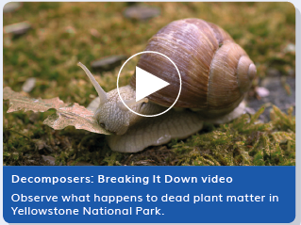  Decomposers: Breaking It Down

Designed for the NGSS: Foundations Teacher Support Evidence Chart

Teacher materials… | Strong | Adequate | Weak
SP1. Three-dimensional Performances. Provide support with a range of sample student responses and/or rubrics for interpreting evidence of student learning across the three dimensions, specific to the element of each dimension, and related to the phenomenon/problem that provides context for the student performance. | ✓
SP2. Variety of Measure. Provide guidance and scoring tools for using a variety of measures matched to the targeted learning goals to help students monitor their progress toward learning goals and reflect on what they have learned, how they learn it, and how to use metacognition productively. | ✓
SP3. Student Progress Over Time. Provide guidance for using formative and summative assessments to monitor student progress over time. Examples include support for: capturing student growth; interpreting results; adjusting instruction and planning for future instruction; providing feedback to students; prompting students to consider what and how they’ve learned. | ✓
SP4. Equitable Access. Provide support and strategies for ensuring that assessments are accessible to students from diverse backgrounds and with diverse learning needs. | ✓

Strengths related to these Teacher Supports
SP1. Three-dimensional Performances.
The module provides strong support with a range of sample student responses and rubrics for interpreting evidence of student learning across the three dimensions. These are specific to the element of each dimension and related to the Module Phenomenon that provides the context for the student performance.
Evidence  - Rubrics are provided for the Performance Tasks and the Benchmark Assessment. The rubrics provide sample answers in the form of look fors that support teachers to interpret evidence of student attainment of the four different levels—emerging, developing, proficient, and advanced. The rubrics are specific to certain performance expectations with the assessed dimensions highlighted.  - The assessment tasks are well connected to the problems, phenomena, and dimensions being assessed. In the Benchmark Assessment From Matter to Organisms (TE p. 184), Rubrics 1 and 2 assess PE 5-LS2-1, while Rubric 3 assesses PE 5-PS3-1. Rubric 1 details that a student developing mastery of these dimensions would develop a model showing some accurate interactions of living and nonliving components. An example answer of incorrect labeling and misunderstanding decomposition is provided. | 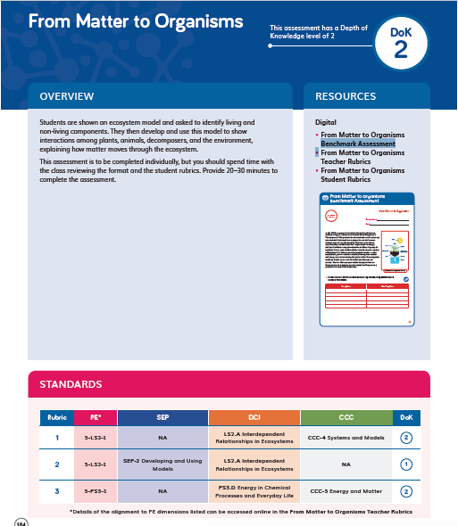  Benchmark Assessment TE p. 184
SP2. Variety of Measure.
The module provides strong guidance and scoring tools for using a variety of measures matched to the targeted learning goals to help students monitor their progress toward learning goals and reflect on what they have learned, how they learn it, and how to use metacognition productively.
Evidence  - Teacher support for guidance and scoring tools matched to the learning goals is integrated through the module. In addition to the rubrics mentioned above and answer guides for the module multiple choice assessment, the printed teacher edition contains TB pages with sample student answers, so at a glance teachers have guidance on what student understanding looks like (e.g., DQ1L3 TE Investigate p. 23, DQ6L2 TE Investigate p. 205). A digital version of this completed TB is available online. | 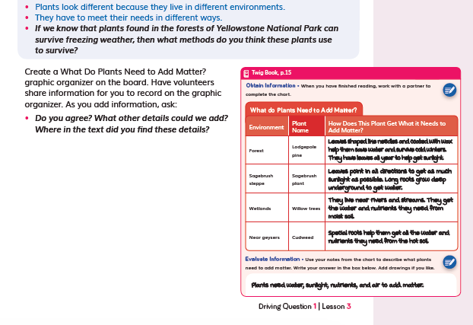  DQ1L3 TE Investigate p. 23  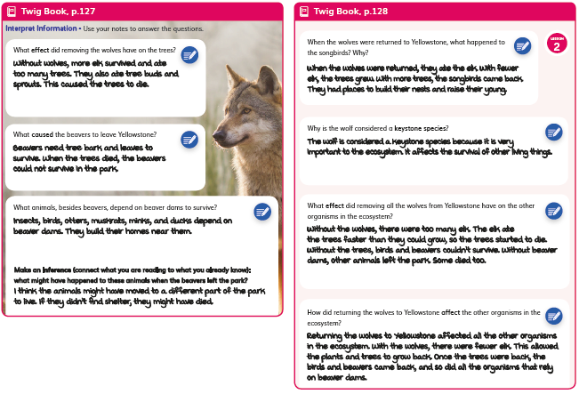  DQ6L2 TE Investigate p. 205
- Assessments are multimodal and support a variety of learning styles and abilities. They include:  - Performance Tasks (written, DQ2L6 TB p. 35, DQ3L4 TB p. 62, DQ4L4 TB p. 84, DQ5L4 TB p. 107) | 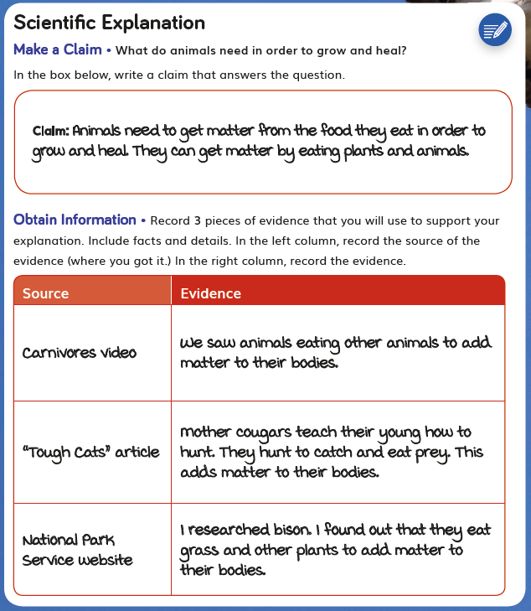  DQ2L6 TB p. 35  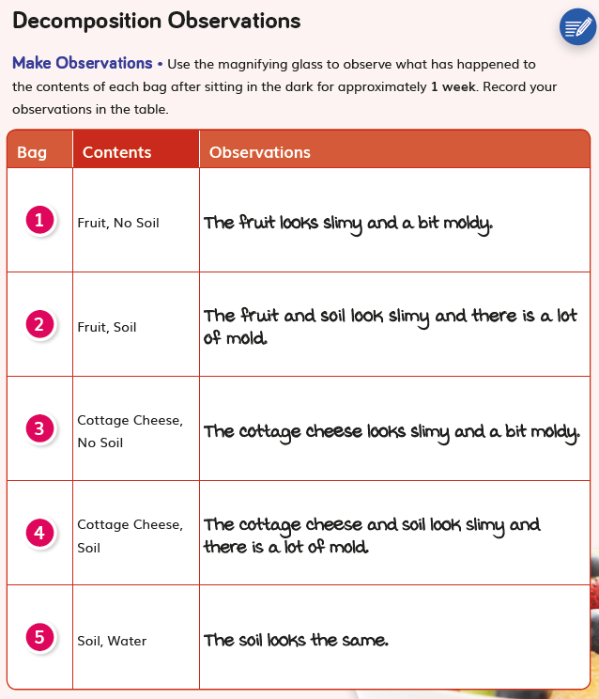  DQ5L4 TB p. 107
- Formative Assessments (written, and drawn, DQ2L2 TE p. 50, DQ2L5 TE p. 73, DQ4L2 TE p. 135, DQ5L2 p. 167) | 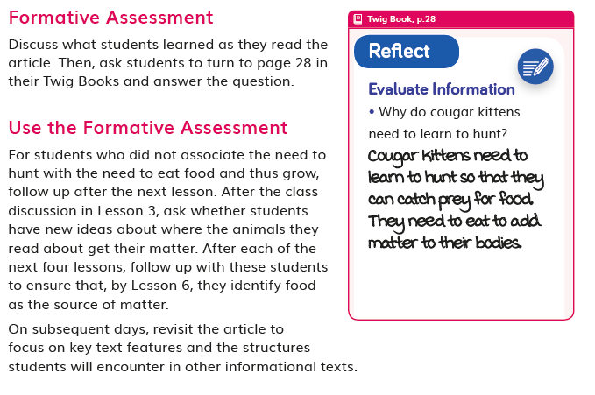  DQ2L2 TE p. 50  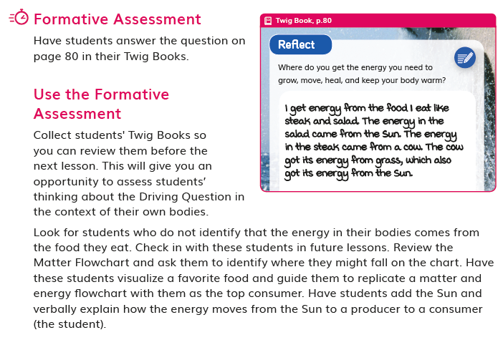  DQ4L2 TE p. 135
- Constructed response (written and drawn, DQ2L4 TB p. 32, DQ4L3 TB p. 83, DQ5L2 TB p. 102) | 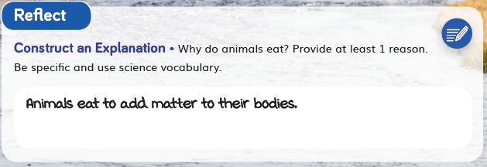  DQ2L4 TB p. 32  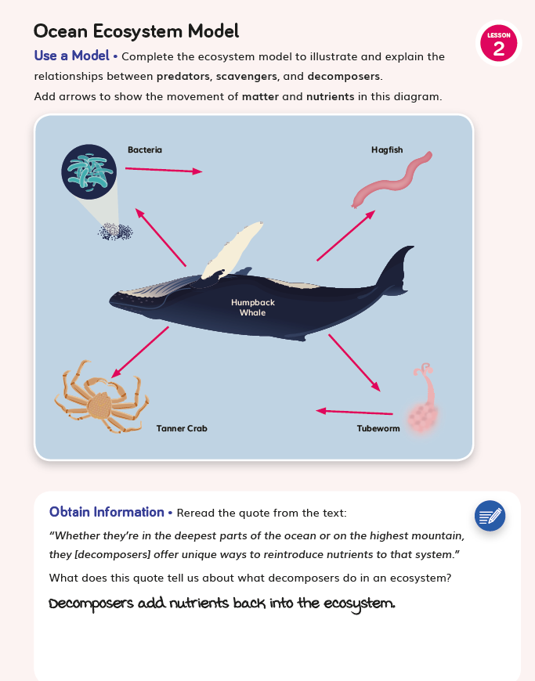  DQ5L2 TB p. 102
- Self- and peer assessment (DQ2L6 TE Reflect p. 79, DQ5L4 TB p. 112) | 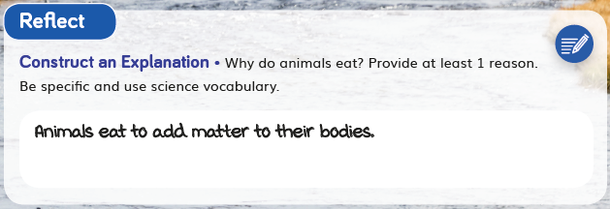  DQ2L6 TE Reflect p. 79  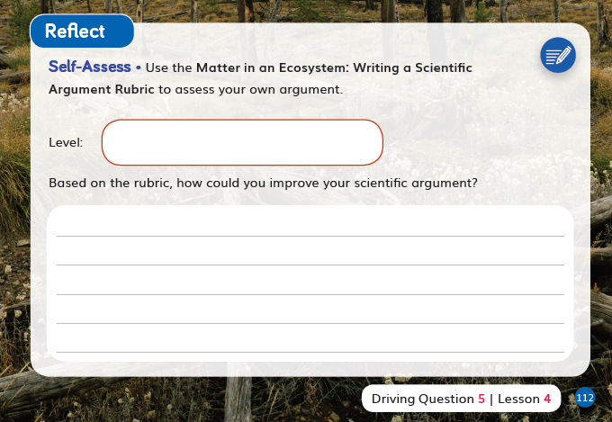  DQ5L4 TB p. 112
- Multiple choice (digital, DQ6). | 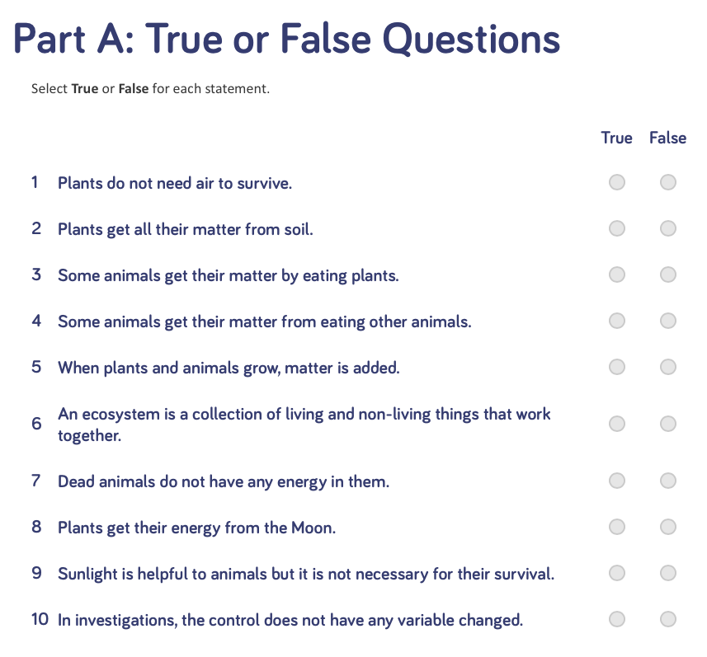  Multiple choice (digital, DQ6)
- Text-to-speech functionality is available for all assets.  - Class discussions are supported with suggested question scaffolds and sample answers (for example, DQ2L4 TE Report, p. 62). | DQ2L4 TE Report, p. 62
- The Reflect of most lessons integrates formative assessment opportunities for the students to reflect on what they have learned and how they used the three dimensions to grow their understanding of the module phenomena and problems (for example, DQ2L2 TE Reflect p. 50, DQ4L2 TE Reflect p. 135). | 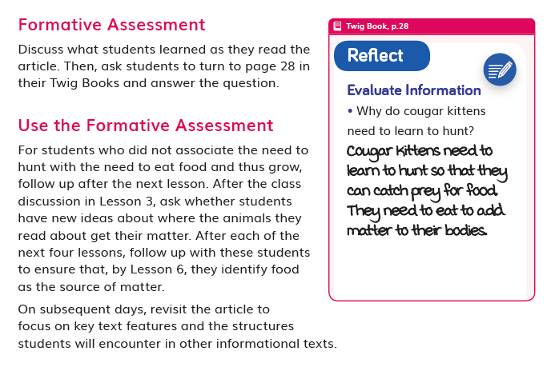  DQ2L2 TE Reflect p. 50  DQ4L2 TE Reflect p. 135
SP3. Student Progress Over Time.
The module provides strong guidance for using Formative and Summative Assessments to monitor student progress over time. Examples include support for capturing student growth, interpreting results, adjusting instruction and planning for future instruction, providing feedback to students, and prompting students to consider what and how they’ve learned.
Evidence  - Teachers can elect to administer the Pre-Explorations, Benchmark Assessment, and Multiple Choice assessments digitally or in print. Answers are tagged to specific dimensions and, if administered digitally, teachers will be able to track student growth in level of attainment of the dimensions over time and tailor instruction accordingly. Teachers can also provide students with feedback digitally. Teachers can opt to add the scores manually for all non-digital assessment tasks.  - Downloadable Progress Trackers support teachers to track students' mastery of their misconceptions as assessed in the Pre-Explorations as well as the results of formative assessments of the three dimensions across the DQs (for example, the Energy in Ecosystems Progress Tracker used in DQ4). Guidance for teachers on how to adjust instruction for students needing more support to clear up their misconceptions is provided at point of use in the instructions (for example, DQ2L4 TE Report p. 62, DQ3L1 TE Report p. 97, and DQ4L3 TE Investigate p. 142). | DQ2L4 TE Report p. 62  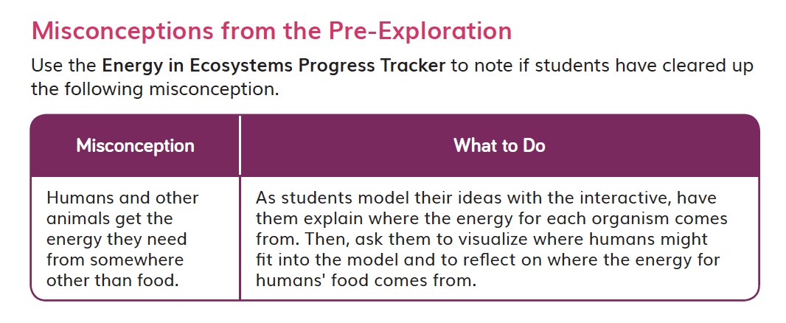  DQ4L3 TE Investigate p. 142
SP4. Equitable Access.
The module provides strong support and strategies for ensuring that assessments are accessible to students from diverse backgrounds and with diverse learning needs.
Evidence  - Assessments of the three dimensions are multimodal and include multiple choice, writing, drawing, physical models, and oral discussions, allowing all students to access a range of assessment types to suit their learning style and/or reading level.  - The digital TB and digital assessment items (Benchmark, Multiple Choice, Rubrics) have a text to speech function allowing students of all reading levels to access the assessments.  - The rubrics for the performance tasks (DQ2L6, DQ3L4, DQ4L4, DQ5L4) and Benchmark Assessment (DQ5 TE p. 184) have four levels (emerging, developing, proficient, advanced) allowing all students to demonstrate their current level of attainment. | 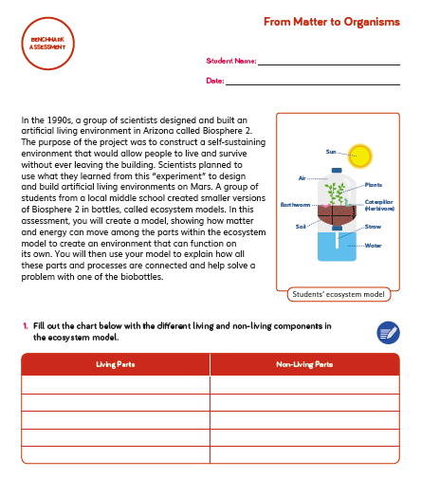  DQ5 TE p. 184
- The multiple choice assessment (DQ6) contains questions targeting different DoK levels, with an extended section available to further challenge GATE students. | Multiple choice (digital, DQ6)
- Writing, Reading, Listening and Speaking domain tasks dedicated to monitor English language development are integrated into the core instructional resources (DQ3L3 TE p. 111, DQ4L2 TE p. 137) and the on-level reader lessons (TE Chapter 3 Second Read, p. 231). | 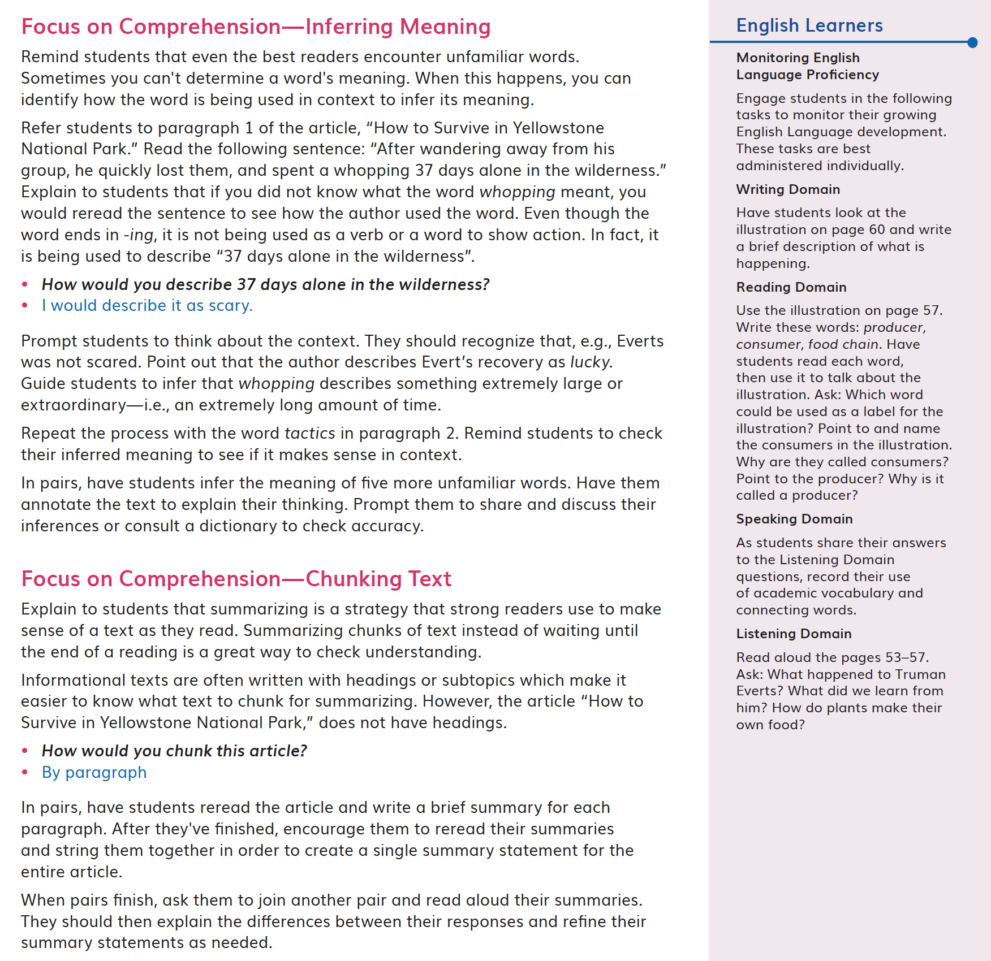  DQ3L3 TE p. 111  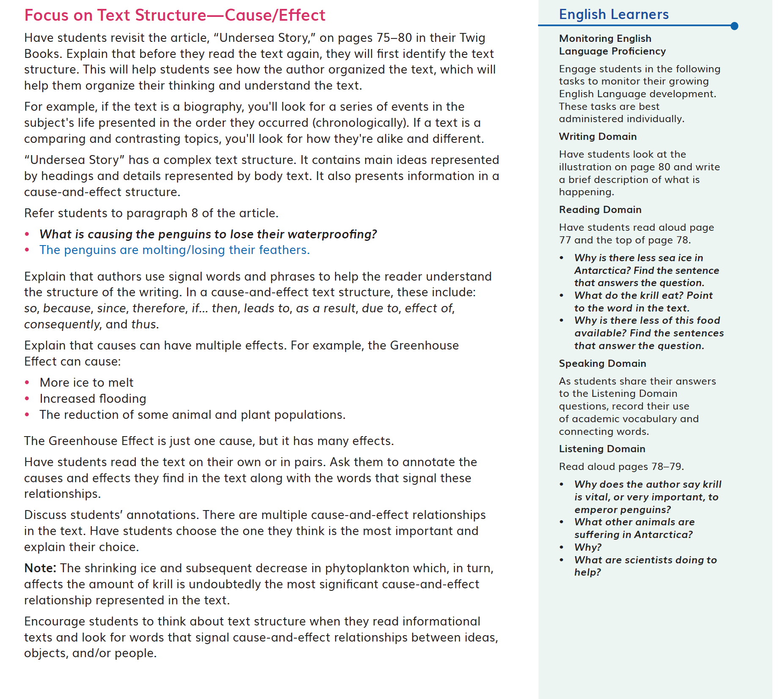  DQ4L2 TE p. 137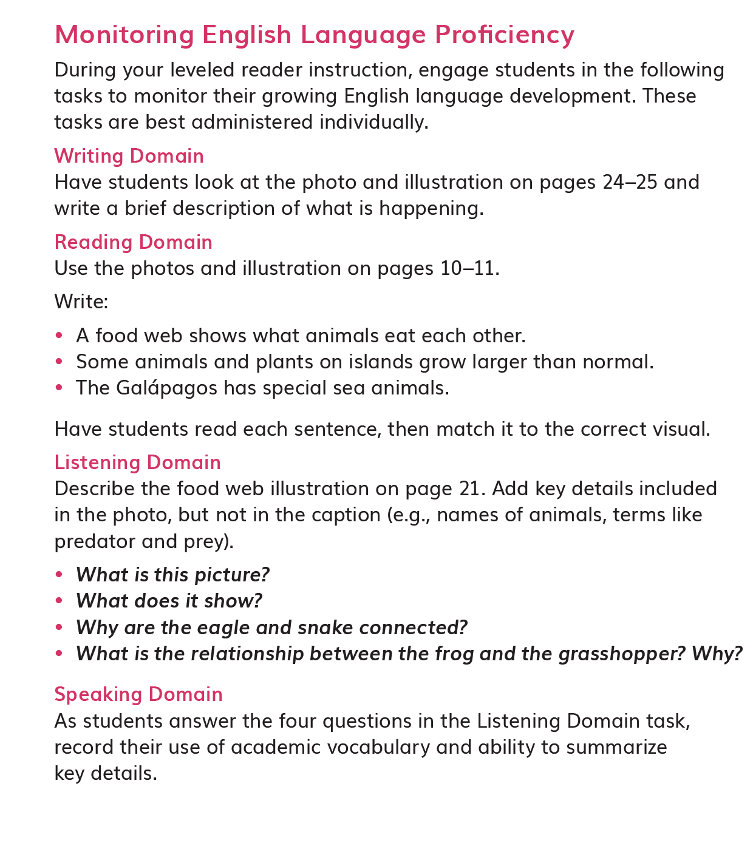TE Chapter 3 Second Read, p. 231
Designed for the NGSS: Foundations | High Quality  5 | Medium Quality  3 | Low Quality  1
TS1. Phenomenon/Problem Driven Three-Dimensional Learning. Teacher materials provide:  - background information about the phenomena or problems included in the learning sequence and across sequences;  - an explanation of the role of phenomena or problems in driving student learning;  - rationale for why the unit phenomena or problems were selected for the targeted DCIs, SEPs, and CCCs.  Refer to F1, F2, SW1, SW2, SP1. | Materials provide clear guidance to teachers on how students develop, use, and integrate the three dimensions to make sense of phenomena or design solutions to problems. | Materials provide some guidance to teachers about how students develop, use, and integrate the three dimensions. | Materials provide little guidance on developing, using, or integrating them to make sense of phenomena or design solutions to problems.
TS2. Coherence. Teacher materials describe and provide a rationale for:  - the conceptual framework and sequence of ideas, practices, and learning experiences in the learning sequences and across sequences;  - strategies for linking student experiences across lessons to ensure student sense- making and/or problem-solving focused on phenomena or problems is linked to learning across all three dimensions;  - Connections to other Science Domains, Nature of Science, Engineering, Technology, and Applications of Science, math, and ELA.  Refer to F2, F3, SW2, SP2. | Materials provide strong support for understanding unit coherence and helping students link experiences to learning across all three dimensions and to phenomena or problems. | Materials provide some support for understanding unit coherence and helping students link experiences to learning across all three dimensions and to phenomena or problems. | Materials provide little support for understanding unit coherence and helping students link experiences to learning across all three dimensions and to phenomena or problems.
TS3. Effective Teaching. Teacher materials support the use of and provide a rationale and evidence of effectiveness for strategies that:  - support students in learning through authentic and meaningful phenomena or design problems;  - support student learning across the three dimensions;  - make student thinking visible; promote reasoning, sense-making, and problem- solving; challenge student thinking; and develop metacognitive abilities.  Refer to SW1, SW2, SW3, SW4, SP3. | Materials provide rationale and robust support for implementing strategies that enhance student performances, thinking, and metacognition. | Materials provide some rationale and support for implementing strategies that enhance student performances, thinking, and metacognition. | Materials provide little rationale and support for teachers to implement strategies that enhance student performances, thinking, and metacognition.
TS4. Support for Students with Diverse Learning Needs. Teacher materials provide an array of strategies:  - to support student access to the targeted learning goals, experiences, and performances;  - that help teachers differentiate instruction.  Refer to SW5, SP4. | Materials include robust and comprehensive strategies for supporting learners with diverse needs. | Materials include some robust strategies for supporting learners with diverse needs. | Materials include few robust strategies for supporting learners with diverse needs.
TS5. Support to Monitor Student Progress. Materials provide support for teachers to:  - monitor student learning and progress over time;  - make decisions about instruction and provide feedback to students.  Refer to SW3, SW4, SP1, SP2, SP3. | Materials provide robust support for interpreting and using data generated from assessments. | Materials provide some support for interpreting and using data generated from assessments. | Materials provide little support for interpreting and using data generated from assessments.

Designed for NGSS: Teacher Support
Analyze Evidence
Directions:
- Review the Designed for NGSS: Foundations Rubric.
- Reflect on the evidence (or lack of evidence) that you and your team gathered and represented.
- Record strengths and limitations for each criterion based on your evidence. Cite specific examples.

Strengths
TS1. Phenomenon/Problem Driven Three-Dimensional Learning.
The Module materials are High Quality 5 in regards to TS1.
They provide clear guidance to teachers on how students develop, use, and integrate the three dimensions to make sense of phenomena or design solutions to problems.
Evidence
- In DQ1, students start by exploring what plants need to grow. They set up an investigation into plant needs, applying the concepts of scale, proportion, and quantity (CCC-3), and observe the Van Helmont experiment set up in Module 1. Through observations and reading an informational text, they explore the phenomena of matter and energy flow in organisms (LS1.C).
- In DQ2, students explore the phenomenon of matter and energy flow in ecosystems, engaging in video and reading investigations. They apply the concepts of energy and matter (CCC-5) and systems and system models (CCC-4) to model food chains and food webs. This culminates in students writing scientific explanations to answer the Driving Question.
- In DQ3, students review and analyze the data from their two hands-on plant investigations and evaluate their findings. They consolidate their learning of matter and energy flow in organisms (LS1.C) by writing arguments from evidence that explain where plants get matter to grow.
- In DQ4, students activate prior knowledge of energy, exploring the phenomenon of energy in chemical processes and everyday life (PS3.D). They close read an informational text and use an interactive to model food chains, and apply the concept of cause and effect (CCC-2) to construct explanations about how energy moves through the food chain.
- In DQ5, students turn to decomposition. They apply the concept of energy and matter (CCC-5) as they observe a guided experiment and then embark on a hands-on investigation to observe decomposition in the field. Their explorations and data collection culminate in written arguments they share with the class, demonstrating their grasp of cycles of matter and energy transfers in an ecosystem (LS2.B).
- In DQ6, students close the module with a focus on interdependent relationships in ecosystems (LS2.A). They apply the concepts of cause and effect (CCC-2) and stability and change (CCC-7) to examine what happens when a non-native species is introduced to an ecosystem. They explore this idea using an interactive and a final digital and video investigation.
TS2. Coherence.
The Module materials are High Quality 5 in regards to TS2.
They provide teachers with a clear conceptual framework in a logical sequence, strategies for linking student experiences across lessons, and connections to other science domains, CNS (NoS), CETAS (ETS), math, and ELA.
Evidence  - The instructional materials have been designed to support the teacher to guide students on a scaffolded learning journey to solve the Module Phenomenon: How do matter and energy move through an ecosystem? They tackle the problem one Driving Question at a time, applying the three dimensions with increasing sophistication, building the skills and knowledge they need through a series of investigations.  - A digital guide to SEPs and CCCs provides a clear explanation for each practice and concept with guidance on what these skills should look like in a 5th grade classroom, with specific reference for how students ask questions and develop investigations in Grade 5 Module 2.  - Additional module-specific support is frequently given at point of use in the instructional materials for all dimensions, Connections to the Nature of Science (CNS) and Connecting to Engineering, Technology, and Applications of Science (CETAS), often in the Connect. For example, in DQ1L2 TE Connect p. 19, support is given on connecting the learning activity to CCC-3 Scale, Proportion, and Quantity.  - Opportunities to articulate, question, and revise students’ conceptual framework are woven into the instructional resources with teachers supported with continuous assessment for learning strategies and with support for how to tailor instruction accordingly. | 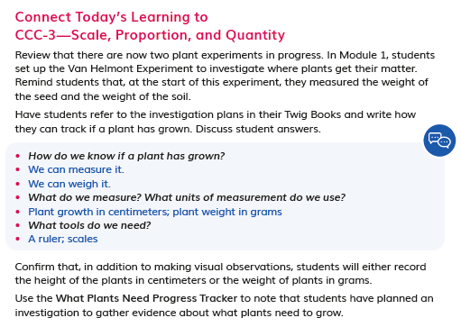  DQ1L2 TE Connect p. 19
TS3. Effective Teaching.
The Module materials are High Quality 5 in regards to TS3.
They provide strong guidance to support students in learning through authentic and meaningful phenomena/problems, support student learning across the three dimensions, and develop students’ metacognitive abilities.
Evidence  - The teacher is supported in the instructional material to connect their learning experiences back to the Module Phenomenon at strategic points with frequent class discussions where students share their ideas and evidence. For example, in DQ4L4 TE p. 149, the teacher leads a discussion of matter and energy flow, encouraging students to connect their learning to a reading investigation from DQ3. | DQ4L4 TE p. 149
- The instructional materials are designed to elicit students' understanding of matter and energy at the start of the module and then develop their understanding over time, through hands-on, reading, digital, video and data investigations.  - Support is given at point of use for how to develop students' metacognitive abilities. The Connect of the lesson often guides the teacher to draw students' attention to their growing use of the SEPs and CCCs, understanding of the DQ, or increasing ability to answer the Module Phenomenon (e.g., connecting to CCC-3 in DQ1L2 TE p. 19, and SEP-2 and SEP-3 in DQ6L1 TE p. 200).  - Teachers can elect to administer the Pre-Explorations, Benchmark Assessment, and Multiple Choice assessments digitally or in print. Answers are tagged to specific dimensions and, if administered digitally, teachers will be able to track student growth in level of attainment of the dimensions over time and tailor instruction accordingly. Teachers can also provide students with feedback digitally. Teachers can opt to add the scores manually for all non-digital assessment tasks. | DQ1L2 TE p. 19  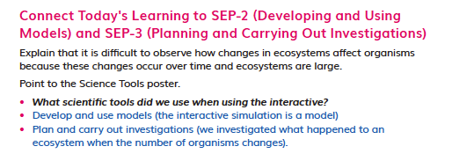  DQ6L1 TE p. 200
TS4. Support for Students with Diverse Learning Needs.
The Module materials are High Quality 5 in regards to TS4.
They provide a strong array of strategies to support student access to the targeted learning goals and help teachers differentiate instruction.
Evidence  - Integrated EL sidebars offer teachers guidance to support students’ engagement with the material (DQ1L1 TE p. 8, DQ2L3 TE p. 54, DQ3L4 TE p. 115, D4L4 TE p. 147). | DQ1L1 TE p. 8  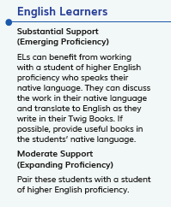  DQ2L3 TE p. 54  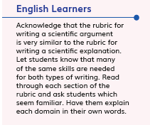  DQ3L4 TE p. 115
- Integrated Cultural Connection sidebars offer teachers guidance to engage students of all backgrounds (DQ1L1 TE p. 8, DQ2L3 TE p. 55, DQ3L3 TE p. 106, DQ5L3 TE p. 172). | DQ1L1 TE p. 8  DQ5L3 TE Spark p. 172
- Integrated Special Needs sidebars offer teachers guidance to support students of all abilities as they participation in class activities and grasp key concepts (DQ1L2 TE p. 18, DQ2L3 TE p. 56, D4L4 TE p. 148). | 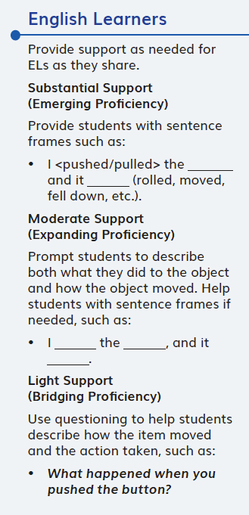  DQ1L2 TE p. 18
- Integrated Challenges interspersed throughout the TB support GATE students who have met the learning goals (DQ1L1 TB p. 4, DQ2L2 TB p. 28, DQ3L2 TB p. 51, DQ5L2 TB p. 103). | 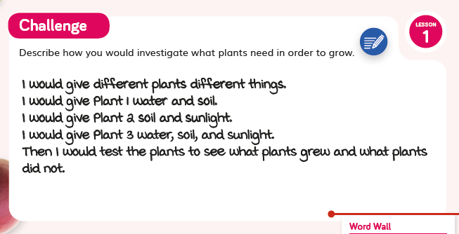  DQ1L1 TB p. 4
- Videos like Time-Lapse of a Plant (DQ1L1), Butterfly’s Breakfast (DQ2L5), Decomposers: Breaking It Down (DQ5L2), and Wolves in Yellowstone (DQ6L2) bring phenomena and concepts to life for all students.  - Assessments of the three dimensions are multimodal and include multiple choice, writing, drawing, physical models, and oral discussions, allowing all students to access a range of assessment types to suit their learning style and/or reading level.  - The digital TB and digital assessment items (Benchmark, Multiple Choice, Rubrics) have a text to speech function allowing students of all reading levels to access the assessments. | 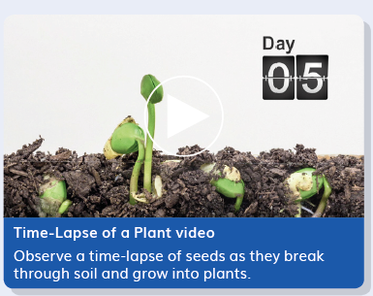  Time-Lapse of a Plant  Decomposers: Breaking It Down
- The rubrics for the performance tasks (DQ2L6, DQ3L4, DQ4L4, DQ5L4) and Benchmark Assessment (DQ5 TE p. 184) have four levels (emerging, developing, proficient, advanced) allowing all students to demonstrate their current level of attainment. | DQ5 TE p. 184
- The multiple choice assessment (DQ6) contains questions targeting different DoK levels, with an extended section available to further challenge GATE students. | Multiple choice (digital, DQ6)
- Writing, Reading, Listening and Speaking domain tasks dedicated to monitor English language development are integrated into the core instructional resources (DQ3L3 TE p. 111, DQ4L2 TE p. 137) and the on-level reader lessons (TE Chapter 3 Second Read, p. 231). | DQ3L3 TE p. 111  DQ4L2 TE p. 137TE Chapter 3 Second Read, p. 231
TS5. Support to Monitor Student Progress.
The Module materials are High Quality 5 in regards to TS5.
They provide strong support for teachers to monitor student learning and progress over time, and make decisions about instruction and provide feedback.
Evidence  - There are four diagnostic pre-assessments called Pre-Explorations at strategic points in the module that assess prior knowledge and misconceptions (e.g., DQ1L1 TB p. 4 and DQ4L4 TB p. 88). Notes in the TE and Progress Trackers support teachers to monitor students as they clear up their misconceptions and master the three dimensions, giving suggestions for how to tailor instruction accordingly. | DQ1L1 TB p. 4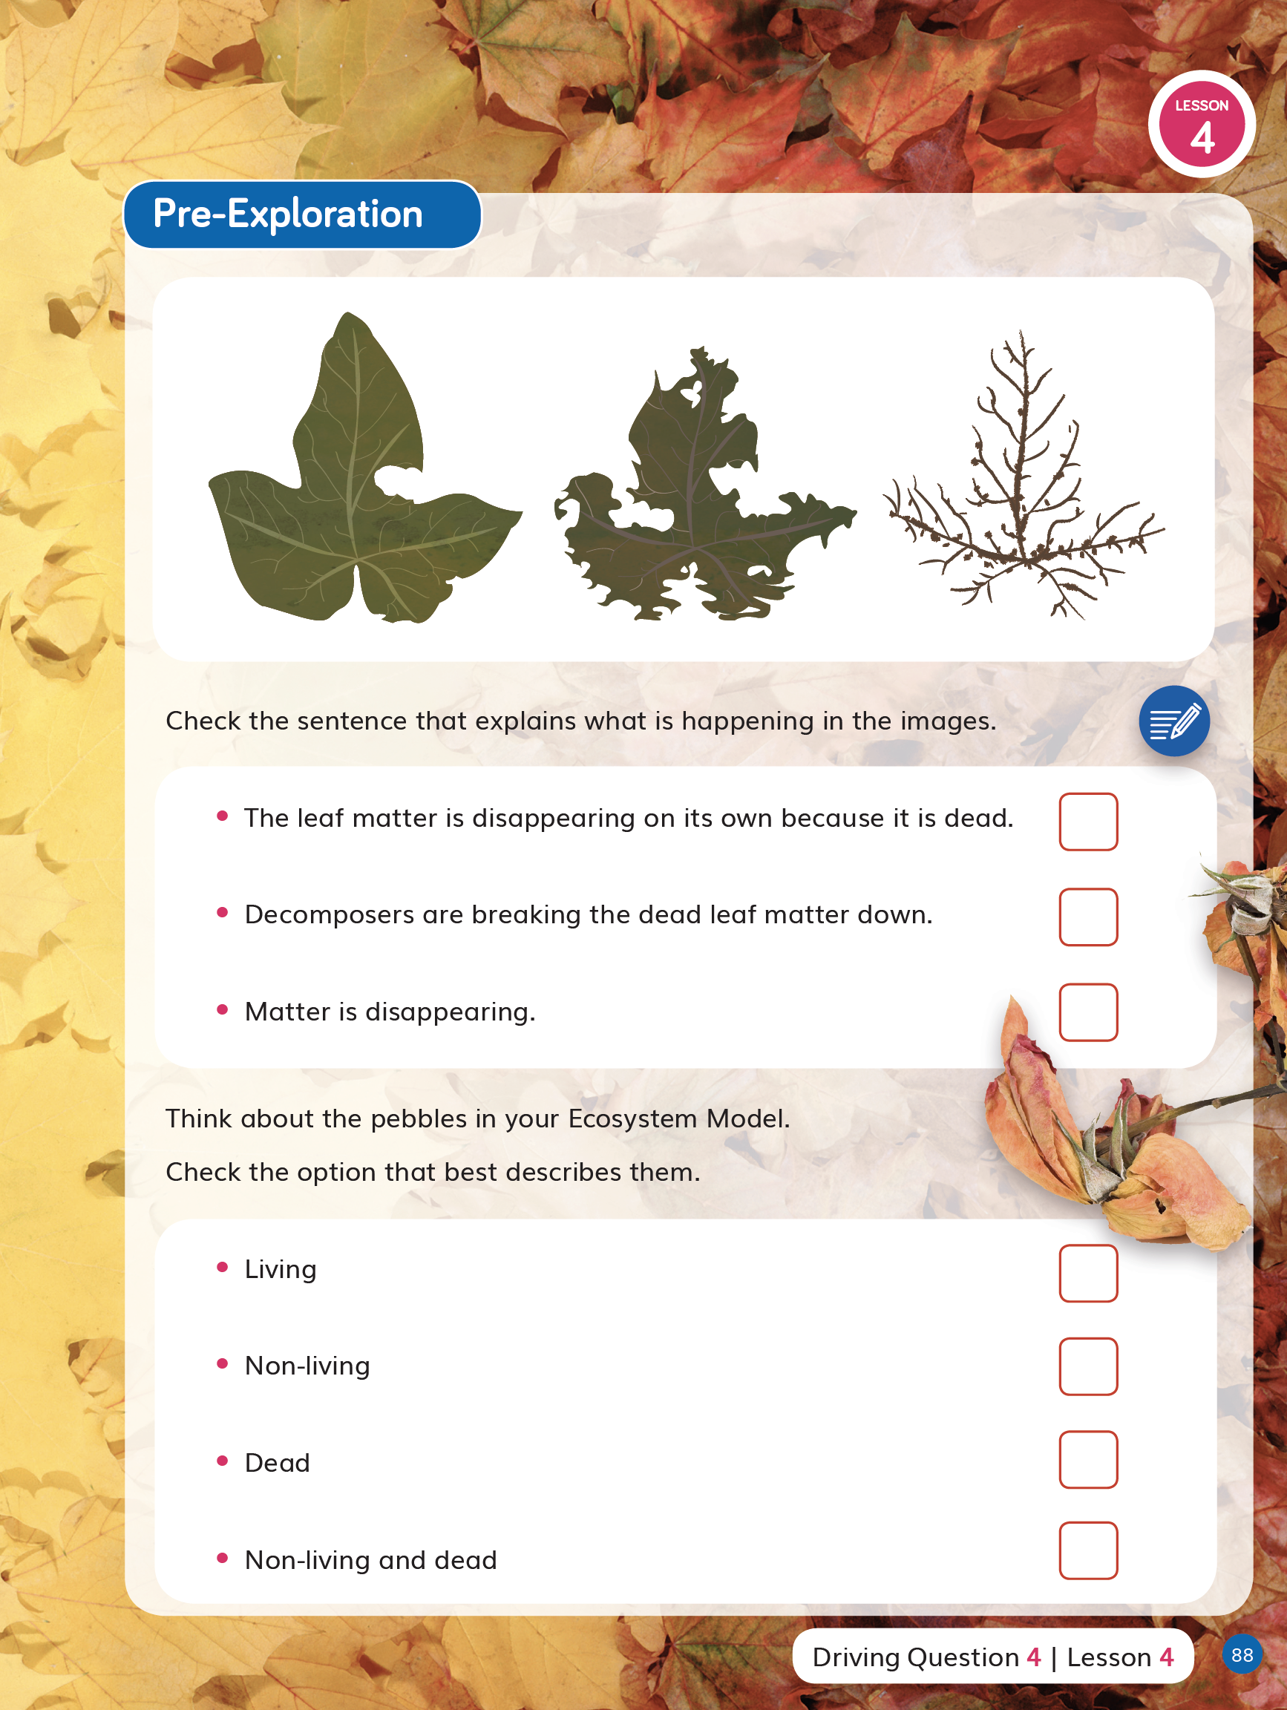  DQ4L4 TB p. 88
See, for example, DQ2L4 TE Report p. 62, DQ3L1 TE Report p. 97, and DQ4L3 TE Investigate p. 142. | DQ2L4 TE Report p. 62  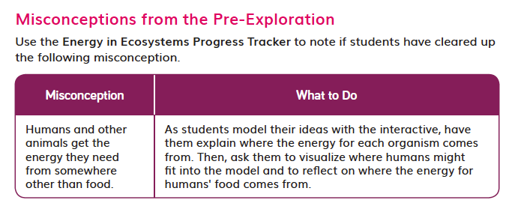DQ4L3 TE Investigate p. 142
- Downloadable Progress Trackers support teachers to track students' mastery of their misconceptions as assessed in the Pre-Explorations as well as the results of formative assessments of the three dimensions across the DQs (for example, the Energy in Ecosystems Progress Tracker used in DQ4). Guidance for teachers on how to adjust instruction for students needing more support to clear up their misconceptions is provided at point of use in the instructions (for example, DQ2L4 TE Report p. 62, DQ3L1 TE Report p. 97, and DQ4L3 TE Investigate p. 142). | DQ2L4 TE Report p. 62  DQ4L3 TE Investigate p. 142

