Introduction to Assessment

The Twig Science Assessment System has been developed in partnership with the Stanford University’s SCALE team. It is designed to provide a three-dimensional assessment system that allows teachers to evaluate student attainment of the NGSS three dimensions and Performance Expectations (PEs).

The assessment strategies measure students’ knowledge and ability, favoring Performance Tasks over rote memorization and include a variety of measures such as written assignments, collaborative engineering design challenges and oral presentations. There are frequent opportunities to evaluate student progress against the standards in each module. The G3 M1 Assessment Module Overview offers details of where and how those dimensions are assessed.

Near the start of each module students complete a Pre-Exploration (diagnostic pre-assessment) that supports teachers and students to identify prior knowledge and misconceptions about the dimensions addressed in the module. Teachers are supported to track how students address their misconceptions as they gain new understanding as the module unfolds. Additional Pre-Explorations are integrated at strategic points through the module.

Ongoing assessment opportunities are woven into each lesson. They are quick and easy to implement and support teachers to tailor their instruction to the class requirements. They include class discussions, constructed responses (written and drawn), self- and peer assessment, and teacher observations.

Summative Performance Tasks allow students to demonstrate their attainment level of the module PEs. These rich and highly engaging activities vary from written reports, to project work and oral presentations. Rubrics are provided to support assessment.

The Ultimate Playground also includes a summative Benchmark Assessment developed in partnership with SCALE, that allows students to apply the knowledge and skills gained in this module to new contexts, giving them exposure to the types of assessment items they will face in the Grade 5 state test.
In addition, a summative Multiple Choice Assessment gives teachers the opportunity to quickly assess student understanding of a range of dimensions covered in this module. An extended section C has been designed to stretch GATE students.

The Ultimate Playground Assessment Story

In this module students figure out the Module Phenomenon: How are objects affected by the forces of push and pull? Through a series of investigations, students observe and explain how push and pull forces affect the motion of objects, such as playground equipment, and soccer balls. They carry out investigations to figure out how balanced and unbalanced forces affect objects, how forces can act upon a stationary object, and work like engineers to test roller coaster cars. Students develop and use models to collect and analyze data, and identify patterns that help them to predict a swing’s motion. They then explore non-contact forces, focussing on magnetic forces. In the final Performance Task, students design, build, test and refine a Dragon Ride for their Ultimate Playground, using magnets to solve the problem of how the ride will be exciting and fun. Students are assessed on their ability to evaluate multiple design solutions, and ensuring that the final design meets criteria and constraints.

Designed for the NGSS: Student Progress Rubric

Evidence Chart
Directions
- Review your assigned materials to identify assessments of and for learning. Complete an evidence chart for each identified assessment.
- Respond to the prompts or answer the questions in the space provided.
- Be prepared to represent your responses visually on a public chart.

Assessment Description
DQ2L1 Reflect TE p. 119 / TB p. 39  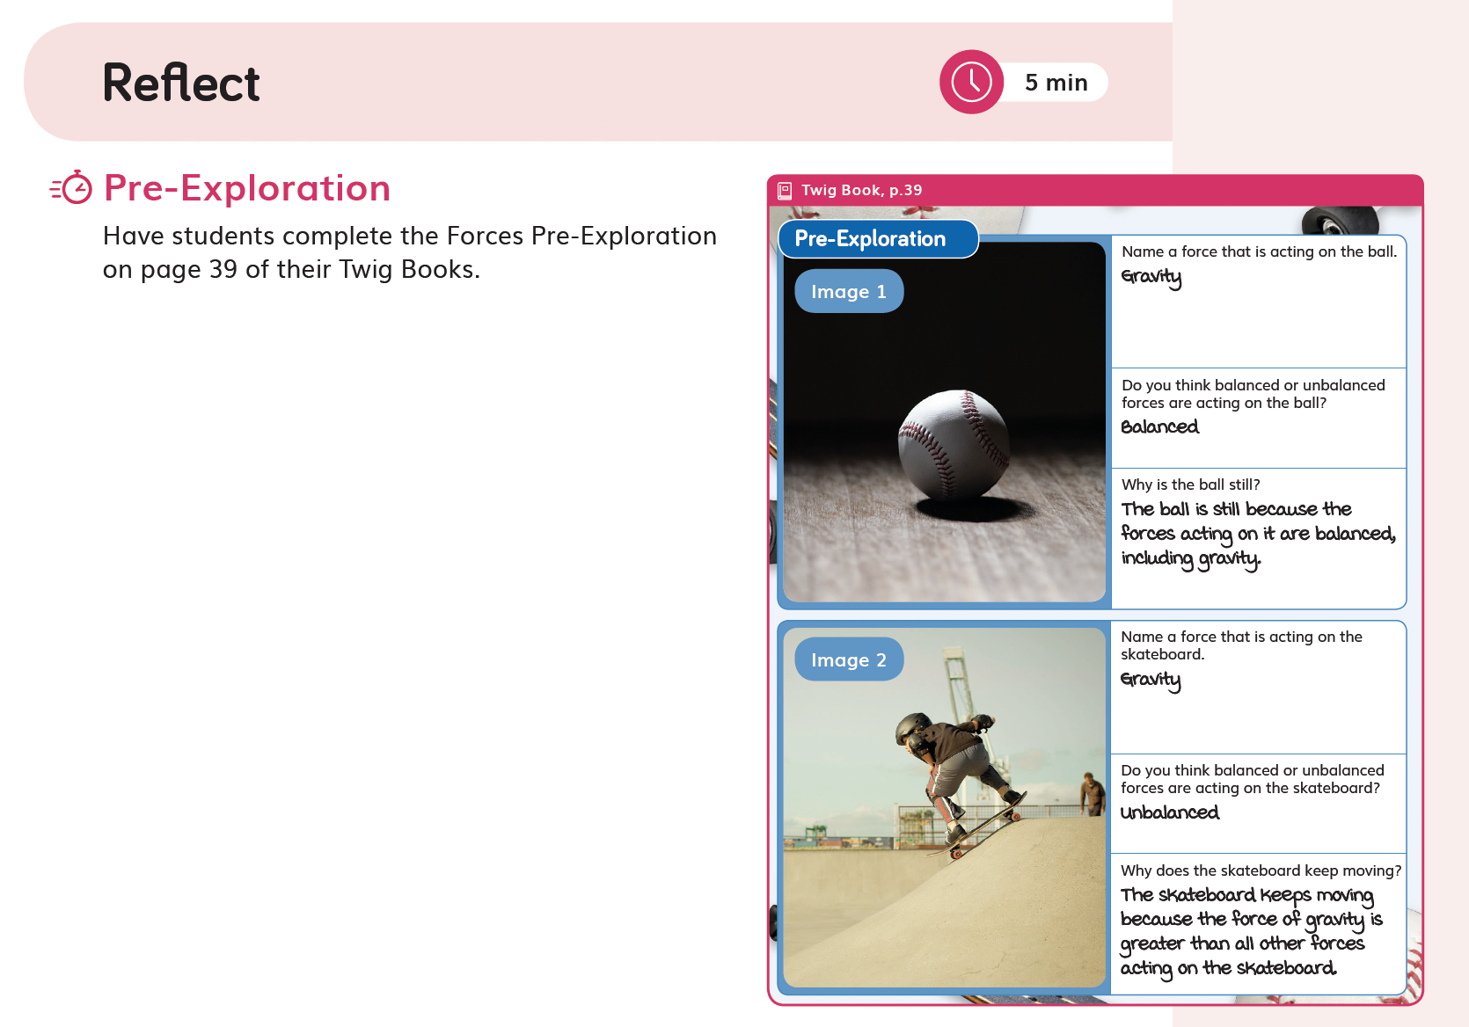 | Describe the assessment (e.g., how many questions, presence of tables/charts, graphs). | Purpose of Assessment  (i.e., peer, self, formative, summative, per/post) | Type of Measure (e.g., Performance Task, discussion, multiple choice, constructed response) | Note evidence of bias or problems with accessibility.
 | Two images, each with three writing prompts | Pre-assessment/ formative | Images with written response
Match among Assessment, Phenomena/Problem, and Three Dimensions
What phenomenon or problem, if any, are students trying to figure out in this assessment? |  | What is the 2-3 dimensional learning goal assessed in this task?
Students use prior knowledge to work out whether balanced or unbalanced forces are affecting the motion of a skateboarder and a stationary baseball. |  | Students are pre-assessed on their knowledge of push and pull forces, and the effects of balanced and unbalanced forces on objects’ motion. They apply the concept of cause-and-effect to construct their responses. (PS2.A, PS2.B, CCC-2)

Assessment Description
DQ1L2 Reflect TE p. 68 / TB p. 20  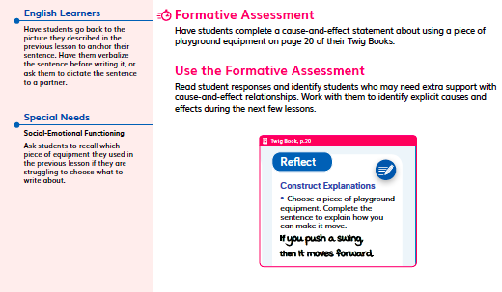 | Describe the assessment (e.g., how many questions, presence of tables/charts, graphs). | Purpose of Assessment  (i.e., peer, self, formative, summative, per/post) | Type of Measure (e.g., Performance Task, discussion, multiple choice, constructed response) | Note evidence of bias or problems with accessibility.
 | One question prompt to construct an explanation. | Formative | Constructed written response | No evidence of bias. Extra measures are taken to provide the teacher with ways to modify the task for English Learners and students with special needs. Text to speech function is available.
Match among Assessment, Phenomena/Problem, and Three Dimensions
What phenomenon or problem, if any, are students trying to figure out in this assessment? |  | What is the 2-3 dimensional learning goal assessed in this task?
Students construct a cause-and-effect statement explaining how push and pull forces cause a piece of playground equipment to move. |  | Communicating information in the form of a scientific explanation (SEP-8) about how push and pull forces can cause an object’s motion to change (CCC-2, PS2.A).  Students are assessed on their understanding of cause and effect, and their ability to base their explanation on evidence and observations.

Assessment Description
DQ2L2 Reflect TE p. 129 / TB p. 41  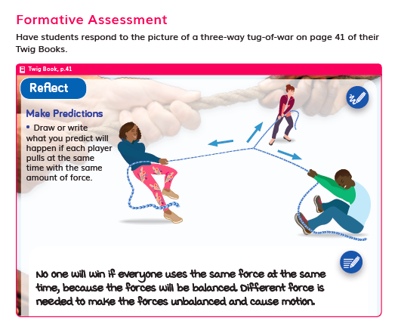 | Describe the assessment (e.g., how many questions, presence of tables/charts, graphs). | Purpose of Assessment  (i.e., peer, self, formative, summative, per/post) | Type of Measure (e.g., Performance Task, discussion, multiple choice, constructed response) | Note evidence of bias or problems with accessibility.
 | One question prompt asking students to make a prediction about the outcome of a game of tug-of-war. Students annotate a diagram or write what they think will happen. | Formative | Constructed written response | No evidence of bias. Text to speech function. The assessment can be completed by either annotating a diagram to show the forces and motion or causes and effects, or by writing a statement.
Match among Assessment, Phenomena/Problem, and Three Dimensions
What phenomenon or problem, if any, are students trying to figure out in this assessment? |  | What is the 2-3 dimensional learning goal assessed in this task?
Students are asked to predict the effects balanced forces will have on the motion of a tug-of-war rope. |  | Students are assessed on their understanding of balanced and unbalanced forces (PS2.A) and the cause-and-effect relationship (CCC-2) between forces and motion. Students demonstrate their understanding by annotating a model (SEP-2) or constructing a statement based on evidence and reasoning (SEP-8).

Assessment Description
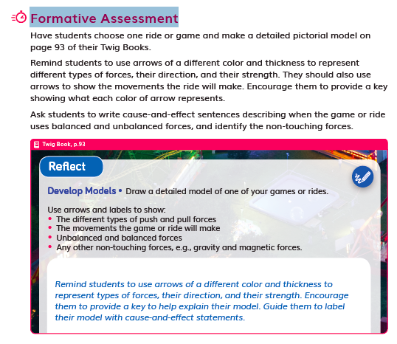  DQ5L8 Reflect TE p. 287 / TB p. 93 | Describe the assessment (e.g., how many questions, presence of tables/charts, graphs). | Purpose of Assessment  (i.e., peer, self, formative, summative, per/post) | Type of Measure (e.g., Performance Task, discussion, multiple choice, constructed response) | Note evidence of bias or problems with accessibility.
 | Prompt for students to draw a detailed model of one of the rides in the module. It includes a list of details to include. | Formative, post | Constructed written and drawn response | No evidence of bias. Text to speech function is available.
Match among Assessment, Phenomena/Problem, and Three Dimensions
What phenomenon or problem, if any, are students trying to figure out in this assessment? |  | What is the 2-3 dimensional learning goal assessed in this task?
Students are assessed on the Module Phenomena: How are objects affected by the forces of push and pull? |  | Students are assessed on their ability to develop and use detailed pictorial models (SEP-2), and their ability to write cause-and-effect sentences (CCC-2) describing the relationship between forces and motion (PS2.A).

Assessment Description
DQ2L5 Reflect TE p. 148 / TB p. 47  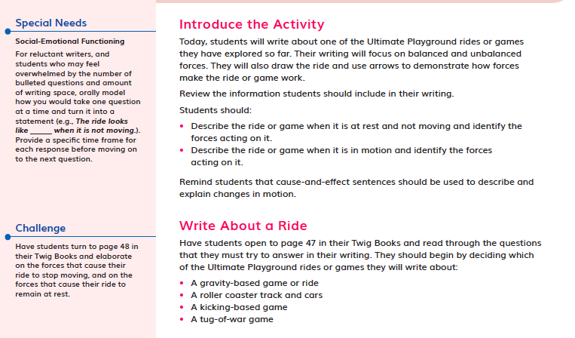 | Describe the assessment (e.g., how many questions, presence of tables/charts, graphs). | Purpose of Assessment  (i.e., peer, self, formative, summative, per/post) | Type of Measure (e.g., Performance Task, discussion, multiple choice, constructed response) | Note evidence of bias or problems with accessibility.
 | Writing prompt with 4 questions | Summative | Performance Task, written | No evidence of bias. Modifications suggested for students with special needs, gifted and ELA students.
Match among Assessment, Phenomena/Problem, and Three Dimensions
What phenomenon or problem, if any, are students trying to figure out in this assessment? |  | What is the 2-3 dimensional learning goal assessed in this task?
Students describe and explain how amusement park rides move, showing how unbalanced forces change their motion. |  | Students are assessed on their ability to describe the way amusement park rides move, and explain how unbalanced forces cause their motion to change (PS2.A, CCC-2, SEP-8)

Assessment Description
DQ5L7 Investigate TE p. 278 / TB p. 89 | Describe the assessment (e.g., how many questions, presence of tables/charts, graphs). | Purpose of Assessment  (i.e., peer, self, formative, summative, per/post) | Type of Measure (e.g., Performance Task, discussion, multiple choice, constructed response) | Note evidence of bias or problems with accessibility.
 | Developing model rides using a criteria and design. | Summative | Performance Task | No evidence of bias. Modifications suggested for students with special needs, gifted and ELA students.
Match among Assessment, Phenomena/Problem, and Three Dimensions
What phenomenon or problem, if any, are students trying to figure out in this assessment? |  | What is the 2-3 dimensional learning goal assessed in this task?
Over the course of three lessons, students research, design, build and test a magnetic ride. They figure out how magnetic interactions can create an amusement park ride that moves in exciting and fun ways. |  | Students are assessed on their ability to research, design and build a dragon ride to test. They define criteria and constraints and measure their success using a rubric. They apply knowledge of forces and motion, non-contact forces, and generate solutions to an engineering problem. (PS2.A, PS2.B, ETS1.B, ETS1.C, CCC-1, CCC-2, SEP-2, SEP-3, SEP-6)

Assessment Description
Multiple Choice Assessment  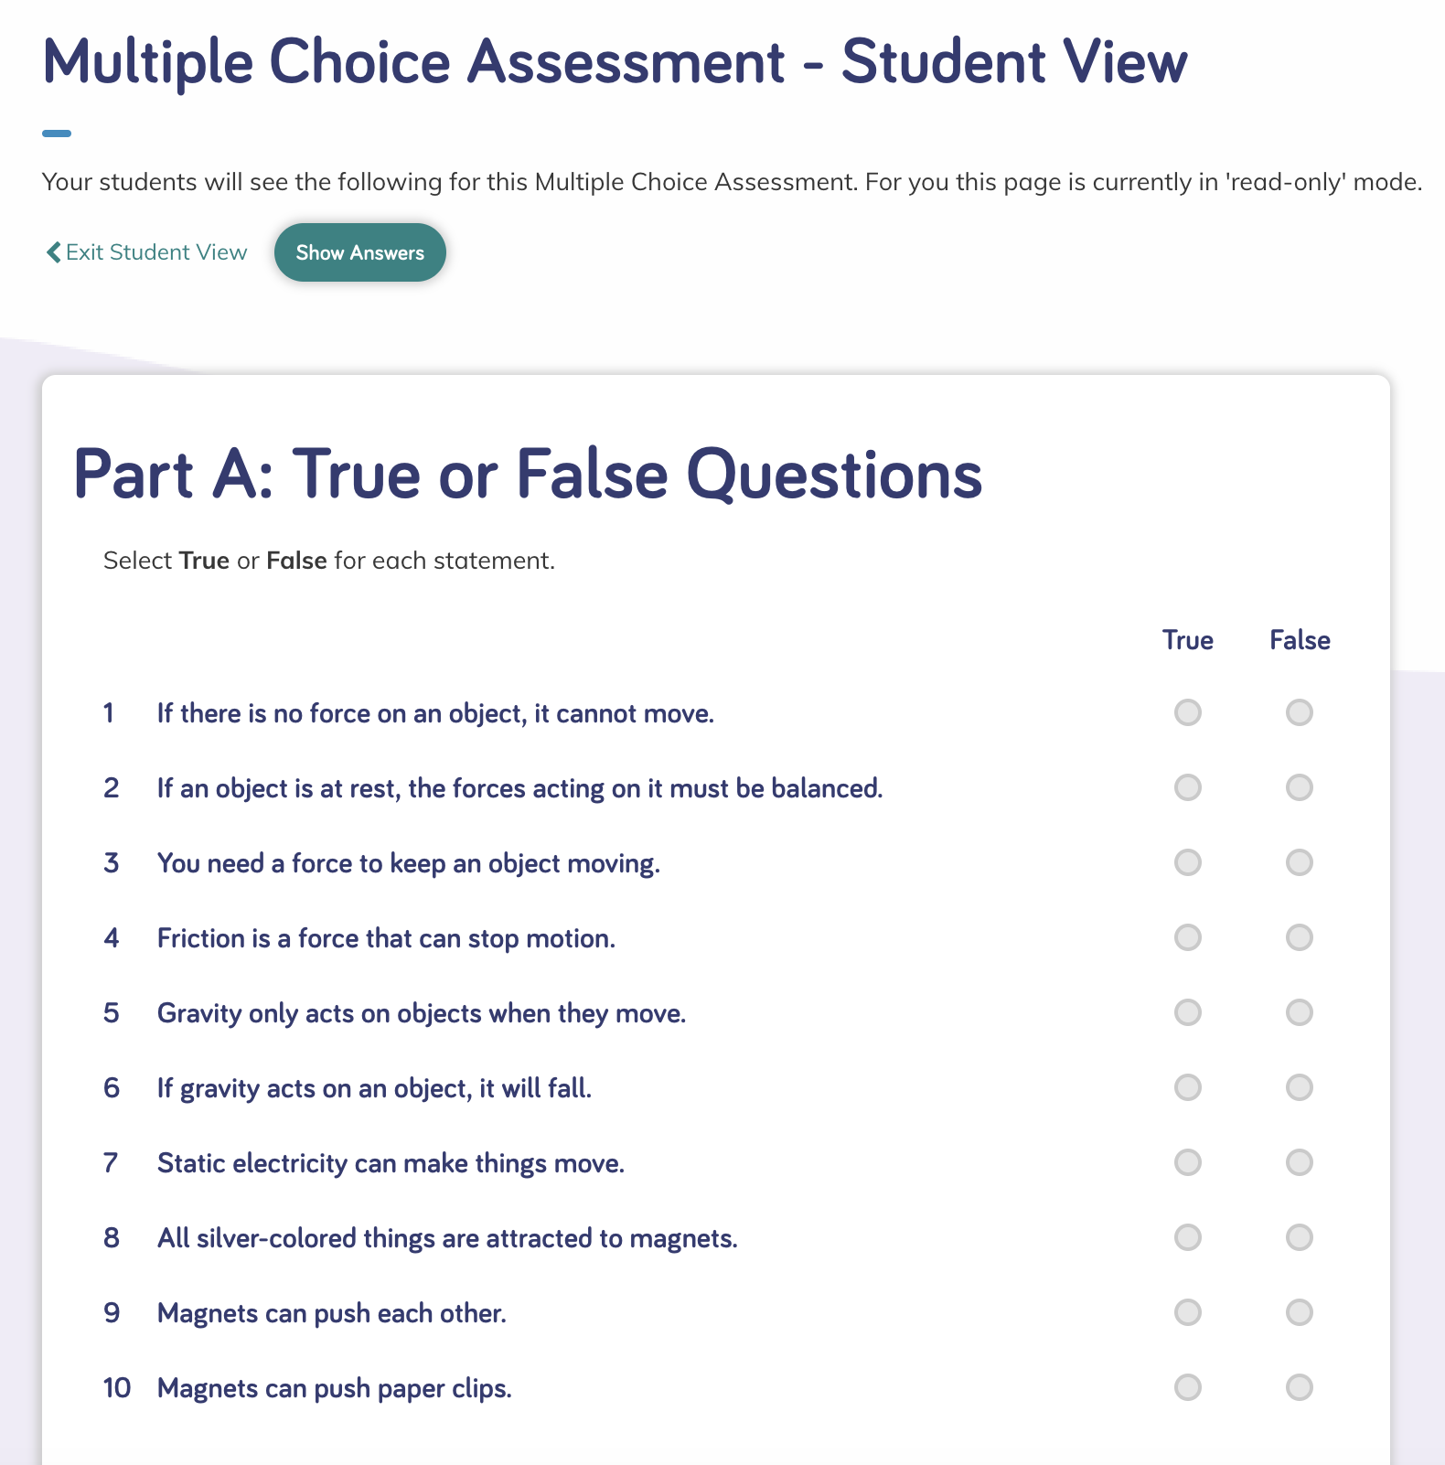 | Describe the assessment (e.g., how many questions, presence of tables/charts, graphs). | Purpose of Assessment  (i.e., peer, self, formative, summative, per/post) | Type of Measure (e.g., Performance Task, discussion, multiple choice, constructed response) | Note evidence of bias or problems with accessibility.
 | Multiple Choice Assessment:  Part A: 10 True or False questions  Part B: 17 Multiple Choice questions  Part C: 5 Extended questions.  Suggested pacing: 20-30 minutes | Summative | Multiple Choice | No bias. A good mix of image-based and text questions, with text to speech function available.  Extended questions in part C for GATE students.
Match among Assessment, Phenomena/Problem, and Three Dimensions
What phenomenon or problem, if any, are students trying to figure out in this assessment? |  | What is the 2-3 dimensional learning goal assessed in this task?
Students figure out the Module Phenomenon: How are objects affected by the forces of push and pull? using a number of question types, and answering the Driving Questions covered in the module. |  | Students are assessed on their ability to answer questions applying the SEPs, CCCs, DCIs and engineering skills covered across the module.

Assessment Description
Benchmark Assessment: What Are Magnetic Forces?  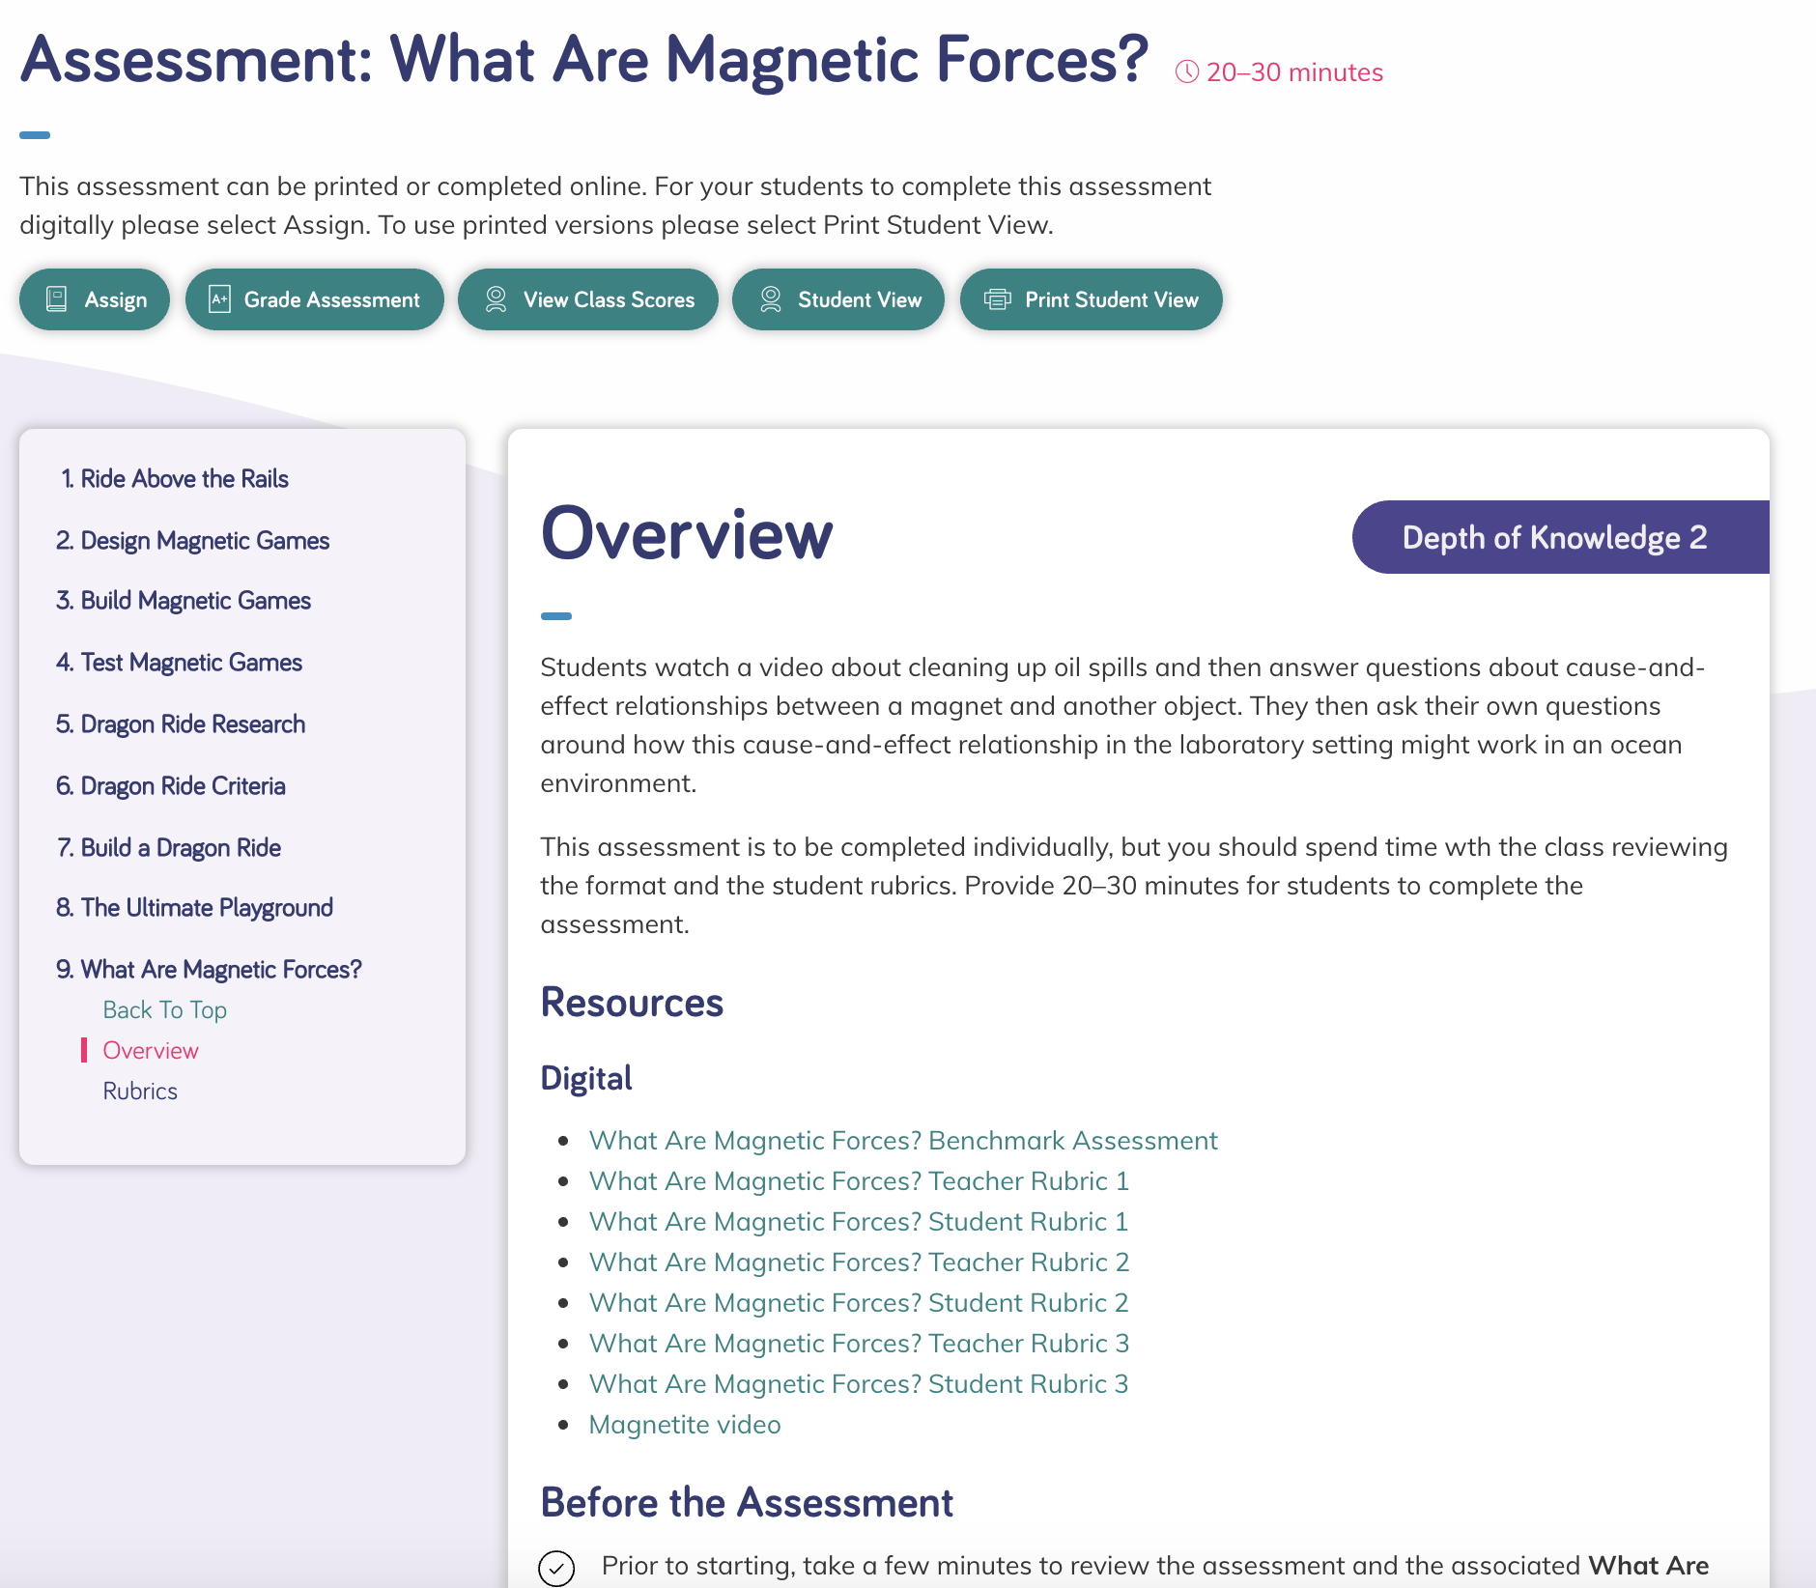 | Describe the assessment (e.g., how many questions, presence of tables/charts, graphs). | Purpose of Assessment  (i.e., peer, self, formative, summative, per/post) | Type of Measure (e.g., Performance Task, discussion, multiple choice, constructed response) | Note evidence of bias or problems with accessibility.
 | Benchmark Assessment: Students watch a video about cleaning up oil spills and answer questions about cause-and-effect relationships between a magnet and another object. They then ask their own questions about how this cause-and-effect relationship in the laboratory setting might work in an ocean environment. | Summative | Constructed response, written and drawn | No evidence of bias. Text to speech is available.
Match among Assessment, Phenomena/Problem, and Three Dimensions
What phenomenon or problem, if any, are students trying to figure out in this assessment? |  | What is the 2-3 dimensional learning goal assessed in this task?
Students figure out how non-contact forces, such as magnetism, can be used to solve engineering problems, such as cleaning up an oil spill. |  | Students are assessed on their ability to use what they have learned throughout the module to solve a real-world problem—cleaning up oil spills (PS2.B, SEP-2, SEP-6, CCC-2, ETS1.B).

Assessment Description
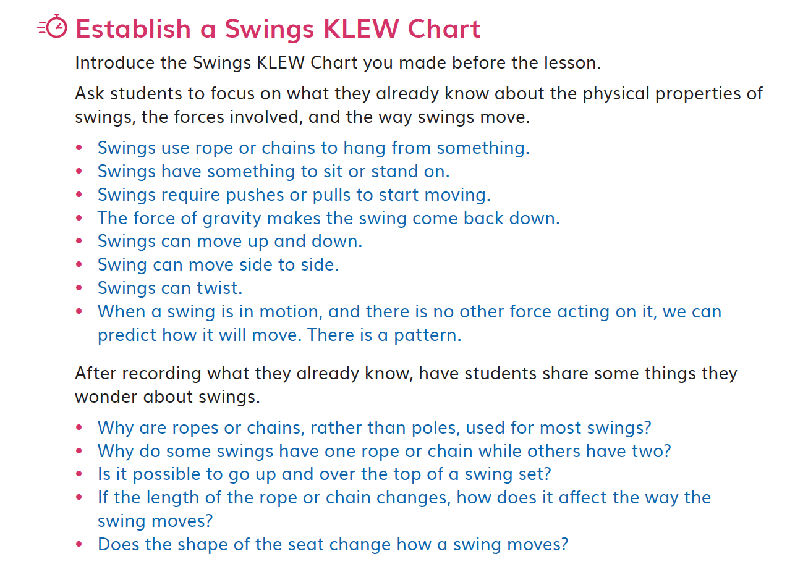  DQ3L1 Investigate TE p. 161 | Describe the assessment (e.g., how many questions, presence of tables/charts, graphs). | Purpose of Assessment  (i.e., peer, self, formative, summative, per/post) | Type of Measure (e.g., Performance Task, discussion, multiple choice, constructed response) | Note evidence of bias or problems with accessibility.
 | Prior Knowledge Assessment: KLEW Chart (Know, Learned, Evidence, Wonder) | Self-reflection | Discussion | No evidence of bias.
Match among Assessment, Phenomena/Problem, and Three Dimensions
What phenomenon or problem, if any, are students trying to figure out in this assessment? |  | What is the 2-3 dimensional learning goal assessed in this task?
Diagnostic assessment to allow students and teachers to identify the prior knowledge, and adapt support as necessary. |  | Students are assessed on their prior knowledge of forces, and communicate questions they want to answer about the Module Phenomenon.

Assessment Description
DQ3L3 Report TE p. 175  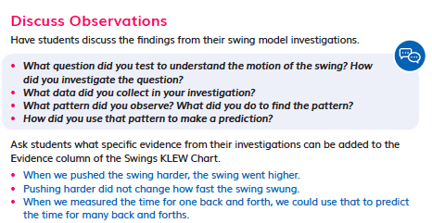 | Describe the assessment (e.g., how many questions, presence of tables/charts, graphs). | Purpose of Assessment  (i.e., peer, self, formative, summative, per/post) | Type of Measure (e.g., Performance Task, discussion, multiple choice, constructed response) | Note evidence of bias or problems with accessibility.
 | Two writing prompts. | Self-reflection | Constructed written | No evidence of bias.
Match among Assessment, Phenomena/Problem, and Three Dimensions
What phenomenon or problem, if any, are students trying to figure out in this assessment? |  | What is the 2-3 dimensional learning goal assessed in this task?
Students summarize what they have learned about the phenomena of how swings move and about identifying patterns in their motion. |  | Students are assessed on their ability to reflect on what they have learned, and define questions for investigation (SEP-3, CCC-1, 3-5-ETS1-3).

Assessment Description
DQ5L5 Reflect TE p. 267  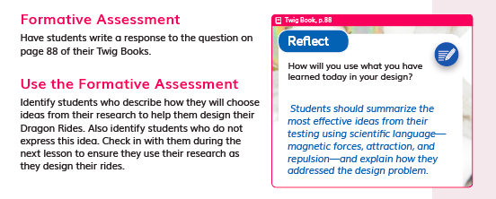 | Describe the assessment (e.g., how many questions, presence of tables/charts, graphs). | Purpose of Assessment  (i.e., peer, self, formative, summative, per/post) | Type of Measure (e.g., Performance Task, discussion, multiple choice, constructed response) | Note evidence of bias or problems with accessibility.
 | One writing prompt. | Self-reflection | Written response | No evidence of bias.
Match among Assessment, Phenomena/Problem, and Three Dimensions
What phenomenon or problem, if any, are students trying to figure out in this assessment? |  | What is the 2-3 dimensional learning goal assessed in this task?
Students figure out the most effective ideas from their ride designs, models and testing. They use scientific language—magnetic forces, attraction, and repulsion—to explain how they addressed the design problem. |  | Students are assessed on their ability to generate and compare multiple solutions to a design problem based on how well it meets criteria. (3-PS2-4, 3-5-ETS1-2)

Assessment Description
DQ5L7 Investigate TE p. 279  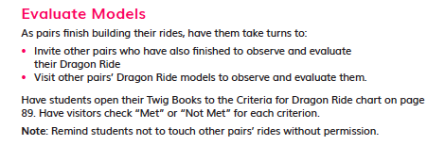 | Describe the assessment (e.g., how many questions, presence of tables/charts, graphs). | Purpose of Assessment  (i.e., peer, self, formative, summative, per/post) | Type of Measure (e.g., Performance Task, discussion, multiple choice, constructed response) | Note evidence of bias or problems with accessibility.
 | Evaluation of models with criteria. | Peer | Discussion, written | No evidence of bias.
Match among Assessment, Phenomena/Problem, and Three Dimensions
What phenomenon or problem, if any, are students trying to figure out in this assessment? |  | What is the 2-3 dimensional learning goal assessed in this task?
Students evaluate model rides and designs against criteria. |  | Students are assessed on their ability to generate design solutions to an engineering problem applying a set of criteria, and assess their peers. (3-5-ETS1-2)

Designed for the NGSS: Foundations | High Quality  5 | Medium Quality  3 | Low Quality  1
SP1. Three-dimensional Performances. Materials include assessments designed to:  - match the targeted learning goals;  - elicit observable evidence of students’ use of grade-appropriate elements of the three dimensions to make sense of phenomena and/or to design solutions to problems. | Materials include assessments that are consistently designed to connect to learning goals and require students to apply appropriate elements of the three dimensions to make sense of the phenomenon/ solve the problem. | Materials include assessments that are sometimes designed to connect to learning goals and require students to apply appropriate elements of the three dimensions to make sense of the phenomenon/solve the problem. | Materials include assessments that are designed such that they have limited connection to learning goals and/or they require students to apply elements of only one dimension to demonstrate their understanding of the phenomenon/solve the problem.
SP2. Variety of Measures. Assessments within a unit of instruction are matched to the targeted learning goals and elicit a full range of student thinking through:  - use of a variety of measures (e.g., Performance Tasks, discussion questions, constructed response questions, project- or problem- based tasks, portfolios, justified multiple choice);  - multiple assessment opportunities so that students can demonstrate their understanding of the same learning goals in a variety of ways. | Materials include assessments that include a wide variety of formats with clear expectations that allow students to demonstrate their understanding of the learning goals in multiple ways. | Materials include assessments that include some variety of formats with clear expectations that allow students to demonstrate their understanding of the learning goals in multiple ways. | Materials include assessments that use just one format and/or the expectations for students to demonstrate their knowledge are absent or unclear.
SP3. Student Progress Over Time. The unit of instruction includes assessments that serve a variety of purposes (e.g., pre/post; formative, summative, peer, self) to measure students’ progress over time. The assessments:  - provide opportunities to see growth and development in the use of the dimensions over time;  - allow students to reflect on and monitor their sense-making/problem-solving over time. | Materials include assessments that offer multiple opportunities, using more than one type of measure to demonstrate learning, and these measures are strongly connected to show student progress both in and across the three dimensions. | Materials include assessments that offer multiple opportunities, using more than one type of measure to demonstrate learning, and these measures are somewhat connected to show student progress in or across the three dimensions. | Materials include assessments that offer limited opportunities for students to demonstrate progress on the three dimensions.
SP4. Equitable Access. Assessments within the unit of instruction are designed to:  - be free from bias (e.g., gender, racial, socioeconomic status, cultural, etc.);  - be accessible to all students (e.g., reading level, accommodations). | Most assessments in the materials are free from bias and are accessible. | Some assessments in the materials are free from bias and are accessible. | Few assessments in the materials are free from bias and are accessible.

Designed for the NGSS: Student Progress Rubric

Analyze Evidence

Directions
  - Review the Designed for NGSS: Student Progress Rubric.
  - Reflect on the evidence (or lack of evidence) that you and your team gathered.
  - Record strengths and limitations for each criterion based on your observations. Cite specific examples.

Strengths
SP1: Three-Dimensional Performance
The materials are High Quality 5 in regards to SP1.
They include assessments that are consistently designed to connect to learning goals and require students to apply appropriate elements of the three dimensions to make sense of the Module Phenomenon.
Evidence  - Assessments are well-matched to the learning goals and require students to demonstrate observable use of three dimensions to make sense of phenomenon and solve problems. For example:  - DQ2 Performance Task, students describe the way amusement park rides move, and explain how unbalanced forces cause their motion to change (PS2.A, CCC-2, SEP-8). (DQ2L5 Investigate TE p. 148) | DQ2L5 Investigate TE p. 148
- DQ5 Performance Task, students research, design and build a dragon ride to test. They define criteria and constraints and measure their success using a rubric. They apply knowledge of forces and motion, non-contact forces, and generate solutions to an engineering problem (PS2.A, PS2.B, ETS1.B, ETS1.C, CCC-1, CCC-2, SEP-2, SEP-3, SEP-6). (DQ5L7 Investigate TE p. 278) | 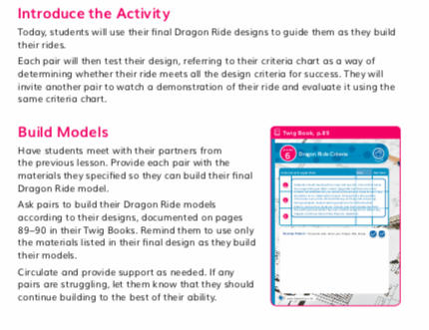  DQ5L7 Investigate TE p. 278
SP2: Variety of Measures
The materials are High Quality in regards to SP2.
Materials include assessments that include a wide variety of formats with clear expectations that allow students to demonstrate their understanding of the learning goals in multiple ways.
Evidence  - Assessments allow students to demonstrate their understanding of the learning goals in a variety of way including:  - Performance Tasks (written, drawn, and hands-on DQ2L5 Investigate TE p. 148, DQ5L7 Investigate TE p. 27),  - Discussions (DQ3L1 Investigate TE p. 161),  - Constructed response (written and drawn DQ5L8 Reflect TE p. 287), | DQ2L5 Investigate TE p. 148
- Self and peer assessment (DQ3L3 Reflect TE p. 175, DQ5L5 Reflect TE p. 267, DQ5L7 Investigate TE p. 279),  - Multiple choice (DQ5, Multiple Choice Questions).  - Student versions of rubrics for the Performance Tasks and Benchmark Assessment are shared with the class so they have a clear understanding of what success looks like (available online). | DQ5L5 Reflect TE p. 267  DQ5L7 Investigate TE p. 279

SP3: Student Progress Over Time
The materials are High Quality in regards to SP3.
Materials include assessments that offer multiple opportunities, using more than one type of measure, to demonstrate learning and these measures are strongly connected to show student progress both in and across the three dimensions.
Evidence  - There are four diagnostic pre-assessments called Pre-Explorations at strategic points in the module that assess prior knowledge and misconceptions (DQ2L1 Reflect TE p. 119). Notes in the TE and Progress Trackers support teachers to monitor students as they clear up their misconceptions and master the three dimensions, giving suggestions for how to tailor instruction accordingly.  - Formative assessments are frequent and varied, supporting students and teachers to understand how their learning journey is progressing (DQ1L2 Reflect TE p. 68, DQ2L2 Reflect p. 129, DQ5L8 Reflect p. 287).  - The DQ5 Benchmark Assessment (TE p. 288) allows students to demonstrate their ability to apply their growing skills and knowledge to new contexts.  - The performance tasks at the end of DQs 2, 3, and 5 allow students to demonstrate their attainment of the PEs in a variety of ways.  - A module-level Multiple Choice assessment supports teachers to assess all three dimensions targeted in the module. | DQ2L1 Reflect TE p. 119
SP4: Equitable Access
The materials are High Quality in regards to SP4.
Most assessments in the materials are free from bias and are accessible.
Evidence
- The digital Twig Book and digital assessment items (Benchmark, Multiple Choice, Rubrics) have a text-to-speech function allowing students of all reading levels to access the assessments.
- Assessments of the three dimensions are multimodal and include multiple choice, writing, drawing, physical models, posters, and oral presentations, giving all students access to a range of assessment types to suit their learning style and/or reading level.
- The rubrics for the Performance Tasks (e.g., the Balanced and Unbalanced Forces Writing Rubric in DQ2L5 TE p. 148) and the Benchmark Assessment (TE p. 288, online, DQ5) have four levels—emerging, developing, proficient, and advanced, allowing all students to demonstrate their current level of attainment.
- The multiple choice assessment (DQ5) contains questions targeting different DoK levels, with an extended section available to further challenge GATE students.
- Writing, Reading, Listening and Speaking domain tasks dedicated to monitor English language development are integrated into the core instructional resources (DQ1L7 Extension TE p. 108, DQ5L1 TE p. 241) and the on-level reader lessons (Chapter 3 Second Read TE p. 313).

