Designed for NGSS: Student Work Rubric
Analyze Evidence
Directions:
- Review your assigned materials to describe the path of student thinking.
- Represent your answers to the questions in the space provided.
- Be prepared to share the path of student thinking visually on a public chart.

Answer (in words, graphics, or both)
Answer the following questions as you describe the path of student thinking in the materials. Consider what you would expect students to be thinking about through the learning experiences.
What are students figuring out/solving?
- What is driving student learning (e.g., question, scenario, problem, phenomenon, etc.)?
- What ideas and practices do students develop through these experiences?
- How do students access, engage, and use prior knowledge to further their thinking?
- How do students develop metacognitive abilities?
SW1. Phenomena/Problems.
Student learning is driven by figuring out a solution to the Module Phenomenon: What happens when we push, pull, and drop objects? How can we change their speed and direction?
In order to solve the problem, students work through a series of Driving Questions (DQs) that require them to make sense of a subset of smaller phenomena/problems and then connect what they now know to the central phenomenon. The skills and knowledge gained over these investigations culminate in an Engineering Design Challenge in which students utilize and demonstrate their understanding of the Module Phenomenon.  - DQ1: How can we make an object move faster or move in a different direction?  - DQ2: How can we get marbles where we want them?  - DQ3: How do we understand and design a marble run?  Interwoven with this science narrative is a storyline that requires students to take on the role of engineers and design their own marble runs. They are introduced to the storyline through a movie-style module Trailer video.  The Module is complemented with Pushes and Pulls, a magazine-style leveled reader (available in four levels, plus Spanish) that provides additional exposure to relevant phenomena/problems as well as an interview with a scientist based at a university. Packed with stunning images, cartoons, and jokes, it’s designed to appeal to students with a diverse range of learning abilities. | 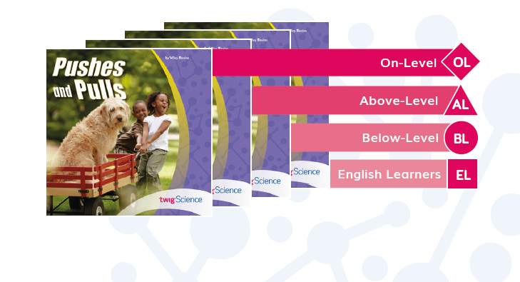  Pushes and Pulls Leveled Reader (Front Cover)  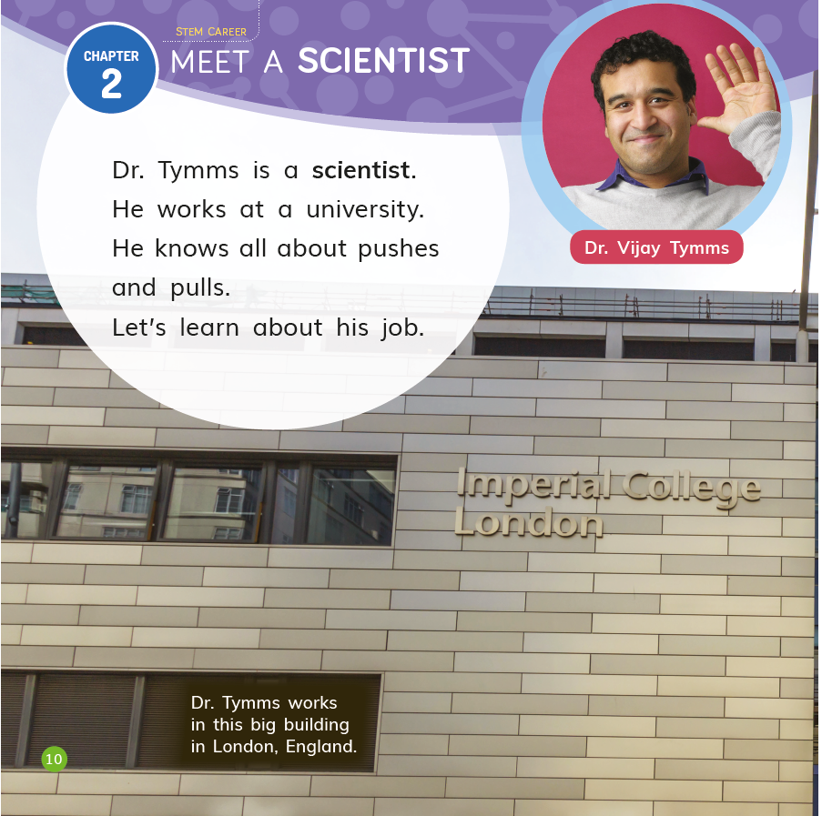  Pushes and Pulls Leveled Reader p. 10
Evidence  - Students share ideas about what happens when they push or pull objects, answering the first part of the Module Phenomenon (DQ1L2 Connect TE p. 18).  - Students conduct a hands-on investigation into the phenomenon of gravity (DQ1L8 Investigate TE p.59).  - Students write a narrative story or informational text that illustrates their understanding of the first Driving Question (DQ1L10 TE pp. 70–75).  - Over the course of DQ2, students conduct a series of investigations into the problem of changing the speed or direction of an object (for example, DQ2L4 TE p. 105, DQ2L5 TE pp. 111–112, DQ2L6 TE p. 119).  - Students use their learning from the first two DQs to design, build, test, and revise a marble run that solves a design problem (DQ3L5 TE pp. 160–162). They present their completed marble runs to the class, using their knowledge of the Module Phenomenon to explain how their marble run works (DQ3L6 TE p. 167). | 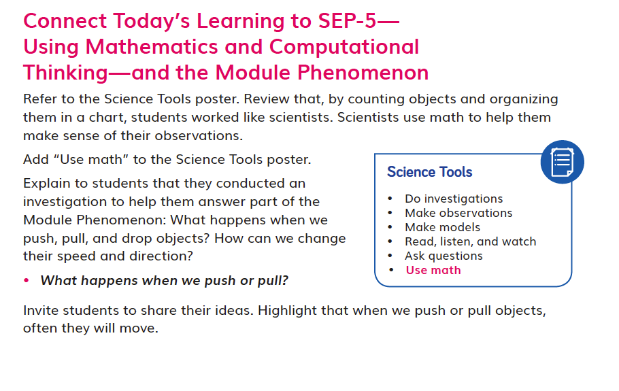DQ1L2 Connect TE p. 18
SW2. Three-Dimensional Conceptual Framework.
Students’ experiences consistently support them to use their prior knowledge to negotiate new understandings and abilities and apply their understandings in a variety of ways.
In DQ1, students start by exploring how different objects move. They activate their prior knowledge with a Prior-Knowledge Read-Aloud, learn to use the terms push and pull correctly in context, and then explore the classroom to identify objects that can be pushed, pulled, or neither (SEP-3). They watch videos that show and reinforce that force is responsible for making things move (PS2.A), and conduct hands-on investigations into how the strength of a push or pull affects an object’s movement (SEP-3). They discuss their findings about forces and motion (PS2.A) and the relationship between energy and forces, relating their discoveries to cause and effect (CCC-2).

Students analyze and interpret images relating to forces and motion (SEP-4, PS2.A) and engage in a close reading about moving and rolling, identifying causes and effects (CCC-2). They carry out hands-on investigations to explore the phenomenon of gravity (SEP-3, PS2.A) and demonstrate their new understandings of pushes and pulls by writing a short narrative story or informational text that they share with the class (SEP-8).

Students then conduct a series of hands-on investigations to compare the effects of different strengths or directions of pushes or pulls on the motion of an object (SEP-3, PS2.A, PS3.C). They ask how they might change their experiments (SEP-1) and debate which of two setups was more effective (SEP-7). They explore different types of interactions by investigating what happens when marbles collide (PS2.B), and write and draw an example of something they can do to change the speed or direction of a marble (SEP-2), sharing their results with the class (SEP-8).

Students start their engineering project, first investigating and observing a set of marble run parts in order to clearly understand the problem of creating a marble run (ETS1.A, SEP-4, CCC-2). They use what they have learned about forces and motion (PS2.A, PS2.B, PS3.C) as they build, predict the outcome of, and test marble runs. They close read an informational text about engineers and what they do, and reflect on how they have completed tasks that engineers also perform (SEP-8).

Finally, students define a design problem (ETS1.A, SEP-1), develop a model based on their learning (SEP-2, PS2.A), and build, test, and revise their marble runs (SEP-3, SEP-4). They engage in a gallery walk as they present their marble runs to the class and use their understanding of the Module Phenomenon to explain how the marble moves through their design (SEP-8).
The SEPs and CCCs that the students are using in each learning activity are labeled at point of use in the student edition (Twig Book) in grade-appropriate language. | 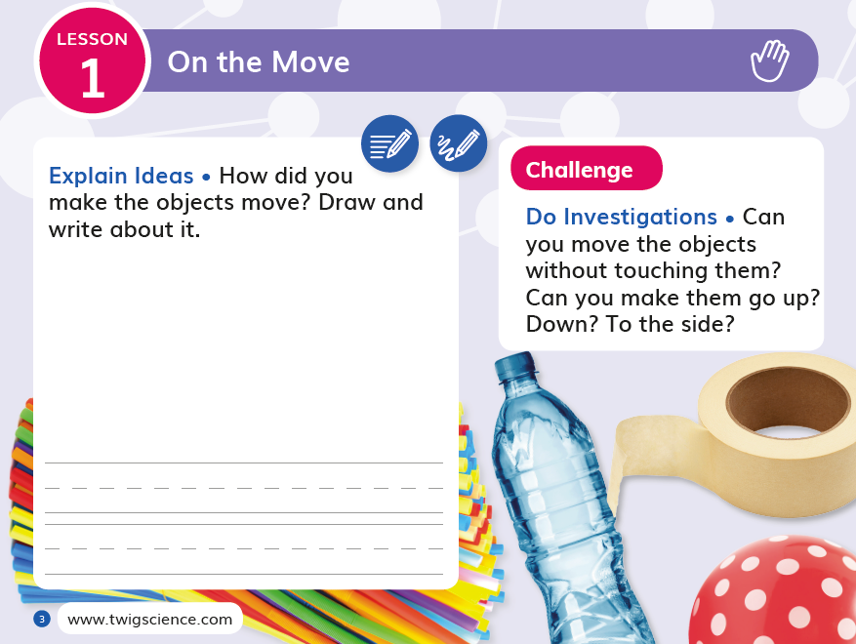  Twig Book
Evidence  - After investigating objects in the classroom, students draw their observations, showing something that can be pushed, something that be pulled, and something that cannot be pushed or pulled (DQ1L2 TB p. 5).  - Students read a text that reinforces the terms push and pull, and then analyze and discuss images with a partner, determining if each image shows a push or a pull (DQ1L9 TB pp. 23–26).  - After an investigation, students complete a sentence starter, relating the motion of a marble to the phenomenon of gravity in terms of cause and effect (DQ2L3 TB p. 36).  - Students investigate what happens when marbles of different sizes collide, drawing their predictions and observations (DQ2L6 TB pp. 43–44). | 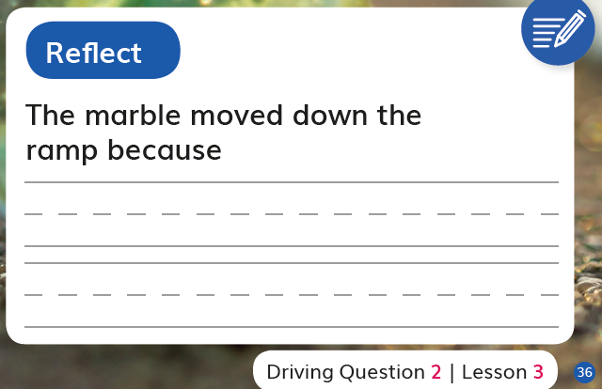  DQ2L3 TB p. 36
- Students apply their new understandings and ideas to revise their marble runs. They explain how their design changed as they learned from their failures and challenges (DQ3L5 TB pp. 64–65). | 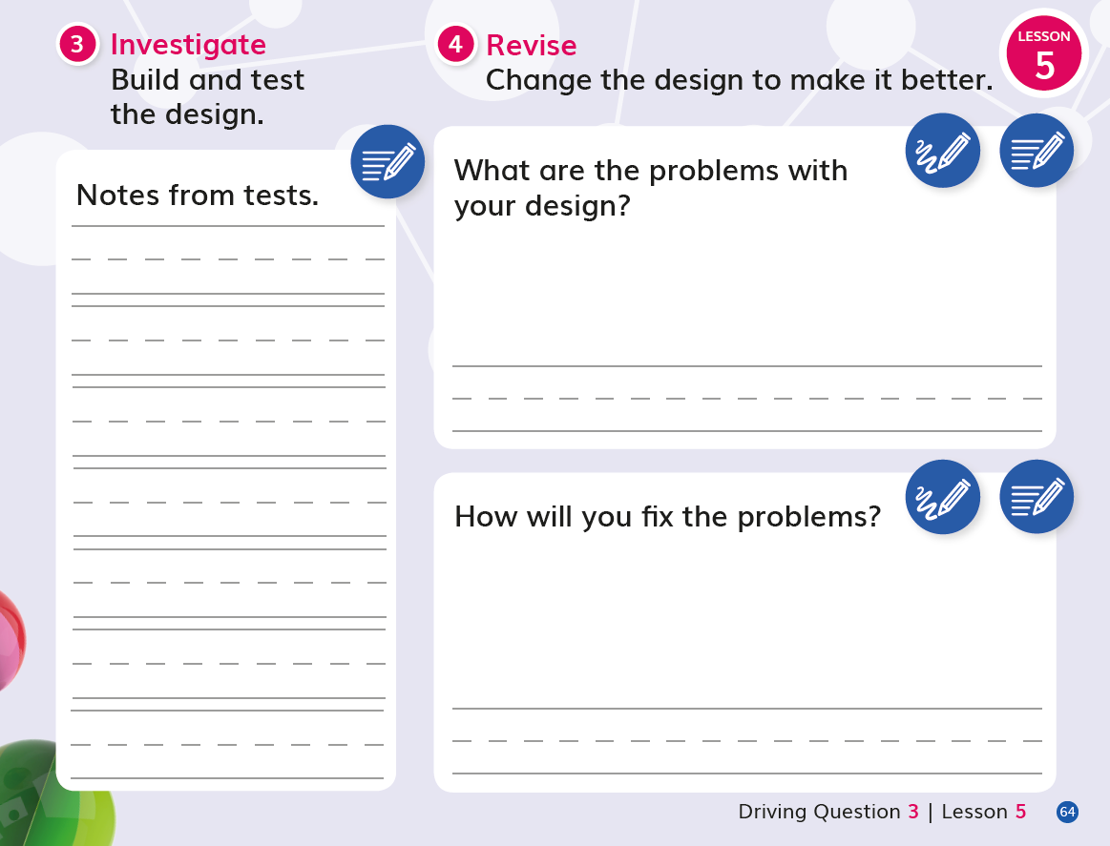  DQ3L5 TB pp. 64
SW3. Prior Knowledge.
Materials consistently leverage student prior knowledge and experiences to motivate their learning.
In DQ1L2, students use a Prior-Knowledge Read-Aloud to activate prior knowledge of the different ways that things can move. They link their observations of cause and effect (CCC-2) to their learning in Grade K Module 1, My Big Nature Adventure.

Throughout the module, students are consistently supported to revise their claims and relate their new understandings to answer the Driving Questions and solve the Module Phenomenon.

Throughout the module, students refer and add to their classroom Science Tools poster, which explicitly details their growing use of the SEPs, and motivates them by helping them visualize their progression.
Evidence  - Students complete a Pre-Exploration (diagnostic pre-assessment) to elicit awareness of their prior knowledge and misconceptions (DQ1L1 TB p. 4).  - Students engage with a Prior Knowledge Read-Aloud about different types of movement (DQ1L2 TE p. 16).  - Students reflect on the new ideas that they have learned about pushes and pulls (DQ1L5 TB p. 12).  - Students review their use of science tools and add “Design solutions” to their Science Tools poster (DQ3L3 TE p. 151).  - Students use their learning to revise their marble runs (DQ3 5 TE pp. 161–161). | 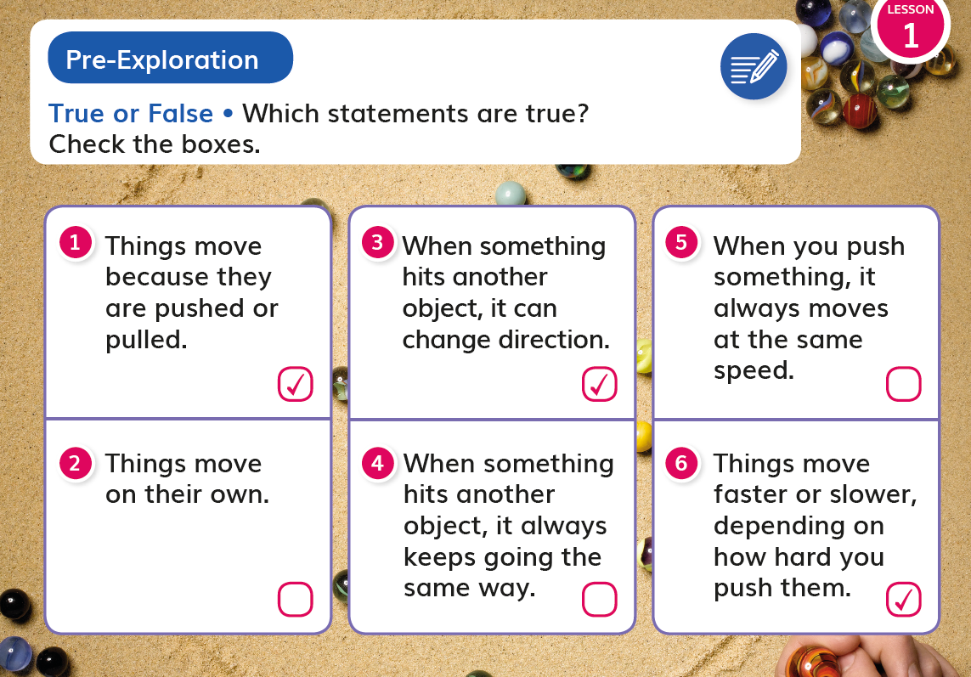  DQ1L1 TB p. 4
SW4. Metacognitive Abilities.
Marble Run Engineer regularly provides students with explicit opportunities to consider how their learning experiences have changed their thinking.
A diagnostic pre-assessment (Pre-Exploration) in DQ1L1 supports students to think about the three dimensions they are already familiar with, and those they are not.

Meta-Think-Aloud language routines help students develop an understanding of how they learn particular concepts or why they approach activities in certain ways.

“I can…” statements written in grade appropriate language are detailed for each Driving Question, supporting student awareness of their growing skills and knowledge and of the three dimensions that they will use to figure out phenomenon/solve problems.

The five-part Twig Science lesson structure has been designed to support students to develop their metacognitive abilities on a daily basis and monitor what and how they have learned across the three dimensions.

Spark: An engaging hook activity motivates students for the investigations ahead.
Investigate: Students think like scientists and design like engineers through hands-on, digital, video, and informational text investigations.
Report: Students articulate what they’ve learned today citing evidence and their use of the three dimensions.
Connect: Students make connections to the Driving Questions and Module Phenomenon while building knowledge of CCCs and SEPs.
Reflect: Here students use different means to think about what they have learned so far and how they can use their new understandings to better figure out phenomena/problems.
Evidence  - Students consider what they have learned so far, and write or draw to complete a sentence that partly answers the Module Phenomenon (DQ1L5 TB p. 14). | 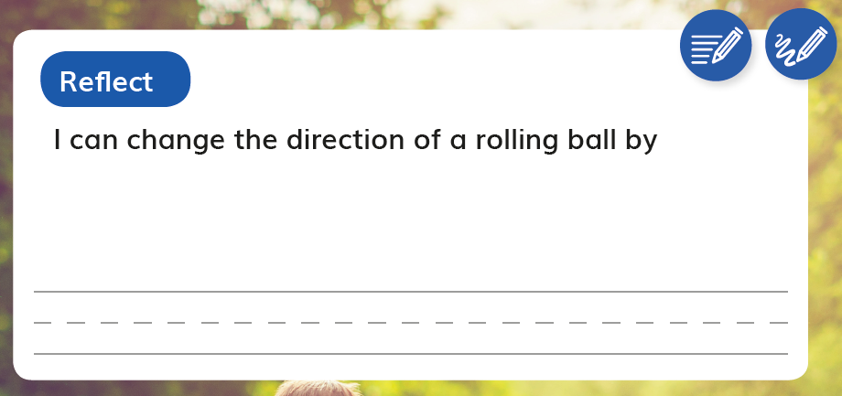  DQ1L5 TB p. 14
- The teacher uses a Meta-Think-Aloud (DQ1L6 TE p. 45) to show how the Change Direction visual might be analyzed, explicitly pointing out key aspects of the image and their significance. | 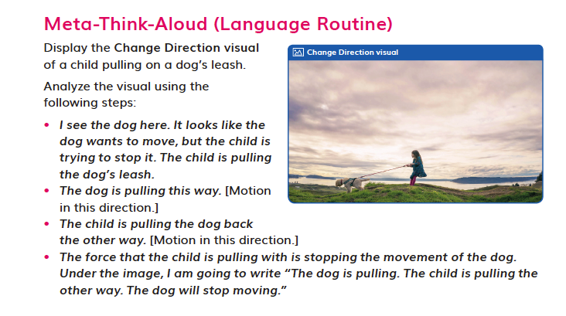  Meta-Think-Aloud (DQ1L6 TE p. 45)
- Students reflect on different ideas the class came up with for using a Score 10 Tool and a marble, and write or draw which idea they think is best and why (DQ2L1 TE p. 89).  - Students reflect on what they learned during a marble game and what useful information they could give someone who wanted to play the game (DQ2L2 TB p. 35). | 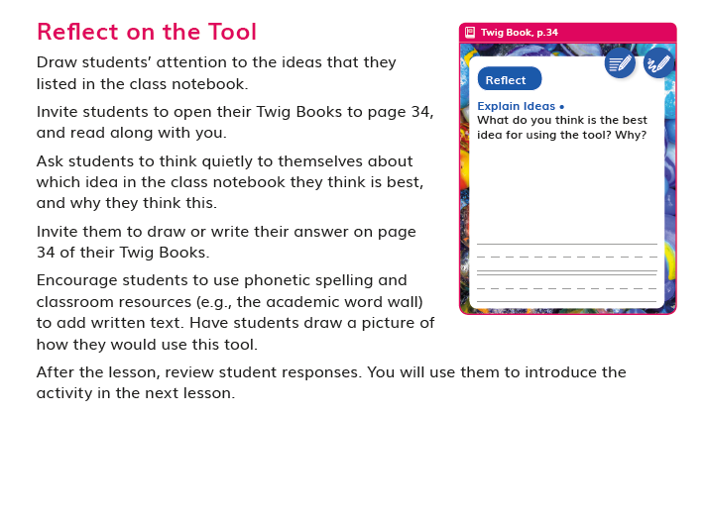  DQ2L1 Reflect TE p. 89
- The “I can…” statements (DQ3 TB p. 48) details use of the three dimensions students will use in this Driving Question. “I can... use a design to build a marble run.”  - Students reflect on what they have learned during their Engineering Design Challenge (DQ3L5 TB p. 66). | 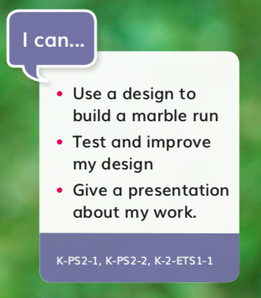  “I can…” statements (DQ3 TB p. 48)
SW5. Equitable Learning Opportunities.
Most learning experiences across Marble Run Engineer are multimodal in approach with numerous cross curricular connections, designed to engage students meaningfully in a variety of ways, with multiple access points, and with supports for students.
The learning experiences in the module are designed to appeal to students of all learning styles and abilities and include tasks in all domains—writing, reading, listening (read-alouds and videos), speaking (discussion and presentations), drawing, and hands-on investigations.

Instructional materials frequently provide support for language scaffolding for EL students at point of use in the Teacher Editions, as well as research-based integrated language routines to support all students to “talk science” using grade-level appropriate scientific vocabulary. The digital version of the Twig Book (TB) includes a text to speech function.

Suggestions for extra access points for students with special needs are provided frequently at point of use.

Culturally relevant content is core to the module. For example, in DQ3L4, students play a Snap game using images of structures in California, with additional culturally-relevant contexts added at point of use.

Higher Order Challenges for GATE student that have already met the learning goals are interspersed through the learning activities.

The frequent use of videos helps all students access and engage with phenomena and science concepts. Key words are overlaid as on-screen text, so students can access the ideas visually as well as via the spoken and written word. Captions are provided in both English and Spanish.
The Pushes and Pulls Leveled Reader has been designed to capture the imagination of young readers with jokes and cartoons and it provides an alternative means to access the scientific content. The reader is available in four levels (Below, On, Above, English Learner) plus Spanish, with complementary lessons to build language acquisition and develop informational text reading skills. On-Level lessons are in the TE, with other levels available digitally. The reader features many positive role models in the field of science and engineering, designed to cultivate interest in STEM careers for all students. Chapter 2 is dedicated to an interview with a scientist based at a university in London. The digital version of the reader includes a text to speech function. | Pushes and Pulls Leveled Reader (Front Cover)
Evidence  - Integrated EL sidebars offer teachers guidance to support students’ engagement with the material (DQ1L1 TE p. 11, DQ1L2 TE p. 18, DQ1L8 TE p. 59, DQ2L5 TE p. 110, DQ3L5 TE p. 161). | 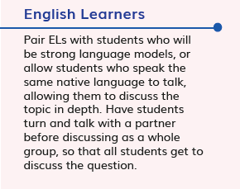  DQ1L1 English Learners TE p. 11
- Integrated Cultural Connection sidebars offer teachers guidance to engage students of all backgrounds and abilities (DQ2L1 TE p. 86, DQ2L5 TE p. 114, DQ3L6 TE p. 168). | 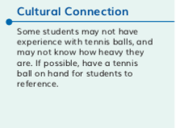  DQ2L5 Cultural Connection TE p. 114
- Integrated Special Needs sidebars offer teachers guidance to support students of all abilities as they participation in class activities and grasp key concepts (DQ1L2 TE p. 17, DQ1L3 TE p. 27, DQ2L1 TE p. 88, DQ3L2 TE p. 142, DQ3L6 TE p. 166). | 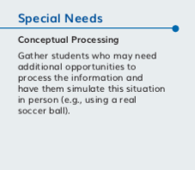  DQ1L3 Special Needs TE p. 27
- Integrated Challenges interspersed throughout the TB support GATE students who have met the learning goals (DQ1L1 TB p. 3, DQ1L8 TB p. 21, DQ2L3 TB p. 35, DQ2L5 TB p. 42, DQ3L4 TB p. 61). | 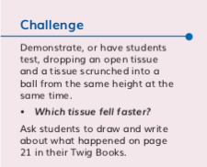  DQ3L4 Challenge TB p. 61
- Videos like What Makes Things Move? (DQ1L3), Exploring Forces (DQ1L4), Gravity (DQ1L8), and Speed (DQ2L4) bring phenomena and concepts to life for all students. | Gravity video (DQ1L8)

Designed for the NGSS: Foundations | High Quality  5 | Medium Quality  3 | Low Quality  1
SW1. Phenomena/Problems. Materials provide phenomena/problems that:  - engage students as directly as possible in authentic and relevant experiences.  - are matched to targeted learning goals.  - can be figured out/solved using scientifically accurate understandings and abilities.  - make connections beyond and to their daily lives including to their homes, neighborhoods, communities, and/or cultures. | Materials consistently offer quality phenomena/ problems sufficient to motivate and drive student learning. | Materials sometimes offer quality phenomena/ problems sufficient to motivate and drive student learning. | Materials rarely offer quality phenomena/ problems sufficient to motivate and drive student learning.
SW2. Three-dimensional Conceptual Framework. Materials include learning experiences that help students to build scientifically accurate understandings and abilities through opportunities for students to:  - link prior knowledge to negotiated new understanding and abilities  - use reasoning to connect grade-appropriate SEP, DCI, and CCC elements.  - ask and answer questions that link learning over time.  - negotiate new understandings and abilities by comparing their ideas, their peers’ ideas, and ideas encountered in the learning experience(s).  - apply their understandings and abilities in a variety of ways. | Materials consistently include learning experiences that help students build from prior experiences to negotiate new understandings and abilities and apply their understandings in a  variety of ways. | Materials sometimes include learning experiences that help students build from prior experiences to negotiate new understandings and abilities and apply their understandings in a  variety of ways. | Materials rarely include learning experiences that help students build from prior experiences to negotiate new understandings and abilities and apply their understandings in a  variety of ways.
SW3. Prior Knowledge. Materials leverage students’ prior knowledge and experiences to motivate student learning in ways that:  - make visible students’ prior knowledge and experiences related to the phenomena/problems and relevant SEPs, DCIs, and CCCs.  - revisit students’ early ideas to see how they have changed (or not) as they figure out phenomena/solve problems.  - make explicit links to new ideas and practices being developed by students. | Materials consistently leverage student prior knowledge and experiences to motivate their learning. | Materials sometimes leverage student prior knowledge and experiences to motivate their learning. | Materials rarely leverage student prior knowledge and experiences and when included, they do not relate to the phenomena or problems.
SW4. Metacognitive Abilities. Materials include learning experiences for students to:  - set and monitor their learning in light of the targeted learning goals.  - consider, over time, what and how they have learned across the three dimensions.  - articulate how the three dimensions helped them figure out phenomena/solve  problems. | The materials provide students with regular, explicit opportunities to consider how their learning experiences  changed their thinking. | The materials provide students with some opportunities to consider how their learning experiences changed  their thinking. | The materials provide few opportunities for students to consider how their learning experiences changed their thinking.
SW5. Equitable Learning Opportunities: Materials ensure that all students, including those from non-dominant groups and with diverse learning needs, have access to the targeted learning goals and experiences, including:  - appropriate reading, writing, listening, and/or speaking alternatives for students who are English language learners, have special needs, read below the grade level, or have high interest and have already met the intended learning goals.  - culturally-relevant contexts and examples that support all students.  - opportunities to cultivate interest and confidence as scientists and engineers for  all students. | Most learning experiences in materials are designed such that students can engage meaningfully in a variety of ways, with multiple access points, and with supports for students. | Some learning experiences in materials are designed such that students can engage meaningfully in a variety of ways, with multiple access points, and with supports for students | Few learning experiences in materials are designed such that students can engage meaningfully in a variety of ways, with multiple access points, and with supports for students.

Designed for NGSS: Student Work Rubric
Analyze Evidence
Directions:
  - Review the Designed for NGSS: Student Work Rubric.
  - Reflect on the evidence (or lack of evidence) that you and your team gathered.
  - Record strengths and limitations for each criterion based on your observations. Cite specific examples.

Strengths
SW 1: Phenomena/ Problems
The Student Work is High Quality (5) in terms of SW1
Materials consistently offer quality phenomena/ problems sufficient to motivate and drive student learning.
Evidence  - Students share ideas about what happens when they push or pull objects, answering the first part of the Module Phenomenon (DQ1L2 TE p. 18).  - Students conduct a hands-on investigation into the phenomenon of gravity (DQ1L8 TE p. 59).  - Students write a narrative story or informational text that illustrates their understanding of the first Driving Question (DQ1L10 TE pp. 70–75).  - Over the course of DQ2, students conduct a series of investigations into the problem of changing the speed or direction of an object (for example, DQ2L4 TE p. 105, DQ2L5 TE pp. 111–112, DQ2L6 TE p. 119).  - Students use their learning from the first two Driving Questions to design, build, test, and revise a marble run that solves a design problem (DQ3L5 TE pp. 160–162). They present their completed marble runs to the class, using their knowledge of the Module Phenomenon to explain how their marble run works (DQ3L6 TE p. 167 | 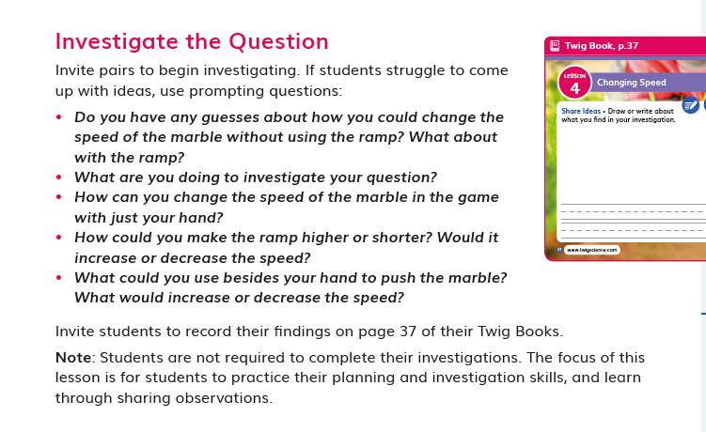  DQ2L4 TE p. 105
SW 2: Three-Dimensional Conceptual Framework
The Student Work is High Quality (5) in terms of SW2
Materials consistently include learning experiences that help students build from prior experiences to negotiate new understandings and abilities and apply their understandings in a variety of ways.
Evidence  - After investigating objects in the classroom, students draw their observations, showing something that can be pushed, something that be pulled, and something that cannot be pushed or pulled (DQ1L2 TB p. 5).  - Students read a text that reinforces the terms push and pull, and then analyze and discuss images with a partner, determining if each image shows a push or a pull (DQ1L9 TB pp. 23–26).  - After an investigation, students complete a sentence starter, relating the motion of a marble to the phenomenon of gravity in terms of cause and effect (DQ2L3 TB p. 36).  - Students investigate what happens when marbles of different sizes collide, drawing their predictions and observations (DQ2L6 TB pp. 43–44).  - Students apply their new understandings and ideas to revise their marble runs. They explain how their design changed as they learned from their failures and challenges (DQ3L5 TB pp. 64–65). | 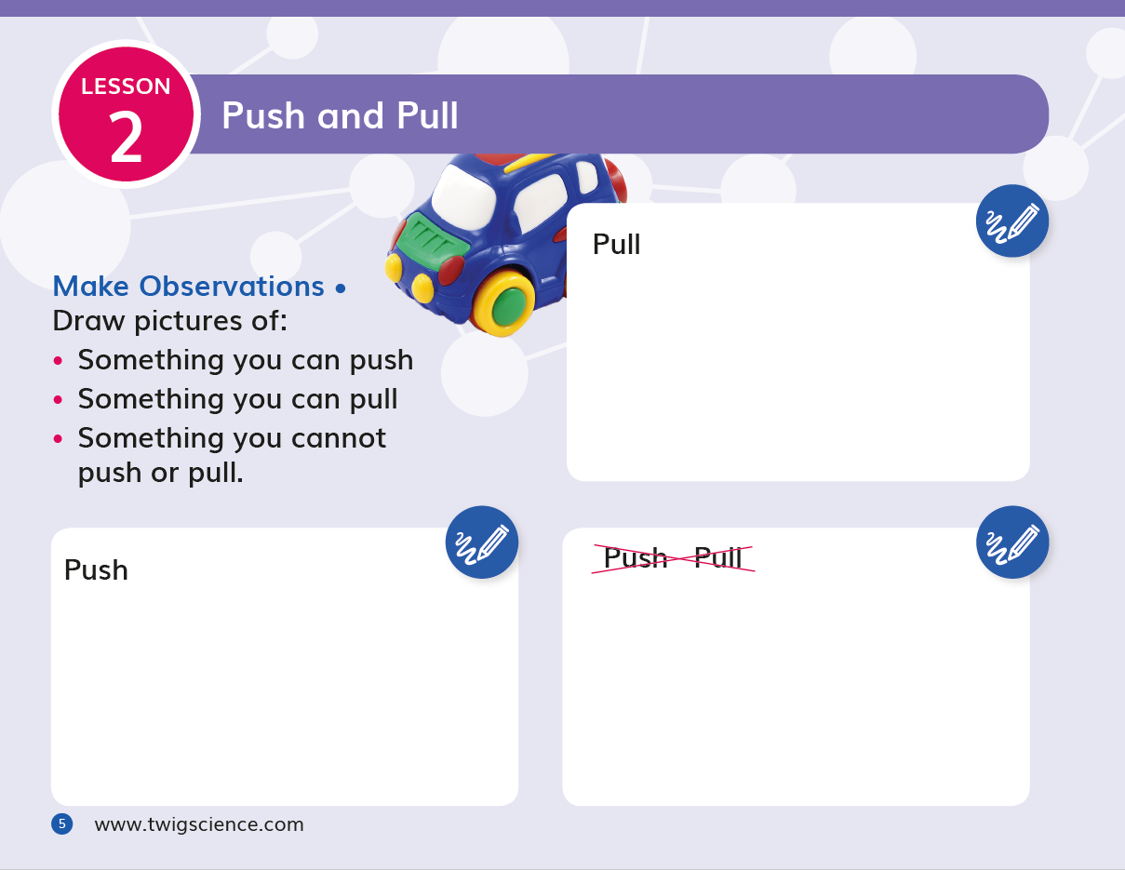  DQ1L2 TB p. 5
SW 3: Prior Knowledge
The Student Work is High Quality (5) in terms of SW3
Materials consistently leverage student prior knowledge and experiences to motivate their learning.
Evidence  - Students complete a Pre-Exploration (diagnostic pre-assessment) to elicit awareness of their prior knowledge and misconceptions (DQ1L1 TB p. 4).  - Students engage with a Prior Knowledge Read-Aloud about different types of movement (DQ1L2 TE p. 16).  - Students reflect on the new ideas that they have learned about pushes and pulls (DQ1L5 TB p. 12).  - Students review their use of science tools and add “Design solutions” to their Science Tools poster (DQ3L3 TE p. 151).  - Students use their learning to revise their marble runs (DQ3L5 TE pp. 161–161). | DQ1L1 TB p. 4
SW 4: Metacognitive Abilities
The Student Work is High Quality (5) in terms of SW4
The materials provide students with regular, explicit opportunities to consider how their learning experiences changed their thinking.
Evidence  - Students consider what they have learned so far, and write or draw to complete a sentence that partly answers the Module Phenomenon (DQ1L5 TB p. 14).  - The teacher uses a Meta-Think-Aloud to show how the Change Direction visual might be analyzed, explicitly pointing out key aspects of the image and their significance (DQ1L6 TE p. 45).  - Students reflect on different ideas the class came up with for using a Score 10 Tool and a marble, and write or draw which idea they think is best and why (DQ2L1 TE p. 89).  - Students reflect on what they learned during a marble game and what useful information they could give someone who wanted to play the game (DQ2L2 TB p. 35).  - The ‘I Can’ statement details use of the three dimensions students will use in this Driving Question. “I can... use a design to build a marble run.” (DQ3 TB p. 48)  - Students reflect on what they have learned during their Engineering Design Challenge (DQ3L5 TB p. 66). | DQ2L1 TE p. 89
SW 5: Equitable Learning Opportunities
The Student Work is High Quality (5) in terms of SW5
Most learning experiences in materials are designed such that students can engage meaningfully in a variety of ways, with multiple access points, and with supports for students.
Evidence  - Integrated EL sidebars offer teachers guidance to support students’ engagement with the material (DQ1L1 TE p. 11, DQ1L2 TE p. 18, DQ1L8 TE p. 59, DQ2L5 TE p. 110, DQ3L5 TE p. 161).  - Integrated Cultural Connection sidebars offer teachers guidance to engage students of all backgrounds and abilities (DQ2L1 TE p. 86, DQ2L5 TE p. 114, DQ3L6 TE p. 168).  - Integrated Special Needs sidebars offer teachers guidance to support students of all abilities as they participation in class activities and grasp key concepts (DQ1L2 TE p. 17, DQ1L3 TE p. 27, DQ2L1 TE p. 88, DQ3L2 TE p. 142, DQ3L6 TE p. 166).  - Integrated Challenges interspersed throughout the TB support GATE students who have met the learning goals (DQ1L1 TB p. 3, DQ1L8 TB p. 21, DQ2L3 TB p. 35, DQ2L5 TB p. 42, DQ3L4 TB p. 61).  - Videos (What Makes Things Move? (DQ1L3), Exploring Forces (DQ1L4), Gravity (DQ1L8)) bring phenomena and concepts to life for all students. | 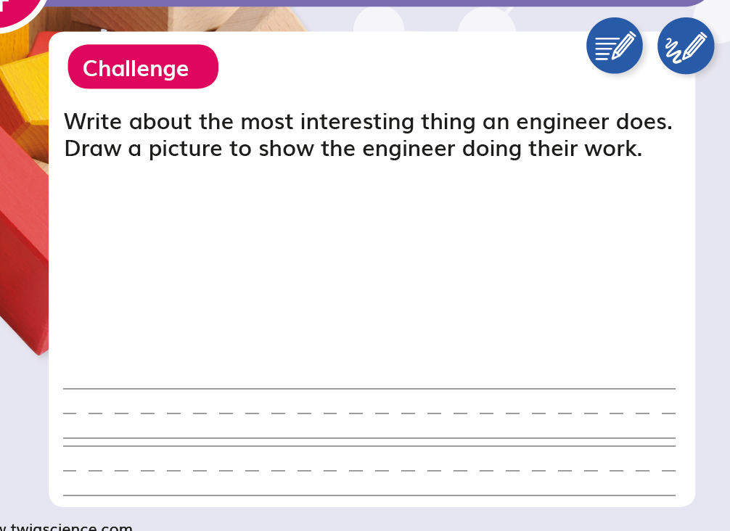  DQ3L4 TB p. 61

